

**TRAFFIC PROPOSAL**

|  |  |  |
| --- | --- | --- |
| **Title of Proposal** | **BATH AND NORTH EAST SOMERSET COUNCIL**  **THE COMBE,WRITHLINGTON,RADSTOCK**  **(PROHIBITION OF DRIVING A VEHICLE EXCEEDING 3 TONNES MAXIMUM GROSS WEIGHT) ORDER 2020** | |
| **TRO Reference** | | **TRO 19-025/GW** |
| **Closing date for Objections and Representations** | | 20/02/2020 |

NOTICE is given that the Bath and North East Somerset Council proposes to make an order under provisions contained in the Road Traffic Regulation Act 1984, the effect of which will be to prohibit any vehicles exceeding the maximum gross weight of 3 Tonnes to proceed onto The Combe, Writhlington, Radstock as shown on the plan below:

Full details of the proposal are contained in the draft order which, together with a map and a Statement of the Council’s Reasons for proposing to make the order, may be inspected at: The One Stop Shops at The Hollies, High Street, Midsomer Norton, 3-4 Manvers Street, Bath and at the Civic Centre, Market Walk, Keynsham during normal office hours. The proposal may also be viewed on the Council’s website: [**www.bathnes.gov.uk**](http://www.bathnes.gov.uk)**,** by searching for the TRO number above.

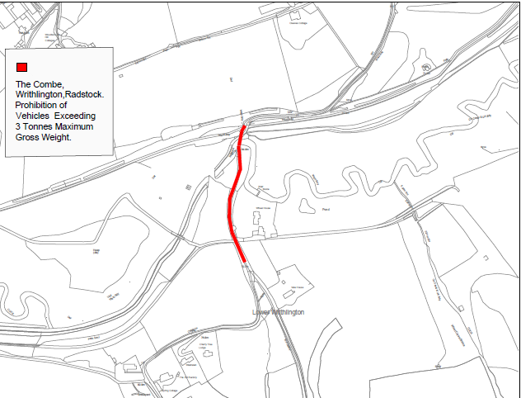

Objections and representations with respect to the proposal, together with the grounds on which they are made, must be sent in writing by the above date to the Council at the following addresses: **Traffic Management Team, Bath and North East Somerset Council, Lewis House, Manvers Street, BATH, BA1 1JG** or [transportation@bathnes.gov.uk](mailto:transportation@bathnes.gov.uk)  please quote the TRO reference shown above.

Please note that all representations received may be considered in public by the Council and that the substance of any representations, together with the name and address of the person making it, could become available for public inspection.

|  |  |
| --- | --- |
| Officer Name: | Gina West |
| Tel No: | 01225 477603 |