

**TRAFFIC PROPOSAL**

|  |  |  |
| --- | --- | --- |
| **Title of Proposal** | **(VARIOUS ROADS, BATH) – (WIDTH RESTRICTION) ORDER 2018** | |
| **TRO Reference** | | **TRO 18-010/NT** |
| **Closing date for Objections and Representations** | | 1st August 2018 |

NOTICE is given that the Bath and North East Somerset Council proposes to make an order under provisions contained in the Road Traffic Regulation Act 1984, the effect of which will prohibit any vehicle exceeding the width of 6 feet 6 inches to proceed on Cavendish Road, Lansdown Crescent, Lansdown Place East, Lansdown Place West, that part of Sion Hill and Upper Lansdown Mews as shown on the plan below:

Full details of the proposal are contained in the draft order which, together with a map and a Statement of the Council’s Reasons for proposing to make the order, may be inspected at: The One Stop Shops at The Hollies, High Street, Midsomer Norton, 3-4 Manvers Street, Bath and at the Civic Centre, Market Walk, Keynsham during normal office hours. The proposal may also be viewed on the Council’s website: [**www.bathnes.gov.uk**](http://www.bathnes.gov.uk)**,** by searching for the TRO number above.

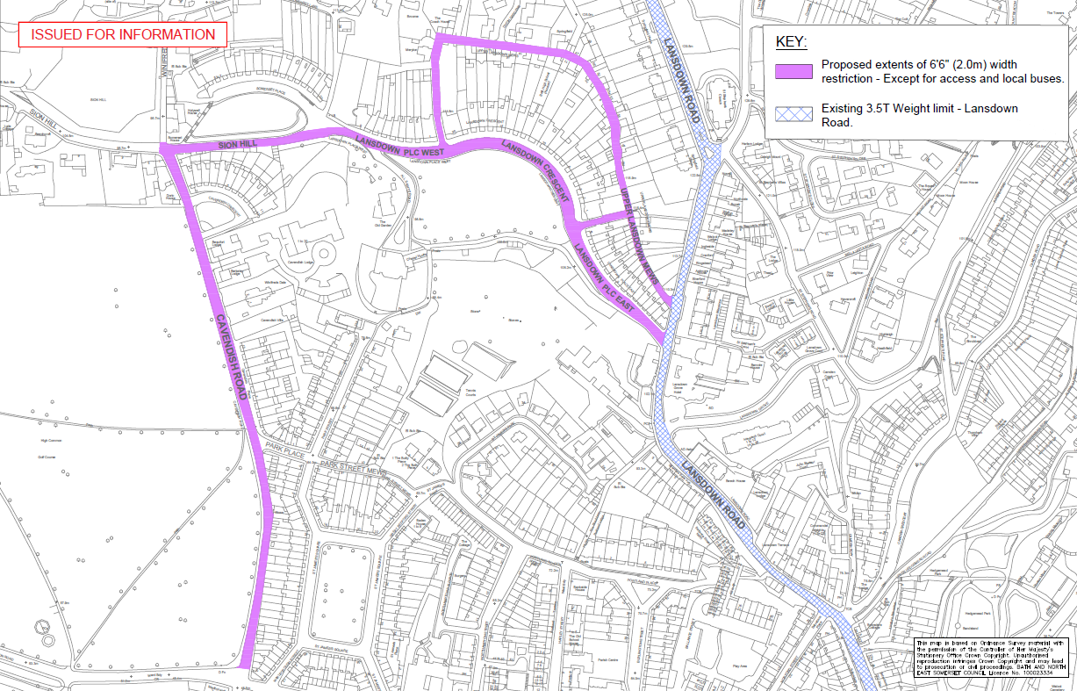

Objections and representations with respect to the proposal, together with the grounds on which they are made, must be sent in writing by the above date to the Council at the following addresses: **Traffic Management Team, Bath and North East Somerset Council, Lewis House, Manvers Street, BATH, BA1 1JG** or [transportation@bathnes.gov.uk](mailto:transportation@bathnes.gov.uk)

Please quote the TRO reference shown above.

Please note that all representations received may be considered in public by the Council and that the substance of any representations, together with the name and address of the person making it, could become available for public inspection.

Dated 12th July 2018

Kelvin Packer

Group Manager - Highways and Traffic

Bath & North East Somerset Council

|  |  |
| --- | --- |
| Officer Name: | Neil Terry |
| Tel No: | 01225 394431 |