TRAFFIC PROPOSAL

Title of Proposal | BATH & NORTH EAST SOMERSET COUNCIL  (WELLSWAY, KEYSNAHM) (CHEWTON ROAD) (20 M.P.H. SPEED LIMIT) (30 M.P.H. SPEED LIMIT) ORDER 2022
Reference TRO reference |  | TRO 21-029/LC
Closing date for Objections and Representations |  | 21st July 2022

NOTICE is given that the Bath and North East Somerset Council proposes to make an order under provisions contained in the Road Traffic Regulation Act 1984, the effect of which will prohibit a motor vehicle from driving at a speed exceeding 20 miles per hour and 30 miles per hour on the lengths of road as shown on the plan below.

Full details of the proposal are contained in the draft order which, together with a map and a Statement of the Council’s Reasons for proposing to make the order, may be inspected at: The One Stop Shops at The Hollies, High Street, Midsomer Norton, 3-4 Manvers Street, Bath and at the Keynsham Civic Centre, Market Walk, Keynsham during normal office hours. The proposal may also be viewed on the Council’s website: www.bathnes.gov.uk, by searching for the TRO number above.

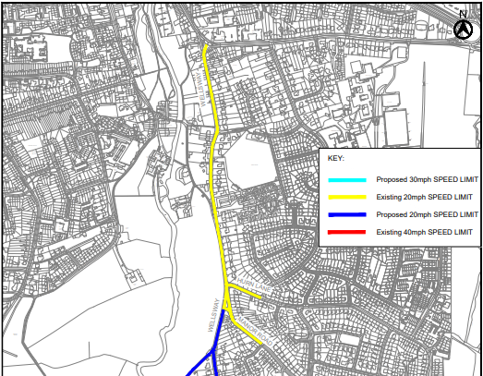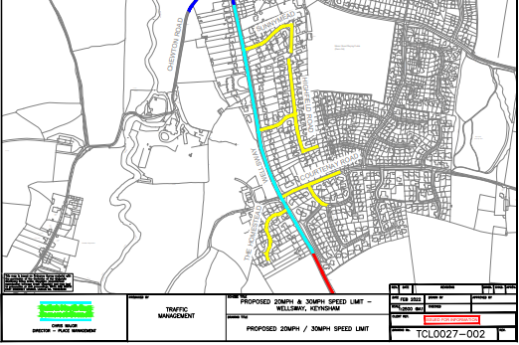
Objections and representations with respect to the proposal, together with the grounds on which they are made, must be sent in writing by the above date to the Council at the following addresses: Traffic Management Team, Bath and North East Somerset Council, Lewis House, Manvers Street, BATH, BA1 1JG or transportation@bathnes.gov.uk

Please quote the title of the proposal and the reference as shown above.
Please note that all representations received may be considered in public by the Council and that the substance of any comments together with the name and address of the person making it could become available for public inspection.
Chris Major
Director of Place Management
Bath & North East Somerset Council
Dated: 30th June 2022

Officer Name: | Lewis Cox
Tel No: | 01225 394041

