**Award**

**Skill Me Up**



**This award is just for young people, aged 11 years and above, in Bath and North East Somerset, and gives you the chance to get credit for the stuff you take part in.**

This award is for young people, aged 11 years and above, in Bath and North East Somerset, and gives you the chance to get credit for the stuff you take part in.

☺ Taking part in projects and activities

☺ Getting recognised for what you do

☺ Celebrate your achievements

☺ Personal development

☺ Learn new skills

☺ Have Fun!

INFO SHEET

Please complete this page printing clearly and using a pen

|  |  |  |  |  |  |
| --- | --- | --- | --- | --- | --- |
| MCj04077340000%5b1%5dName: |  |  |  |  |  |
|  | |  |  |  |  |
| Male | |  | Female |  |  |
| Date of Birth: | |  |  |  |  |
| Address: | |  |  |  |  |
|  | |  |  |  |  |
|  | |  |  |  |  |
| Postcode: | |  |  |  |  |
| Project/Hub: | |  |  |  |  |
| Expected Outcomes: | | | |  |  |

|  |  |  |  |  |
| --- | --- | --- | --- | --- |
|  | Being Healthy |  |  | Staying Safe |
|  | Enjoying & Achieving |  |  | Economic Wellbeing |
|  | Making a Positive Contribution | | | |

Youth Worker: ____________________

Start Date: __________

What do I do now?

“I would like to complete the Skill Me Up Award and I understand that I need to show evidence of at least 10 hours of activities over a minimum of 6 weeks (maximum 12 weeks) that have learning outcomes. I know who I get help, support and advice from and that my learning will be assessed by a youth worker when I have completed this pack.”

|  |
| --- |
|  |

**Your signature:**

|  |
| --- |
|  |

**Youth Worker’s signature:**

1. Chat with a youth worker about the Skill Me Up Award and which project or activity you are going to do. They will work with you to complete this pack.
2. Have fun and enjoy yourself whilst doing the project, just remember to collect as much evidence as you can (e.g. photos, statements etc).
3. Meet with a youth worker to look at what you have achieved and fill in this pack.
4. Fill in the evaluation sheet (this is so we know what you think of the award).
5. Go back to the checklist and check that you have done everything on it.

What happens next?

1. When the pack is completed, you will be awarded a certificate and invited to a celebration event.
2. CONGRATULATIONS!!!!! You will have achieved the Skill Me Up Award.

**What Skills!!!**

Think about what you want to achieve. What is it that you want to learn, get better at, or just have a go at? What evidence will you collect? Talk this through with your youth worker and they will help you to complete this sheet …

What are you planning to do in your project?

What skills are you hoping to gain (in other words what do you think you will get out of doing this project/activity)?

Your signature: ___________________________

Youth Worker’s signature: ___________________

Date: _________________

**All about me ……**

This award is about you gaining skills while you have fun. Have a look at the questions below and tick the box that you most agree with.

How good are you at:

(1 = fantastic 2 = really good 3 = okay 4 = not so good 5 = pants)

|  |  |  |  |  |  |
| --- | --- | --- | --- | --- | --- |
|  | 1 | 2 | 3 | 4 | 5 |
| Team work? ………………………………………………. |  |  |  |  |  |
| Solving problems? …………………………………… |  |  |  |  |  |
| Communicating/listening to people?.... |  |  |  |  |  |
| Leading others? ………………………………………. |  |  |  |  |  |
| Being responsible? …………………………………. |  |  |  |  |  |

How confident are you about yourself?

□ Super □ Very □ Quite □ Not

How important do you think it is to respect others?

□ Super □ Very □ Quite □ Not

Your signature: _______________________________

Youth Worker’s signature: ____________

**Prove it**

The next few pages are for you to prove to the assessors that you are doing what you say you are doing.

There are:

**Diary sheets** – fill these in when you do something. Just write about what you have been doing, draw a picture, make a tape, record a video clip, take photos or just write down some words that explain what you have been doing, what you have learnt or what skill you have been trying to work on. You can write as much or as little as you like, but it needs to show others what you have learnt.

**Witness statements** – you need to give these to anyone that can write something about what you have been doing. It can be a youth worker, a friend, an instructor, etc. They’ll be happy to help and it’s evidence for what you are trying to achieve. You don’t have to get a witness statement for everything, but one or two would be great.

**Wallet** – this is for you to collect other sorts of evidence such as photos, handouts, leaflets or posters, etc. Basically, anything that is to do with the project that you are doing and helps prove it. Just write on them to say what they are and pop them in the wallet.

**Remember** – you must EVIDENCE 10 HOURS of what you have been doing – it’s as easy as that! Any questions, just ask a youth worker, who will be happy to help.

**Diary**

|  |  |  |  |  |  |  |  |
| --- | --- | --- | --- | --- | --- | --- | --- |
| Date |  | Start Time |  | Finish Time |  | Total Time |  |

**What I did**

|  |
| --- |
|  |

**What I enjoyed most**

|  |
| --- |
|  |

**What I learnt**

|  |
| --- |
|  |

**Diary**

|  |  |  |  |  |  |  |  |
| --- | --- | --- | --- | --- | --- | --- | --- |
| Date |  | Start Time |  | Finish Time |  | Total Time |  |

**What I did**

|  |
| --- |
|  |

**What I enjoyed most**

|  |
| --- |
|  |

**What I learnt**

|  |
| --- |
|  |

**Diary**

|  |  |  |  |  |  |  |  |
| --- | --- | --- | --- | --- | --- | --- | --- |
| Date |  | Start Time |  | Finish Time |  | Total Time |  |

**What I did**

|  |
| --- |
|  |

**What I enjoyed most**

|  |
| --- |
|  |

**What I learnt**

|  |
| --- |
|  |

**Diary**

|  |  |  |  |  |  |  |  |
| --- | --- | --- | --- | --- | --- | --- | --- |
| Date |  | Start Time |  | Finish Time |  | Total Time |  |

**What I did**

|  |
| --- |
|  |

**What I enjoyed most**

|  |
| --- |
|  |

**What I learnt**

|  |
| --- |
|  |

**Diary**

|  |  |  |  |  |  |  |  |
| --- | --- | --- | --- | --- | --- | --- | --- |
| Date |  | Start Time |  | Finish Time |  | Total Time |  |

**What I did**

|  |
| --- |
|  |

**What I enjoyed most**

|  |
| --- |
|  |

**What I learnt**

|  |
| --- |
|  |

**Diary**

|  |  |  |  |  |  |  |  |
| --- | --- | --- | --- | --- | --- | --- | --- |
| Date |  | Start Time |  | Finish Time |  | Total Time |  |

**What I did**

|  |
| --- |
|  |

**What I enjoyed most**

|  |
| --- |
|  |

**What I learnt**

|  |
| --- |
|  |

**Diary**

|  |  |  |  |  |  |  |  |
| --- | --- | --- | --- | --- | --- | --- | --- |
| Date |  | Start Time |  | Finish Time |  | Total Time |  |

**What I did**

|  |
| --- |
|  |

**What I enjoyed most**

|  |
| --- |
|  |

**What I learnt**

|  |
| --- |
|  |

**Diary**

|  |  |  |  |  |  |  |  |
| --- | --- | --- | --- | --- | --- | --- | --- |
| Date |  | Start Time |  | Finish Time |  | Total Time |  |

**What I did**

|  |
| --- |
|  |

**What I enjoyed most**

|  |
| --- |
|  |

**What I learnt**

|  |
| --- |
|  |

**Witness Statement**

Skill Me Up Award is about recognising the personal and social development of young people. It is a personal journey of learning for each individual.

Young person’s name _______________________

|  |
| --- |
| **Please write a few comments about how you think the young person has developed.** |

|  |  |
| --- | --- |
| Witness’s Name: |  |
| Witness’s signature |  |
| Witness’s role (if any) |  |

**Witness Statement**

Skill Me Up Award is about recognising the personal and social development of young people. It is a personal journey of learning for each individual.

Young person’s name _______________________

|  |
| --- |
| **Please write a few comments about how you think the young person has developed.** |

|  |  |
| --- | --- |
| Witness’s Name: |  |
| Witness’s signature |  |
| Witness’s role (if any) |  |

Photo evidence

|  |  |  |  |
| --- | --- | --- | --- |
| Date | Start time | End time | Total hours |

|  |
| --- |
|  |

What’s in the picture? _____________________________________________________________________________________________________________________________________________________________________

Photo evidence

|  |  |  |  |
| --- | --- | --- | --- |
| Date | Start time | End time | Total hours |

|  |
| --- |
|  |

What’s in the picture? _____________________________________________________________________________________________________________________________________________________________________

Photo evidence

|  |  |  |  |
| --- | --- | --- | --- |
| Date | Start time | End time | Total hours |

|  |
| --- |
|  |

What’s in the picture? _____________________________________________________________________________________________________________________________________________________________________

**All about me …… Review**

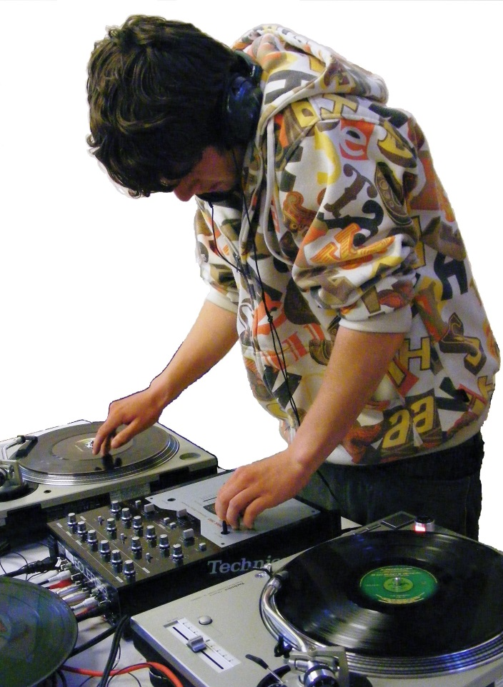Okay, you have nearly finished your project so it’s time to look and see if anything has changed. Remember the questions below from the beginning? Well, now is your chance to have another look and think about whether you have improved on any of the skills, whether what you have done has helped you … tick the box you most agree with.

How good are you at:

(1 = fantastic 2 = really good 3 = okay 4 = not so good 5 = pants)

|  |  |  |  |  |  |
| --- | --- | --- | --- | --- | --- |
|  | 1 | 2 | 3 | 4 | 5 |
| Team work? ………………………………………………. |  |  |  |  |  |
| Solving problems? …………………………………… |  |  |  |  |  |
| Communication/listening to people?.... |  |  |  |  |  |
| Leading others? ………………………………………. |  |  |  |  |  |
| Being responsible? …………………………………. |  |  |  |  |  |

How confident are you about yourself?

□ Super □ Very □ Quite □ Not

How important do you think it is to respect others?

□ Super □ Very □ Quite □ Not

Your signature: _______________________________

Youth Worker’s signature: _______________________

**Youth Worker**

**Recommendation Sheet**

(Please add the young person’s details below and then sign)

Name of Project/Club for which this certificate is being awarded

Name (please print clearly) _________________________

Address ______________________________________

_____________________________________________

Postcode ______________________________________

Date of Birth ___________________________________

Youth Worker’s name (please print clearly)

Date completed (to appear on certificate) : **_____________**

**Skill Me Up Review**

**Youth Worker**

This page is to be completed by your Youth Worker, they must sign this section and help you complete the rest of the sheets in this file.

What did the young person achieve/learn? (NB This is the wording that will appear on actual certificate)

What skills have they gained?

What did they find most challenging?

|  |
| --- |
|  |
|  |
|  |
|  |

Total hours completed ____________________________

What evidence has been collected to verify this (tick the boxes)

|  |  |  |  |  |  |  |
| --- | --- | --- | --- | --- | --- | --- |
|  |  |  |  |  |  |  |
| **Photos** | **Video Clips** | **Witness Statements** | **Pictures** | **Certificates** | **Press Cuttings** | **Other** |

Youth Worker’s signature ______________________________________

**Skill Me Up Review**

**Young Person**

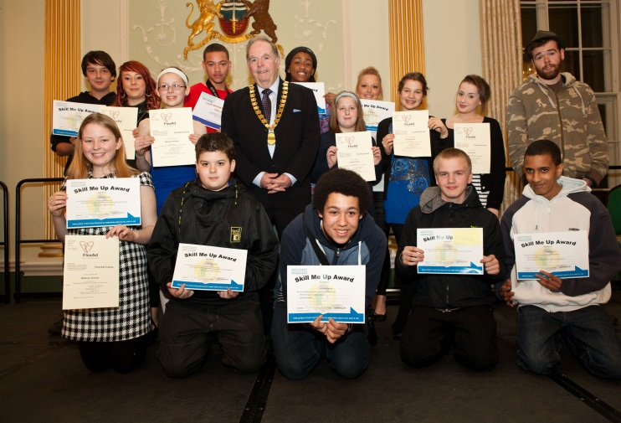

So, it’s almost finished. Think about what you have done … did you learn anything? Did you enjoy it? Think back to the targets you set out at the beginning, have a look at them, then complete the form below with your Youth Worker.

What did you actually do in the Project? ________________________

How did you feel about the project now it’s almost over?

|  |  |  |  |  |
| --- | --- | --- | --- | --- |
| :-D | :-) | :-l | :-S | :-O |
| Great | Happy | Okay | Unsure | Worried |

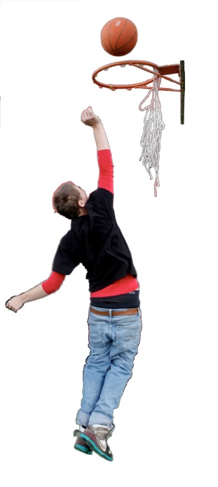

What skills have you gained?

What did you enjoy most? **__________________________________**

What did you find most challenging? ___________________________

**I have completed …….**

Work through the folder, and as you complete the different parts, you can tick them off on this list.

|  |  |
| --- | --- |
| The info sheet |  |
| ‘All About Me’ sheet |  |
| ‘My Diary’ and evidence (e.g. photos, witness statements, etc) |  |
| ‘Skill Me Up’ Review Sheet |  |
| ‘All About Me’ Review Sheet |  |
| I have completed the Bath & North East Somerset Skill Me Up Award |  |

Your signature: __________________________________

Youth Worker’s signature: _________________________

Now you need to copy and send pages **21, 22, 23 and 24** to:

Youth Connect

Bath & North East Somerset Council

Lewis House

Manvers Street

Bath

BA1 1JG

**What did you think?**

**MCj04077340000%5b1%5dThe Skill Me Up Award is new and available to all young people, aged 11 years and above, in Bath & North East Somerset. We would like to know what you thought about completing this award. Please be honest because we will make changes to the award based on what you tell us!**

**1. Did you enjoy doing the award? Yes / No**

**If No, why?**

**2. Was the pack easy to complete? Yes / No**

**If No, Why?**

**3. Was the award challenging? Yes / No**

**If No, why?**

1. **Did you feel a sense of achievement Yes / No**

**when you completed the award?**

**If No, why?**

**5. Would you make any changes to the award? Yes/ No**

**If Yes, what?**

**6. Would you complete another award? Yes / No**

**If No, why?**

**7. Any other comments you would like to make?**

This document can be made available in a range of languages, large print,

Braille, on tape, electronic and other accessible formats from:

Youth Connect 01225 396980 or e-mail youthconnect_supportservices@bathnes.gov.uk