Year of Mental Health
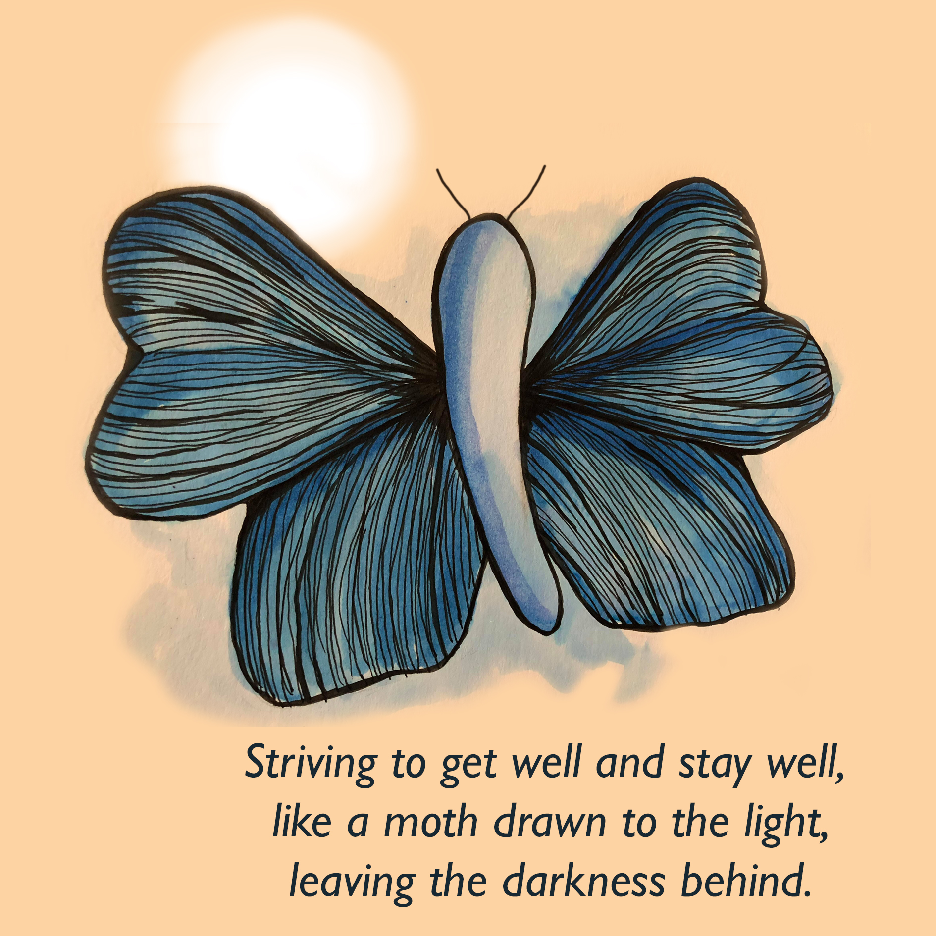
Programme for 2018/19
TBC, Chew Valley Children's Centre in either June or July | Virgin Care delivering Connect 5 Level 3 training | Paul Wilson, Virgin Care  Contact Paul Wilson, Virgin Care  Paul.Wilson@virgincare.co.uk  07976 918787
6th June, Trowbridge | Healthy School Celebration (closed event) | Nick Bolton, Wiltshire Council  Contact Nick Bolton, Wiltshire Council  Nick.Bolton@Wiltshire.gov.uk  01225 718842
6th June, 10am – 1.30pm, Bath Artist Studio, Comfortable Place, Lower Bristol Road, Bath, BA1 3AJ | Connect 5 Training Session 1 -  ‘Connect 5 Session 1 is designed to help participants talk with others about emotional health and wellbeing. It takes the position that we don’t need to be mental health specialists to help those experiencing emotional and mental health problems. Connect 5 provides tools to empower others to take proactive steps to build resilience and look after themselves. Connect 5 Session 1 is suitable for anyone whose job involves working with others either in a public/service user facing way or within their work teams’.  For further information, please see the attached - | Clare Laker, B&NES Council  Contact Clare Laker, B&NES Council  Clare_Laker@bathnes.gov.uk  01225 394062
15th June, 9.30am – 1pm, Curo, The Maltings, River Place, Lower Bristol Road, Bath, BA2 1EP | Connect 5 Training Session 1 -  ‘Connect 5 Session 1 is designed to help participants talk with others about emotional health and wellbeing. It takes the position that we don’t need to be mental health specialists to help those experiencing emotional and mental health problems. Connect 5 provides tools to empower others to take proactive steps to build resilience and look after themselves. Connect 5 Session 1 is suitable for anyone whose job involves working with others either in a public/service user facing way or within their work teams’.  For further information, please see the attached - | Clare Laker, B&NES Council  Contact Clare Laker, B&NES Council  Clare_Laker@bathnes.gov.uk  01225 394062
21st June, 3pm – 5pm, Keynsham Community Space, Civic Centre, Keynsham | Launch of new CAMHS Thrive Model -  ‘An opportunity to hear how the new service model will improve the lives of young people with lived experiences being told by the young people themselves along with meeting the clinicians that work within the service’.  This event is by invitation only for professionals. Invitations will be distributed to leads for dissemination accordingly.  If any information is required regarding the new Service model, professionals can email: SWBCAMHsNewModel@oxfordhealth.nhs.uk and this will be signposted for response. | Emma Lewin, Oxford Health/Mary Kearney-Knowles, B&NES Council  Contact Emma Lewin, Oxford Health – emma.lewin@oxfordhealth.nhs.uk  07827 985812  Contact Mary Kearney-Knowles, B&NES Council  Mary_Kearney-Knowles@bathnes.gov.uk  01225 394412
21st June | Youth Mental Health First Aid training for schools (closed event)  Details, including venues, can be found here - https://www.wiltshirehealthyschools.org/partnership-projects/youth-mental-health-first-aid/ | Judy Edwards, Wiltshire Council  Contact Judy Edwards, Wiltshire Council  Judy.Edwards@Wiltshire.gov.uk
24th June | TWIGS Summer Open Day | Contact Alan Holland  alan.holland.twigs@gmail.com
25th – 26th June | Mental Health First Aid – 2 day course | Kate Morton, Bath Mind  Contact Kate Morton, Bath Mind  KateMorton@bathmind.org.uk  01225 316356
26th June, Trowbridge | Promoting children’s health and wellbeing for school governors (closed event) | Nick Bolton, Wiltshire Council  Contact Nick Bolton, Wiltshire Council  Nick.Bolton@Wiltshire.gov.uk  01225 718842
TBC | Maternal Mental Health | Karen Paul (via Frances Mayes, Swindon Council)
18 July | Open Day Allotment Project | Kate Morton, Bath Mind  Contact Kate Morton, Bath Mind  KateMorton@bathmind.org.uk  01225 316356
July 2018 | Event | Lead
9th July, 9.30am – 1pm, Kaposvar Room, Guildhall, Bath, BA1 5AW | Connect 5 Training Session 1 -  ‘Connect 5 Session 1 is designed to help participants talk with others about emotional health and wellbeing. It takes the position that we don’t need to be mental health specialists to help those experiencing emotional and mental health problems. Connect 5 provides tools to empower others to take proactive steps to build resilience and look after themselves. Connect 5 Session 1 is suitable for anyone whose job involves working with others either in a public/service user facing way or within their work teams’.  For further information, please see the attached - | Clare Laker, B&NES Council  Contact Clare Laker, B&NES Council  Clare_Laker@bathnes.gov.uk  01225 394062
27th July | TWIGS (NGS) | Contact Alan Holland  alan.holland.twigs@gmail.com
TBC | Survivors Support Day | Swindon
August 2018 | Event | Lead
2nd – 3rd August | Youth Mental Health First Aid training for school nurses and children’s services staff (closed event)  Details, including venues, can be found here - https://www.wiltshirehealthyschools.org/partnership-projects/youth-mental-health-first-aid/ | Judy Edwards, Wiltshire Council  Contact Judy Edwards, Wiltshire Council  Judy.Edwards@Wiltshire.gov.uk
1st August and 18th August | ‘Carry on Cropping’ events at Monksdale Allotment, Bath | Kate Morton, Bath Mind  Contact Kate Morton, Bath Mind  KateMorton@bathmind.org.uk  01225 316356
20th and 21st August, Community Space, Keynsham | Applied Suicide Intervention Skills Training  Please see the attached – | Clare Laker, B&NES Council  Contact Clare Laker, B&NES Council  Clare_Laker@bathnes.gov.uk  01225 394062
TBC | Open Day Event at Wellbeing House to mark its third anniversary and to recognise the importance of preventative, pre-crisis residential care. | Paul Wilson, Virgin Care & Curo  Contact Paul Wilson, Virgin Care  Paul.Wilson@virgincare.co.uk  07976 918787
TBC | Children in Care Video | Mary Kearney-Knowles, B&NES Council  Contact Mary Kearney-Knowles, B&NES Council  Mary_Kearney-Knowles@bathnes.gov.uk  01225 394412
TBC | Wellbeing in the Workplace Event | Neil Cardwell/Sam Gillett St John’s  Kate Morton Bath Mind  Contact Neil Cardwell, St Johns Foundation  Neil.Cardwell@stjohnsbath.org.uk  01225 486449  Contact Sam Gillett, St Johns Foundation  Sam.Gillett@stjohnsbath.org.uk  01225 486405  Contact Kate Morton, Bath Mind  KateMorton@bathmind.org.uk  01225 316356
September 2018 | Event | Lead
10th September | Event in recognition of World Suicide Prevention Day | Paul Wilson, Virgin Care  Contact Paul Wilson, Virgin Care  Paul.Wilson@virgincare.co.uk  07976 918787
12th September, 10am – 1.30pm, Bath College Boardroom, Somer Valley Campus, Wells Road, Radstock, BA3 3RW | Connect 5 Training Session 1 -  ‘Connect 5 Session 1 is designed to help participants talk with others about emotional health and wellbeing. It takes the position that we don’t need to be mental health specialists to help those experiencing emotional and mental health problems. Connect 5 provides tools to empower others to take proactive steps to build resilience and look after themselves. Connect 5 Session 1 is suitable for anyone whose job involves working with others either in a public/service user facing way or within their work teams’.  For further information, please see the attached - | Clare Laker, B&NES Council  Contact Clare Laker, B&NES Council  Clare_Laker@bathnes.gov.uk  01225 394062
13th September | Federation of Small Businesses Stress event | Kate Morton, Bath Mind  Clare Laker, B&NES Council  Contact Kate Morton, Bath Mind  KateMorton@bathmind.org.uk  01225 316356  Contact Clare Laker, B&NES Council  Clare_Laker@bathnes.gov.uk  01225 394062
12th and 19th September | Bath College Freshers Fairs | Theresa Hallett, Bath College  Contact Theresa Hallett, Bath College –  Theresa.Hallett@bathcollege.ac.uk  01225 328569
14th September, 9.30am – 4.30pm, The Brunswick Room, Guildhall, High Street, Bath, BA1 5AW | Connect 5 Training Session 2 –  Connect 5 Session 2 is designed to build your skills and confidence to work with and improve the mental health and wellbeing of others. Including, how to support greater insight into experiences of stress and distress and how to help people take first steps to make themselves feel better. Connect 5 Session 2 is suitable for those with the opportunity through their working practice to engage in brief interventions.  For further information, please see the attached – | Clare Laker, B&NES Council  Contact Clare Laker, B&NES Council  Clare_Laker@bathnes.gov.uk  01225 394062
14th September | Food for Thought Lunch launch, St Andrew’s Church, Hawthorne Grove, tackling loneliness and increasing community engagement | Kate Morton, Bath Mind  Contact Kate Morton, Bath Mind  KateMorton@bathmind.org.uk  01225 316356
15th September | Music for The Mind - Wells | Kate Morton, Bath Mind  Contact Kate Morton, Bath Mind  KateMorton@bathmind.org.uk  01225 316356
18th September | Time to Change Employer’s Pledge lunch with Royds Withy King | Kate Morton, Bath Mind  Contact Kate Morton, Bath Mind  KateMorton@bathmind.org.uk  01225 316356
21st September | Youth Mental Health First Aid training for schools (closed event)  Details, including venues, can be found here - https://www.wiltshirehealthyschools.org/partnership-projects/youth-mental-health-first-aid/ | Judy Edwards, Wiltshire Council  Contact Judy Edwards, Wiltshire Council  Judy.Edwards@Wiltshire.gov.uk
TBC | Children in Care Council Mental Health Arts project | Judy Edwards, Wiltshire Council  Contact Judy Edwards, Wiltshire Council  Judy.Edwards@Wiltshire.gov.uk
TBC | Activities in Universities and COFE for Freshers week | TBC
TBC | ELSA roll-out | Frances Mayes, Swindon  Contact Frances Mayes, Swindon Council  FMayes@swindon.gov.uk  01793 444677
October 2018 | Event | Lead
8th and 9th October | Youth Mental Health First Aid Training (course full) | Clare Laker, B&NES Council  Contact Clare Laker, B&NES Council  Clare_Laker@bathnes.gov.uk  01225 394062
10th October | Gig for World Mental Health Day (Paul Wilson, Virgin Care) -  ‘I have been asked to support a gig at the Chapel Arts Centre in recognition of World MH Day on October 10. I will be promoting the gig and part-compering. Please see attached flyer’. | Paul Wilson, Virgin Care  Contact Paul Wilson, Virgin Care  Paul.Wilson@virgincare.co.uk  07976 918787
10th October | World Mental Health Day (Float Your Hopes) | Theresa Hallett, Bath College  Contact Theresa Hallett, Bath College –  Theresa.Hallett@bathcollege.ac.uk  01225 328569
10th October | World Mental Health Day series of events across the week | Kate Morton, Bath Mind/St John’s  Contact Kate Morton, Bath Mind  KateMorton@bathmind.org.uk  01225 316356
10th October | Managing Mental Health in the Workplace with Royds Withy King | Kate Morton, Bath Mind  Contact Kate Morton, Bath Mind  KateMorton@bathmind.org.uk  01225 316356
10th October | Time to Change with local Champions event | Kate Morton, Bath Mind  Contact Kate Morton, Bath Mind  KateMorton@bathmind.org.uk  01225 316356
10th October | World Mental Health Day (supporting partners to celebrate, theme TBC) | Paul Wilson, Virgin Care  Contact Paul Wilson, Virgin Care  Paul.Wilson@virgincare.co.uk  07976 918787
Week of 10th October | World Mental Health Day (week of activity) | Karen Spence, Wiltshire  Contact Karen Spence, Wiltshire Council  Karen.Spence@wiltshire.gov.uk  01225 713094
11th October | Youth Mental Health First Aid training for schools (closed event)  Details, including venues, can be found here - https://www.wiltshirehealthyschools.org/partnership-projects/youth-mental-health-first-aid/ | Judy Edwards, Wiltshire Council  Contact Judy Edwards, Wiltshire Council  Judy.Edwards@Wiltshire.gov.uk
16th October, 9.30am – 1.00pm, Winter Garden Room, St Martins Hospital, Midford Road, Bath, BA2 5RP | Connect 5 Training Session 1 -  ‘Connect 5 Session 1 is designed to help participants talk with others about emotional health and wellbeing. It takes the position that we don’t need to be mental health specialists to help those experiencing emotional and mental health problems. Connect 5 provides tools to empower others to take proactive steps to build resilience and look after themselves. Connect 5 Session 1 is suitable for anyone whose job involves working with others either in a public/service user facing way or within their work teams’.  For further information, please see the attached - | Clare Laker, B&NES Council  Contact Clare Laker, B&NES Council  Clare_Laker@bathnes.gov.uk  01225 394062
23rd October, 9.30am – 4.30pm, Bath College Boardroom, Somer Valley Campus, Wells Road, Radstock, BA3 3RW | Connect 5 Training Session 2 –  Connect 5 Session 2 is designed to build your skills and confidence to work with and improve the mental health and wellbeing of others. Including, how to support greater insight into experiences of stress and distress and how to help people take first steps to make themselves feel better. Connect 5 Session 2 is suitable for those with the opportunity through their working practice to engage in brief interventions.  For further information, please see the attached – | Clare Laker, B&NES Council  Contact Clare Laker, B&NES Council  Clare_Laker@bathnes.gov.uk  01225 394062
30th October, 9.30am – 4.30pm, Curo, The Maltings, River Place, Lower Bristol Road, Bath, BA2 1EP | Connect 5 Training Session 2 –  Connect 5 Session 2 is designed to build your skills and confidence to work with and improve the mental health and wellbeing of others. Including, how to support greater insight into experiences of stress and distress and how to help people take first steps to make themselves feel better. Connect 5 Session 2 is suitable for those with the opportunity through their working practice to engage in brief interventions.  For further information, please see the attached – | Clare Laker, B&NES Council  Contact Clare Laker, B&NES Council  Clare_Laker@bathnes.gov.uk  01225 394062
TBC | MSK B&NES stress related event/awareness | Paul Scott, B&NES Council  Contact Paul Scott, B&NES Council  Paul_Scott@bathnes.gov.uk  01225 394060
TBC | Mindful Employer Conference | Swindon
November/December 2018 | Event | Lead
7th November | National PSHE CPD. New intake (closed event) | Nick Bolton, Wiltshire Council  Contact Nick Bolton, Wiltshire Council  Nick.Bolton@Wiltshire.gov.uk  01225 718842
12th – 13th November | Youth Mental Health First Aid training for school nurses and children’s services staff (closed event)  Details, including venues, can be found here - https://www.wiltshirehealthyschools.org/partnership-projects/youth-mental-health-first-aid/ | Judy Edwards, Wiltshire Council  Contact Judy Edwards, Wiltshire Council  Judy.Edwards@Wiltshire.gov.uk
14th November | Anti-Bullying Week – ‘big conversation’ (closed event) | Judy Edwards, Wiltshire Council  Contact Judy Edwards, Wiltshire Council  Judy.Edwards@Wiltshire.gov.uk
15th November, 1.00pm – 4.30pm, The Brunswick Room, Guildhall, High Street, Bath, BA1 5AW | Connect 5 Training Session 1 -  ‘Connect 5 Session 1 is designed to help participants talk with others about emotional health and wellbeing. It takes the position that we don’t need to be mental health specialists to help those experiencing emotional and mental health problems. Connect 5 provides tools to empower others to take proactive steps to build resilience and look after themselves. Connect 5 Session 1 is suitable for anyone whose job involves working with others either in a public/service user facing way or within their work teams’.  For further information, please see the attached - | Clare Laker, B&NES Council  Contact Clare Laker, B&NES Council  Clare_Laker@bathnes.gov.uk  01225 394062
19th November, Trowbridge | Healthy School Conference (closed event) | Nick Bolton, Wiltshire Council  Contact Nick Bolton, Wiltshire Council  Nick.Bolton@Wiltshire.gov.uk  01225 718842
20th November, 9.30am – 4.30pm, Curo, The Maltings, River Place, Lower Bristol Road, Bath, BA2 1EP | Connect 5 Training Session 3  Connect 5 Session 3 is designed to advance your skills to work collaboratively with clients to create an action plan and integrate brief interventions to motivate and support people to make changes that last. Connect 5 Session 3 is suitable for those with the opportunity, through their working practice to engage in brief interventions over an extended period of time.  For further information, please see the attached - | Clare Laker, B&NES Council  Contact Clare Laker, B&NES Council  Clare_Laker@bathnes.gov.uk  01225 394062
TBC | Launch of Dual Diagnosis Event | Swindon
TBC | Winter Health | TBC
5th December, 9.30am – 1.30pm, The Community Space, (above Keynsham Library) Market Walk, Keynsham, BS31 1FS | Connect 5 Training Session 1 -  ‘Connect 5 Session 1 is designed to help participants talk with others about emotional health and wellbeing. It takes the position that we don’t need to be mental health specialists to help those experiencing emotional and mental health problems. Connect 5 provides tools to empower others to take proactive steps to build resilience and look after themselves. Connect 5 Session 1 is suitable for anyone whose job involves working with others either in a public/service user facing way or within their work teams’.  For further information, please see the attached - | Clare Laker, B&NES Council  Contact Clare Laker, B&NES Council  Clare_Laker@bathnes.gov.uk  01225 394062
12th December, 9.30 – 4.30pm, Bath College Boardroom, Somer Valley Campus, Wells Road, Radstock, BA3 3RW | Connect 5 Training Session 3  Connect 5 Session 3 is designed to advance your skills to work collaboratively with clients to create an action plan and integrate brief interventions to motivate and support people to make changes that last. Connect 5 Session 3 is suitable for those with the opportunity, through their working practice to engage in brief interventions over an extended period of time.  For further information, please see the attached - | Clare Laker, B&NES Council  Contact Clare Laker, B&NES Council  Clare_Laker@bathnes.gov.uk  01225 394062
TBC December | Event to highlight social isolation and loneliness at Christmas | Paul Wilson, Virgin Care  Contact Paul Wilson, Virgin Care  Paul.Wilson@virgincare.co.uk  07976 918787
January 2019 | Event | Lead
1st January | Annual Safeguarding and Prevent Employee Updates including Mental Health | Jayne Davis/Theresa Hallett, Bath College  Contact Theresa Hallett, Bath College –  Theresa.Hallett@bathcollege.ac.uk  01225 328569
9th January, 1.00pm – 2.30pm, The Community Space, (above Keynsham Library) Market Walk, Keynsham, BS31 1FS | Connect 5 Training Session 1 -  ‘Connect 5 Session 1 is designed to help participants talk with others about emotional health and wellbeing. It takes the position that we don’t need to be mental health specialists to help those experiencing emotional and mental health problems. Connect 5 provides tools to empower others to take proactive steps to build resilience and look after themselves. Connect 5 Session 1 is suitable for anyone whose job involves working with others either in a public/service user facing way or within their work teams’.  For further information, please see the attached - | Clare Laker, B&NES Council  Contact Clare Laker, B&NES Council  Clare_Laker@bathnes.gov.uk  01225 394062
14th January | Blue Monday | Neil Cardwell, St John’s  Contact Neil Cardwell, St Johns Foundation  Neil.Cardwell@stjohnsbath.org.uk  01225 486449
17th January, 9.30am – 4.30pm, The Aix en Provence Room, Guildhall, Bath, BA1 5AW | Connect 5 Training Session 3  Connect 5 Session 3 is designed to advance your skills to work collaboratively with clients to create an action plan and integrate brief interventions to motivate and support people to make changes that last. Connect 5 Session 3 is suitable for those with the opportunity, through their working practice to engage in brief interventions over an extended period of time.  For further information, please see the attached - | Clare Laker, B&NES Council  Contact Clare Laker, B&NES Council  Clare_Laker@bathnes.gov.uk  01225 394062
18th January, 9.30am – 4.30pm, Curo, The Maltings, River Place, Lower Bristol Road, Bath, BA2 1EP | Connect 5 Training Session 2 –  Connect 5 Session 2 is designed to build your skills and confidence to work with and improve the mental health and wellbeing of others. Including, how to support greater insight into experiences of stress and distress and how to help people take first steps to make themselves feel better. Connect 5 Session 2 is suitable for those with the opportunity through their working practice to engage in brief interventions.  For further information, please see the attached – | Clare Laker, B&NES Council  Contact Clare Laker, B&NES Council  Clare_Laker@bathnes.gov.uk  01225 394062
February 2019 | Event | Lead
1st February | Time to Talk Day | Kate Morton, Bath Mind/Neil Cardwell, St John’s  Contact Kate Morton, Bath Mind  KateMorton@bathmind.org.uk  01225 316356  Contact Neil Cardwell, St Johns Foundation  Neil.Cardwell@stjohnsbath.org.uk  01225 486449
5th February | Internet Safety Day | Theresa Hallett/Steph Wynne-Davey, Bath College  Contact Theresa Hallett, Bath College –  Theresa.Hallett@bathcollege.ac.uk  01225 328569
5th – 6th February | Valentine’s Campaign, Healthy Lifestyles, Sexual Health/Drugs and Alcohol/Sexting/Consent/Exploitation | Theresa Hallett, Bath College in association with Virgin Care  Contact Theresa Hallett, Bath College –  Theresa.Hallett@bathcollege.ac.uk  01225 328569
6th February, 9.30am – 1.00pm, The Aix en Provence Room, Guildhall, High Street, Bath, BA1 5AW | Connect 5 Training Session 1 -  ‘Connect 5 Session 1 is designed to help participants talk with others about emotional health and wellbeing. It takes the position that we don’t need to be mental health specialists to help those experiencing emotional and mental health problems. Connect 5 provides tools to empower others to take proactive steps to build resilience and look after themselves. Connect 5 Session 1 is suitable for anyone whose job involves working with others either in a public/service user facing way or within their work teams’.  For further information, please see the attached - | Clare Laker, B&NES Council  Contact Clare Laker, B&NES Council  Clare_Laker@bathnes.gov.uk  01225 394062
8th February, 9.30am – 4.30pm, Kaposvar Room, Guildhall, High Street, Bath, BA1 5AW | Connect 5 Training Session 3  Connect 5 Session 3 is designed to advance your skills to work collaboratively with clients to create an action plan and integrate brief interventions to motivate and support people to make changes that last. Connect 5 Session 3 is suitable for those with the opportunity, through their working practice to engage in brief interventions over an extended period of time.  For further information, please see the attached - | Clare Laker, B&NES Council  Contact Clare Laker, B&NES Council  Clare_Laker@bathnes.gov.uk  01225 394062
14th and 15th February, Community Space, Keynsham | Applied Suicide Intervention Skills Training  Please see the attached – | Clare Laker, B&NES Council  Contact Clare Laker, B&NES Council  Clare_Laker@bathnes.gov.uk  01225 394062
TBC | Pupil Parliament | Mary Kearney-Knowles, B&NES Council  Contact Mary Kearney-Knowles, B&NES Council  Mary_Kearney-Knowles@bathnes.gov.uk  01225 394412
March 2019 | Event | Lead
13th March, 9.30am – 1.00pm, The Aix en Provence Room, Guildhall, High Street, Bath, BA1 5AW | Connect 5 Training Session 1 -  ‘Connect 5 Session 1 is designed to help participants talk with others about emotional health and wellbeing. It takes the position that we don’t need to be mental health specialists to help those experiencing emotional and mental health problems. Connect 5 provides tools to empower others to take proactive steps to build resilience and look after themselves. Connect 5 Session 1 is suitable for anyone whose job involves working with others either in a public/service user facing way or within their work teams’.  For further information, please see the attached - | Clare Laker, B&NES Council  Contact Clare Laker, B&NES Council  Clare_Laker@bathnes.gov.uk  01225 394062
TBC | What Works Conference | Kate Morton, Bath Mind  Contact Kate Morton, Bath Mind  KateMorton@bathmind.org.uk  01225 316356
TBC | Summing up (what we have done over the course of the year) | TBC
TBC | Bath Half Marathon (awareness raising) | TBC
April 2019
May 2019

Please submit updates/amendments to the programme to –
Claire Botley
Senior Administrator/PA to Jane Shayler
Claire_Botley@bathnes.gov.uk

