Equality Impact Assessment / Equality Analysis

Title of service or policy | Tenancy Strategy
Name of directorate and service | Adult Social Care and Housing
Name and role of officers completing the EIA | Sue Wordsworth
Date of assessment | August 2012

1. | Identify the aims of the policy or service and how it is implemented.
 | Key questions | Answers / Notes
1.1 | Briefly describe purpose of the service/policy | The Localism Act 2011 was passed on the 15th November 2011. Part 7 of the Act refers to Housing and enables the council to implement key social housing, allocations and homelessness legislation reforms. Reforms will be delivered by the council’s Housing Services in partnership with registered providers (RPs) of social housing. This strategy sets out the guidance we will provide to RPs in order to implement social housing reform. Allocations and homelessness reforms are implemented via the companion Allocations Policy.  Social housing reform includes: giving individual registered provider landlords new powers to grant tenancies for a fixed term, where they choose to do so. All registered providers of social housing should have regard to this tenancy strategy in framing their own tenancy policies covering:  - the kinds of tenancies they grant, including new Affordable Rent Tenancies ART,  - the circumstances in which they will grant a tenancy of a particular kind,  - where they grant tenancies for a term certain, the lengths of the terms, and  - The circumstances in which they will grant a further tenancy on the coming to an end of an existing tenancy.  Intended outcomes  Social landlords no longer have to grant lifetime tenancies and can make better use of housing to help those in greatest housing need.
1.2 | Provide brief details of the scope of the policy or service being reviewed. | - The Tenancy Strategy is a new national requirement, it must be:  - published by 15 January 2013  - kept under review  - published after any modifications made under review  - Sent in draft strategy, or proposed modification, to every private registered provider of social housing for its district allowing them reasonable opportunity to comment on those proposals.
1.3 | Do the aims of this policy link to or conflict with any other policies of the Council? | The Tenancy Strategy is consistent with the council’s Sustainable Community Strategy; Allocations Policy and Homelessness Strategy.  No conflicts have been identified.
2. Consideration of available data, research and information

 | Key questions | Data, research and information that you can refer to
2.1 | What is the equalities profile of the team delivering the service/policy? | Not relevant. This is a local authority strategy which sets out matters to which Registered Providers must have regard to when formulating their Tenancy Policies.
2.2 | What equalities training have staff received? | Not relevant see 2.1
2.3 | What is the equalities profile of service users? | Service users are B&NES residents equalities profile attached as appendix 1  Note low representation in resident population of:  - Black and other minority ethnic groups  - Muslim, Buddhist or other non-Christian religions
2.4 | What other data do you have in terms of service users or staff? (E.g. results of customer satisfaction surveys, consultation findings). Are there any gaps? | See 2.5
2.5 | What engagement or consultation has been undertaken as part of this EIA and with whom?  What were the results? | The Localism Act 2011 states that the Council must consult with all Registered Providers (RPs) operating in the district and anyone else prescribed by the Secretary of State.  All RPs have been invited to attend a series of strategic meetings during 2011-2012 to support and advise on the development of this Strategy and the associated Allocations Policy.  The Tenancy Strategy was sent in draft strategy, or proposed modification, to every private registered provider of social housing in Bath and North East Somerset allowing them reasonable opportunity to comment on those proposals. (01.05.12 – 26.06.12)  The Cabinet member for Homes & Planning has been kept fully informed throughout the consultations.  Housing & Major Projects Policy Development and Scrutiny Panel were invited to comment on the draft (March 2012).  Equalities groups representatives were consulted on 30/01/12 to comment on proposals. Results are incorporated in section 3.  In addition the views of service users, and potential services, were sought on the use of ART and flexible tenancies using e-consult and to which around 100 responses were received.  The results of our engagement and consultation are set out in appendix 2. Key points are:  - ART should not be targeted to specific client groups and hence should be provided as an option for all service users including all equalities groups on the Homesearch scheme. This aligns with the Government’s guidance. The majority of Homesearch applicants, who responded to the survey, stated that they would consider bidding for ART properties.  - Views were divided on the length of flexible tenancy. There is a broad alignment from larger RPs and Homesearch applicants with the recommendations set out in the Strategy. The majority of Homesearch applicants, who responded to the survey, stated the tenancy period should be at least 5 years and possibly longer. Most RPs also thought that the minimum period should be 5 years though there was some support for longer tenancies with one RP stated that a 20 year tenancy should be the norm. Most RPs thought that in certain circumstances they may issue longer tenancies, for example for elderly tenants.
2.6 | If you are planning to undertake any consultation in the future regarding this service or policy, how will you include qualities considerations within this? | No further consultation planned.
3. Assessment of impact: ‘Equality analysis’

Based upon any data you have considered, or the results of consultation or research, use the spaces below to demonstrate you have analysed how the service or policy:
- Meets any particular needs of equalities groups or helps promote equality in some way.
- Could have a negative or adverse impact for any of the equalities groups
How will the Tenancy Strategy:
a) Foster good relations between people who share a protected characteristic and others.

b) Eliminate unlawful discrimination

c) Advance equality of opportunity between people who share a protected characteristic and others
3.1 | Age – identify the impact/potential impact of the policy on different age groups | Affordable Rent Tenancies (higher rents): rents will be below LHA. Working age tenants claiming Housing Benefit may need additional support to manage transitions in and out of work.  Fixed term tenancies (loss of lifetime security). Exemptions apply to older people. Working age tenants may need support to consider housing options and to move on.  Tenancy review (the circumstances in which they will grant a further tenancy on the coming to an end of an existing tenancy). Reviews must take account of individual circumstances and be applied fairly.
3.2 | Disability - identify the impact/potential impact of the policy on disabled people (ensure consideration of a range of impairments including both physical and mental impairments) | Affordable Rent Tenancies (higher rents): rents will be below LHA. Working age tenants claiming Housing Benefit may need additional support to manage transitions in and out of work.  Fixed term tenancies (loss of lifetime security): Exemptions apply to people in housing with support.  Tenancy review (the circumstances in which they will grant a further tenancy on the coming to an end of an existing tenancy): Reviews must take account of individual circumstances and be applied fairly.
3.3 | Gender reassignment – identify the impact/potential impact of the policy on transgender people | Affordable Rent Tenancies (higher rents): rents will be below LHA. Working age tenants claiming Housing Benefit may need additional support to manage transitions in and out of work.  Fixed term tenancies (loss of lifetime security): Exemptions apply to people in housing with support.  Tenancy review (the circumstances in which they will grant a further tenancy on the coming to an end of an existing tenancy): Reviews must take account of individual circumstances and be applied fairly. Capacity to move to new community should be taken into account at review of fixed term.
3.4 | Marriage and civil partnership | No adverse impact
3.5 | Pregnancy and maternity | No adverse impact
3.6 | Race – this includes ethnic or national origins, colour or nationality | Affordable Rent Tenancies (higher rents): rents will be below LHA. Working age tenants claiming Housing Benefit may need additional support to manage transitions in and out of work.  Fixed term tenancies (loss of lifetime security): Exemptions apply to people in housing with support.  Tenancy review (the circumstances in which they will grant a further tenancy on the coming to an end of an existing tenancy): Reviews must take account of individual circumstances and be applied fairly. Capacity to move to new community should be taken into account at review of fixed term.
3.7 | Religion/belief – identify the impact/potential impact of the policy on people of different religious/faith groups and also upon those with no religion. | Affordable Rent Tenancies (higher rents): rents will be below LHA. Working age tenants claiming Housing Benefit may need additional support to manage transitions in and out of work.  Fixed term tenancies (loss of lifetime security): Exemptions apply to people in housing with support.  Tenancy review (the circumstances in which they will grant a further tenancy on the coming to an end of an existing tenancy): Reviews must take account of individual circumstances and be applied fairly. Capacity to move to new community should be taken into account at review of fixed term.
3.8 | Gender | No adverse impact
3.9 | Sexual orientation - identify the impact/potential impact of the policy on  lesbians, gay, bisexual & heterosexual people | Affordable Rent Tenancies (higher rents): rents will be below LHA. Working age tenants claiming Housing Benefit may need additional support to manage transitions in and out of work.  Fixed term tenancies (loss of lifetime security): Exemptions apply to people in housing with support.  Tenancy review (the circumstances in which they will grant a further tenancy on the coming to an end of an existing tenancy): Reviews must take account of individual circumstances and be applied fairly. Capacity to move to new community should be taken into account at review of fixed term.
4.0 | Socio-economic | Affordable Rent Tenancies (higher rents): rents will be below LHA. Working age tenants claiming Housing Benefit may need additional support to manage transitions in and out of work.  Fixed term tenancies (loss of lifetime security): no adverse impact  Tenancy review (the circumstances in which they will grant a further tenancy on the coming to an end of an existing tenancy): no adverse impact
4.1 | Rural communities – identify the impact / potential impact on people living in rural communities | Affordable Rent Tenancies (higher rents): rents will be below LHA. Working age tenants claiming Housing Benefit may need additional support to manage transitions in and out of work.  Fixed term tenancies (loss of lifetime security): potential adverse impact needs to be mitigated by end of period review see below.  Tenancy review (the circumstances in which they will grant a further tenancy on the coming to an end of an existing tenancy): potential adverse impact mitigated by taking account of the contribution of the household to the community and the potential impact on the community if they were to move out of the area.

4. Bath and North East Somerset Council & NHS B&NES Equality Impact Assessment Improvement Plan

Please list actions that you plan to take as a result of this assessment. These actions should be based upon the analysis of data and engagement, any gaps in the data you have identified, and any steps you will be taking to address any negative impacts or remove barriers. The actions need to be built into your service planning framework. Actions/targets should be measurable, achievable, realistic and time framed.

Issues identified | Actions required | Progress milestones | Officer responsible | By when
Working age tenants claiming Housing Benefit may need additional support to manage transitions in and out of work. | Monitor RP compliance with national planning policy guidance on definition of affordability. | Current RP tenancy policies reviewed to ensure that these matters are considered.  RP move-on advice monitored.  RP tenancy review process monitored | Housing Services | Jan 2013  Monitoring to be effective from date of end of fixed term tenancies.
Working age tenants may need support to consider housing options and to move on. | Monitor RP move-on advice. |  | Housing Services
Reviews must take account of individual circumstances and be applied fairly. | Monitor RP tenancy review processes. |  | Housing Services
Capacity to move to new community should be taken into account at review of fixed term. | Monitor RP tenancy review processes. |  | Housing Services

5. Sign off and publishing

Once you have completed this form, it needs to be ‘approved’ by your Divisional Director or their nominated officer. Following this sign off, send a copy to the Equalities Team (equality@bathnes.gov.uk), who will publish it on the Council’s and/or NHS B&NES’ website. Keep a copy for your own records.

Signed off by:  (Divisional Director or nominated senior officer)

Date: 28/11/2012
Appendix 1

Equalities Profiling Data Analysis

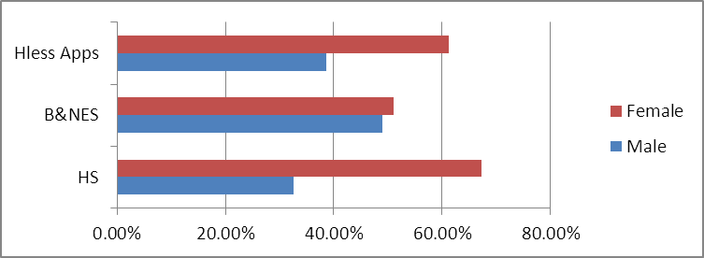

Ethnicity – Low representation of minority ethnic groups in all segments.
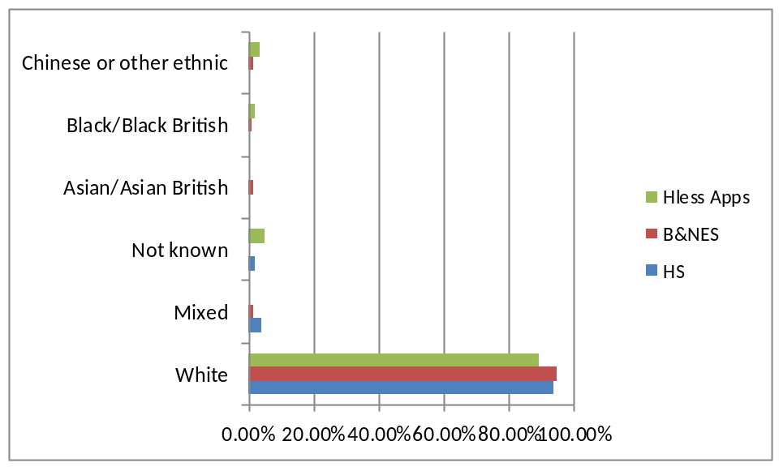

Religion – low representation of Muslim, Buddhist or other non-Christian religions in all segments
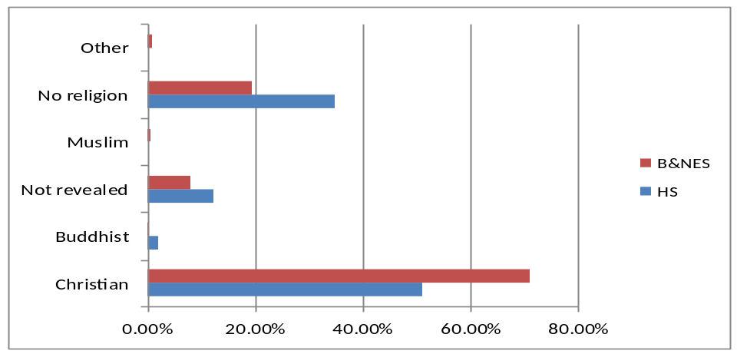

Sexual orientation – low representation of LGBT in all segments. HS data skewed by not stated.
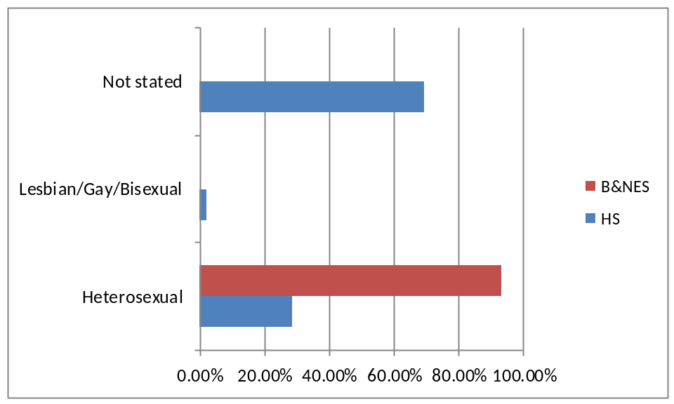

Disability – low representation of disabled in HS
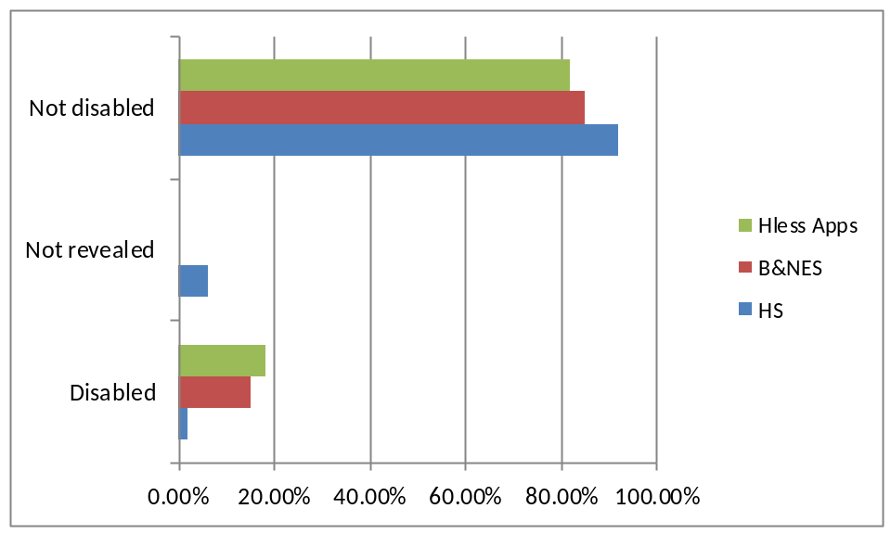

Age – low representation of under 24s and over 65s in HS
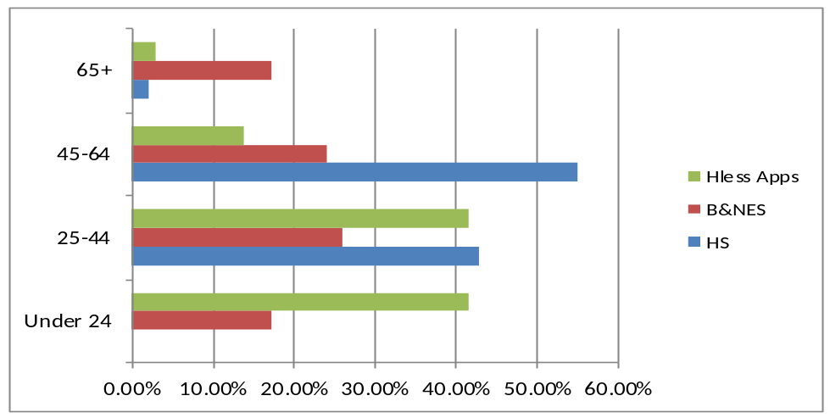
Tenancy Strategy Summary of Consultations

A consultation programme was implemented from June 2011-June 2012.

A variety of methods were used to consult with registered providers; service users; political stakeholders; internal and external partners; ward councillors and MPs; social housing residents and applicants; community groups; B&NES residents; parish councillors.

Consultation methods included focus group meetings with registered providers and equalities groups representatives; opinion sampling of affordable housing applicants; briefing notices in local press, council website, Inform and Staff Matters; two public consultations using econsult online consultation system:

Name |  | Status |  | Open Date | Close Date
Implementing the Government's Proposals to Reform Social Housing  The Government plans to make some big changes to social housing, including changing the way tenants access social housing, how much rent they could be charged and the length of tenancy they may be given. This consultation will help us gather people's views on the Government's plans. |  | Closed |  | 10 Oct 2011 | 20 Nov 2011
Shaping the future of social housing in Bath and North East Somerset  The Localism Act has introduced changes to the way people can access social housing and to the types of social housing tenancies that are available. Housing Services have already asked key stakeholders such as registered providers of social housing and service users for their views on the key issues. Their responses have informed the preparation of a draft Tenancy Strategy and draft Allocations Scheme. This consultation will help us ensure clarity and inclusiveness before we begin implementation. These are important plans that set out how we would like registered providers of social housing to respond to the Localism Act, they are likely to affect all new tenants to social housing. They include increasing rents on some properties to fund new affordable housing, offering fixed term in place of lifetime tenancies, restricting the social housing register so that only people with a local connection and without sufficient means to access other forms of housing can apply. | Closed |  | 01 May 2012 |  | 26 Jun 2012

Principle consultation outcomes and key points within the Strategy issues are listed in the table below. Numbers next to RPs represent general needs properties managed and provide scope of impact:

 | Flexible Tenancies | ART
Strategy recommendations | Lifetime tenancies only for elderly or where the tenant has a serious and long term illness or disability or in other exceptional circumstances.  All other tenancies to be fixed term of minimum 5yrs and maximum10 years. | All new build property and current properties selected for ‘conversion’ to be let at up to 80% local market rent (exceptions apply).
Affordable housing applicants | 50% of respondents want lifetime tenancies  25% want minimum term of 5 yrs.  25% want minimum term of 10 yrs. | 52% would apply for ART  28% would not apply for ART
Equalities group representatives  (January 2012). | People with protected characteristics need to be protected from harassment and victimisation if/when they move out of established communities at end of tenancy  Policy needs to reference RPs making an assessment of people’s contribution to the community when they are considering housing options at the end of fixed term tenancy (it is important to try to maintain communities)  Consensus of approval for exemptions | Policy needs to reference RPs role in fostering good relations – supporting and encouraging mixed communities – being mindful of not creating ghettos – ensuring safe places to live.
Curo  7172 | Standard form of tenancy will be a 6 year fixed term tenancy, which will include a probationary first year (“starter tenancy”).  8-10 years where there is an educational need.  Life tenancies for elderly and disabled.  - For all social rent homes: lifetime assured tenancy  - For all Affordable Rent (including intermediate rent) homes: either a lifetime assured tenancy or an assured short hold tenancy  - For “rent to buy” homes: 3 year assured short hold tenancy  - For market rent homes: 1 year assured short hold tenancy  - For supported housing: licence or assured short hold tenancy  - For all the above, 16/17 year olds will be granted Equitable tenancies. An existing Redland tenant holding a Secure tenancy who transfers to another Redland social rent property will retain a Secure tenancy  - All fixed term tenancies of more than 4 years will include a 1 year ‘probationary’ assured short hold element | 4+ beds not included in ART.  Sheltered included but not when supported.  Non affordable to not be included.  We will set rents at the start of a tenancy at 80% of market rent and subsequently increase rents in accordance with the TSA Rent standard  Applies to conversions and all new homes
Knightstone  (+Western Challenge)  794 | Standard form of tenancy will be a 6 year fixed term tenancy, which will include a probationary first year (“starter tenancy”).  Life tenancies for elderly and disabled. | Starter AST of 12 months. On satisfactory completion of that “starter period”, we will offer a new tenancy for a fixed term of 5 years. There are limited exceptions to this policy  Exclusions apply to sheltered, extra care and supported. Also for older people and adapted properties.  Transfers to be given advice about implications of loss of security  1 in 3 re-lets will be ART.  All properties likely to be included in ART.
Guinness  429 | Lifetime tenancies for all stock including ART | 80% rent on most ART  Exclusions apply to transfers, sheltered and supported and some conversions (eg adapted properties)  Financial assessment prior to allocation  Starter tenancy converting to Assured
Sovereign  165 |  | Will only be using ART in high demand areas. 80% market rent  On new homes and some conversions
Sanctuary  92 |  | Conversions to ART apply  Sheltered and supported excluded
Flourish / Aster  54 |  | ART on all new tenancies and all re-lets.  At the point of letting, affordable rent levels charged will be at the lower of:  - 80% market rent including service charge  - the relevant Local Housing Allowance  - 30% gross median local household income in the locality
English RHA  11 | Fixed term tenancies for a period of 20 years a ‘Generational Tenancy’.  General opinion seems to be that longer tenancies better suit English Rural’s objectives of sustaining rural communities. To support households and offer security of tenure particularly for families whilst children are within the education system.  to facilitate increased movement within social housing and to act as an incentive for households able to secure accommodation within the private sector | convert all relets to the new model of tenancy and to charge a level of rent that is (85-90%) less than the Local Housing Allowance

