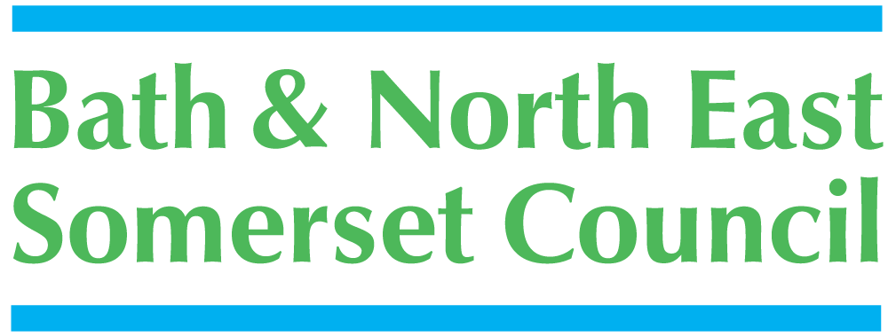

Bath and North East Somerset Council
Equality Impact Assessment Toolkit

Title of service, function or policy being assessed | Emergency Procedures
Name of directorate and service | Customer Services – Heritage Services
Name and role of officers completing the assessment | Iain Johnston, Facilities Manager
Contact telephone number | 01225 477753
Date assessment completed | 4 Dec 08

1. | Identify the aims of the policy/service/function and how it is implemented.
 | Key questions | Answers / Notes | Actions required
1.1 | Is this a new a new policy / function or service or a review of an existing one? | A review of an existing service
1.2 | What is the aim, objective or purpose of the policy/service/function? | To ensure all users of the buildings are able to egress the buildings in the event of an emergency. | Continuing review of emergency plans
1.3 | Whose needs is it designed to meet? Who are the main stakeholders? | All persons in the site, including Local and overseas visitors, staff, diners, corporate hospitality customers, schools, residents of B&NES
1.4 | Who defines or defined the policy/function? How much room for manoeuvre is there? | Heritage Services Management Team and consultation with staff and focus group, together with relevant Fire and H&S regulations
1.5 | Who implements the policy function? Is it possible for bias/prejudice to creep into the process? | Frontline staff and Management Team.  Bias would be possible but is mitigated by the need to ensure that all persons are evacuated from the site.
1.6 | Are there any areas of the policy or function that are governed by discretionary powers or judgement? If so is there clear guidance on how to exercise these? | Staff are given clear guidance at induction and through Customer Care Training
1.7 | What factors or forces are at play that could contribute or detract from the outcomes identified earlier in 1.2? | Some language barriers; some parts of the historic sites are not accessible to people with limited mobility.  Members of staff able to speak a variety of languages | Continue with development plans to improve accessibility (and egressability) on all sites
1.8 | How do these outcomes meet or hinder other policies, values or objectives of the public authority (this question will not always apply) | N/A
1.9 | How does the local authority interface with other bodies in relation to the implementation of this policy function? (this question will not always apply) | Heritage Services policies are applied to our contractors and included in the contracts eg Searcy’s the caterers, the security contact and Acoustiguide, the audio guide contract
1.10 | Consider if any of the six equalities strands have particular needs relevant to the policy. | Disability - People with mobility problems cannot easily access all areas. Some improved accessibility (and egressability) needed for hearing and visually impaired people. | Work in progress with the Roman Baths Development plan and the Victoria Art Gallery DDA plan to improve accessibility (and egressability) for a whole range of disabilities.
1.11 | Taking the six strands of equalities, is there anything in the policy that could discriminate or disadvantage any groups of people? | As above | Carry out the above

2. Consideration of available data, research and information

 | Key questions | Answers / Notes | Actions required
2.1 | What do you already know about who uses and delivers this service or policy? | Country of origin, age, nationality, number of children, adults, seniors, groups, schools, socio-economic group | The issue is to ensure that all persons are able to egress the site in the event of an emergency.
2.2 | What quantitative data do you already have? (e.g census data, employee data, customer profile data etc) | Visitor profiles from ALVA benchmarking surveys, group organisers data, schools database, local resident database, audio guide data on languages used  MLA statistics of children’s ages/key stage, admission till statistics of categories of type of visitors | The issue is to ensure that all persons are able to egress the site in the event of an emergency.
2.3 | What qualitative data do you already have? (e.g results of customer satisfaction surveys, results of previous consultations, staff survey findings etc). | N/A
2.4 | What additional information is needed to ensure that all equality groups’ needs are taken into account? Do you need to collect more data, carry out consultation at this stage? | The Museum Focus Group usually meets to identify accessibility issues. This group includes at least one visually impaired person, one with mobility problems and one who is hearing impaired. We are also consulting with Three Ways special school students and Bath Vision | Consult the Focus Group on 21 Jan 09  Consult Three Ways School 11 Dec 08
2.5 | How are you going to go about getting the extra information that is required? | Consult the Focus Group on 21th January 2009 and Three Ways school on 11 Dec 08.

3. Formal consultation (include within this section any consultation you are planning along with the
results of any consultation you undertake)

 | Key questions | Answers/notes | Actions required
3.1 | Who do you need to consult with? | Staff  Fire Specialists  H&S specialists
3.2 | What method / form of consultation can be used? | N/A
3.3 | What consultation was actually carried out as part of this EQIA and with which groups? | Management Team  Heritage Services Impact Assessment team | The Management Team considered this Impact Equality Assessment on 11 Dec 08
3.4 | What were the main issues arising from the consultation? | Physical access difficulties around historic sites  Effective communication with all staff, owing to 7 days a week operation and number of part time staff | The Roman Baths Development Plan and Victoria Art Gallery DDA improvements  Managers to be mindful that everyone needs to know  Training and action plan for occasional security guards needs to be followed with all new staff. This will be built into the new security contract

4. Assessment of impact

 | Based upon any data you have analysed, or the results of consultation or research, use the spaces below to list how the policy will or does actually work in practice for each equalities group. Identify any differential impact and consider whether the policy/function meets any particular needs of each of the six equalities groups. Also include any examples of how the policy or service helps to promote race, disability and gender equality.
 |  | Impact or potential impact (negative, positive or neutral)
4.1 | Gender – identify the impact/potential impact of the policy on women, men and transgender people | Neutral.
4.2 | Disability - identify the impact/potential impact of the policy on disabled people (ensure consideration of a range of impairments including visual and hearing impairments, mobility impairments, learning disability etc) | Negative for people with mobility difficulties  Users with mobility impairments may find it difficult to access the lower floors of the Roman Baths and the upper floors of the Victoria Art Gallery. Passenger lifts are being installed on both sites to improve accessibility during 2008/09
4.3 | Age – identify the impact/potential impact of the policy on different age groups | The sites have stairs for emergency egress. This could cause problems for people with mobility difficulties
4.4 | Race – identify the impact/potential impact on different black and minority ethnic groups | None; The issue is to ensure that all persons are able to egress the site in the event of an emergency.
4.5 | Sexual orientation - identify the impact/potential impact of the policy on lesbians, gay men, bisexual and heterosexual people | None; The issue is to ensure that all persons are able to egress the site in the event of an emergency.
4.6 | Religion/belief – identify the impact/potential impact of the policy on people of different religious/faith groups and also upon those with no religion. | None; The issue is to ensure that all persons are able to egress the site in the event of an emergency.
 | Key questions | Answers/notes | Actions required
4.7 | Have you identified any areas in which the policy/service or function is indirectly or directly discriminatory? If you answer yes to this please refer to legal services on whether this is justifiable within legislation. | No
4.8 | If you have identified any adverse impact(s) can it be avoided, can we make changes, can we lessen it etc? (NB: If you have identified a differential or adverse impact that amounts to unlawful discrimination, then you are duty bound to act to ensure that the Council acts lawfully by changing the policy or proposal in question). | No
4.9 | Are there additional measures that could be adopted to further equality of opportunity in the context of this policy/service/function and to meet the particular needs of equalities groups that you have identified? | Physical access/egress | Improvements to be made by Roman Baths Development Plan and Victoria Art Gallery DDA improvement plan. Visitor Services will then be reviewed with users to ensure that their needs have been met

5. | Internal processes for the organisation – to be explored at the end of the mentoring process.
Making a decision in the light of data, alternatives and consultations

 | Key questions | Answers/notes | Actions required
5.1 | How will the organisations decision making process be used to take this forward? | Business Team and Management Team | Ensure RB Development Plan and VAG DDA plan are implemented and review Visitor Services in 2010
Monitoring for adverse impact in the future

 | Key questions | Answers/notes | Actions required
5.2 | What have we found out in completing this EqIA? What can we learn for the future? | Our procedures are non-discriminatory; The issue is to ensure that all persons are able to egress the site in the event of an emergency. | Ensure that any/all visitors who access the site are able to egress the site in the event of an emergency
5.3 | Who will carry out monitoring? | Management Team  External: H&S auditors, access audits
5.4 | What needs to be monitored? | Number of people with mobility impairments who access the sites
5.5 | What method(s) of monitoring will be used? | Front of House staff
5.6 | How will the monitoring information be published? | Access statements for this area will be included in Heritage Services access statements.
Publication of results of the equality impact assessment

 | Key questions | Answers/notes | Actions required
5.7 | Who will take responsibility for writing up the EqIA report? | Iain Johnston | send to Equalities Team
5.8 | How will the results of the EqIA be published? | By Equalities Team
5.9 | Who will take responsibility for this? | EIA Team

Appendices:

1. Evacuation Procedures – Pump Room
2. Evacuation Procedures – Assembly Rooms
3. Evacuation Procedures – Victoria Art Gallery

6. Bath and North East Somerset Council
Equality Impact Assessment Improvement Plan

Please list actions that you plan to take as a result of this assessment (continue on separate sheets as necessary). These actions need to be built into the service planning framework and targets should be measurable, achievable, realistic and time bound.

Title of service/function or policy being assessed: Heritage Services Service Standards
Name and role of officers completing assessment: Katie Smith, Tom Deller, Patricia Dunlop, Jon Benington, Iain Johnston
Date assessment completed: 10.3.08

Issues identified | Actions required | Progress milestones | Officer responsible | By when
Physical Access/Egress | Roman Baths Development Plan | Completion | Iain Johnston | 31.3.10
Physical Access/Egress | Victoria Art Gallery DDA Improvement Plan | Completion | Jon Benington | 31.3.09
Update working practices to take account of the improved access/egress | Organise Review Visitor Services | After completion of work | Katie Smith | 31.05.10

Once you have completed this form, use it as a basis for writing a report of the Equality Impact Assessment. Keep a copy of the form as a record of the processes you have been through in carrying out the EqIA and send one copy to the Equalities Team (equality@bathnes.gov.uk, or by post to Equalities Team, Keynsham Town Hall, Bristol, BS31 1NL

Please contact your Directorate equalities officer for advice and guidance.

Major Projects: Cordelia Johnney
Support Services Cordelia Johnney
Customer services – Cordelia Johnney
Improvement and performance – Louise Murphy
Children’s services – Louise Murphy
Adult Social services and housing – Samantha Jones
Democratic and legal services - Samantha Jones

Corporate Equalities Team
August 2007

