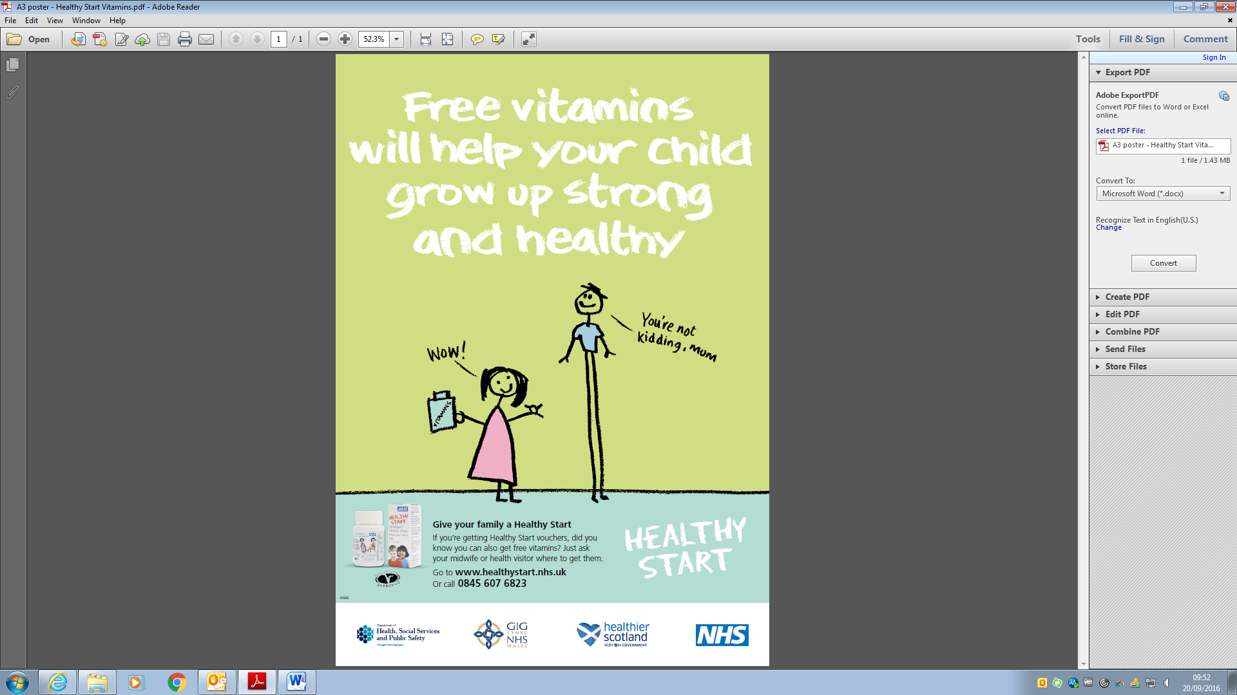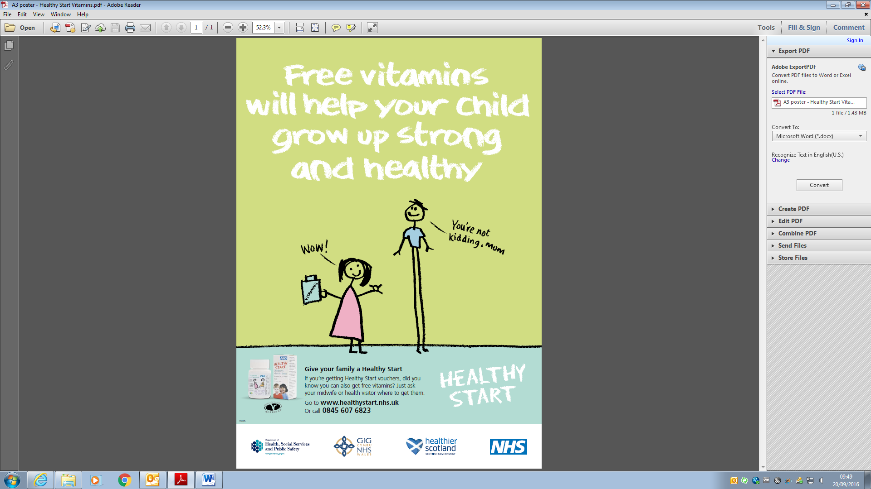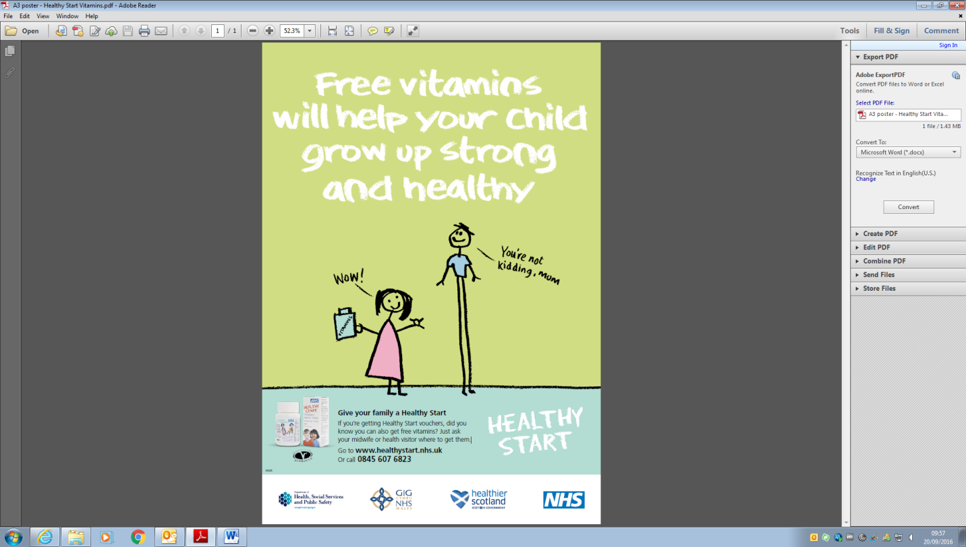

If you’re getting Healthy Start vouchers, did you know you can also get **free vitamins**?

**Exchange your Healthy Start Vitamin Vouchers at Bright Start Children Centre’s:**

* **Keynsham Children’s Centre , 65 West View Road, BS31 2UE**
* **Radstock Children’s Centre, Greystone Building, BA3 3QQ**
* **Parkside Children’s Centre, Charlotte Street, BA1 2NE**

**Vitamin drops can also be purchased:**

£2.10 for children’s vitamin drops

£1.25 for adult vitamins

**Even through a healthy balanced diet you still might not get everything you need at certain times in your life or the right amount of Vitamin D during winter months**

* Children’s vitamin drops are for children aged **from six months\*** to **four years** and contain **Vitamins A, C & D** *(****\*****unless children are having 500ml or more of formula milk a day)*
* Women’s vitamin tablets are suitable for **pregnant, breastfeeding** and for **women with a child under 12 months** and contain **Folic Acid and Vitamins C & D**

**Give your family a Healthy Start**