Gender Pay Gap Report 2020 (snapshot date of 31 March 2020)

The gender pay gap is different to equal pay. Equal pay relates to men and women receiving equal pay for equal work. The gender pay gap is concerned with differences in the average earnings of men and women, regardless of their role or seniority. It is a broader measure that captures the pay inequalities resulting from differences in the sorts of jobs performed by men and women in the workforce.

The data set out in this report has been calculated using the standard methodologies used in the Equality Act 2010 (Gender Pay Gap Information) Regulations 2017.

Workforce Profile

There were 2221 employees working on the snapshot date of 31 March 2020. At this date the workforce comprised of 57.9% female and 42.1% male employees. Bath & North East Somerset (B&NES) Council’s workforce is predominately female, although over the last years is steadily evening out (compared with 63% female at the first snapshot date of March 2017)

Of this headcount, 2174 employees were identified as ‘full pay relevant employees’, as set out in the regulations, and included in the calculations.

During the financial year of 2019/2020 there were the following staffing changes that will have had a small impact on the 2020 Gender Pay figures. However there were no major restructures or large scale redundancy exercises as per previous years

- Set up of Aequus Developments Ltd and Aequus Construction Ltd (small TUPE transfer) to develop, deliver, own and manage property.

Gender Pay Gap 2020

New analysis reveals that as at 31/03/2020 the mean average hourly rate of pay of female employees across the council was £15.12 while the mean average hourly rate of male employees was £15.50. It means that the mean gender pay gap (ie. the difference in average earnings between men and women) is 38 pence (This reduced from 96 pence (2018) to 36 pence (2019).

The median average gap has reduced with a mid-point hourly rate gap of -5.99% which shows that the mid-point of our female employees is £0.77 hour higher than the mid-point of our males.

Mean - Average hourly rate of pay and the percentage difference

Female = £15.12 (previously £14.74)
Male = £15.50 (previously £15.10)
Gap = 2.48% £0.38 (previously 2.38% £ 0.36)

Median – Middle hourly rate of pay and the percentage difference

Female = £13.63 (previously £13.19)
Male = £12.86 (previously £12.09)
Gap = - 5.99% £0.77 (previously -9.1%% £ 1.10)

Figure 1.

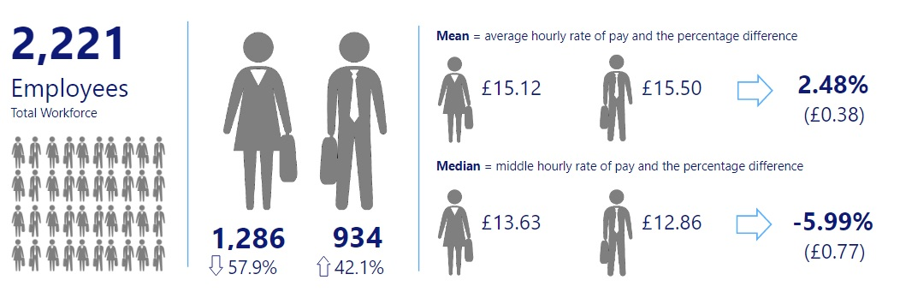

Comparison with other Local Authorities

The mean gender pay gap in local government for 31 March 2018 was 6.1% and the median gap was 4% so B&NES Council compares favourably to this.

There was no LGA summary data published for the snapshot date of 31 March 2019. The Government Equalities Office and the Equality and Human Right Commission (EHRC) suspended gender pay gap reporting regulations for the snapshot date of 31 March 2019 due to the coronavirus pandemic. Data for 2020 is not expected until late 2021 due to the date for reporting being extended until 5 October 2021.

Variations in pay gap between authorities are likely to be due at least in part to differences in structures, types of services provided and the extent of insourcing/outsourcing activity.

 | 2017 Mean | 2017 Median | 2018 Mean | 2018 Median | 2019 Mean | 2019 Median | 2020 Mean | 2020 Median
LGA (across 322 Local Authorities) | 6.8% | 5% | 6.1% | 4% | no data | no data | tbc | tbc
B&NES Council | 8.41% | -0.6% | 6.61% | -0.5% | 2.38% | -9.1% | 2.48% | -5.99%

Proportion of Men and Women Receiving Bonus Pay3

Whilst the Council doesn’t pay ‘bonus’ payments in the traditional sense, there are a small number of one off payments (eg long service awards, recruitment and retention allowances) that, in the spirit of transparency, are identified separately.

Closer scrutiny of these payments highlighted that many of these actually relate to ‘acting up’, ad hoc ‘cover’ arrangements and reflective supervision for newly qualified professionals (ie social workers). In December 2019 the HR/Payroll process changed to help ensure some of these payments are no longer treated as ‘ex gratia’ and are paid in a more appropriate way. This will ultimately mean the amount will be reflected in the overall ‘hourly rate’ figure rather than as a ‘bonus’ payment.

The 2020 data shows an overall reduction in the average amounts and median gap, yet a widening gap of the mean average difference, in favour of males. The proportion of both male and females receiving such payments remains small at 4.1% and 3.7%, (38 males and 48 females).

Mean - Average annual bonus payment and the percentage difference between

Female = £372.89 (compared with £567.99 in 2019
Male = £736.98 (compared with £965.20 in 2019
Gap = 49.4% , £364.09 difference

Median – Middle annual bonus payment and the percentage difference between

Female = £250.00 (compared with £281.09 in 2019)
Male = £307.62 (compared with £495.82 in 2019)
Gap = 18.7% £57.62 difference

The significant difference in the male and female mean and median bonus payment is due to a higher number of female employees receiving lower amounts and a small number of male employees receiving a higher amount.

Figure 2

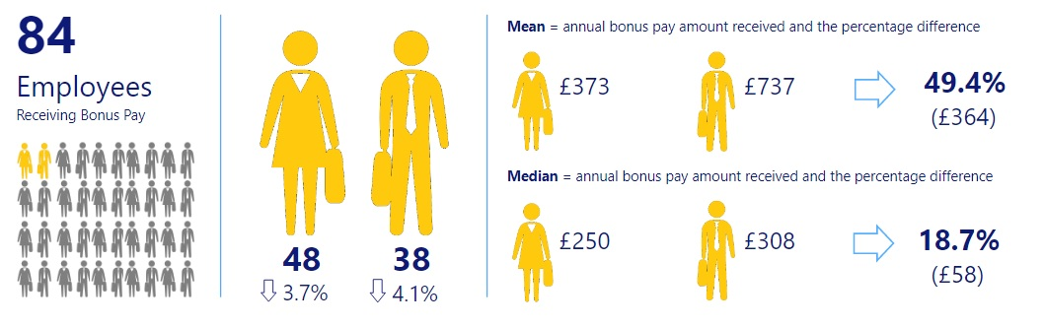

‘Bonus’ payments since 2017

Figure 3

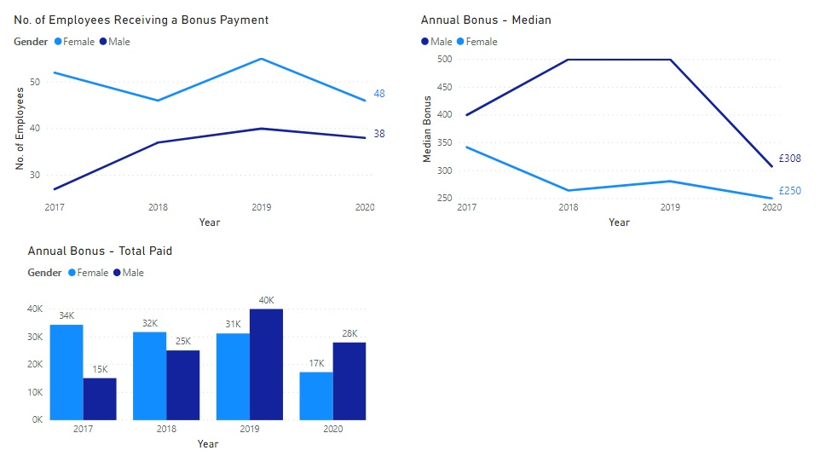

Quartile Pay Bands

The table below shows the workforce composition in each pay quartile. In order for there to be no gender pay gap, the representation of male and female in each quartile would need to match the overall representation of our workforce, ie 57.9% female and 42.1% male. There are approximately 540 employees in each quartile.

Quartile | 2020 Male | 2020  Female | 2020 difference in % of females compared with B&NES workforce
Upper quartile Q4 (highest paid)  (Grade 9 to top) | 44.4 | 55.6 | -2.3
Upper middle quartile, Q3  (Grade 6 to 9) | 34.3 | 65.7 | 7.8
Lower middle quartile, Q2  (Grade 4 to 6) | 43.4 | 56.6 | -1.3
Lower quartile Q1 (lowest paid)  (Apprentice rate to Grade 4) | 48.1 | 51.9 | -6.0

Figure 4
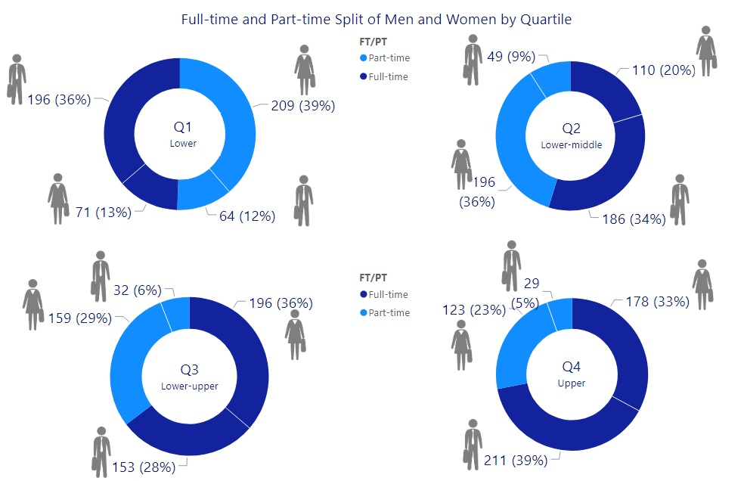

There continues to be a higher representation of male employees in the highest paid quartile although this difference is gradually reducing since both 2019 and 2018.

There is still a higher representation of female employees in the upper middle quartile which highlights that there still exists a gap for females between that upper middle quartile and the upper quartile, however this gap has reduced again since 2019 and 2018.

Quartile data of male/female and full time/part time over the 4 years

Many of the jobs that are available across the UK on a part-time basis are in the lower and middle paid roles rather than the senior higher paid roles and this is regarded as a key contributing factor in a gender pay gap as it can be a barrier to females accessing senior roles. It’s interesting to note that there has been a rise in male employees in the lower quartile in the last 2 years (Figure 5).

B&NES Council supports part time and other forms of flexible working, however the quartiles data shows that there are more part time roles in the lowest quartile. As the hourly rate increases so does the number of full time roles (the number of part time roles decrease).

Across these quartiles, the trend is that part-time posts are more likely to be filled by females. It could be that females are more attracted to positions in these quartiles because of the greater opportunity for working part time and more flexibly. Of course, flexible working isn’t just about part time hours and the data doesn’t show how other forms of flexible working are supported, eg condensed hours in the form of a 4 day week or 9 day fortnight, or working flexible hours throughout a longer day.

Figure 5
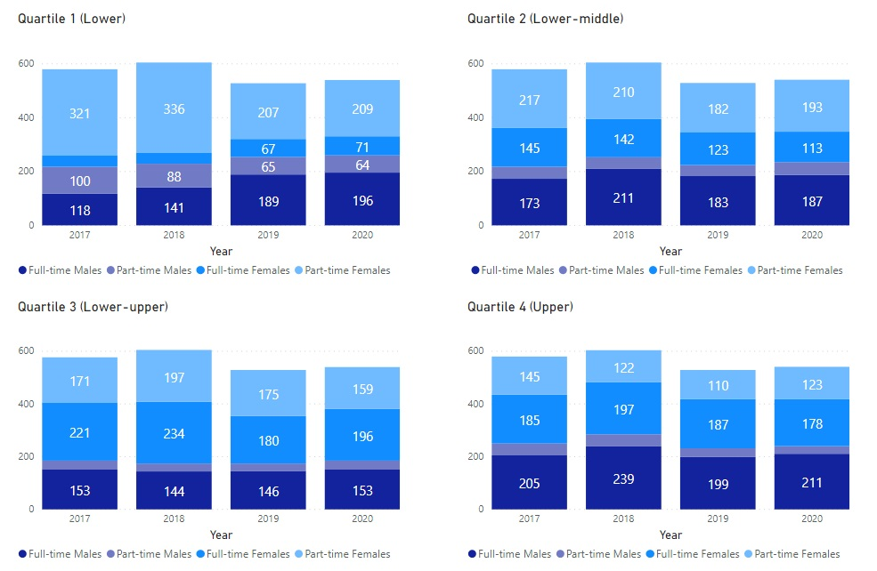

Note: there is no number shown when the number is less than 50

Highest Paid Employees

Further analysis of the top end of the upper quartile (highest paid), the higher up the salary scale the more significant the gap

Figure 6 – Highest Paid Employees (%)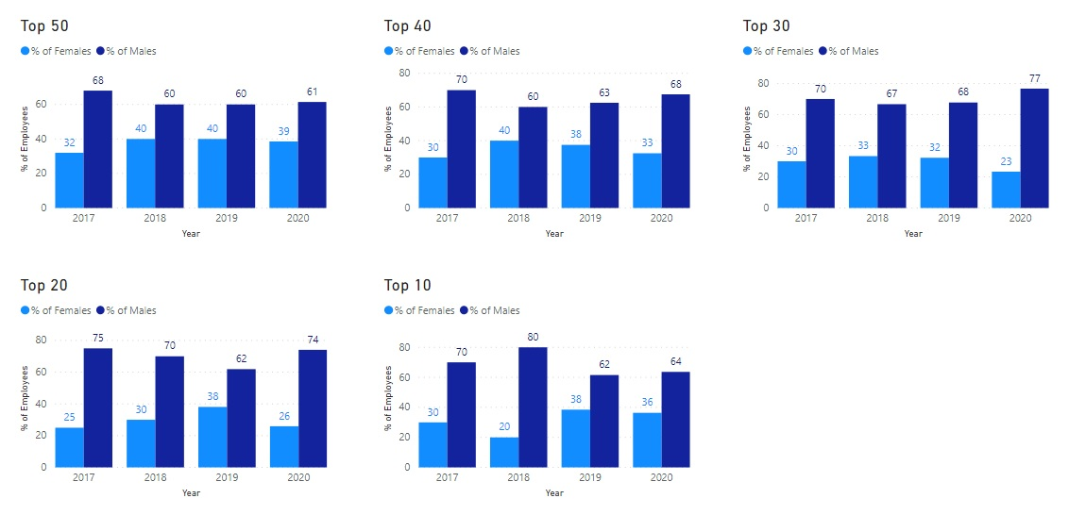

What is B&NES Council doing to address its gender pay gap?
B&NES Council is committed to the principle of equal opportunities and equal treatment for all employees, regardless of sex, race, religion or belief, age, marriage or civil partnership, pregnancy/maternity, sexual orientation, gender reassignment or disability. It has a clear policy of paying employees equally for the same or equivalent work, regardless of their sex (or any other characteristic set out above). As such, it evaluates job roles and pay grades using the HAY job evaluation analytical methodology to ensure a fair and consistent pay structure.
B&NES Council is therefore confident that its gender pay gap does not stem from paying men and women differently for the same or equivalent work. Rather its gender pay gap is the result of the roles in which men and women work within the organisation and the salaries that these roles attract.
Whilst B&NES Council’s gender pay gap compares favourably with that of organisations both across the whole UK economy and within the public sector, this is not a subject about which the Council is complacent, and it is committed to further analysing and addressing the gap.
The table below sets out what we said we were going to do to tackle the gender pay gap, what we have actually done and what we plan to do next.

Bath & North East Somerset Gender Pay Gap Action Plan

Area of… | Previously we said we would… | So far we have… | During 2021 we will…
Pay | review our policy on ex-gratia (bonus) payments  continue to build upon existing good practice to take a fair and consistent approach to pay and grading through robust job evaluation processes  review a sample of male and female recruits and their starting salary /spinal column point to determine if male recruits negotiate/are offered a higher starting salary than female recruits | reviewed further the detailed payment of honoraria and ex gratia payments, resulting in the reviewing and removal of some payments, strict sign off protocol for initiating or extending - including monthly monitoring of HRBP and overview by Director of HR  continued with robust job evaluation process with regular JE panels including HR, Management and TU representation. Further Hay JE training has been provided for more HR reps, Managers and TU reps in July 2017  undertaken an HR research project to review a sample of male and female recruits to investigate this complies with our clear policy on starting salaries | Ensure payments are appropriately paid (so fewer ex gratia payments and therefore a reduction in bonus payments and increasing accuracy of hourly rate data)  Arrange further JE training
Recruitment | review our gender monitoring through all employee lifecycles to identify any barriers to gender equality and inform priorities for action  review existing recruitment practices to identify which areas need more promotion to attract women and men into roles where they are underrepresented | ensured that ACAS Unconscious Bias awareness principles and promotion of Flexible Working principles are featured within our standard Recruitment and Selection Training  explored unconscious bias training more with external consultant and neighbouring authority, together with our own Equalities team and Staff Working Groups  identified a suite of reports that will feed into the HR dashboard | Continue with the piece of work to identify gaps in data.  Improve our reporting capability to have data to enable some detailed analysis on the gender balance within the employee lifecycle eg re. interest in posts, shortlisted candidates, successful appointed candidates  Identify key areas of underrepresentation and further action  Continue to embed unconscious bias training in our own practice and corporate training recruitment programmes
Area of… | Previously we said we would… | So far we have… | During 2021 we will…
Development | analyse the upper and upper middle quartiles to identify any barriers indicated by the differential to enable targeted action | promoted career development within the workforce through;-  in total, supported 12 senior female employees through the Springboard Development Plus - Senior Women’s Development Programme (in partnership with local public sector organisations). This programme is aimed at women managers in middle management posts and above and who are seeking the opportunity to consider and explore career aspirations in more senior posts and there has been high positive feedback  Since Feb 2019 we have supported 12 senior managers on the Level 7 MBA programmes across 3 cohorts, 6 were female. Of those females, 2 left the Council on promotion to other organisations and are continuing with their MBA. 1 left the programme early. 3 others are still on the programme with the council. We also support another female from a Primary School on this level programme who will shortly be transferring to an Academy.  supported a new cohort of Management Diploma Level 3 (5 female and 3 male ) and Level 5 (9 female and 2 male) started May 2019  supported a new cohort of Project Manager Level 4 Apprenticeships. 13 due to commence, 10 females and 3 males | support a further cohort of the Springboard Development Plus programme for women, with a further 4 B&NES employees signed up for the April 2020 cohort. The programme was delayed to Sept due to Covid. We have 4 on the programme. We will support future programmes locally.  Have one female manager on a Level 6 Chartered Manager Degree Apprenticeship. 2 x female managers on the level 5 Diploma progamme (and one male)  1 female started a level 7 Town Planning Apprenticeship with UWE (no male comparison)  1 female started a level 6 Chartered Legal Executive (no male comparison)  menopause staff support group established and a development of a managers training package (40 females attended Menopause Awareness session, 24 managers attended Managers session (4 males) 19 male employees attended Men: Let’s talk menopause June 2021  3 successful candidates for the 1 year Stepping Up programme (a diversity leadership development programme) 2 female, 1 male - started April 2021
Managing Change | monitor the effects and any associated risks on gender equality of the Council’s planned change programme | assessed the impact of the 2018 VR programme where 54 volunteers accepted for redundancy, 35 female and 19 male (65% female and 35% male) which closely matched our gender workforce ratio | continue with workforce monitoring analysis in relation to change programmes
Flexible Working | analyse the impact of the gender prevalence of part time working associated with lower rates of pay and the pay gap between the average hourly rate of men who work full time and the average hourly rate of women who work part time  analyse the breakdown by gender of take-up of part-time and flexible working, at senior levels in B&NES Council | undertaken a project (within HR&OD) which produced some useful findings re. attitudes within the organisation to working remotely  publicised a welcome for flexible working requests on every advert  promoted flexible working ethos specifically within recruitment and selection training and at Council induction  undertaken some analysis on part time/full time ratios within the quartiles  undertaken a staff engagement survey which includes the topic of flexible working  Linked with Bath Spa University to support their students in a research project in strategies being adopted to reduce the gender pay gap | continue to promote flexible working – particularly within Managers @MyBest essential managers package and as part of the wider Preparing for the Future programme  review Staff Engagement survey results to understand barriers to flexible working  Introduce Blended Working Charter as part of Preparing for the Future and new ways of working post-Covid

Full pay relevant employees are those relevant employees who, during the relevant pay period, are not being paid at a reduced or nil rate as a result of being on ‘leave’. This data includes casual workers.
Data taken from LGA Report 2019 (based on 31 March 2018 data) - https://www.local.gov.uk/gender-pay-gap accessed January 2020 and May 2021.
3 Bonus pay for B&NES is defined as long service award payments, golden hellos and recruitment and retention allowances to attract and retain teaching staff, one-off ex-gratia payments. It does not include honorarium payments which are already included in the overall basic hourly rate pay calculation.
A small number of specialist roles fall under Soulbury, JNC or School Teacher Pay terms and conditions that are not Hay evaluated

