Gender Pay Gap Report - snapshot date of 31 March 2021

The gender pay gap is different to equal pay. Equal pay relates to men and women receiving equal pay for equal work. The gender pay gap is concerned with differences in the average earnings of men and women, regardless of their role or seniority. It is a broader measure that captures the pay inequalities resulting from differences in the sorts of jobs performed by men and women in the workforce.

The data set out in this report has been calculated using the standard methodologies used in the Equality Act 2010 (Gender Pay Gap Information) Regulations 2017.

Workforce Profile

There were 2488 employees working on the snapshot date of 31 March 2021. At this date the workforce comprised of 62.4% female and 37.6% male employees.

The job roles across the council cover a broad spectrum of services and work activities in a wide range of roles. We have over 1000 staff employed in frontline operational roles as waste and recycling operatives, as Registrars, in bereavement services, in customer services and libraries, in highways, as visitor assistants in our museums and heritage services, and as support (care) workers in our care homes. We have around 400 staff employed in frontline social care, education and protection roles working in environmental health, public protection, mental health, children’s social workers, educational psychologists, SEND support and safeguarding. We also employ over 1000 staff in professional and support office-based roles such as planning, finance, HR&OD, IT and pensions.

Of this headcount, 2401 employees were identified as ‘full pay relevant employees’, as set out in the regulations, and included in the calculations.

During the financial year of 2020/2021 there was one significant staffing change that will have had an impact on the March 2021 Gender Pay figures. The TUPE transfer into the council from Sirona Health Ltd, of 3 Community Resource Centres (Care Homes) and 5 Extra Care Facilities meant that 260 staff (20 male and 240 female) in mostly lower graded roles, joined the council’s workforce. In addition approximately a further 80 casual workers engaged via the ‘casual bank’ to support the service, the majority being in lower graded roles of Support Worker/Night Support Workers.

This is the main factor that accounts for the increase in total employees and the widening of female/male workforce ratio from the previous year.

Gender Pay Gap 2021

As at 31 March 2021 the mean average hourly rate of pay of female employees across the council was £15.12 while the mean average hourly rate of male employees was £15.91. It means that the mean gender pay gap (ie. the difference in average earnings between men and women) has increased to 79 pence. (This reduced from 96 pence (2018) to 36 pence (2019) and 38 pence (2020).

The median average gap has reduced with a mid-point hourly rate gap of -6% . The minus represents the gap showing higher rate for females. The mid-point of our female employees is £0.80 hour higher than the mid-point of our males.

Mean - Average hourly rate of pay and the percentage difference

Female = £15.12 (previously £15.12)
Male = £15.91 (previously £15.50)
Gap = 5% £0.79 (previously 2.48% £ 0.38)

Median – Middle hourly rate of pay and the percentage difference

Female = £14.01 (previously £13.63)
Male = £13.21 (previously £12.86)
Gap = - 6% £0.80 (previously -5.99% £0.77)

The median average is considered more representative measure of the pay gap. The mean figure can be skewed by a small number of highly paid individuals, so the median figure is less affected by outliers.

Figure 1.

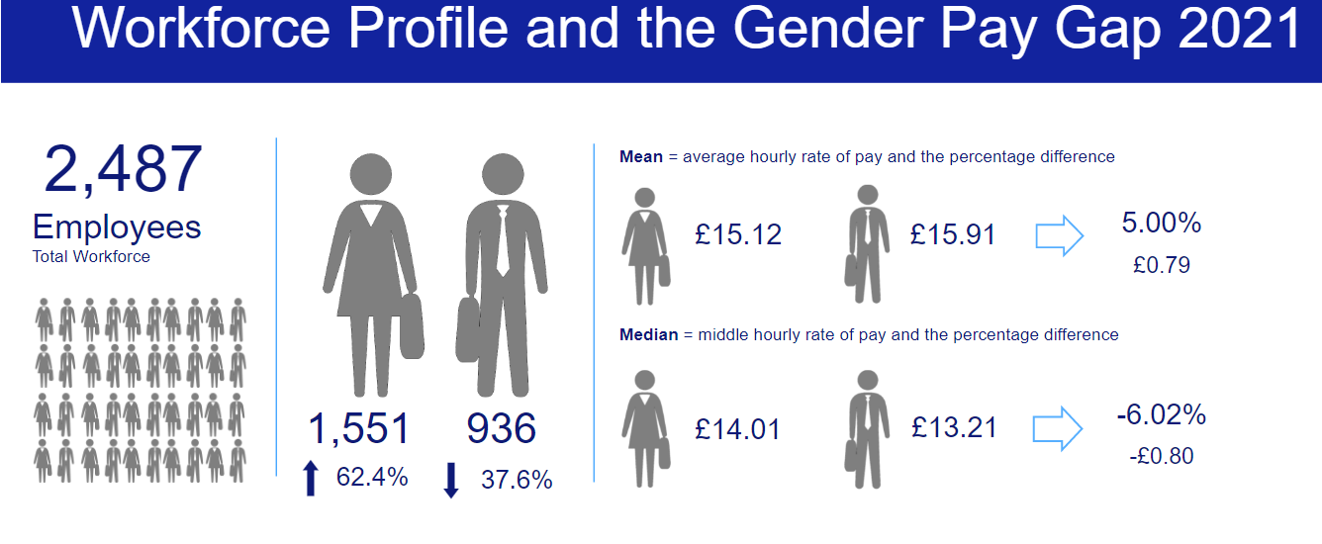

Comparison with other Local Authorities
There is currently no updated LGA summary data for 2020. It was expected late 2021 (after the extended reporting date of 5 October 2021 had passed). There was no LGA summary data published for the snapshot date of 31 March 2019. The Government Equalities Office and the Equality and Human Right Commission (EHRC) suspended gender pay gap reporting regulations for the snapshot date of 31 March 2019 due to the coronavirus pandemic.

The mean gender pay gap in local government for 31 March 2018 was 6.1% and the median gap was 4% so B&NES Council compares favourably to this.

Variations in pay gap between authorities are likely to be due at least in part to differences in structures, types of services provided and the extent of insourcing/outsourcing activity.

 | 2017 Mean | 2017 Median | 2018 Mean | 2018 Median | 2019 Mean | 2019 Median | 2020 Mean | 2020 Median | 2021 Mean | 2021 Median
LGA (across 322 Local Authorities) | 6.8% | 5% | 6.1% | 4% | no data | no data | tbc | tbc | tbc | tbc
B&NES Council | 8.41% | -0.6% | 6.61% | -0.5% | 2.38% | -9.1% | 2.48% | -5.99% | 5% | -6%

Proportion of Men and Women Receiving Bonus Pay3

Whilst the Council doesn’t pay ‘bonus’ payments in the traditional sense, there are a small number of one off payments (eg long service awards, recruitment and retention allowances) that, in the spirit of transparency, are identified separately.

Closer scrutiny of these payments in 2019 highlighted that many of these were actually related to ‘acting up’, ad hoc ‘cover’ arrangements and reflective supervision for newly qualified professionals (ie social workers). In December 2019 the HR/Payroll process changed to help ensure some of these payments are no longer treated as ‘ex gratia’ and are paid more appropriately.

The proportion of both male and females receiving one off ‘ex gratia’ payments is now very small at 0.9% and 0.4%, (8 males and 6 females).

The 2021 data reflects an overall reduction in the average amounts showing no median gap at all and a much reduced gap of the mean average difference.

Mean - Average annual bonus payment and the percentage difference between

Female = £285.60 (compared with £372.99 in 2020)
Male = £391.55 (compared with £736.98 in 2020)
Gap = 27.1%, £105.95 difference

Median – Middle annual bonus payment and the percentage difference between

Female = £250.00 (compared with £250 in 2020)
Male = £250 (compared with £307.62 in 2020)
Gap = 0% £0.00 difference

The significant % difference in the male and female mean bonus payment is due to more female employees receiving lower amounts and a small number of male employees receiving a higher amount.

Figure 2

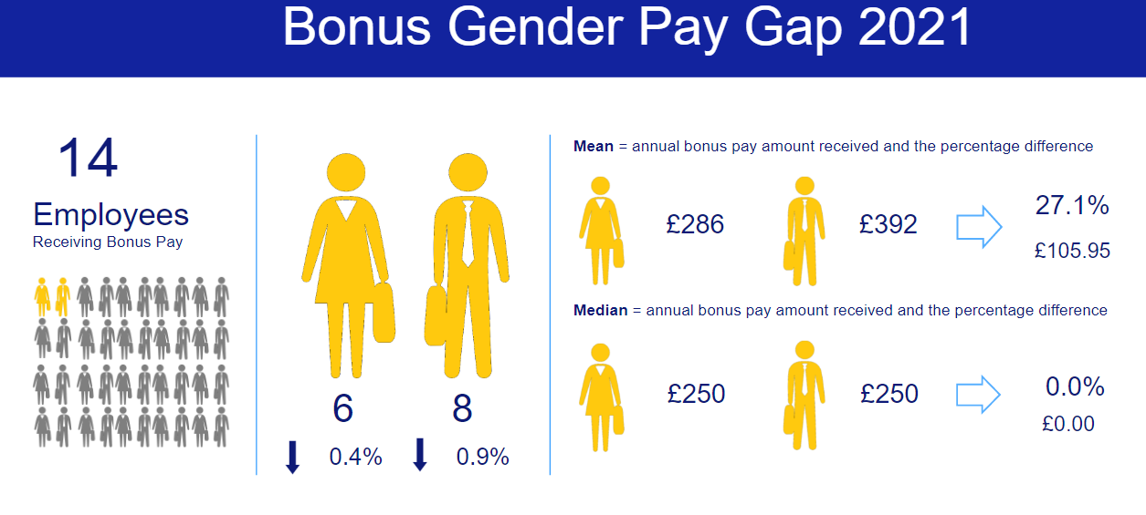
‘Bonus’ payments since 2017

Figure 3

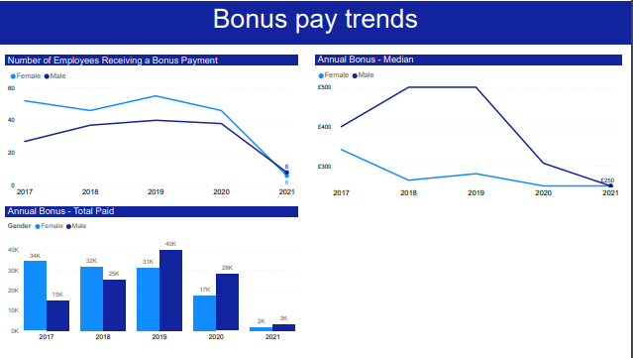
Quartile Pay Bands

The table below shows the workforce composition in each pay quartile. In order for there to be no gender pay gap, the representation of male and female in each quartile would need to match the overall representation of our workforce, ie 62.4% female and 37.6% male. There are approximately 600 employees in each quartile.

Quartile | 2021 Male | 2021  Female | 2021 difference in % of females compared with B&NES workforce
Upper quartile, Q4 (highest paid)  (Grade 9 to top) | 42.1 | 57.9 | -4.5
Upper middle quartile, Q3  (Grade 6 to 9) | 33.5 | 66.5 | 4.1
Lower middle quartile, Q2  (Grade 4 to 6) | 37.7 | 62.3 | 0.0
Lower quartile Q1 (lowest paid)  (Apprentice rate to Grade 4) | 41.5 | 58.5 | -3.9

There continues to be a higher representation of male employees in the highest paid quartile The gap in this quartile has widened in 2021, whereas the gap has evened out for the other three quartiles.

There is still a higher representation of female employees in the upper middle quartile which highlights that there still exists a gap for females between that upper middle quartile and the upper quartile, however this gap has reduced over last 3 years.

It’s interesting to note that despite the increase in workforce being largely due to the TUPE of Residential Care (predominantly females in lower quartile, it is still our male employees who are over represented in the lower quartile, although this gap has reduced from 48.1% in 2020.

Quartile data of male/female and full time/part time over the 5 years

Many of the jobs that are available across the UK on a part-time basis are in the lower and middle paid roles rather than the senior higher paid roles and this is regarded as a key contributing factor in a gender pay gap as it can be a barrier to females accessing senior roles.

B&NES Council supports part time and other forms of flexible working, however the quartiles data shows that there continues to be more part time roles in the lowest quartile. As the hourly rate increases so does the number of full time roles (the number of part time roles decrease).

Across these quartiles, the trend continues that part-time posts are more likely to be filled by females. It could be that females are more attracted to positions in these quartiles because of the greater opportunity for working part time and more flexibly. Of course, flexible working isn’t just about part time hours and the data doesn’t show how other forms of flexible working are supported, eg flexible location with blended working, condensed hours in the form of a 4 day week or 9 day fortnight, or working flexible hours throughout a longer day.

Figure 4
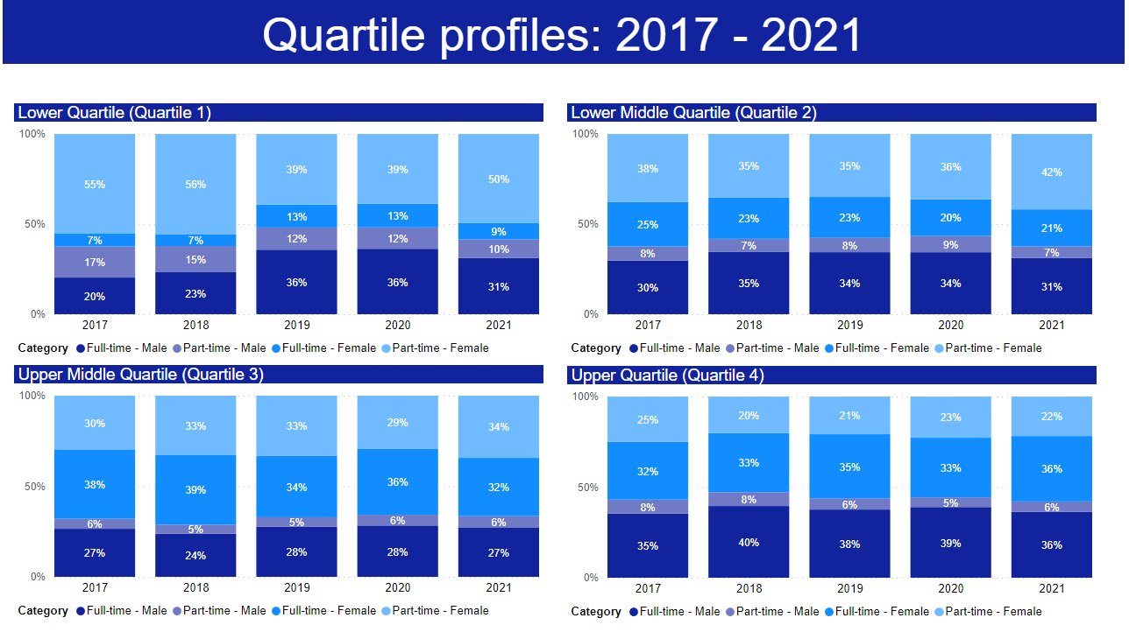
Note: there is no number shown when the number is less than 30

Highest Paid Employees

Further analysis of the top end of the upper quartile (highest paid), the higher up the salary scale the more significant the gap

Figure 5 – Highest Paid Employees (%)

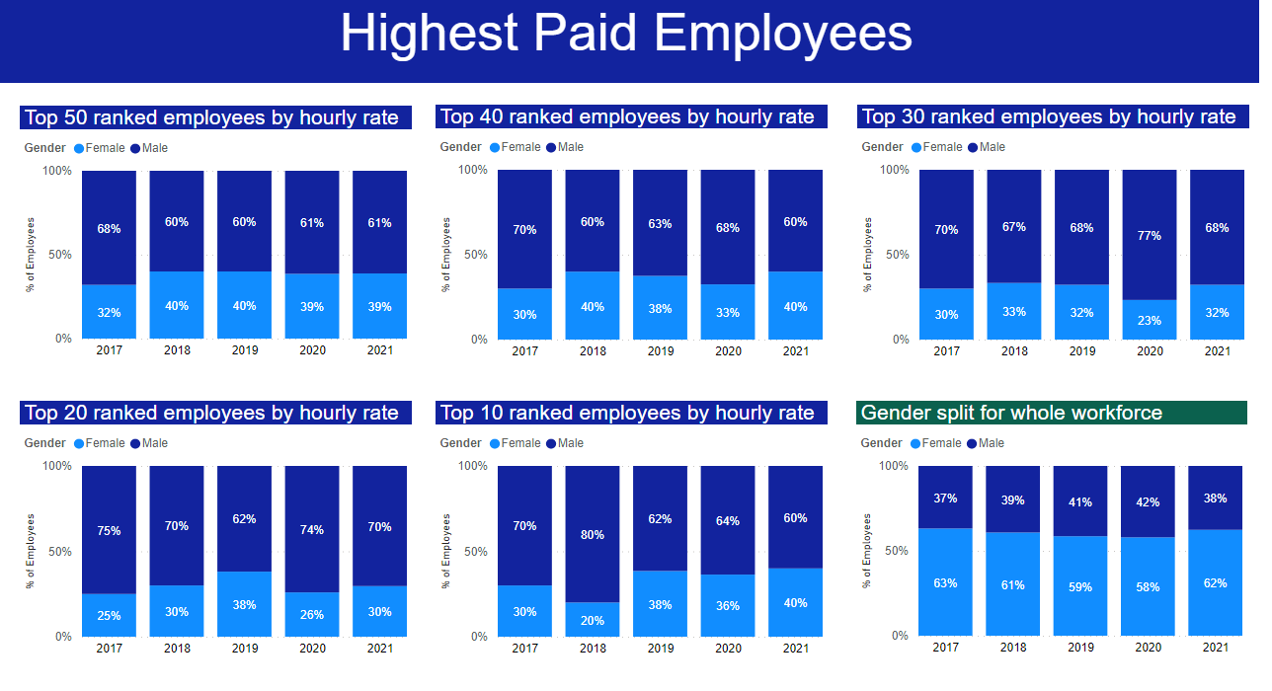

What is B&NES Council doing to address its gender pay gap?
B&NES Council is committed to the principle of equal opportunities and equal treatment for all employees, regardless of sex, race, religion or belief, age, marriage or civil partnership, pregnancy/maternity, sexual orientation, gender reassignment or disability. It has a clear policy of paying employees equally for the same or equivalent work, regardless of their sex (or any other characteristic set out above). As such, it evaluates job roles and pay grades using the HAY job evaluation analytical methodology to ensure a fair and consistent pay structure.
B&NES Council is therefore confident that its gender pay gap does not stem from paying men and women differently for the same or equivalent work. Rather its gender pay gap is the result of the roles in which men and women work within the organisation and the salaries that these roles attract.
Whilst B&NES Council’s gender pay gap compares favourably with that of organisations both across the whole UK economy and within the public sector, this is not a subject about which the Council is complacent, and it is committed to further understanding, analysing and addressing the gap.
During 2021 we undertook a project to understand the impact of Covid on our workforce, identifying and highlighting any differences between men and women. The report found that whilst both male and female colleagues reported impacts on both their physical health and mental health, more female colleagues were required to shield, and have been absent from work with Covid, however this is in line with the gender split of the workforce. More female colleagues have been absent with long Covid and work is underway to ensure that the right policies and support is in place for these staff.
We heard from many staff who had to balance demanding job roles with demanding caring roles during the pandemic and in particular during the first lockdown; caring for small children, young adults, elderly parents, family and friends. More female staff accessed carers leave during this period and it does appear that female colleagues undertook more caring responsibilities from the experiences we heard.
The table below sets out what we said we were going to do to tackle the gender pay gap, what we have actually done and what we plan to do next.
Development work is underway to prepare for ethnicity pay reporting.

Bath & North East Somerset Gender Pay Gap – ‘Closing the Gap’ Action Plan

Area of… | Previously we said we would… | So far we have… | During 2022 we will…
Pay | review our policy on ex-gratia (bonus) payments  continue to build upon existing good practice to take a fair and consistent approach to pay and grading through robust job evaluation processes  review a sample of male and female recruits and their starting salary /spinal column point to determine if male recruits negotiate/are offered a higher starting salary than female recruits | reviewed ex gratia payments, resulting in the reviewing and removal of some payments, strict sign off protocol for initiating or extending - including monthly monitoring of HRBP and overview by Director of People & Policy  continued with robust job evaluation process with regular JE panels including HR, Management and TU representation.  undertaken an HR research project to review a sample of male and female recruits to investigate this complies with our clear policy on starting salaries | Continue to ensure payments are appropriately paid (so fewer ex gratia payments and therefore a reduction in bonus payments and increasing accuracy of hourly rate data)  Further JE training planned for March 2022  Prepare for ethnicity pay gap reporting
Recruitment | review our gender monitoring through all employee lifecycles to identify any barriers to gender equality and inform priorities for action  review existing recruitment practices to identify which areas need more promotion to attract women and men into roles where they are underrepresented | ensured that ACAS Unconscious Bias awareness principles and promotion of Flexible Working principles are featured within our standard Recruitment and Selection Training  explored unconscious bias training more with external consultant and neighbouring authority, together with our own Equalities team and Staff Working Groups  identified a suite of reports that will feed into the HR dashboard and improve management reporting capability | Continue with the piece of work to identify gaps in data.  Finalise reports and publish – to enable some detailed analysis on the gender balance within the employee lifecycle eg re. interest in posts, shortlisted candidates, successful appointed candidates  Identify key areas of underrepresentation and further action  Continue to embed unconscious bias training in our own practice and corporate training recruitment programmes
Area of… | Previously we said we would… | So far we have… | During 2022 we will…
Development  Development (cntd) | analyse the upper and upper middle quartiles to identify any barriers indicated by the differential to enable targeted action | promoted career development within the workforce through;-  in total, supported 16 senior female employees through the Springboard Development Plus - Senior Women’s Development Programme (in partnership with local public sector organisations). This programme is aimed at women managers in middle management posts and above and who are seeking the opportunity to consider and explore career aspirations in more senior posts and there has been high positive feedback  Since Feb 2019 we have supported  14 senior managers on the Level 7 MBA programmes across 4 cohorts, 6 were female. Of those females, 2 left the Council on promotion to other organisations and are continuing with their MBA. 1 left the programme early. We also supported another female from a Primary School on this level programme who has since transferred to an Academy.  Since June 2018 we have supported 16 managers to complete their Diploma 5 in Management, 4 male and 12 female. (Of those, 5 females did not complete. All others have either completed or are mid studies.) We have one female manager on a level 6 Chartered Management Diploma, one female started a level 7 Town planning apprenticeship with UWE (no male comparison)  3 candidates in April 2021 for the 1 year Stepping Up programme (a diversity leadership development programme) 2 female, 1 male  1 female started a level 6 Chartered Legal Executive ( no male comparison)  Since Jan 2019 we have supported 19 managers for Level 4 Project Management Apprenticeship (6 male, 13 female)  Increased support for ‘Menopause at Work’ – Since 2021 delivered three all colleague Menopause in the Workplace awareness sessions and a specialist HRT information session (90 attendees across all sessions).  Offered a Menopause Awareness session for male colleagues (17 attended).  Trained three lead Menopause Champions (one of which is male) and twelve of our health champions are now ‘menopause aware’ | Support a further 2 delegates on the Springboard Development Plus programme in April 2022.  Continue to support 4 managers on Level 7 MBA programme  Support 4 females on Level 7 Town Planning Apprenticeship (commenced in 2021)  No candidates for the Stepping Up programme came forward  Promote International Women’s Day – engage Bath Uni to run ‘being a game changer’ – breaking the bias of sexism/sex discrimination in the workplace  Offer menopause café sessions for women to talk about symptoms and share stories.  Offer drop-in virtual cuppa sessions for all colleagues to find out more about the menopause and how to support colleagues in the workplace or at home.  Offer ‘Blush Boxes’ in our staff bathrooms so free sanitaryware is available to colleagues.  Deliver targeted menopause awareness sessions to teams through our menopause champions.
Managing Change | monitor the effects and any associated risks on gender equality of the Council’s planned change programme | assessed the impact of the 2018 VR programme where 54 volunteers accepted for redundancy, 35 female and 19 male (65% female and 35% male) which closely matched our gender workforce ratio | continue with workforce monitoring analysis in relation to change programmes
Flexible Working | analyse the impact of the gender prevalence of part time working associated with lower rates of pay and the pay gap between the average hourly rate of men who work full time and the average hourly rate of women who work part time  analyse the breakdown by gender of take-up of part-time and flexible working, at senior levels in B&NES Council | undertaken a project (within HR&OD) which produced some useful findings re. attitudes within the organisation to working remotely  publicised a welcome for flexible working request on adverts  promoted flexible working ethos specifically within recruitment and selection training and at Council induction  undertaken some analysis on part time/full time ratios within the quartiles  undertaken a staff engagement survey which includes the topic of flexible working  Linked with Bath Spa University to support their students in a research project in strategies being adopted to reduce the gender pay gap | continue to promote flexible working – particularly within Managers @MyBest essential managers package and as part of the wider Preparing for the Future programme. The focus has so far been on location flexibility/home working during the Covid Pandemic. We will continue to promote other forms of flexibility ie job share and part time working, particularly to leadership roles. (eg publicise senior manager job share/flexible working arrangements via video on our website)  review Staff Engagement survey results to understand barriers to flexible working. Undertake a further staff survey February 2022.  Introduce Blended Working Charter as part of Preparing for the Future and new ways of working post-Covid and follow up with workshops for managers  Review and extend our carers leave policy

Full pay relevant employees are those relevant employees who, during the relevant pay period, are not being paid at a reduced or nil rate as a result of being on ‘leave’. This data includes casual workers.
Data taken from LGA Report 2019 (based on 31 March 2018 data) - https://www.local.gov.uk/gender-pay-gap accessed January 2020 and May 2021.
3 Bonus pay for B&NES is defined as long service award payments, golden hellos and recruitment and retention allowances to attract and retain teaching staff, one-off ex-gratia payments. It does not include honorarium payments which are already included in the overall basic hourly rate pay calculation.
A small number of specialist roles fall under Soulbury, JNC or School Teacher Pay terms and conditions that are not Hay evaluated

