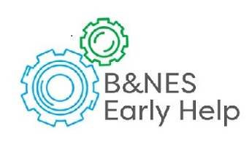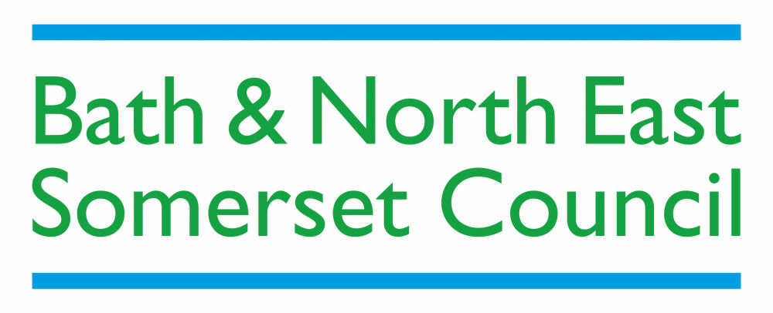

**A One Minute Guide to Early Help**

**Early Help means providing effective support to children and young people as soon as needs start to be identified, and to bring about change to prevent these from escalating and leading to poor outcomes. Early Help may occur at any point when needs arise, from pregnancy through to the teenage years and at any stage in adulthood.**

**What is Early Help?**

**Our vision is that all children, young people and families have access to well-coordinated, good quality and timely Early Help when it is required, so needs can be identified and addressed to promote fulfilling family lives.**

**Early Help- A Shared Responsibility**

**Everyone** working with children and young people has a responsibility to **safeguard**

children and young people and promote their welfare. This depends upon effective

**joint-working** between agencies. Practitioners will have different roles and expertise

to be able to support children, young people and their families. Vulnerable children

and those at risk will need **co-ordinated help** from a range of services.

Most children’s needs are met by their family or **universal services**, that is, those services that are available to everyone. These are provided as a right to all children, young people and their families, including those whose needs are also met within targeted and/ or specialist and statutory services. Further information on a wide range of universal services, can be found at the online [Bath and North East Somerset Family Information on](http://www.bathnes.gov.uk/services/children-young-people-and-families/childcare-information-and-support-your-family/family) line.

For those children and families who face more challenges and may have additional needs, identified through an assessment, **targeted support services** provide additional capacity and expertise to work with these families and address their needs. Details of these services can be found on the Early Help App which can be downloaded for free from the Apple or Android store by searching for ‘**B&NES Early Help’** or visit [www.bathnes.gov.uk/earlyhelpapp](http://www.bathnes.gov.uk/earlyhelpapp).

For children whose needs and circumstances make them more vulnerable, a coordinated multi-disciplinary approach is required, with needs identified through an Early Help Assessment, which identifies a Lead Practitioner to work closely with the child and family to ensure they receive all the support they require. We provide and commission a range of services to deliver Early Help targeted support and ensure that these align and complement both universal and specialist services.

When a child’s needs cannot be met in universal or targeted services, practitioners can make a request directly to **specialist services.** This includes when a child is in need of help, and where it is believed that a child is suffering or likely to suffer significant harm. If you believe a child or young person is at risk of significant harm, rather than in need of early help, use local child protection procedures, visit [www.online-procedures.co.uk/swcpp](http://www.online-procedures.co.uk/swcpp). Complete a [C2 Request for Service Form](https://www.bathnes.gov.uk/sites/default/files/c2_request_for_service_form_with_guidance_june_2019_amended_seraf.docx) from Social Care which, if there is parental consent and it doesn’t meet the threshold for Social Care, could be directed to an Early Help service or to the Early Help Allocation Panel who will ensure the child, young person or family are then offered the right help.

There are three different processes in Bath and North East Somerset to access Early Help which depend on needs identified through an assessment. Please refer to the Local Safeguarding Children’s Board guide to assessments and thresholds if you need help to identify the most appropriate level of intervention and support.LSCB Thresholds Document can be found [here.](https://www.safeguarding-bathnes.org.uk/sites/default/files/threshold_for_assessment_.pdf)

These thresholds should be seen in the context of the diagram below, which shows where early help sits between universal and statutory social care.

If, after consulting the “LSCB Thresholds Document” and consulting colleagues or your manager you are still unsure, you can contact Children’s Social Care Duty team for further guidance on 01225 396312 or 01225 396313.

