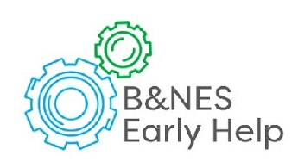

**Early Help**

**Toolkit**

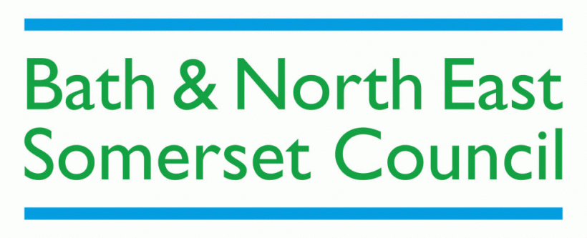

**By the right service**

**At the right time**

**The right help**

**Our vision is that all children, young people and families have access to well-coordinated, good quality and timely Early Help when it is required, so needs can be identified and addressed to promote fulfilling family lives**

**E: Early_Help@bathnes.gov.uk**

**http://www.bathnes.gov.uk/services/children-young-people-and-families/early-help-support-families**



This information leaflet sets out the arrangements for Early Help in Bath & North East Somerset for children, young people and families. We do this by working together, sharing information and putting the child and family at the centre of everything we do.

**In Bath and North East Somerset we agree that Early Help means…**

…providing effective support to children, young people and families as soon as needs start to be identified, and to bring about change to prevent these from escalating and leading to poor outcomes. Early Help may occur at any point when needs arise, from pregnancy through to the teenage years and at any stage in adulthood

Early Help is the term used to describe the approach to providing support to potentially vulnerable children, young people and their families as soon as problems start to emerge.

Although research shows that the most impact can be made during a child’s early years, early help is not just for very young children, as problems can emerge at any point throughout childhood and adolescence.

The purpose of early help is, through prompt and targeted interventions, to address needs and risks early and by doing so, prevent issues and problems increasing and requiring a statutory intervention.

**Bath and North East Somerset - levels of need and service intervention**

Working Together 2015 makes it clear that Early Help is based on agencies in Bath and North East Somerset working together to:

* **Identify** children, young people and families who would benefit from early help;
* Undertake an **assessment** of the need for early help;
* Provide **targeted** early help services and interventions to address the assessed needs of a child, young person and their families and improving their **outcomes**.

Whilst most children’s needs are met by their family or **universal** services, (services that are available to everyone, for instance from schools, health visitors or school nurses), there will be some children and young people who have additional needs. These can often be met through an increase in the level of support by these universal services.

For those children and families who face more challenges and/or have complex needs above what universal services can meet, a referral can be made to **targeted** early help services (either delivered or commissioned by the council). These can provide additional capacity and expertise to meet needs and reduce risks.

Where a child or young person has multiple needs, a co-ordinated multi agency approach is usually best. This is where a number of agencies come together as a team around the child and family to meet their needs. Where this is the case, an **Early Help** **Assessment** (EHA) should be undertaken and co-ordinated by a practitioner in a lead professional role who will work closely alongside the family to ensure they receive all the support they require.

Where a child or young person is at **risk of significant harm** rather than early help, a request for a service should be made to Children’s Social Care Duty team.

**Thresholds**

The Local Safeguarding Children’s Board has produced a guide to assessment and thresholds. This provides useful guidance to assist practitioners to identify the **most appropriate level of intervention and support** and should be consulted when deciding the best way to support a child or young person to ensure they are safeguarded and their needs met. It is always beneficial to discuss the level of need and type of support required with the child, young person and their family, colleagues or your manager.

If you are unsure of the arrangements to make you can always ring the duty social care team to seek guidance to help assess whether it should be a ‘request for a service’ from Social Care or not. The LSCB Thresholds document can be found [here.](https://www.safeguarding-bathnes.org.uk/sites/default/files/threshold_for_assessment_.pdf)

The thresholds should be seen in the context of the diagram below, which shows where Early Help and targeted support sits in between universal services and statutory Social Care as part of the wider care and support system.

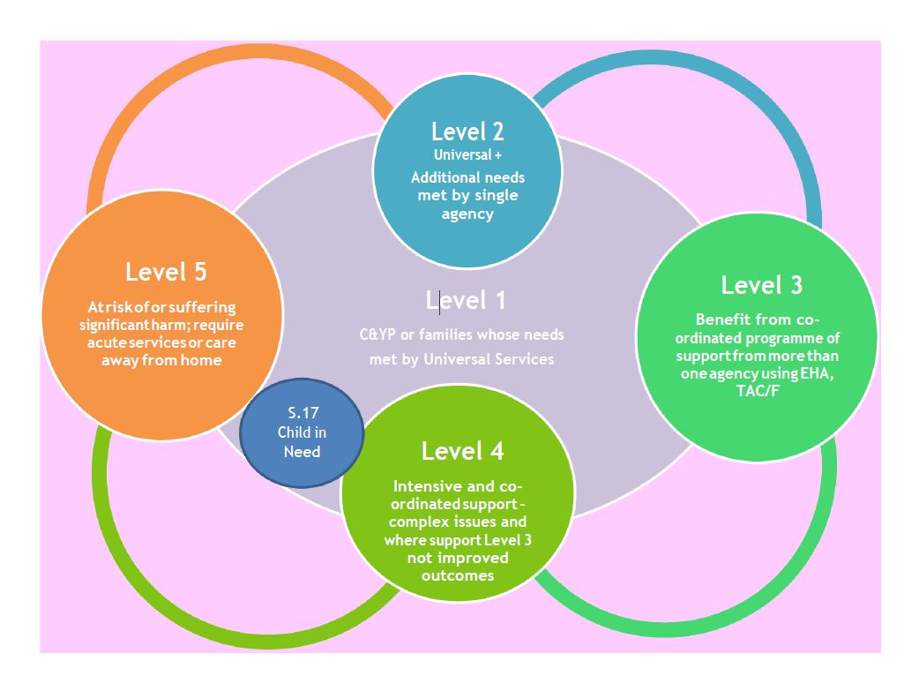

Local agencies in Bath and North East Somerset should have in place ways to **identify** emerging problems and unmet need for individual children and families. This means that all practitioners, including those in universal services and those providing services to adults with children, understand their role in identifying emerging risks and protective factors including those listed below though this is not an exclusive list. Please refer to the LSCB Thresholds document for further information.

Child in Need

**Family Risk Factors**

* Lack of parenting capacity
* Parental conflict
* Family violence
* Low income
* Poor housing
* Homelessness
* Substance misuse
* Sustained non-engagement with any services

**Additional Young People’s Risk Factors**

* Low self-esteem, poor emotional resilience
* Low school attendance
* Child Sexual Exploitation

**Protective Factors**

* Strong attachment
* Clear boundaries
* Positive engagement in community and family
* Good attendance and engagement in school
* Positive role models
* Clear, high aspirations
* Ability to find solutions
* Recognition and praise
* Stability
* Resilience

If, after consulting the LSCB Thresholds document and consulting colleagues or your manager you are still unsure whether the child or young person would benefit from early help or the risk of harm is so significant it requires a request for a service from children’s social care, you can contact Children’s Social Care Duty team for further guidance.

Children, young people and their families may also benefit from early help services following a period of statutory intervention to help prevent problems re-emerging. This is often referred to as ‘step down’. Where a child or family is being ‘stepped –down’ either into an early help targeted service or universal service, a multi-agency team around the child or family meeting ( TAC or TAF) will be arranged by Children’s Social Care with the family and agency taking the lead professional role. Details of the needs still to be met and any outstanding actions from the social work plan will be shared at this meeting along with any other information e.g. previous completed assessments and outcomes achieved.

In summary there are three simple processes in Bath and North Somerset:

**1. Early Help Targeted Support** (where there is clear evidence of a single overarching need)

If you have checked the thresholds and know the child, young person or family need early help and the unmet needs are clear, and you can identify a service to meet them, **refer directly** to that service. Consider a common assessment if more information becomes available that identifies more complex needs. You will need to discuss and agree this with the child, young person or family.

The Council provides and commissions a range of services to deliver Early Help targeted support and interventions for children, young people and their families and referrals can be made directly to them. Details of these services can be found on the Early Help App which can be downloaded for free from the Apple or Android store by searching for ‘**B&NES Early Help’**. For those unable to access the App, the same information is available at: [www.bathnes.gov.uk/earlyhelpapp](http://www.bathnes.gov.uk/earlyhelpapp)

**2. Early Help Assessment (formerly CAF)** (where there are complex or multiple issues that may need others’ involvement)

If you know early help is needed but the needs are unclear, multiple or complex requiring the input of several agencies, begin an Early Help Assessment **(EHA)** ***with*** the child, young person and family. This is a voluntary process and signed consent is needed. You can download an Early Help Assessment form [here](https://www.bathnes.gov.uk/services/children-young-people-and-families/early-help-support-families) If you need any help or guidance with the assessment you can contact the Integrated Services Team on 01225 395021.

**Practitioner support and advice with Early Help and Integrated Working**

Practical advice and support for practitioners identifying needs and undertaking an Early Help Assessment (EHA) is available through the Integrated Working Team who can be contacted at [IWT@bathnes.gov.uk](mailto:CAF@bathnes.gov.uk) or 01225 395021. Further guidance on the lead professional role, completing an EHA and managing team around the child or family meetings can be found [here](https://www.bathnes.gov.uk/services/children-young-people-and-families/early-help-support-families)

Training on Early Help is provided regularly on the lead professional role, completing a common assessment and having difficult conversations. Details of training available can be found through the Children’s Workforce Training [webpage.](http://www.bathnes.gov.uk/services/children-young-people-and-families/childrens-workforce-training)

**3. Request for Service from Social Care** (where a child or young person is at risk of significant harm)

If you believe a child is at risk of significant harm, rather than in need of early help, use local child protection procedures. For further guidance, see [www.online-procedures.co.uk/swcpp](http://www.online-procedures.co.uk/swcpp). The Council’s Social Care Duty team, on 01225 396312 or 01225 396313 can discuss concerns and provide guidance on the most appropriate course of action. Again it is always best to discuss and inform the family in the first instance as parental consent is needed before further enquiries can be made by Social Care, unless obtaining this poses an immediate risk to the child or young person.

All practitioners making a ‘request for service’ are asked to consider whether the request meets the threshold for social work intervention, or whether early help interventions can address the need and reduce the risk to the child or young person.

**What happens when a request for service is made?**

All requests for a service from social care go through a screening process in the duty team to determine whether thresholds for statutory intervention are met.

If the request meets the threshold for social care involvement the Duty team will process the form and will be in touch to inform you of the outcome.

If the thresholds are not met and early help is more appropriate you will receive feedback about why thresholds have not been met. Options for providing support will be discussed with you and you may be directed or sign posted to a more appropriate early help service.

You may be asked to complete an EHA and where this is the case support will be offered on an individual basis to complete the assessment.

Where a child or young person’s circumstances do not meet thresholds but would benefit from early help but it is not clear which early help services are best to help these will be considered at the **Early Help Allocation Panel**.

**The Early Help Allocation Panel (EHAP)**

This is a multi-agency and professional panel. It meets fortnightly and will ensure that the child, young person and family receive timely support from the most appropriate service in the right sequence.

The panel is administered by the Local Authority Connecting Families team. The EHAP will have the resources to track individuals and families to ensure children, young people and families are offered and receive the most appropriate service and compile information about outcomes.

All requests for services that are processed through the panel will be done on the basis of informed consent from the parent/carer or young person.

If as part of processing a request for service during the EHAP discussion a safeguarding concern is apparent, the Chair of the EHAP will ensure it is passed to the Social Care Duty Manager or Service Manager for a discussion and agreement about the best course of action.

**What happens if a request for a service does not meet statutory thresholds - Multi-agency Safeguarding Hub (MASH)**

These processes fall outside the remit of the Multi-agency Safeguarding Hub (MASH), which will continue to make decisions regarding thresholds of need within the Social Care arena where further information is required to determine if thresholds are met for a service from Social Care or whether the needs of the family should be met via an EHA.

**Best Practice in Early Help**

Children, young people and families have told us that early help is more effective where**:**

* Children and young people are **actively involved** in their assessment and plan, along with parents and carers to meet their needs and their voice is strong throughout the process.
* Families are best **supported by those who already work with them** organising additional support with local partners as needed.
* Agencies **work in partnership** and jointly with families to find solutions to their problems using a **strength-based approach**.
* The best interventions are those which are **tailored and proportionate to the need.**
* A **“Think Family”** approach is taken (the Council is developing a Think Family approach which means increasing co-ordination between Adults and Children’s services to enable them to focus on the strengths and difficulties of the whole family rather than just those of the parent or child in isolation).

**Our Principles**

* Adopting a whole family approach and providing joined up support to families with the service supporting children and young people to build their resilience. Also supporting parents in terms of their ability to support and care for their children and supporting them to take up support as vulnerable adults where appropriate.
* Adopting a strengths-based approach which builds capacity within families and their communities and uses this as a basis for change, support from friends, neighbours, wider family members, volunteers and local groups often make the difference in enabling families to improve outcomes.
* Support is timely to prevent problems getting worse and tackle inequalities. By placing the child, young person and their family at the heart of the services, they will receive the right support at the right time to meet their needs.
* The approach is enabling and builds capacity and resilience within the child or young person so they develop the skills to find their own solutions.
* To work in partnership with children, young people, and families to establish positive relationships to enable and support them to bring about positive change within their family unit.
* A restorative approach which both supports and challenges, fosters a sense of social responsibility and shared accountability between the service users and the service.
* An approach which promotes the role of attachment in healthy family life and parenting.
* Evidence-based and informed approaches – continually learning and sharing best practice about what works for children, young people and families, this should be a combination of both national and local learning.
* Purposeful – intervention and support is clearly focused on achieving Early Help outcomes which prevent further need arising or escalating.
* Integrated and collaborative – joining up where it makes sense to do so, simplifying and reducing the number of assessments and processes

**Effective Early Help relies upon agencies working together to:**

* Ensure a lead professional is allocated and named to co-ordinate the work/key agencies and the plan around the family’s needs
* Undertake a comprehensive assessment of needs which considers the whole family but is a holistic appraisal of a child’s needs (or use existing assessments if complied within the last 6 to 8 months, unless the family dynamics have greatly changed).
* Provide targeted support to address the assessed needs of the child, young person and their family which focuses on activity to significantly improve the outcomes for them.
* Identify children, young people and families who would benefit from Early Help.
* Regular Team Around the Child (TAC) or Team Around the Family (TAF) meeting to ensure good progress against the plan, with a multi-agency response to ensure the right service is involved at the right time and the family are fully aware of the plan and their involvement.
* Children, young people and families have told us that Early Help works best when they feel listened to, when there is time to build up a trusting and positive relationship, and that the purpose of the support is clear from the start.

**The following practice elements are essential to effective delivery of Early Help:**

* An open, honest and transparent approach to supporting children, young people and their families.
* In the majority of cases it should be the decision of the parents when to ask for help or advice. However, there are occasions when practitioners may need to engage parents actively to help them to prevent problems from becoming more serious. All practitioners need to work honestly and openly with families, discuss any concerns with them and ensure that they are involved in decision making. It is important that they acknowledge and respect the contribution of parents and other family members.
* Earlier, solution focused and evidence based interventions.
* It is important that any problems are identified early so that the child or young person and their family receive appropriate support in a timely way to prevent the problem from escalating. We will work with families as soon as any difficulties become apparent to help them to identify the things they want to change and the support they need.
* The most effective support is tailored to the family’s needs and provided at the minimum level necessary to ensure the desired outcomes are achieved, with as little interference and disruption to family life as possible.
* The multi-agency approach ensures that children and families are understood and responded to according to need so that they receive the right support and practical help in a co-ordinated way when they need it.
* Partners and professionals who work with children and their families should consult one another, share information and work together to ensure that the child and their family get the most appropriate and effective support.
* Early Help practitioners are able to access information from Council information systems to ensure that allocation of services to families is based on a holistic and multi-disciplinary understanding of the needs.

It is good practice to ensure that where services regularly undertake early help assessments, develop plans with children, young people and their families and provide targeted support, that the following **minimum requirements are met:**

1. There is a manager in the service who has **oversight** of early help assessments and plans and ensures these are signed off.
2. That **risks and concerns about families are discussed** in 1-1s or supervisions or at other meetings in your organisation/ service.
3. That practitioners providing early help r**eceive feedback on the quality of early help assessments** and plans to support them to improve the quality of these.
4. Arrangements are in place for **improving practice**.
5. Practitioners that undertake early help assessments in your organisation attend **assessment and planning training** at least every 3 years.
6. Services have a process for ensuring that EHAs, reviews and outcomes achieved are returned to the **Integrated Working Team**.