Are you safe around water?

Contents
- Why water safety?
- Water Safety Code
- Reservoirs
- Rivers and other open water locations
- Paddleboarding and other water sports
- Tombstoning
- Escaping to a villa?
- At the seaside
- Safety on canals
- Safer outdoor swimming options
- Keeping well (avoiding waterborne diseases)
- What to do if you become unwell
- In and around the home
- Further information

Why water safety?
We want you to enjoy the water, but it is important to be safe. In 2020, 254 people lost their lives in accidental drownings in the UK, with hundreds more near-drowning experiences, sometimes with long-term injuries. 42 of these 2020 fatalities took place in South West England. Children are particularly at risk.
It may surprise you that nearly twice as many deaths happen whilst people are out walking, running or cycling compared to those who died whilst swimming which shows the importance of everyone being aware of the risks posed by water.
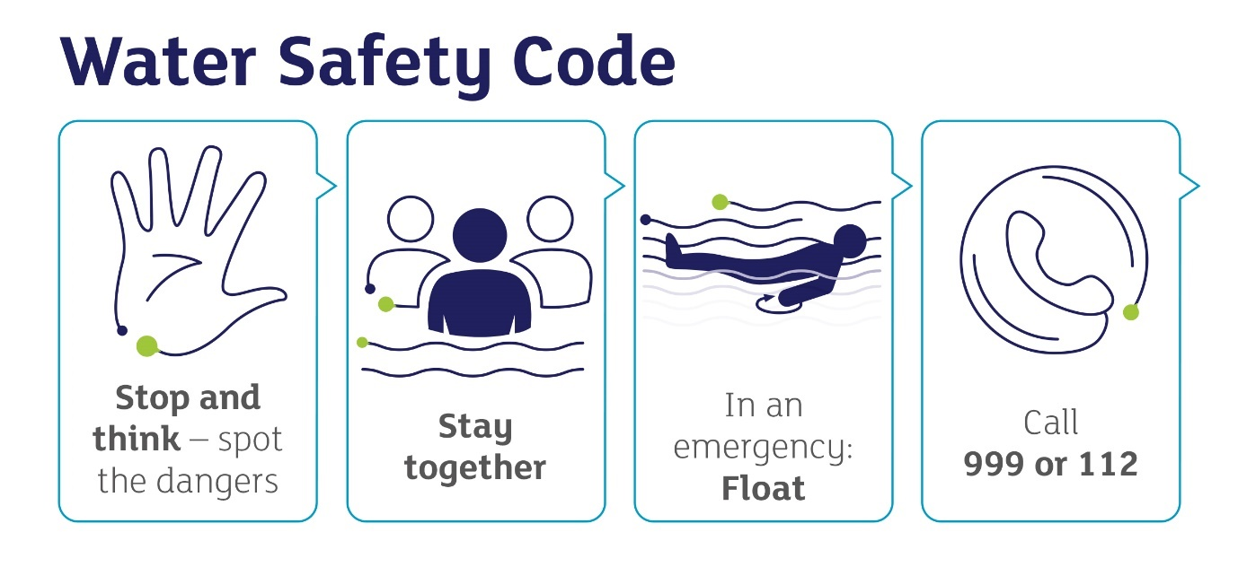
Image from: www.rlss.org.uk/the-water-safety-code
- It is always better to go to the water with a friend or family member
- Children should always be supervised by an adult
- If you get into trouble in the water, float to live. Lean back and use your arms and legs to help you float, then get control of your breathing before calling for help or swimming to safety.
- If you see someone else in trouble in the water, call 999 (UK) or 112 (UK or European Union). If you are at the coast ask for the coastguard, if you are inland, ask for the fire service.

Reservoirs
- Reservoirs are operational sites. Even strong swimmers can get into serious difficulties.
- Reservoirs are incredibly deep in places, but shallow in others – particularly as water levels drop over the summer – making jumping in or swimming extremely dangerous.
- Even on hot days water may be colder than you expect, particularly reservoirs and docks as they're deeper. This can cause shock or hypothermia. Low temperatures can cause your blood to rush away from your muscles to protect your organs and limbs; muscles may become fatigued suddenly, which can cause drowning.
- The water can hide dangers such as machinery, sudden dips and drops, weeds and mud.
- Strong currents are created by the changing depths and continuous pumping of water.

Rivers and other open water locations that are not designated as bathing waters
- Did you know that these waters are not monitored for intestinal enterococci and E. coli? They can contain levels of sewage, faeces from livestock and pollution from farming or industry which are harmless to wildlife but would not be acceptable in designated bathing waters.
In addition to the risks of strong currents, deep, cold water and hidden objects under the surface (e.g. e.g. shopping trolleys, broken glass), it can also be difficult to get out, due to steep, slippery banks.
It is easy to over-estimate how strong a swimmer you or your children are and to under-estimate risks in the sea or open water. You may swim well in a warm indoor pool, but that does not mean that you will be able to swim in cold water.

Enjoy Paddleboarding, rowing or other water sports?
We really want you to have fun, but remember to:
- get the appropriate level of training
- go with a friend
- bring your phone (in a waterproof pouch)
- check the weather forecast and tide times first
- avoid offshore winds
- wear a buoyancy aid or a life jacket
- use an appropriate paddleboard leash.
- More safety advice on paddleboarding is available on The Royal National Lifeboat Institution website.

Think ‘tombstoning’ is rather cool?
Although B&NES has some bridges over water that might seem tempting to jump off, it’s a very dangerous activity that leads to fatalities and life-changing injuries. We would advise you to avoid it. It is particularly dangerous because:
- submerged objects and rocks may not be visible
- the shock of cold water may make it difficult to swim
- currents may be stronger than they look
- the water depth alters with tides and may be shallower than it seems.

Escaping for a villa holiday with your children?
Key points to consider…
Before going:
- check the water safety arrangements in advance
- teach children to never swim alone, not to dive into unknown depths of water, to only jump feet first, not to push or jump into others, and what to do in an emergency
- check if your villa has safety barriers that will stop young children from getting into the pool without your help
- take a first aid course – know how to resuscitate a child
- find out if the hotel pool has a lifeguard. Remember that if they have, their roles are often combined with other duties
- ensure that you and your family can swim, be water confident, and have water safety skills.
When there:
- actively supervise all young children near water. Drowning children don't tend to wave or cry out for help
- even if a pool has a lifeguard, know where your children are, and what they are doing in the water
- significant numbers of holiday pool drownings are reported to happen on the first or the last day of the holiday, possibly because parents/carers are distracted by tasks on arrival and with packing to go home
- choose pools that are fenced with locking gates
- remember that inflatables are not a substitute for supervision or swimming ability
- avoid drinking alcohol before going in the water.

For more information about keeping your family safe on holiday, view the Royal Society for the Prevention of Accidents’ website.

We do like to be beside the seaside…
However, please remember to be water aware!
- Teach children to swim between the two-coloured red and yellow flags – these mark the areas patrolled by lifeguards.
- Learn more about beech flags and water safety signage:
Beech flags: https://www.rospa.com/leisure-water-safety/water/advice/water-safety-code/beach-flags
Water safety signage: https://www.rospa.com/leisure-water-safety/water/advice/signs.
- Inflatables can be swept out to sea; keep children off inflatables when the orange windsock is flying.
- Always supervise children.
- Check water pollution forecasts: https://environment.data.gov.uk/bwq/profiles/.
- Read the safety information displayed at each beach about currents, tide information, local help information, etc.
- Download the free Tide Times app from Googleplay or App Store.

Walking or cycling along the canal? Going on a canal boat holiday? Or do you live on a boat?
We want you to enjoy our lovely stretch of canal in B&NES. However, please remember that:
- if you fall into a canal, reeds and other plant life could get tangled around your arms and legs making it very difficult to climb out
- rubbish can lurk below the surface of canals and rivers, which can cause injury. For example, by cutting yourself on a rusty bicycle or broken glass, or getting trapped by a trolley or motorbike
- locks are not a playground and are dangerous for children to play around
- canal water is untreated and so may contain contaminants. Please bear this in mind when you come into contact with the water and follow basic hygiene measures.
Further information on water safety at canals: https://canalrivertrust.org.uk/enjoy-the-waterways/safety-on-our-waterways/summer-water-safety

Safer Outdoor Swimming Options
Why not try out a local lido? For example:
- Shepton Mallet Lido: http://www.fusion-lifestyle.com/centres/shepton-mallet-lido/
- Portishead open-air pool: https://www.portisheadopenairpool.org.uk/
- Wooton Pool: https://wottonpool.co.uk/
- Greenbank Pool (Street): https://greenbankpool.co.uk/
- Sandford Parks Lido: https://www.sandfordparkslido.org.uk/

Keeping Well
Open water swimming poses a risk of severe infection caused by organisms such as E. coli O157 which may cause severe gastrointestinal illness and leptospirosis (Weil’s Disease), which can cause liver and kidney problems.
Various types of algae occur in freshwaters. Evidence suggests the one that poses the greatest risk to health is cyanobacteria (blue-green algae). Contact with cyanobacteria can lead skin rashes, eye irritation, vomiting, diarrhoea, fever, muscle and joint pain.
Blue-green algal blooms and scum are not always toxic. However, it is not possible to tell from their appearance whether they are harmful. All blue-green algae should be treated with caution.
If you are likely to come into contact with open water it’s sensible to:
- cover cuts and scratches with a waterproof plaster
- wash wet clothing before you wear it again
- choose where and when to swim. Up to date water quality information is available online between May and September: water quality information
- avoid bathing on higher risk days, by checking the pollution risk forecast, or look for signs at the beach
- avoid swimming in water with blue-green algal blooms or scums in freshwaters
- wear appropriate protective footwear and clothing such as a wetsuit, gloves
- avoid stream water running across the beach
- avoid swallowing or splashing water into your mouth
- observe local safety advice
- wash your hands thoroughly with soap and water before eating or handling food
- take a shower and treat cuts with antiseptic and a sterile dressing, if you fall in
- avoid playing in water fountains as the water in these can contain Legionella.

What to do if you become unwell
If you experience flu-like symptoms, diarrhoea or any other symptoms, seek medical help as soon as possible by calling 111 or speaking to your GP; let them know you have been open water swimming. Do not swim again until you have had no diarrhoeal symptoms for at least 48 hours, or for longer if advised by a doctor.

Keeping Water-Safe in and Around the Home
- Keep hot tubs covered to avoid accidental drowning – remember that children can drown in just an inch of water. Clean them in line with the manufacturer’s instructions. Legionella can develop in these tubs.
- Empty paddling pools after every use.
- Keep hot tubs covered to avoid accidental drowning – remember that children can drown in just an inch of water. Clean them in line with the manufacturer’s instructions. Legionella can develop in these tubs.
- Empty paddling pools after every use.
- Make sure your child can’t get to the neighbour’s pond
- Be alert to ponds or pools when visiting other people’s homes
Further information
Reducing the risk of becoming ill after swimming in lakes, rivers and estuaries: www.gov.uk/government/publications/swim-healthy-leaflet
Canal and River Trust Water Safety Resources and Activities for Children: https://canalrivertrust.org.uk/explorers/learning-bundles/water-safety
Top Tips for parents (from Child Accident Prevention Trust) https://www.capt.org.uk/Handlers/Download.ashx?IDMF=43e9ed51-29bd-4aad-bfe1-5310ba183ea1
Cold Water Shock – the facts from the Royal Life Saving Society: https://www.rlss.org.uk/cold-water-shock-the-facts

Last updated: 20 May 2022.

