

### DEFINITIVE MAP MODIFICATION ORDER

Bath & North East Somerset

* ***the*** place to live, work and visit

### INVESTIGATION REPORT

### BATHAMPTON FERRY CROSSING, BATH

Date: 11/05/2022

### **Investigation Report**

**Author:** Graeme Stark

**Date:** 11/05/2022

An application has been made under section 53(5) of the Wildlife and Countryside Act 1981 for an order to be made to amend the Definitive Map and Statement of Public Rights of Way by adding a footpath.

This report tables the evidence of which Bath and North East Somerset Council (“the Authority”) is aware following a preliminary investigation of records held by the Authority and the Somerset Heritage Centre and submitted by the applicant. When the decision is taken as to whether an Order should be made, and if so the status of the route (i.e. footpath, bridleway, restricted byway or byway open to all traffic), it will be based on the Authority’s interpretation of this evidence and any other relevant evidence produced to the Authority before the date of the decision. This Investigation Report is a factual account of the application and its processing up to this point, and the evidence provided and/or discovered which is relevant to the existence and status of the route.

The final decision will be based upon the evidence contained within this report together with any further comments, documents and other evidence supplied by landowners, consultees and other interested parties.

The plan attached at page 4 shows the location of the route under investigation near the Bathampton Toll Bridge in the Lambridge ward of Bath. It should be noted that the Application Route now lies within the city of Bath as a result of changes to ward and parish boundaries. However, this area is still covered by the Definitive Map and Statement for Bathavon Rural District and Keynsham Urban District and, consequently, this is the Definitive Map and Statement which the application seeks to modify.

An order will be made if the evidence shows that:

* A right of way “subsists” or is “reasonably alleged to subsist”
* “The expiration… of any period such that the enjoyment by the public…raises a presumption that the way has been dedicated as a public path”
* The status of a recorded right of way needs to be changed
* There is no right of way over land as recorded on the Definitive Map and Statement
* Details of the Definitive Map and Statement need to be changed.

When considering evidence, if it is shown that a highway exists, then highway rights continue to exist (“once a highway, always a highway”) even if a route has since become disused; this is until a legal order stopping up or diverting the rights has been made.

Section 53 of the Wildlife and Countryside Act 1981 does not allow considerations such as suitability, the security of properties and the wishes of adjacent landowners to be taken into consideration why deciding whether an Order should be made.

**2. Relevant Legislation Considered**

The following legislation was considered when this case was investigated; National Parks and Countryside Act 1949, Countryside Act 1968, Highways Act 1980, Wildlife and Countryside Act 1981, Countryside and Rights of Way Act 2000, Natural Environment and Rural Communities Act 2006.

**3. Application Details**

An application was made by Peter John Wardle on 5th May 2021, pursuant to section 53(5) of the Wildlife and Countryside Act 1981 to add a route to the Definitive Map and Statement.

**4. The Route**

##### The claimed route commences from a junction with public footpath BA2/3 at grid reference ST 7737 6698 (Point A on the Investigation Plan attached at page 4) (see Fig.1 below) and continues in a generally southerly direction for approximately 48 metres to the northern bank of the River Avon at ST 7738 6692 (Point B on the Investigation Plan) (see Fig. 2 below). This route is hereafter referred to as “the Application Route”.

##### There is currently a locked gate topped with barbed wire at point A on the Investigation Plan with a sign attached which reads: ‘Private No public right of way’. There is a second sign mid-way along the Application Route which appears to relate to the adjacent field reading: ‘Private Property Keep Out’. There is a third sign visible from the river and attached to a tree at point B on the Investigation Plan which reads ‘PRIVATE Keep out’.

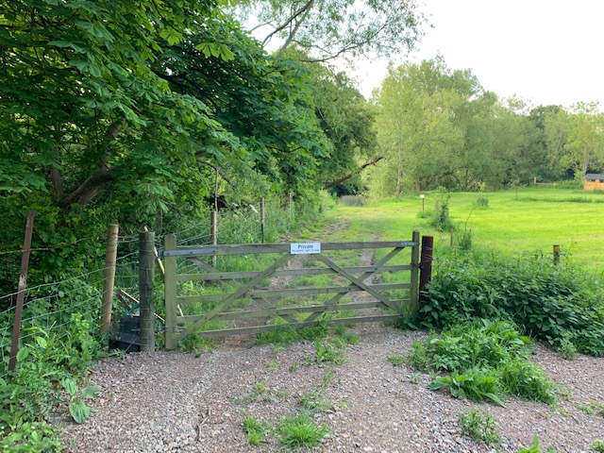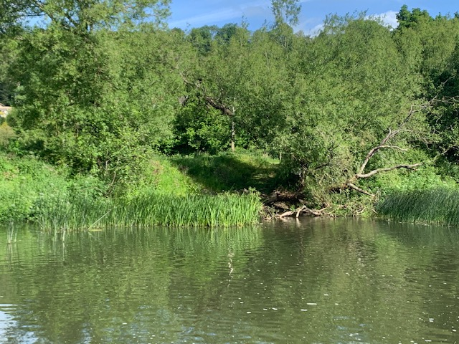

Fig.1: From Point A looking south along the Application Route.

Fig.2: From Bathampton looking north across river to Point B.

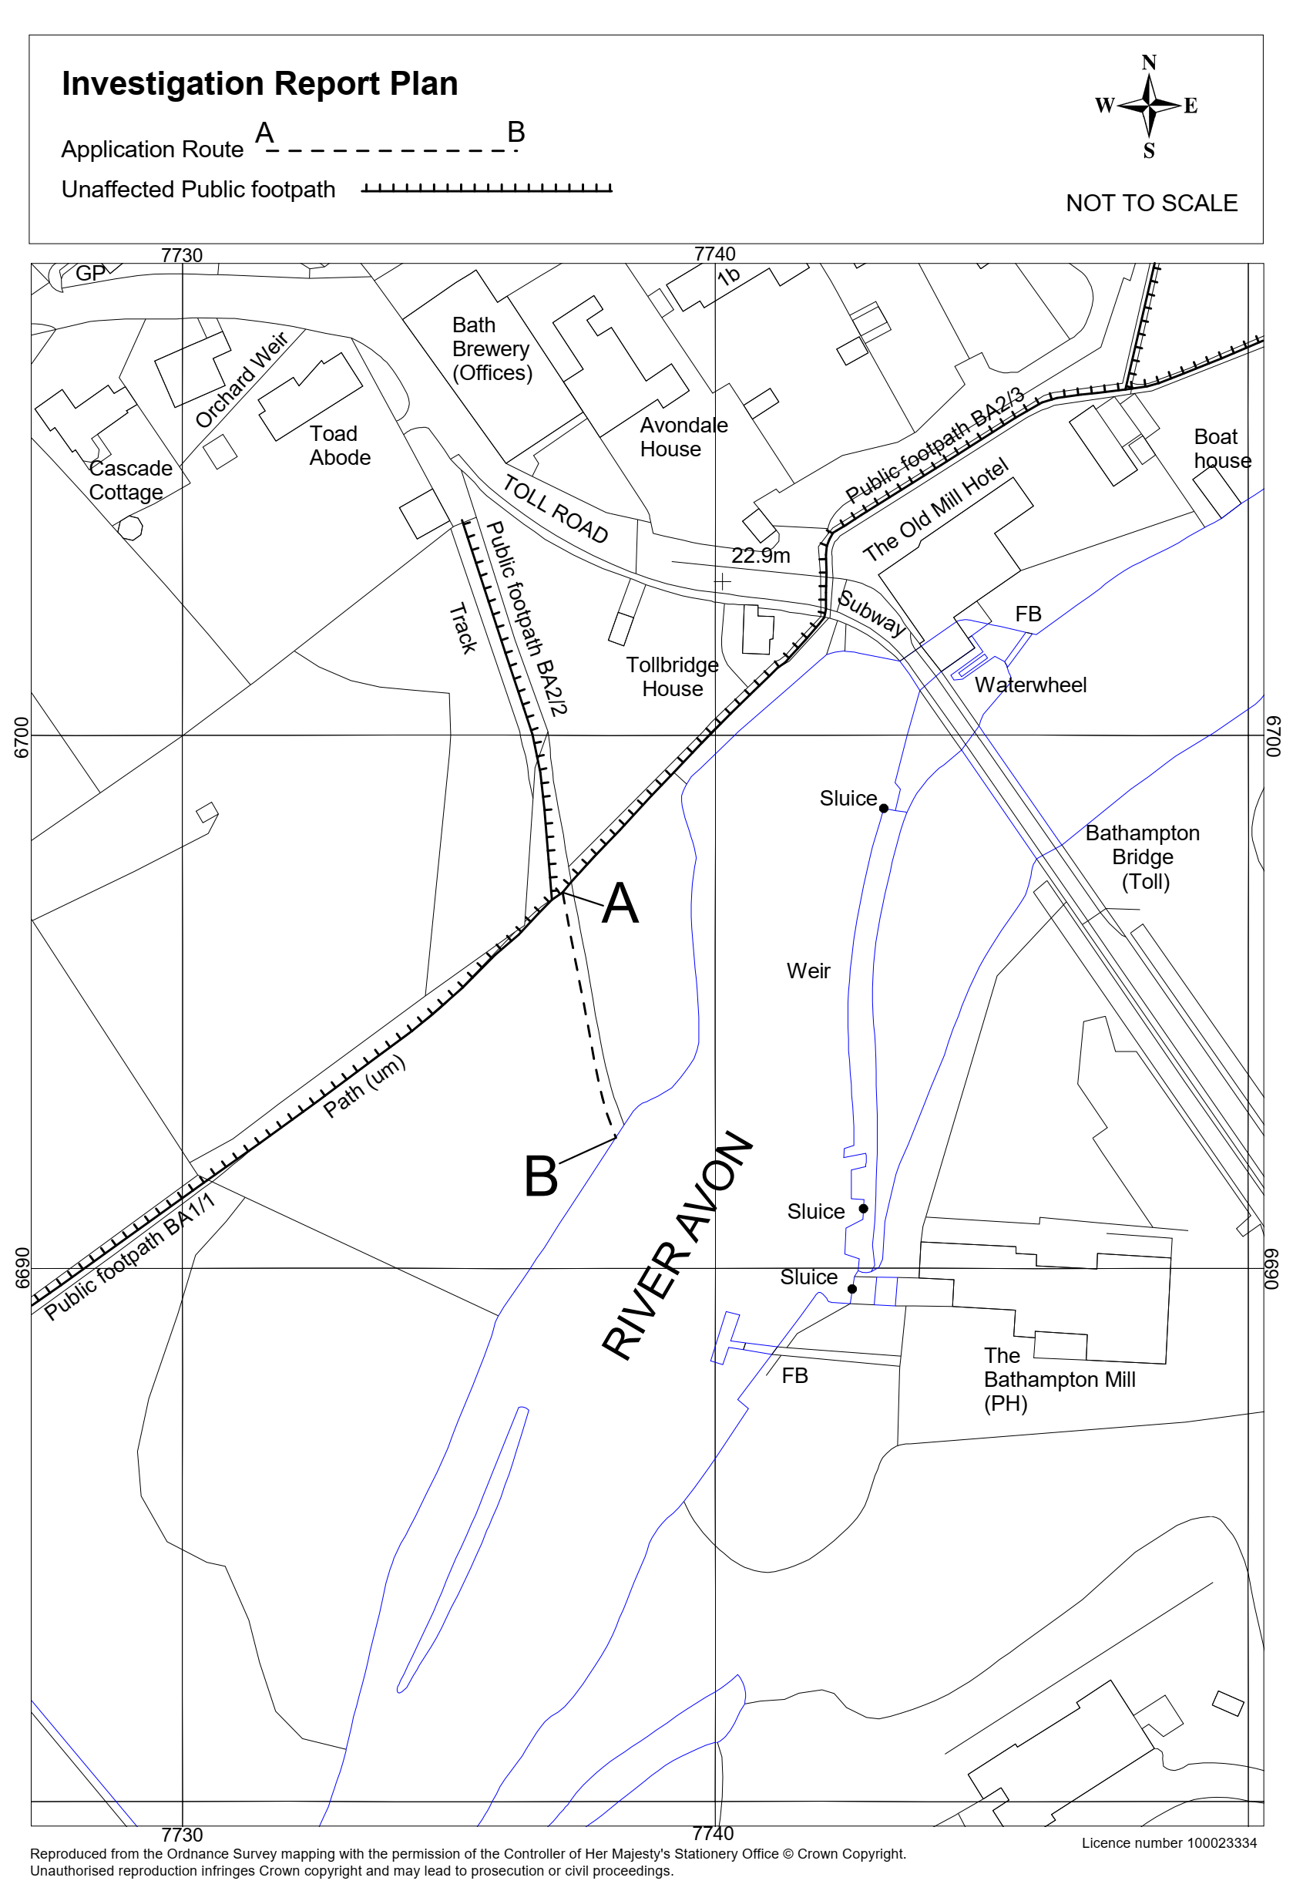

###### 5. Documentary Evidence

|  |  |  |  |  |
| --- | --- | --- | --- | --- |
| **Doc No.** | **Document title** | Date | **Brief description of document & nature of evidence** | **Document reference**  **(& location)** |
| 1. | Day and Masters’ Map | 1782 | **County Map made from an original survey to be sold to the travelling public, which could be indicative of routes shown probably being public. Footnote states that the map was published according to an Act of Parliament.**  The Application Route appears to be shown schematically with solid parallel lines as part of a longer route continuing north to London Road West at a junction opposite a building annotated as ‘*The Villa’*. The Application Route runs through an area with heavy shading, possibly indicating woodland, and this partially obscures any demarcation of the Application Route. | D\B\wsm/38/6 (SHC) |
|  | Investigating Officer’s comments |  | This suggests that the Application Route was a public highway. |  |
| 2. | Avon Land Mead Conveyance | 1807 | **Indenture of Release dated 4th December 1807 relating to Avon Land Mead**  The document conveys land identified as ‘*Avon Land Mead*’ from George Edward Allen to Thomas Walters. The document reserves a right for the vendor and various parties associated with the vendor to pass over the land “*from the Ferry…into a…Lane…leading into the London Turnpike Road (London Road West)”* in “*carts, waggons, carriages and Horses*”. An associated letter indicates that Mr Allen retained ownership of the ferry crossing. | D/P/baton 23/15  (SHC) |
|  | Investigating Officer’s comments |  | If the Application Route carried higher public rights than that of a footpath there would have been no need for the vendor to reserve a private right of way to use the Application Route with carts, waggons, carriages and horses. If the Application Route wasn’t a public footpath then Mr Allen would have needed to retain a right on foot for his customer and associates to continue to access his ferry. This suggests that the Application Route was already a public footpath. |  |
| 3. | Drawing of Bathampton Ferryhouse | 1820 | **Photocopy of drawings, marked up with British Library references, depicting the ferryhouse on the Bathampton side of the River Avon.**  The Application Route is outside the area shown in the drawing. | DD\SAS/G1818/4/2/3  (SHC) |
|  | Investigating Officer’s comments |  | This does not provide any evidence regarding the Application Route. |  |
| 4. | Greenwood’s map | 1822 | **County Map made from an original survey carried out in 1820 and 1821 to be sold to the travelling public, which could be indicative of routes shown probably being public.**  The Application Route is shown with parallel pecked lines as part of a longer route continuing on to London Road West. | A\AUS\60  (SHC) |
|  | Investigating Officer’s comments |  | This suggests that the Application Route was a public highway. |  |
| 5. | Stopping Up Proposal | 1826 | **A proposal to stop up a route between Batheaston Bridge to Bathampton Ferry**  The minutes from the September 1826 meeting of ‘*The Committee for Protecting the Rights of the Public to the Footway through Batheaston Meadow*’ (“the Committee”) states that the Surveyor of the Parish of Batheaston was attempting to apply to the Quarter Sessions for an order to “*stop up part of an ancient and commodious Footway leading from Batheaston Bridge to Bathampton Ferry and from thence into the London Road of Lambridge*”; the Application Route is shown with parallel pecked lines to the ferry crossing on an accompanying plan. The minutes show that the Committee opposed the proposals on the grounds that they would be an “*infringement of the Rights of the Public and more particularly of the Poor Inhabitants of the neighbourhood who have from time immemorial enjoyed the user of the said footway*”. On 5th October 1826, the Bath Chronicle and Weekly Gazette reported that the Committee requested that the Magistrates rescind the order and the Quarter Sessions records do not appear to contain any reference to the application actually being heard in the Magistrates Court or that the public rights were stopped. | D/P/baton/23/7  (SHC) |
|  | Investigating Officer’s comments |  | This provides strong evidence that the Application Route was a public footpath and that those rights continued to subsist. |  |
| 6. | Stopping Up Proposal | 1840 | **A proposal to stop up public highway in Batheaston in May and June 1840**  This application relates to what is now public footpath BA2/5 and BA2/4; these paths run from Batheaston Carpark along the northern edge of the River Avon to what is now the Old Mill Hotel and then turn in a northerly direction to the High Street. The plan which accompanied the application to the Quarter Sessions shows the northern tip of public footpath BA2/2 but the Application Route is outside the mapped area and the deposited documents do not contain any reference to the Application Route. | D/P/baton/23/7  (SHC) |
|  | Investigating Officer’s comments |  | This does not provide any evidence in respect of the Application Route. |  |
| 7. | Tithe Map and Tithe Award or Apportionment | 1840 | **The Tithe Map is a detailed large scale map of the parish. It was produced to locate titheable land described in the award, not rights of way and their status. However, the maps do mark roads quite accurately and can provide useful supporting evidence (in conjunction with the Tithe award) to other documents.**  **The Tithe Award is a legal document (produced under the Tithe Commutation Act of 1836) to show the value of titheable lands in a parish. Some awards contain additional information from which status of ways may be inferred**.  The Application Route is shown as a continuation of what is now public footpath BA2/2; this route is delineated on the Tithe Map with parallel pecked lines. The Application Route lies in the vicinity of enclosures 13 and 14; enclosure 14 is identified as ‘*Part of Ebland*’ (pasture) on the Tithe Apportionment but enclosure 13 does not appear to be listed in the Apportionment. It is unclear whether the Application Route runs through one or both of these enclosures or between them. The Application Route would have run between enclosures 9 and 1A in the documents produced in pursuance of the Extraordinary Tithe Redemption Act but it is again unclear whether the Application Runs through or between those enclosures. | D/D/rt/A/352  D/D/rt/M/352  (SHC) |
|  | Investigating Officer’s comments |  | This shows that the Application Route physically existed but it is ambiguous with regards to the status of the Application Route. |  |
| 8. | Etching | c.1800-1850 | **Illustration of Bathampton mill and ferry. Reproduction engraving by W. Williams.**  The etching shows a boat, presumably a ferry, at point B on the Investigation Plan. The etching is undated but other etchings from around the local area by the same artist were executed in the first half 19th century. | A/DQO/26/4  (SHC) |
|  | Investigating Officer’s comments |  | This etching supports the existence of a ferry at the time but does not provide evidence regarding the existence of legal rights over the Application Route. |  |
| 9. | Ordnance Survey Maps | 1886-1965 | **The Ordnance Survey has produced a series of topographic maps at different scales notably the One Inch, Six Inch and 1:2500. They generally do not provide evidence of status.**  The Application Route is shown with a broken black line on each of the 25-inch to the mile and one-inch to the mile Ordnance Survey Maps published between 1886 and 1924. The Application Show is not shown on any of the subsequent OS maps published at those scales. | https://maps.nls.uk/ |
|  | Investigating Officer’s comments |  | This shows that the Application Route physically existed between 1886 and 1924 but does not provide evidence regarding the rights over the Application Route. |  |
| 10. | Inland Revenue documents | 1910-1914 | Plans, valuation books, and field books created under the Finance (1909-10) Act 1910. Deductions in value provide good evidence of public rights if position can be accurately located. Annotations on field maps and colouring of routes may provide supporting evidence of status. However, if no reduction was claimed this does not necessarily mean that no rights of way exist.  The Application Route runs through hereditament 181 on the plan; the valuation book shows that tax was levied against this land and that no deductions were made for ‘*Rights of Way or User*.’ | DD/IR/B/18/6  DD/IR/m/14/2  DD/IR/m/8/14  (SHC) |
|  | Investigating Officer’s comments |  | This does not provide any evidence in respect of the Application Route. |  |
| 11. | Definitive Map records | 1949-1967 | **The National Parks and Access to the Countryside Act 1949 required the County Council to prepare a Definitive Map. Each Parish carried out a Parish Survey**. **The Parish Surveys were collated into the Draft Map, and given a “Relevant Date”. Notice was published and the** **public (including landowners) then had the opportunity to object to what was included in, or omitted from, the map. The Draft Map was amended following the recommendations for the area, and Notice of the Provisional Map was published. Landowners, lessees and tenants could apply to the Crown Court for amendment of the map, but the public could not. Definitive Map and Statement was then produced from the Provisional Map, and included any amendments made.**  The Application Route is not shown on the Parish Survey, Draft, Provisional or Definitive Map and Statement. | PROW |
|  | Investigating Officer’s comments |  | This does not provide any evidence in respect of the Application Route. |  |
| 12. | Local history book | Unknown | **Extract of local history book written by Mike Chapman submitted by the Applicant.**  The Application Route is shown with a dotted black line on a plan included in the book. The map shows both relatively recently constructed houses and the ferry crossing (which ceased operating around the time the toll bridge was constructed in 1872) and it’s therefore unclear when the information relates to. | (PROW) |
|  |  |  | This shows that the Application Route physically existed at some point in time but does not provide evidence of the existence of public rights over the Application Route. |  |

Notes: These documents are available for inspection; please note that the references are as follows:

SHC = Somerset Heritage Centre PROW = Documents held within the Public Rights of Way Team

**6. User Evidence**

The Authority has received user evidence forms from 52 individuals detailing their use of the Application Route; the Authority has attempted to carry out short telephone interviews with each user. The users’ stated periods of use are summarised on the bar chart on attached at page 11.

All users state that they have used the Application Route on foot; User 26 also states that they used the Application Route bike between 2015 and 2020.

12 users[1] stated that there was a sign erected at point A on the Investigation Plan in September, October, Autumn or late 2020 with wording which was variously described as prohibiting picnics, bathing, boating or fishing or asking people to keep the footpath. Three users[2] refer to the ‘private’ signs midway along the Application Route as having been erected in 2020; User 29 states this was erected in Autumn 2020, User 8 states this was erected in December 2020 and User 50 states that the sign was erected in ‘*Dec 2020 or earlier Jan 2021*’. 11 users[3] refer to the ‘Private Keep Out’ sign at point A on the Investigation Plan as having been erected in March 2021; 5 users[4] variously describe the sign as being erected in ‘early 2021’, ‘April 2021’, ‘recently’ or in the ‘last few months’ prior to April 2021.

16 users[5] state that the gate at point A on the Investigation Plan was erected and locked in March 2021; user 21 states that the exact date was 17th March 2021. Nine users[6] variously describe the locked gate as being erected in ‘*Late 2020/early 2021*’, ‘*February*’, ‘*April*’, ‘*recently*’, in the ‘*last few months*’ prior to April 2021 or just being present.

Prior to the erection of signs and locked gates as described above, all users state that their use was without force, secrecy or permission.

User

Year

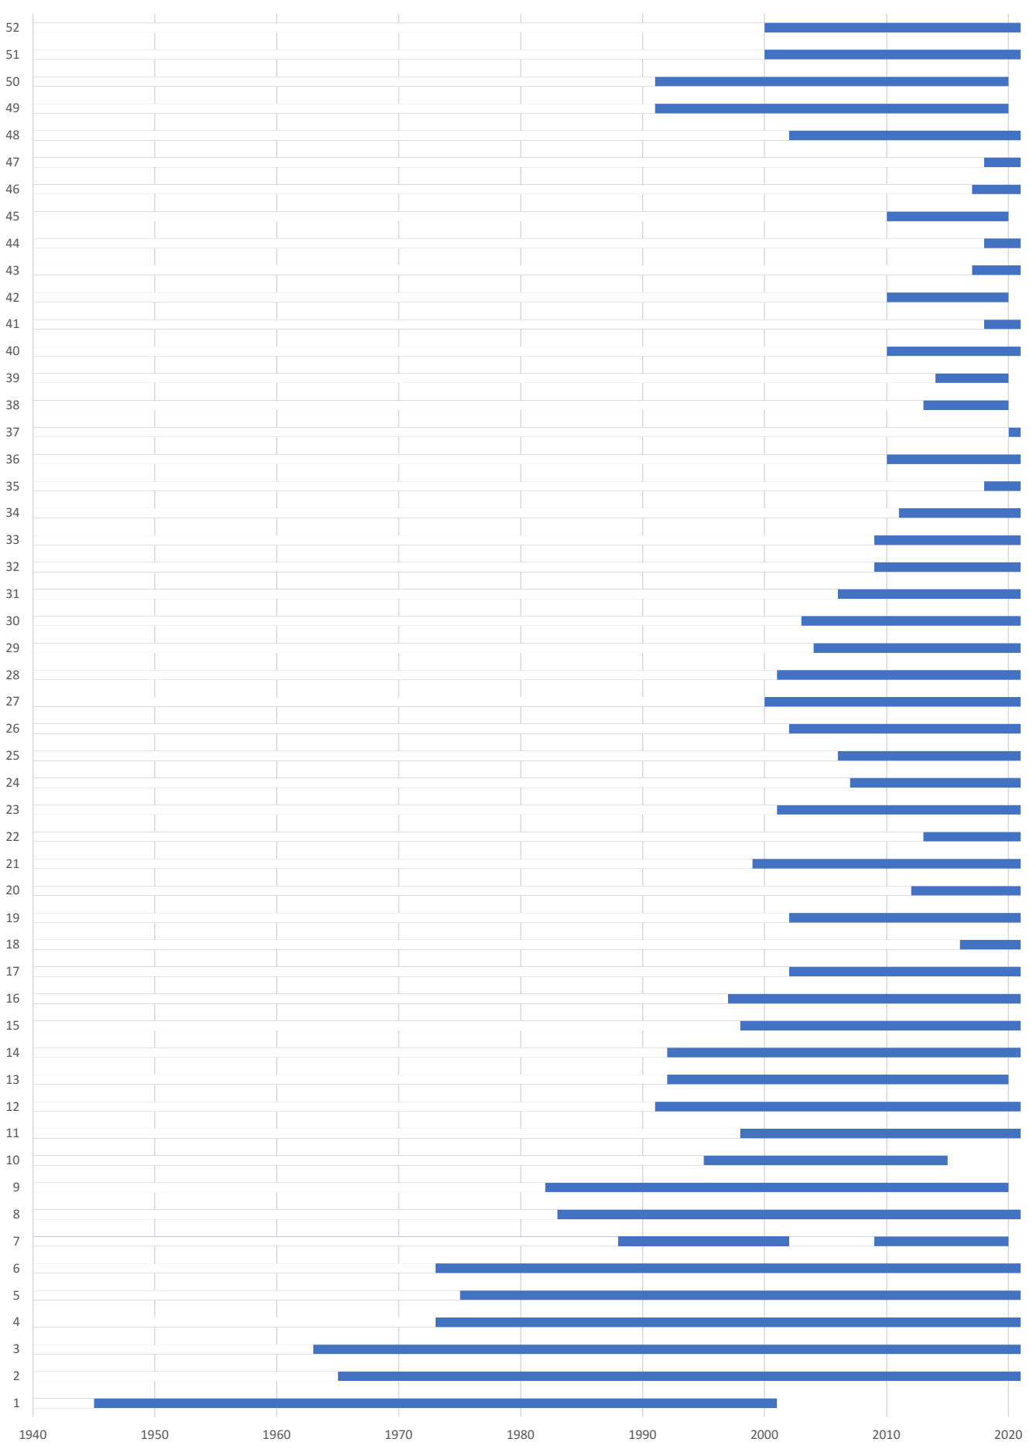

1. Users 3, 9, 11, 17, 20, 21, 27, 28, 29, 46, 47 and 48
2. # Users 8, 29 and 50

  
3. # Users 3, 4, 6, 7, 8, 9, 12, 18, 26, 29 and 45

  
4. Users 15, 16, 24, 43 and 49
5. Users 4, 6, 7, 9, 12, 13, 17, 18, 20, 26, 28, 29, 45 and 46
6. Users 2, 16, 24, 25, 27, 43, 49 and 50