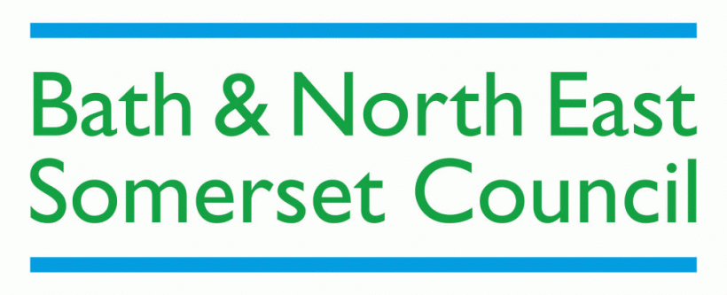
B&NES Park Activity Registration
Please refer to the following documents for further guidance:
- B&NES Parks Friends Groups Events and Activity Guidance
- B&NES Parks How to run a small scale activity in the park
Friends Group:
Park or Green Space:
Activity title:
Contact name & phone number of organiser:
Activity
Date
Event or Activity Times
Set Up and Pack Down Times
Area of the park used
Staff or Activity Leader(s)
Number of participants expected

Any additional information about participants e.g. children attending

Tools or equipment being used
Gazebo or tables or chairs being used
Safety Plan for the activity – who has charged mobile phone, who will take action etc

Risk Assessment completed | Yes / No. Please send as an attachment.
Friends Group or Council’s Public Liability insurance | If Friends Group PL insurance please send certificate as an attachment.
Any additional comments or things of note

Activity Registration seen by Parks Service:

Name:

Contact:

Date:

Any comments:

