What is risk assessment?
A risk assessment is simply a careful examination of what, at your event, could cause harm to people, so that you can weigh up whether you have taken enough precautions or should do more to prevent harm. Visitors, volunteers, workers and others have a right to be protected from harm caused by a failure to take reasonable control measures.

A hazard is anything that may cause harm, such as chemicals, electricity, working at height, trailing cables, vehicles, animals etc

The risk is the chance, high or low, that somebody could be harmed by these and other hazards, together with an indication of how serious the harm could be.

Step 1
Identify the hazards
Consider the activities you have booked for your event, what could reasonably be expected to cause harm? Ask the other members of your organising group. Consider the set up and clear down stages of your event and how your event may affect others outside of your event site.

Step 2
Decide who might be harmed and how
For each hazard you need to be clear about who might be harmed; it will help you identify the best way of managing the risk. That doesn’t mean listing everyone by name, but rather identifying groups of people (e.g. Visitors to the event, volunteers, staff, public (not visiting the event), young people, and contractors).

In each case, identify how they might be harmed, i.e. what type of injury or ill health might occur. For example, ‘volunteers may suffer back injury from repeated lifting of boxes’.

Step 3
Evaluate the risks and decide on precautions
Having spotted the hazards, you then have to decide what to do about them. The law requires you to do everything ‘reasonably practicable’ to protect people from harm. You can work this out for yourself, but the easiest way is to compare what you are doing with good practice.

Look at what you’re already doing; think about what controls you have in place and how the event is organised. Then compare this with the good practice and see if there’s more you should be doing to bring yourself up to standard. In asking yourself this, consider:
- ?

- Can I get rid of the hazard altogether?
- If not, how can I control the risks so that harm is unlikely?

When controlling risks, apply the principles below, if possible in the following order:
- try a less risky option (e.g. switch to using a less hazardous chemical);
- prevent access to the hazard (e.g. by guarding);
- organise work to reduce exposure to the hazard (eg put barriers between pedestrians and traffic);
- issue personal protective equipment (e.g. clothing, footwear, goggles etc.); and provide welfare facilities (e.g. first aid and washing facilities for removal of contamination).

Step 4
Record your findings and implement them
When writing down your results, keep it simple, for example ‘Tripping over rubbish: bins provided, staff instructed’ We do not expect a risk assessment to be perfect, but it must be suitable and sufficient.
You need to be able to show that:
- a proper check was made;
- you asked who might be affected;
- you dealt with all the significant hazards, taking into account the number of people who could be involved;
- the precautions are reasonable, and the remaining risk is low; and
- you involved your planning team in the process.

Step 5
Review your assessment and update if necessary
Set a date to review your plans and update the assessment as necessary

YOUR RISK ASSESSMENT
There is a template at the end of this document that you can populate to produce your own risk assessment. Use the table and matrix below to help you to evaluate the risk (Risk Rating). Multiply the likelihood value by the consequence value of each hazard to calculate the risk rating.

Some hazards you may wish to consider (this is not an exhaustive list): SLIPS, TRIPS, FALLS; VEHICLES; ELECTRICITY; WATER (DROWNING); HAZARDOUS SUBSTANCES; FIRE; NOISE; CRUSHING (CROWDS); MEDICAL EMERGENCY; WASTE; FOOD SAFETY; CHILD WELFARE; VIOLENT SITUATIONS; WEATHER;

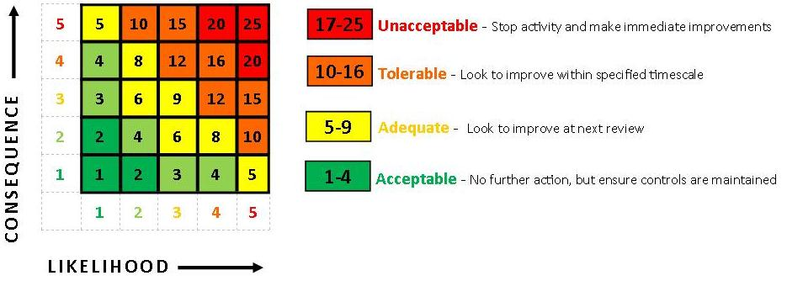
RISK ASSESSMENT
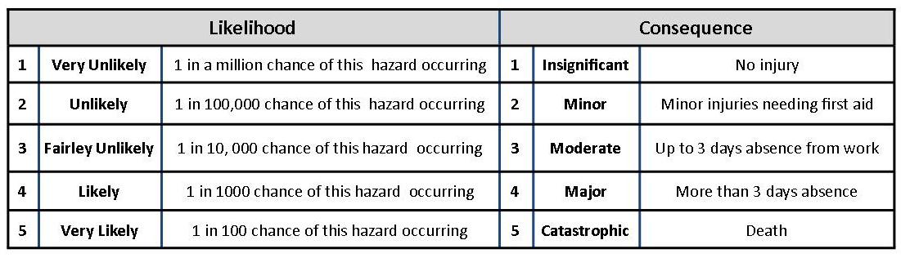

EVENT: |  | LOCATION: |  | DATE: |  | REVIEW DATE
ASSESSOR: |  | DATE OF EVENT: |  | SIGNED:

HAZARDS  IDENTIFIED | GROUPS OF PERSONS AT RISK | EXISTING CONTROLS | RISK  INDEX  L X S = R |  |  | FURTHER RISK MANAGEMENT | RISIDUAL RISK  INDEX |  |  | DATE  COMPLETE  &  SIGNED
 |  |  | L | S | R |  | L | S | R
SLIPS/TRIPS/  FALLS | Staff  Volunteers  Public  Visitors
CRUSHING (Crowd) | Staff  Volunteers  Public  Visitors
TEMPORARY STRUCTURES | Staff  Volunteers  Public  Visitors  Contractors
EXPOSURE TO VIOLENT SITUATIONS | Staff  Volunteers
ADVERSE WEATHER  CONDITIONS | Staff  Volunteers  Visitors
VEHICLE MOVEMENT | Staff  Volunteers  Public  Visitors  Contractors
CHILD PROTECTION | Visitors  Public
WORK PRACTICES | Staff  Volunteers
FOOD POISONING | Staff  Volunteers  Public  Visitors
MANUAL HANDLING | Staff  Volunteers  Contractors
WASTE DISPOSAL | Staff  Volunteers  Public  Visitors
FIRE  FIRE AT PROPERTY | Staff  Volunteers  Public  Visitors  Contractors
STAFF SHORTAGES | Staff  Volunteers
NOISE | Staff  Volunteers  Public  Visitors  Contractors
DISABILITY DISCRIMINATION | Public  Visitors
MEDICAL EMERGENCY | Staff  Volunteers  Public  Visitors  Contractors
CANCELLING THE EVENT | Staff  Volunteers  Public  Visitors  Contractors

