3

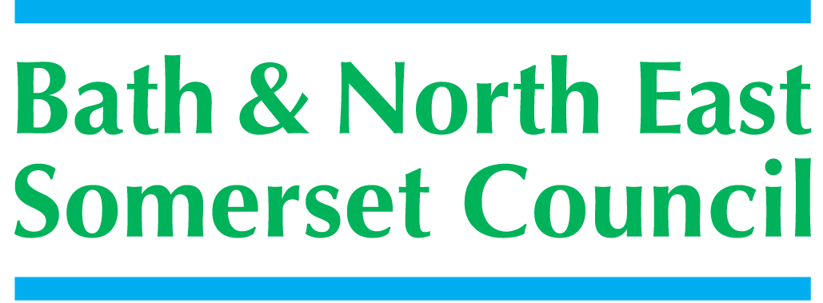 | 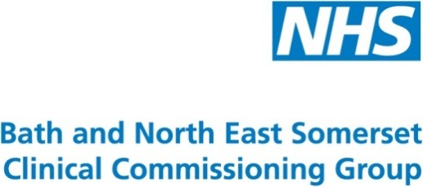

Meeting title | SCHOOLS FORUM
Date | Tuesday 18th September 2018 – Somerdale Pavilion, Keynsham
Forum Members Present | Ed Harker (Chair), Mark Everett, Clare Crowther, John Delaney, Richard Vanstone, Roz Lambert, Gareth Beynon, Alun Williams, Kerrie Courtier, Claire Hudson, Sara Willis
Forum Members Not Present | Sue East, Mairi Lanyon, Dawn Sage
Observers | Kevin Burnett, Jo Stoaling (Three Ways School)
Officers Present | Richard Morgan, Cllr. Paul May, Chris Wilford, Margaret Simmons-Bird, Tom Morrison,
Officers Not Present | Philip Frankland, Angela Clarke, Mike Bowden,
Distribution | As above; Theresa Gale; Colleen Collett; Cllr Charles Gerrish; Cllr. Tim Warren, Tim Richens; Jeff Wring;  Wendy Jefferies, All Headteachers
Next meeting | Tuesday 6th November 2018,  Avonfields Room, Somerdale Pavilion, Keynsham

ACTION
1. | Apologies Received
EH (Chair), welcomed everyone to the meeting the first for the new school year; noting the July meeting was cancelled.
The following apologies had been sent:
Sue East, Angela Clarke, Mike Bowden and Dawn Sage
Role changes for this meeting and the foreseeable future RV will be an observer; Kevin Burnett (BANES NAHT) will be the voting member.
Sara Willis joined the Forum as the new Primary Governor
2. | Declarations of Interest
The following Declaration of Interest and Positions Held were recorded:
John Delaney – Current position, Chair of St Gregory’s College, Bath
Kerrie Courtier – None
Ed Harker – N/A
Sara Willis – Employed as contract manager for Bath Primary Behaviour Panel – report no. 8
Chair of Twerton Infants (Excessive School Balances) – report no. 10
Claire Hudson – Chair of Governors, Midsomer Norton Primary
3. | Minutes of the last meeting (15th May 2018)
The minutes were checked for accuracy and accepted

KB gave a brief explanation for the additional note to Item 6: Excluded Pupils and Alternative Provision:

“As the matter of rising exclusions is not just a B&NES issue, it was agreed to follow the suggestion by AW and refer the issue to the new School Standards Board in June.” MSB further clarified it will be carried over to the meeting on 2nd October.

4. | 2018-2019 Formula Analysis
RM introduced the Schools Funding Formula – 2018-19 National Analysis in order that the Forum can be informed of the national picture shown in the document published by the DfE; in relation to the schools funding formula.

The DfE each year produce a set of graphs from which the details have been extracted to produce the document which shows BANES position in relation to the National picture. The notes below the graphs show BANES as almost always just below average, due to the reduction in resources for SEN and lagged funding.

5. | NFF and Budget Update
 | RM updated the Forum on the purpose of the School Funding 2019-20 (National Funding Formula); the DfE have confirmed their intent; to allow LA’s to run the local formula until 2021.  The Forum were asked to decide on the approach after discussion, to be made, using these recommendations:  - Forum is asked to agree to a consultation process on the introduction of changes to the school funding formula – the Forum agreed  - Forum is asked to comment on the proposal to request additional resources are transferred from the schools block to the High Needs Block. – using the Forum’s comments RM will develop a document  A policy document and operational guide has been produced by the DfE; for LA’s to follow in applying the changes required to the National Funding Formula (NFF) for 2019-20. BANES adopted the funding formula established by the DfE in 2018-19 after a detailed consultation.  A few minor changes are now required to ensure BANES move towards the full National Funding Formula:  - Minimum funding per pupil levels – minimum per pupil funding level for secondary school will increase to £4,800 and for primary schools will increase to £3,500.  - The schools having a funding allocation less than these will be brought up to these levels in 2019-20.  - Growth Funding – will be changing; in the past this was based upon the amount of money the LA had spent. It is not possible to predict the effect of this change until the outcome of the methodology is known.  - Utilisation of Schools Block for High Needs – the DfE have confirmed utilising Schools Block to support High Needs pressure; as Schools Forum agreed in 2018-19 is allowed.  - Level of transfer to High Needs is limited to 0.5% without Secretary of State approval; the LA proposes a consultation to request a further transfer for 2019-20  - Requested transfer would be 1% in total approximately £1,400,000, equating to the original 0.5% approved 2018-19 and a further 0.5% requested for 2019-20  - To gain approval for this request; schools need to be consulted and following comments from Schools Forum the Secretary of State will have to approve. RM requested the Forum’s views before the consultation is issued  - Consultation starts as soon as the papers can be sent out; with a response date of 2^{2nd} October for paper to be prepared for the Forum meeting November 6th.  Following a thorough discussion the Forum felt; a key message to aid understanding the consultation should be put out fully and clearly with the addition of charts and by a cascade system to reach all schools. | RM
6. | SEND bandings – Next Steps
The Forum were asked to approve the next steps for SEND Banding changes and banding values as set-out in the paper. Which will be applied to all new plans assess and agreed from 1st September 2018; and to all existing plans agreed prior to 1st September 2018, from 1st September 2019.
To support pressures on high needs funding the Forum are asked to agree to consult with schools for a continued 0.5% contribution from the DSG and a further 0.5% in support of high needs funding.
7. | SEND Education Strategy
CW advised the council has drafted a 3-year SEND Education Strategy; this is based on a self-evaluation of local services and joint strategic needs analysis (JSNA) to understand the needs of our children with SEND. The report provided the Forum with a summary of key actions which CW went through.
- Considerable growth in SEND pupils and EHCP’s since the SEND reforms in 2014
- Current population and anticipated growth is showing a need to work to address special school capacity in particular areas
- Ongoing work to look at whether another special school for children with complex needs is viable and achievable in BANES
- To develop a universal approach to SEND in schools, BANES will look to introduce core standards
- CW welcomed any conversations outside of the meeting regarding the resource base
8. | Behaviour Panel Outturn Reports
RM requested the Forum decide whether to carry forward over and underspends from 2017-18 to each panel; with the following recommendations:

- To note the reports for 2017-18 for each of the six panels and decide whether to carry forward the balances that exceed the 8% limit. – The forum decided not to withdraw and would like to continue with reports
- To note the allocation of resources to each panel for 2018-19. – The Forum felt a narrative to explain the more-excessive balances would be useful
9. | Alternative Provision Update (verbal)
 | Alice McColl gave a verbal update to the Alternative Provision, a copy of the paper attached with these minutes for information.  The Forum discussed the update, noting it would be good to receive an Annual report each September, on this newly launched service for the most vulnerable young people.  Action: AM to send a report re: Catch 22 only, for the November meeting of the Forum. | AMcC
10. | Maintained Schools Only – Excessive School Balances
The Forum were informed of the revenue balances held by maintained schools; and were asked to consider the following recommendations:
- To note the excessive revenue balances held by schools and to ratify the recommendation shown on the schedule in Appendix B
- Discuss and decide if the methodology to calculate and record excessive school revenue balances should continue for the financial year 2018-19 onwards due to the reduction in number of maintained schools as they convert to academy status
- The Forum agreed to record excessive balances but not withdraw this process will not need to be repeated in the future
11. | A.O.B.
SW requested a venue check be made for the next meeting – it is:
6th November 2018, Avonfields Room, Somerdale Pavilion, Keynsham
12. | Date of Next Meeting
 | 6th November 2018, Avonfields Room, Somerdale Pavilion, Keynsham

