People & Communities Department |  | 3
Civic Centre, Keynsham, Bristol
Tel: 01225 394195

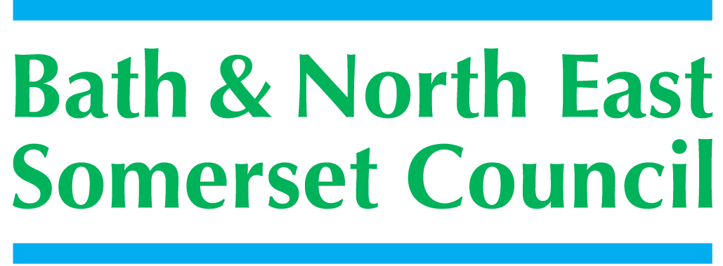 | 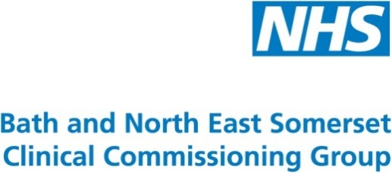

Meeting title | SCHOOLS FORUM
Date | Tuesday 15th March 2016 – Community Space, Keynsham.
Forum Members Present | Mark Mallett (Chair), Dean Anderson, Julie Dyer, Susan Robbins, Roz Lambert, Jim Crouch, Colin Cattanach, Richard Vanstone, Annie Smart, Anne Hewett, Kevin Burnett
Forum Members Not Present | Ed Harker (Vice Chair). Claire Hudson, Alun Williams
Officers Present | Richard Morgan, Sara Willis, Cllr. Michael Evans, Philip Frankland, Cllr. Emma Dixon,
Officers Not Present | Ashley Ayre, Richard Baldwin, Sally Churchyard, Rob Gibbs, Margaret Simmons-Bird, Mike Bowden, Chris Wilford
Distribution | As above; Theresa Gale; Colleen Collett; Cllr Charles Gerrish; Cllr. Lisa Brett; Cllr. Tim Warren, Cllr. Emma Dixon, Tim Richens; Jeff Wring; Wendy Jefferies, All Headteachers
Next meeting | Tuesday 10th May 2016,  3-5pm, Civic Centre West 1.1, Keynsham.

ACTION
1. | Apologies Received
 | Ashley Ayre, Ed Harker, Mike Bowden, Rob Gibbs, Clare Hudson, Alun Williams, Andrea Arlidge.
2. | Minutes of Last Meeting – 19th January 2016
 | Agreed with following amendments/actions.  3.1 – Action for MB regarding the results of the research project regarding potential models for collaboration/partnership for schools. MB not present today, to follow up with AA for next meeting.  5. Behaviour Strategy – a number of questions raised at the last meeting of SF. SW advised that these were being followed up by Debbie Forward. Update at next meeting.  Page 4. Action for RM re pressures on SEN and how the process of funding works. This information was included in the presentation for today’s meeting.  AOB: KB asked for discussion re High cost of SEN placements to be added – RM to draft adjustment to minutes | MB  DF/MB  RM
3. | Matters Arising
 | All on the agenda.
4. | National Funding Formula
RM provided the forum with a presentation of the issues being raised in the consultation documents produced by the DFE.
The presentation S:\Children's Services\Meetings\Schools' Forum\2016\15 March\School Funding Consultation.pptx concentrated on the rational of the funding formula being proposed for the schools block of the DSG.

The forum concentrated the discussion on the response document and how it was difficult for the forum to come to an agreement as to a formal Forum response as individual schools representing different sectors could not agree on some of the issues.

The Forum agreed that a response from the LA officers would be circulated by the Forum Chair to all schools so that individual schools would be informed to make their own response.
5. | A.O.B
 | none
6. | Date of next Meeting
 | Tuesday 10th May 2016, Civic Centre West 1.1, Keynsham.

