3

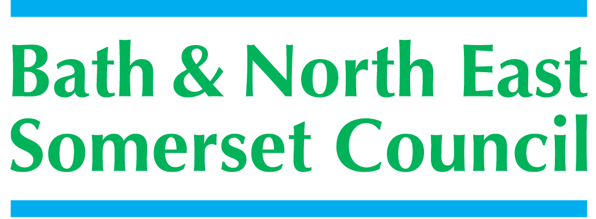

Meeting title | SCHOOLS FORUM
Date | Tuesday 15th January 2019 – Community Space, Keynsham
Forum Members Present | John Delaney, Kevin Burnett, Dawn Sage, Clare Crowther, Roz Lambert, Kerrie Courtier, Claire Hudson,
Forum Members Not Present | Alun Williams, Sara Willis, Ed Harker (Chair), Mark Everett (Vice Chair),
Observers | Richard Vanstone,
Officers Present | Richard Morgan, Cllr. Paul May, Margaret Simmons-Bird, Mike Bowden, Mary Kearney-Knowles, Philip Frankland, Chris Wilford, Marie Lane (SF Clerk)
Officers Not Present
Distribution | As above, Theresa Gale, Colleen Collett, Cllr. Charles Gerrish, Cllr. Tim Warren, Tim Richens, Jeff Wring, Wendy Jefferies, All Headteachers
Next meeting | Tuesday12th March 2019,  Community Space, Library Building, Keynsham

ACTION
1. | Apologies Received
KC agreed to step in as Chair for this meeting, welcomed everyone
The following apologies had been sent:
Ed Harker (Chair), Mark Everett (Vice Chair), Sara Willis, and Alun Williams
Just before Christmas we received the very sad news of the death of Sue East, Head-teacher of St Andrews Church School, Bath. Sue’s contributions to the Forum were very much appreciated by all; Sue was a great ambassador and will be sadly missed. KB said he would attend the funeral – all Forum members would be welcome to attend.
2. | Declarations of Interest
The following Declaration of Interest and Positions Held were recorded:
John Delaney – None
Kevin Burnett – from January 2017, Branch Secretary for BANES NAHT
from October 2018, Foundation Governor - Farrington Gurney Church School
Kerrie Courtier – None
Dawn Sage – member Wellsway Multi Academy Trust
Claire Hudson – Chair of Governors at a schools in the LA (Midsomer Norton Primary).
Governor at a school in the LA (St Mary’s, Timsbury)
3. | Minutes of the last meeting (6th November 2018)
 | The minutes were checked for accuracy and accepted  Excluded Pupils and Alternative Provision: “As the matter of rising exclusions is not just a B&NES issue, it was agreed to follow the suggestion by AW and refer the issue to the new School Standards Board in June.” MSB further clarified it will be carried over to the meeting on 2nd October.  The paper will now go to the March meeting  Alternative Provision Update: Action: AM to send a report re: Catch 22 only, for the November meeting of the Forum.  RM explained this remains ‘on-hold’ as AM has left BANES  A.O.B. Forum membership: Action: RM will contact those representatives who have not continuously attended for some time. RM will make contact – a review of the structure of the Forum will be a March agenda item | RM/CW  RM
4. | Early Years Funding Update
 | PF introduced the report to update the Forum based upon the Forum’s decision made at March 2018 meeting to fix the funding until 2020.  The forum were reminded of the background noting confirmation of the rates received by BANES Council in the Early Years Direct Schools Grant (DSG) formula announcement of 22nd November 2018 for 2019/20 are:  - £5.43 per hour for 2-year old children  - £4.30 for 3 and 4-year old children  The Forum agreed in 2018 if the 2019/20 DfE funding rate remained the revised formula should remain in-place until 31st March 2020.  A discussion followed noting the increasing pressure which indicates demand will increase. In relation to other local authorities; BANES appears to maintain a more buoyant market in the community. It would be useful to make Ofsted aware of the expectations / challenges within the Early Years sector.  PF assured the DfE are being kept aware of the challenging circumstances by raising the topic at all respective forums attended.  Concerns were raised around the impacts and working with on vulnerable / low income families; a large number of Early Years children are reported to have EHCP plans.  Action: KB requested for reference copies of any papers by PF | PF
5. | DSG and Other Grants Update
Following the DFE’s issue of the DSG and Other Grants for 2019-20; this paper is to inform the Forum the impact for BANES schools and settings within the authority.
RM referred to the tables within the paper, noting:
- Schools Block – an overall increase of £3.934m equating to a 3.87% increase
- BANES increase is significantly higher than other local authorities
- High Needs Block shows an increase of 4.15%
- Secretary of State’s recent announcements re: High Needs funding allocation 2018-19 and 2019-20 at £385k is a welcome boost.
- 2019-20 council consideration is now being given to reducing its funding towards High Needs Block pressures
- Central Services Block has increased by £18k between 2018-19 and 2019-20, reflecting the 1.77% increase in pupil numbers
- Pupil Premium Grant rates for 2019-20 have no change from 2018-19 – this has been the same for the last couple of years
- Exact dates for 2019-20 Year-7 Catch-up Premium details are yet to be announced
6. | Teachers’ Pension Cost Updates
This item is to highlight to the Forum the proposed increase to the employers' contributions to the Teachers' Pension Scheme and its impact on schools as raised by a Union Representative.
The extract to local authorities with information about proposed increase in employers Teacher’s Pension Contributions from the current 16.48% to 23.6% from 1st September 2019 and the intention to support this significant increase by allocation of additional funding to schools and academies; is taken from the Education and Skills Funding Authority (ESFA) bulletin 17th October 2018.
The Forum discussed the tables in Appendix 6.1; thanking RM for producing the comparison tables, noting the following points:
- Employers will bear significant increase with no difference to individual teachers
- RV observed there could be pressure on teachers not to join pension schemes – as substantial cost on top of salary
- ESFA advise the DFE fully intends to fund the contribution increase; the methodology for this is yet to be finalised
7. | Growth Fund Budget
 | RM introduced the Growth Funding Update paper  Growth funding is included in local authorities DSG allocation; calculated by using the prior year’s spend as an allocation in the following financial year’s budget (on a lagged funding basis). However in 2019-20 the funding will be calculated on a formulaic methodology. The funding supports new schools that are opening or schools expanding.  Based on the data utilised in the new formula, BANES has been allocated £986,674 for planned growth in financial year 2019-20; currently planned spending is £782,641; with an estimated balance of £204,033 at 31st March 2020.  It is proposed to keep this estimated balance in the growth funding centrally held budget; this would then form part of the overall DSG surplus balance at 31st March 2020, should it remain at the year end .  RM explained this could be allocated to schools directly as per BANES policy should the estimates change during the year.  Members questioned holding the estimated £204,033 and agreed to hold the total budget as the growth fund for 2019-20 | Agreed
8. | Centrally Held Budgets
 | As part of the new regulations in preparation for the new funding regime; under a National Funding Formula the DFE require any centrally held budget by the Local Authority to be approved by the Forum on an annual basis.  The forum were asked to vote on the approval of BANES 4-centrally held budgets funded by the DFE (items and amounts):  - School Admissions: £261,480 for 2019-20; £256,190 in 2018-19  - Servicing of Schools Forums: £4589 no change from 2018-19  - Prudential Borrowing Costs: £0 in 2019-20; £180,076 in 2018-19. The cost of borrowing entered into in 2008-9 comes to an end in March 2019; thereby reducing the budget required to £0.  - Contribution to combined budgets: £63,549 no change from 2018-19  The Forum voted unanimously to approve the 4-centrally held budgets | Agreed
9. | A.O.B.
Future work of the Forum – RM to bring an options paper for discussion to the Forum’s March meeting to discuss how the work of the Schools Forum continues to move forward.

- Forum to consider how to continue with decision making
- Suggestions how to change Schools Forum constitution
- Consider representation
The forum agreed that discussion of papers, are important in order to reach decisions. KB welcomed RM back to ‘good health’ and thanked everyone for their contributions.
6. | Date of Next Meeting
 | 12th March 2019, Community Space, Library Building, Keynsham

