3

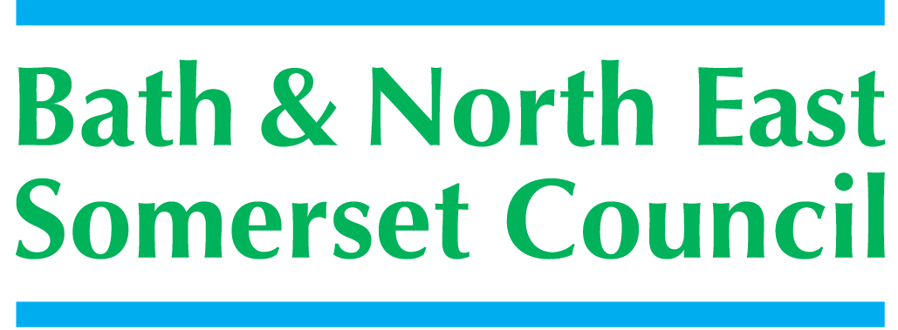

Meeting title | SCHOOLS FORUM
Date | Tuesday 6th November 2018 – Somerdale Pavilion, Keynsham
Forum Members Present | Ed Harker (Chair), Mark Everett, Mairi Lanyon, John Delaney, Kevin Burnett, Alun Williams, Sara Willis
Forum Members Not Present | Sue East, Dawn Sage, Clare Crowther, Roz Lambert, Kerrie Courtier,  Claire Hudson,
Observers | Richard Vanstone,
Officers Present | Richard Morgan, Cllr. Paul May, Margaret Simmons-Bird, Tom Morrison, Mike Bowden, Angela Clarke, Marie Lane (SF Clerk)
Officers Not Present | Philip Frankland, Chris Wilford,
Distribution | As above; Theresa Gale; Colleen Collett; Cllr Charles Gerrish; Cllr. Tim Warren, Tim Richens; Jeff Wring;  Wendy Jefferies, All Headteachers
Next meeting | Tuesday11th December 2018,  Community Space, Above the Library Building, Keynsham

ACTION
1. | Apologies Received
EH (Chair), welcomed everyone to the meeting
The following apologies had been sent:
Sue East, Dawn Sage, Clare Crowther, Roz Lambert, Kerrie Courtier, Claire Hudson, Chris Wilford
2. | Declarations of Interest
The following Declaration of Interest and Positions Held were recorded:
John Delaney – Chair of Governors at St Gregory’s Secondary School
Sara Willis – Contract and Finance Manager for the Bath Area Behaviour Panel
Chair of Twerton Infants and Nursery School
Kevin Burnett – current Branch Secretary of the NAHT and current Foundation Governor of Farrington Gurney Church School
3. | Minutes of the last meeting (18th September 2018)
 | The minutes were checked for accuracy and accepted  Item 6: Excluded Pupils and Alternative Provision: “As the matter of rising exclusions is not just a B&NES issue, it was agreed to follow the suggestion by AW and refer the issue to the new School Standards Board in June.” MSB further clarified it will be carried over to the meeting on 2nd October.  KB asked about the most recent data availability – CW will be able to provide more up-to-date information in due course. Action: To be an agenda item for the next meeting.  Item 9 Alternative Provision Update: Action: AM to send a report re: Catch 22 only, for the November meeting of the Forum.  RM explained this is ‘on-hold’ at present | RM/CW
4. | Formula Consultation 2019-20
RM introduced the 2019-20 BANES Schools Funding Formula Consultation for mainstream schools which was sent out on 28th September 2018 and completed on 22nd October 2018.
The total responses were set out in the annex to the report.
The Forum would be asked to comment on the responses received from schools as detailed in Appendix 4.1; and to make their decision on the planned actions for 2019-20:
- Comment on the consultation responses; recommending to the cabinet member the preference regarding the details of the formula
- Make a decision on the request to support the continued 0.5% contribution from the Schools Block to the High Needs Block for 2019-20
- To make comments on the responses to the consultation regarding the additional request to extend the contribution by 0.5% between Schools and High Needs Blocks
The Forum had a full discussion with comments before making their decisions / recommendations:
Questions 1-5
Q1 – Should the LA introduce the new funding floor factor into the local funding formula calculations for 2019-20 to ensure that every school receives an overall 1% per pupil funding compared to the schools 2017-18 per pupil allocation?
Q2 – Should the LA set the MFG at 0% change in pupil funding in 2019-20 compared to 2018-19 if the new funding floor factor is introduced?
Q3 – Should the LA mirror the sparsity taper in the local formula to mirror the NFF?
Q4 – Should the LA remove the Cap on Gains for 2019-20?
Q5 – Should the LA use an EAL indicator based on three years to mirror the NFF?
- comments made were pertinent – some schools struggling with financial pressures
- RM gave a brief explanation to clarify the Cap on Gains – enabling the funding floor to guarantee +1% on schools 2017/18 budgets
- Teachers pay versus pressures on schools is hard financially, but is being supported by the Teachers pay grant
- a staged approach may have been adopted if it was known that this would be a 3-year programme
- The Forum agreed the right decision was made last year regarding the minimum funding guarantee
The Forum recommended that all 5 proposals should be adopted by the Cabinet Member who will make the formal decision.
Question 6a – the Forum’s views to continue with the transfer of the 0.5% of the schools Block the High Needs Block -decision to made by voting:
Q6a – Do you agree to extend the current arrangement of transferring 0.5% of Schools Block funding to the High Needs Block for 2019-20?
- Schools to appreciate the LA is contributing £2.3 million in the next financial year
- Each LA is dealing in with this in a different way - some making cuts to SEN; but BANES is supportive
- Lots of schools facing financial challenges – contribution of 0.5% maintained is helpful
- Political level shows great support for schools with disadvantaged pupils
The Forum voted in favour to continue the transfer of the 0.5% of the Schools block to the High Needs Block
Question 6b – Recommendation of the Forum to the Secretary of State:
Q6b – Do you agree that a further 0.5% of Schools Block funding can be transferred to the High Needs Block for 2019-20?
- Comment from Midsomer Norton Schools Partnership – “We do not believe there would be sufficient gains for all schools to warrant this change and feel better able to commission our own services’”
- Forum members felt it helpful to have examples of problems
- Problems to manage the parental expectations understanding of EHC plan.
- A scheme where Special Schools have an in-house Practitioner was proving helpful and successful in understanding problems as at Fosseway (Year 9) and ThreeWays
- SEN budget increasing – much better to work with the schools
- BANES can still make an application to the DfE by the end of November 2018, if the Forum does not agree to recommend
The Forum did not agree to recommend an increase of greater than 0.5% to the Secretary of State

5. | A.O.B.
 | RM – the work of the Forum going forwards:  - In the past the work of the Forum required a lengthy agenda  - Going forwards the decision making tasks are being reduced  - With this changing emphasis it would be prudent to amend the number of times in a year the Forum meets  - December meeting to be advised, dependant on agenda items  Forum Membership – Gareth Beynon has resigned there is now a vacancy in the secondary sector, also it was noted the continuing non-attendance of some representatives at Forum meetings.  Action: RM will contact those representatives who have not continuously attended for some time | RM
6. | Date of Next Meeting
 | 11th December 2018, Community Space, Above the Library Building, Keynsham

