People & Communities Department |  | 2
Civic Centre, Keynsham, Bristol
Tel: 01225 394195

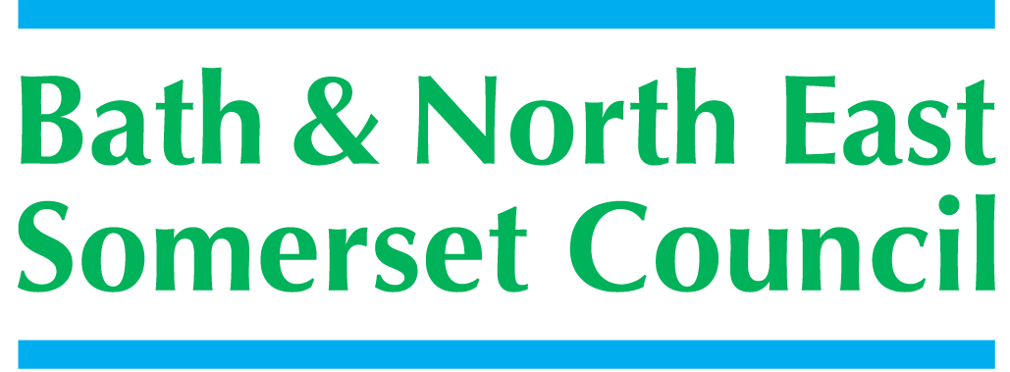

Meeting title | SCHOOLS FORUM
Date | Tuesday 8th December 2015 – West 1.1, Civic Centre, Keynsham.
Forum Members Present | Mark Mallett (Chair), Dean Anderson, Julie Dyer, Claire Hudson, Roz Lambert, Jim Crouch, Alun Williams, Colin Cattanach, Richard Vanstone,
Forum Members Not Present | Annie Smart, Anne Hewett, Susan Robbins, Kevin Burnett, Ed Harker (Vice Chair).
Officers Present | Richard Morgan, Margaret Simmons-Bird, Sara Willis, Cllr. Michael Evans, Mike Bowden, Chris Wilford, Philip Frankland, Cllr Liz Hardman (observing), Rob Gibbs(observing).
Officers Not Present | Ashley Ayre, Caroline Howarth, Richard Baldwin, Sally Churchyard, Cllr. Emma Dixon,
Distribution | As above; Theresa Gale; Colleen Collett; Cllr Charles Gerrish; Cllr. Lisa Brett; Cllr. Tim Warren, Cllr. Emma Dixon, Tim Richens; Jeff Wring; Wendy Jefferies, All Headteachers
Next meeting | Tuesday 19th January 2016,  3-5pm, Community Space, 1st Floor Library Building, Keynsham.

ACTION
1. | Apologies Received
 | Ashley Ayre, Annie Smart, Anne Hewett, Cllr. Emma Dixon, Susan Robbins, Kevin Burnett, Ed Harker
2. | Minutes of Last Meeting – 22nd September 2015
Agreed.

- Question was asked regarding the price of school meals for 2016/17. RM responded that the charge from catering services to schools was £2.40 but that individual schools could set their own charge to parents. RM informed the group that a proposal was currently out for consultation to all providers.
- Comment was noted that SF was looking forward to receiving the result of the research project agreed at the last meeting regarding possible models for collaboration/partnerships between schools.

3. | Matters Arising
 | All on the agenda.
4. | SARI Funding
MB presented the paper. The current SARI Contract ceases on 31st March 2016 and BANES Children’s Services can no longer continue to fund it. The annual cost of the contract is £8230.00 and SF is being asked to consider 4 possible options going forward. SF discussed the services SARI provide via the contract and although SF would not necessarily be in a position to expand the service agreed that it was a valuable service, for a relatively small sum of money, which they would prefer to continue with - this type of support was not available anywhere else.

Decision postponed until January budget meeting.

5. | Early Years Funding Update
PF presented the paper updating SF on the changes to and pressures on EYE including an update on details announced in the Autumn Statement. The paper also included further information on the 30 hour offer to working families and details of a new funding rate based on a national formula. A further paper will be brought to SF when the DSG is updated to reflect the new funding rates and formula.
SF was informed that following an evaluation process BANES had not applied to be a pilot of the new 30 hour offer during 2016/17.
RM asked PF to clarify why Early Years Providers had to claim the EY Pupil Premium when schools received it automatically. PF advised that this was because parents had to apply for it following which qualifying checks were made. It was felt that this system directly affected take up rates not just for Early Years but throughout a child’s subsequent school career.
Appendix 1 – Pay Survey 2015 – Summary of sector responses to be considered with ‘Living Wage’ impact. PF was asked what the percentage of responses to the survey was – this information was not available at the meeting but PF has subsequently confirmed the following;
Day Nurseries had 8 responses from 45 questionnaires, an 18% response rate. Pre-Schools had 9 responses from 35 questionnaires, a 25% response rate.
6. | Area SENCO Practitioners Update on Outcomes
CW introduced Melanie Da Costa and Nicholas Fortt who had carried out some work requested by SF evidencing the impact/outcomes of the Area SENCO Practitioner post following the paper CW presented on 17th November.
Outcomes from Area SENCO Practitioner post;
Increased
- confidence in early years SENCos to proactively contact schools before child starts using the transition timeline.
- skills in early years SENCos to lead transition planning meetings with key school staff, parents and other agencies.
- knowledge in early years SENCos understanding of SEND
- skill in early year’s staff to identify children’s needs.
- confidence in early years staff to liaise with external agencies to
support children with SEND.
- knowledge and skills in early years SENCOs’ understanding and implementation of SEND.
- in early years SENCOs’ skills to submit well-evidenced requests.
Outcomes measurements would be recorded via an Early Years Child Progress Tracker which would become a standard format across BANES. Regular data would be inputted recording the progress of every child supported and funded through SENDIP. This will be started in January 2016 and a follow-up paper will be brought to SF when a years’ worth of data was available.
CW added that this data would be crucial for future commissioning decisions and planning services going forward as well as providing evidence for SF.
The area SENCO role was becoming more complex and more complex cases were being dealt with but the role is preventative insofar as it meets need at an early stage and very targeted.
RL added that the case example given in the paper was a good representation. Transition funding is a real pressure.
Funding decision carried forward to January budget meeting.

7. | Behaviour Strategy for BANES
 | MB presented the draft wider strategy paper ‘Promoting Positive Behaviour’ to SF. MB now wished to go out to consultation share the paper more widely. SF agreed that MB should move forward with this.  MM welcomed the LA getting to grips with this issue.  MB noted to SF that following the last meeting members were asked to contact him, if they had no conflicts of interest, and were willing to join a group to prepare 2-3 Behaviour Strategy models for consideration. Nobody had so far come forward. All to note and consider.  MB to consider best way to take forward. | ALL  MB
8. | Budget Planning
RM provided a brief overview of the Budget.
- Biggest pressure is from increasing pupil numbers
- Inflationary pressures on schools, settings and service areas are also an issue as detailed in the paper.
- Other known pressures include;
- SEN
- Nurture outreach
- Behaviour Strategy
- Overall budget shortfall is £2.8 million.
- RM suggested that this could be met if no inflationary pressures were allocated to schools
- £2m could also be released from the DSG carry forward to help meet some pressures if SF wished to do so
RM informed the SF that the DfE would be carrying out a consultation on a new National funding Formula for Schools in 2016 to take effect from 2017. RM suggested possible options that might be considered/consulted on. One possible option could result in the SF no longer being required – MB asked if that became the case what would happen to the DSG underspend. RM confirmed that this was LA money and could not be taken back. At a recent regional meeting it had been suggested a new NFF could be positive for the south west. PF added that EY funding will also be moving to a NFF in future.
SF discussed funding difficulties being experienced in other LAs and how they were being dealt with. North Somerset were cutting schools budgets now and further cuts were planned going forward. Biggest pressure in N. Somerset was also SEN spending. Support for SEN was not available anywhere else and pupil numbers were increasing significantly. AW suggested that sharing provision with N. Somerset might alleviate some of the problems for both LA’s. MB said that this had been looked at previously and although there was a shared border centres of population were distant which made sharing SEN provision unsuitable – some other things were shared and this would continue to be under review. ME said that N. Somerset members were keen to get some shared provision and AA was looking at this.
RM noted that BANES were already sending some children outside its boundaries and this was a very expensive option. CW said that there was already analysis in motion re future SEN numbers and provision available in BANES. JD also expressed concerns re the increasing numbers of children with SEN and the under-provision of places in BANES.

9. | A.O.B
 | None

Maintained Schools Only

10. | De-delegation of Services (Secondary)
 | SF agreed RM to contact schools directly | RM
11. | Date of next Meeting
 | 19th January 2016, Community Space, Keynsham Civic Centre.

