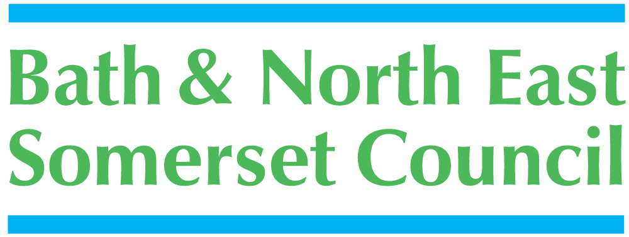




Rainbow Resource Scheme

Registration Form

Your Health Visitor, Social Worker or supporting professional will be happy to help you fill in this form.

This form can be completed by a parent/carer, young person/child.
- Name of Child/Young Person (One child/young person per application form)

- Home address
Postcode:

Email address:

- Name of parent or carer

Updated May 2018

Bath and North East Somerset –
the place to live, work and visit
- Child’s Date of Birth
Day | Month | Year

- Child's Gender:

- Your child's/young person’s needs. Please use the box below to describe briefly your child’s/young person’s needs: (e.g. communication, mobility, continence, epilepsy, etc. please note that a food allergy is not classed as a SEND)

- If a professional has given you a diagnosis of your child's condition, please state the condition and the name, address and status (e.g. Paediatrician, GP) of the professional

Diagnosed condition :

Date of diagnosis :

Name of professional :

Address :

Postcode : Tel No :

- Does your child/young person have an Education and Health Care Plan (EHCP)?
YES NO

- How did you hear about The Rainbow Resource Scheme?

- We are always looking to expand the scheme, and are open to your suggestions for new places and attractions where your Rainbow Resource Card can be used.
Let us have your ideas:

Please read and complete the declaration below

I give my consent for:

- The details that I have given on this form to be entered on to the Bath and North East Somerset Rainbow Resource database.
- This information will be shared anonymously for monitoring purposes and will not be shared with any other parties.
- The details that I have provided on this form to be included on Bath and North East Somerset’s Disabled Children’s Register in accordance with the Children’s Act 1989.

I understand that:

- This information will be treated as confidential If my child’s/young person’s circumstances change I am required to inform you accordingly

Please sign below to indicate that you consent to the above declaration.
*You don't need to provide a signature if completing online form.

Signature : | Date :
Please print your name :
Relationship to child :
Signature : | Date :
Please print your name :
Relationship to child :
Young person’s signature :
(if appropriate)
Please print name : | Date :

Please return to:

The Rainbow Resource Scheme
P & C Communications Team
Bath and North East Somerset Council,
Lewis House,
Manvers Street,
BATH BA1 1JG

Or you can scan and email to p_c_comms@bathnes.gov.uk
This information can be made available in a range of languages, large print, Braille, on tape, electronic and accessible formats.
Email p_c_comms@bathnes.gov.uk
If you need translation or interpretation, or someone to sign in BSL for you this can also be arranged.

