OFFICER DECISION REPORT – TRAFFIC REGULATION ORDER (TRO)
3

APPROVAL TO PUBLICLY ADVERTISE THE TRO

PREPARED BY: Traffic Management Team, Highways and Traffic Group

TITLE OF REPORT:  PROPOSAL:  SCHEME REF No:  REPORT AUTHOR: | The Avenue, Timsbury  Raised Table Speed Humps  25-068  Lewis Cox

1. DELEGATION

The delegation to be exercised in this report is contained within Part 3, Section 4 of the Constitution under the Delegation of Functions to Officers, as follows:

Section A | The Chief Executive, Strategic Directors, Divisional Directors and Heads of Service have delegated power to take any decision falling within their area of responsibility….”
Section B | Without prejudice to the generality of this, Officers are authorised to:  serve any notices and make, amend or revoke any orders falling within his/her area of responsibility.
Section D9 | An Officer to whom a power, duty or function is delegated may nominate or authorise another Officer to exercise that power, duty or function, provided that Officer reports to or is responsible to the delegator.

For the purposes of this report, the Director of Place Management and the Head of Highways Delivery holds the delegated power to make, amend or revoke any Orders.

2. LEGAL AUTHORITY

This proposal is also made in accordance with The Highways Act 1980 Section 90A which permits a highway authority to both construct and remove road humps in a public road, for which they are the highway authority, if the highway is subject to a legal speed limit for motor vehicles of 30 miles per hour or less or the road humps are specially authorised by the Secretary of State.

3. PROPOSAL

To introduce two new raised table speed humps on The Avenue, Timsbury. The proposal consists of:

- Table one, centred approximately 62.2 metres south of the junction with Hayeswood Road / North Road.

- Table two, centred approximately 16 metres north of its junction with Somerset Folly.

The proposals are shown on the attached drawing TCH0031_TA_N

4. REASON

Please refer to the Statement of Reasons.

The Council has had in mind and discharged the duty (as set out in section 122(1) of the Road Traffic Regulation Act 1984) to secure the expeditious, convenient and safe movement of vehicular and other traffic (including pedestrians) so far as practicable. It has also had regard to the factors which point in favour of imposing raised table speed humps. It has balanced the various considerations and concluded that it is appropriate to promote raised table speed humps. The Council has also considered and discharged its network management duty under section 16 of the Traffic Management Act 2004. It has concluded that the proposed raised table speed humps are consistent with that duty, having regard to its other policies and objectives.

5. IMPACT ON EQUALITIES

An Equality Impact Assessment has been undertaken in relation to the introduction of toucan pedestrian crossings and raised tables, which is available upon request. The Council has had due regard to the needs set out in section 149(1) of the Equality Act 2010. It considers that the proposed Order is consistent with the section 149 public sector equality duty, which it has discharged.

6. IMPACT ON HUMAN RIGHTS

The proposal is considered to have a minimal impact on human rights (such as the right to respect for private and family life and the right to peaceful enjoyment of property). However, the Council is entitled to affect these rights where it is in accordance with the law, necessary (in the interests of public safety or economic well-being, to prevent disorder and crime, to protect health, or to protect the rights and freedoms of others), in pursuit of a legitimate aim and proportionate to do so. The proposal(s) within this report are considered to be in accordance with the law, necessary, in pursuit of a legitimate aim and proportionate.

7. SOURCE OF FINANCE

The proposal is being funded through the 2025/26 Local Active Travel & Safety programme.

8. CONSULTATION REQUIREMENT

The proposals require consultation with the Chief Constable, Emergency Services, Road Haulage Association, Freight Transport Association (Logistics UK), Parking Services, Waste Services, Ward Members and the Cabinet Member for Highways.

9. COMMENTS RECEIVED TO DATE

Emergency Services

No comments received.

Chief Constable: The proposals should meet the aspirations behind their introduction.

Road Haulage Association

No comments received.

Freight Transport Association

No comments received.

Parking Services

No comments received.

Waste Services

No comments received.

Parish Council

No comments received.

Ward Member

Cllr Shaun Stevenson-McGall: As the B&NES Ward Member for Timsbury (& as a Parish Councillor, & as a volunteer with SpeedWatch) you would expect me to support this TRO proposal for two raised table speed humps along The Aveune, Timsbury.

I have cc’d the Clerk, Chair and Vice Chair of the Parish Council as well as the acting coordinator of the village’s Community SpeedWatch Team.

These two raised table speed humps are key elements of the village wide pedestrian safety, speed reduction and through traffic deterring schemes across the three main walking routes through the village connecting the residential housing with the community infrastructure and assets such as St Mary’s General Practice Surgery, Pharmacy, Café, convenience stores, public house, and St Mary’s CoE Primary school.

Making our village safer for all will encourage more walking, wheeling and cycling, improve the health of our residents and reduce the burden on the NHS and primary care as well as improving air pollution and reduce carbon emissions.

As an active and regular volunteer with Avon and Somerset Constabularies Community Speedwatch I together with colleagues record 20% to 30% of motorised vehicles travelling more than 26 mph, with many caught in the mid 30 mph and even higher at our approved location on The Avenue, as well as at the other locations on North and South Road, and Radford Hill.

Together with the Parish Council we all want to make our village safer for the most vulnerable road users, support the new Highway Code and its hierarchy of road users and help deliver B&NES Council’s Vision Zero strategy of eliminating all traffic fatalities and serious injuries.

Cabinet Member for Sustainable Transport Delivery-

Councillor Lucy Hodge: I’m pleased to see this proposal for raised table speed humps coming forward. Please proceed to consultation.

10. RECOMMENDATION

As no significant objections and/or comments have been received following the preliminary consultation described above, the public advertisement of the Traffic Regulation Order should progress.
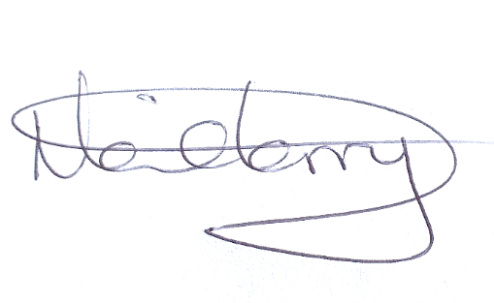
Neil Terry Date: 11/12/2025
Traffic Management and Network Manager

11. DECISION

As the officer holding the above delegation, I approve the progression of this Traffic Regulation Order.
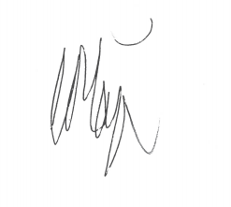
Chris Major Date: 12/12/2025
Director for Place Management

