OFFICER DECISION REPORT – PEDESTRIAN CROSSING & DYL’s
3
Traffic Regulation Order (TRO) and ‘Notice’

APPROVAL TO PUBLICLY ADVERTISE THE PROPOSAL

PREPARED BY: Traffic Management Team, Highways and Traffic Group

TITLE OF REPORT:  PROPOSAL:  SCHEME REF No:  REPORT AUTHOR: | A367 Fosseway South, Midsomer Norton  Zebra Pedestrian Crossing & No Waiting At Any Time Parking Restrictions (DYLs)  26-041  Lewis Cox

1. DELEGATION

The delegation to be exercised in this report is contained within Part 2 Section 2.35 of the Constitution under the Delegations of Functions to Officers, as follows:

Section A | The Chief Executive, Executive Director - Chief Operating Officer,  Directors and Heads of Service have delegated power to take any  decision falling within their area of responsibility….”
Section B | Without prejudice to the generality of this, Officers are authorised to: serve any notices and make, amend or revoke any orders falling within their area of responsibility.
Section D | An Officer to whom a power, duty or function is delegated may  nominate or authorise another Officer to exercise that power, duty  or function, provided that Officer reports to or is responsible to the  delegator.

For the purposes of this report, the Director of Place Management and the Head of Highways Delivery hold the delegated power to make, amend or revoke any Orders.

2. LEGAL AUTHORITY

This proposal is made in accordance with the Road Traffic Regulation Act 1984, which under Section 23 enables local highway authorities to establish crossings for pedestrians.

This proposal is also made in accordance with the Road Traffic Regulation Act 1984, which under Section 1 provides, generally, for Orders to be made for the following reasons, and in the case of this report specifically for the reason(s) shown below:

(a) | for avoiding danger to persons or other traffic using the road or any other road or for preventing the likelihood of any such danger arising, or | X
(b) | for preventing damage to the road or to any building on or near the road, or
(c) | for facilitating the passage on the road or any other road of any class of traffic (including pedestrians), or | X
(d) | for preventing the use of the road by vehicular traffic of a kind which, or its use by vehicular traffic in a manner which, is unsuitable having regard to the existing character of the road or adjoining property,
(e) | (without prejudice to the generality of paragraph (d) above) for preserving the character of the road in a case where it is specially suitable for use by persons on horseback or on foot, or
(f) | for preserving or improving the amenities of the area through which the road runs, or
(g) | for any of the purposes specified in paragraphs (a) to (c) of subsection (1) of section 87 of the Environment Act 1995 (air quality)

3. PROPOSAL

To introduce a new zebra pedestrian crossing on the A367 Fosseway South, Midsomer Norton.

To introduce ‘No Waiting at Any Time’ parking restrictions in the vicinity of the proposed zebra pedestrian crossing.

The proposals are shown on the attached drawing TCN001/02/100.

4. REASON

Please refer to the Statement of Reasons.

The Council has had in mind and discharged the duty (as set out in section 122(1) of the Road Traffic Regulation Act 1984) to secure the expeditious, convenient and safe movement of vehicular and other traffic (including pedestrians) so far as practicable. It has also had regard to the factors which point in favour of imposing a Zebra Pedestrian Crossing and No Waiting At Any Time parking restrictions. It has balanced the various considerations and concluded that it is appropriate to promote these measures. The Council has also considered and discharged its network management duty under section 16 of the Traffic Management Act 2004. It has concluded that the proposed Zebra Pedestrian Crossing and No Waiting At Any Time parking restrictions are consistent with that duty, having regard to its other policies and objectives.

5. IMPACT ON EQUALITIES

An Equality Impact Assessment has been undertaken in relation to the introduction of pedestrian crossing facilities, which is available upon request. The Council has had due regard to the needs set out in section 149(1) of the Equality Act 2010. It considers that the proposed Order is consistent with the section 149 public sector equality duty, which it has discharged.

6. IMPACT ON HUMAN RIGHTS

The proposals are considered to have a minimal impact on human rights (such as the right to respect for private and family life and the right to peaceful enjoyment of property). However, the Council is entitled to affect these rights where it is in accordance with the law, necessary (in the interests of public safety or economic well-being, to prevent disorder and crime, to protect health, or to protect the rights and freedoms of others), in pursuit of a legitimate aim and proportionate to do so. The proposal(s) within this report are considered to be in accordance with the law, necessary, in pursuit of a legitimate aim and proportionate.

7. SOURCE OF FINANCE

This proposal is being funded through a Section 106 legal agreement via developer Barrett Homes.

8. CONSULTATION REQUIREMENT

The proposal requires consultation with the Chief Constable, Emergency Services, Road Haulage Association, Freight Transport Association (Logistics UK), Parking Services, Waste Services, Ward Members and the Cabinet Member for Sustainable Transport Delivery.

9. COMMENTS RECEIVED TO DATE

Chief Constable – With regard to the proposed zebra crossing on the A367 Fosseway South, Midsomer Norton as shown on the attached drawing TCN001/02/100, the proposal should meet the aspirations behind its introduction.

With regard to the proposed waiting restrictions as shown on the attached drawing TCN001/02/100, enforcement of waiting restrictions within the Bath and North East Somerset Council area rests with Bath and North East Somerset Council Parking Services.

Consideration regarding the potential displacement of existing parking, and the enforcement needs of these restrictions should be of importance.

The proposals should meet the aspirations behind their introduction.

Emergency Services –

Road Haulage Association –

Freight Transport Association –

Parking Services –

Waste Services –

Ward Members –

Councillor Shaun Hughes - I have no issues with this TRO.

Councillor Tim Warren - Fully supportive.

Cabinet Member for Sustainable Transport Delivery:

Councillor Lucy Hodge – Please proceed to public consultation

10. RECOMMENDATION

As no significant objections and/or comments have been received following the preliminary consultation described above, the public advertisement of this proposal for a new crossing should progress.
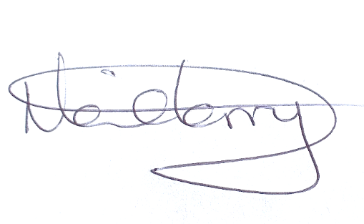
Neil Terry Date: 09/06/2026
Traffic Management & Network Manager

11. DECISION

As the officer holding the above delegation, I approve the progression of this proposal for a new crossing.

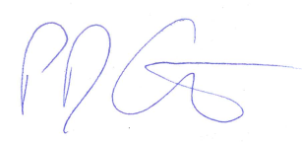

Paul Garrod Date: 09/06/2026
Head of Highways Delivery

