OFFICER DECISION REPORT - TRAFFIC REGULATION ORDER (TRO)
3

APPROVAL TO PUBLICLY ADVERTISE THE TRO

PREPARED BY: Traffic Management Team, Highways and Traffic Group

TITLE OF REPORT:  PROPOSAL:  SCHEME REF No:  REPORT AUTHOR: | North West Outer Bath Area TRO Review  Parking Restrictions  26-062  Traffic Management Team KG

1. DELEGATION

The delegation to be exercised in this report is contained within Part 2 Section 2.35 of the Constitution under the Delegations of Functions to Officers, as follows:

Section A | The Chief Executive, Executive Director - Chief Operating Officer, Directors and Heads of Service have delegated power to take any decision falling within their area of responsibility….”
Section B | Without prejudice to the generality of this, Officers are authorised to: serve any notices and make, amend or revoke any orders falling within their area of responsibility.
Section D | An Officer to whom a power, duty or function is delegated may nominate or authorise another Officer to exercise that power, duty or function, provided that Officer reports to or is responsible to the delegator.

For the purposes of this report, the Director of Place Management and the Head of Highways Delivery hold the delegated power to make, amend or revoke any Orders.

2. LEGAL AUTHORITY

This proposal is made in accordance with the Road Traffic Regulation Act 1984, which under Section 1 provides, generally, for Orders to be made for the following reasons, and in the case of this report specifically for the reason(s) shown below:

(a) | for avoiding danger to persons or other traffic using the road or any other road or for preventing the likelihood of any such danger arising, or | X
(b) | for preventing damage to the road or to any building on or near the road, or
(c) | for facilitating the passage on the road or any other road of any class of traffic (including pedestrians), or | X
(d) | for preventing the use of the road by vehicular traffic of a kind which, or its use by vehicular traffic in a manner which, is unsuitable having regard to the existing character of the road or adjoining property,
(e) | (without prejudice to the generality of paragraph (d) above) for preserving the character of the road in a case where it is specially suitable for use by persons on horseback or on foot, or
(f) | for preserving or improving the amenities of the area through which the road runs, or | X
(g) | for any of the purposes specified in paragraphs (a) to (c) of subsection (1) of section 87 of the Environment Act 1995 (air quality)

3. PROPOSAL

To implement various parking / waiting restrictions around the North West Bath area as requested by the local Ward Members (of behalf of their residents) or Council Officers.

4. REASON

Please refer to the separate Statement of Reasons document attached to this report regarding TRO 26-062.

The Council has had in mind and discharged the duty (as set out in section 122(1) of the Road Traffic Regulation Act 1984) to secure the expeditious, convenient and safe movement of vehicular and other traffic (including pedestrians) so far as practicable. It has also had regard to the factors which point in favour of imposing:

- Additional Double Yellow Line restrictions on lengths of High Street (Weston), Southlands, Yomede Park, Alpine Gardens, Greenbank Gardens, Homelea Park East, Sion Road, Sion Hill, Cavendish Road, Brookfield Park and Lansdown Road, Bath.

- Blue Badge Holder Only Disabled Parking bays on lengths of Chandler Close, Newbridge Road and Southlands, Bath.

- Extension of dual use Permit Holder / 1 hour Limited Waiting parking bay on lengths of Foxcombe Road, Bath.

- Red Route Clearway, No Stopping / No Waiting / No Loading At Any Time on lengths on Lansdown Road, Bath.

- 3 Hour Limited Waiting operating between 10am – 4pm, Monday to Friday on lengths of Cranwells Park, Bath.

- No Parking between 10am – 4pm, Monday to Friday on lengths of Cranwells Park, Bath.

It has balanced the various considerations and concluded that it is appropriate to promote these proposed restriction amendments to prevent obstruction of the highway, improve visibility splays at junctions and provide additional on-street parking provision. The Council has also considered and discharged its network management duty under section 16 of the Traffic Management Act 2004. It has concluded that the proposed restrictions are consistent with that duty, having regard to its other policies and objectives.

5. IMPACT ON EQUALITIES

An Equality Impact Assessment has been undertaken in relation to the introduction or modification of parking restrictions, which is available upon request. The Council has had due regard to the needs set out in section 149(1) of the Equality Act 2010. It considers that the proposed Order is consistent with the section 149 public sector equality duty, which it has discharged.

6. IMPACT ON HUMAN RIGHTS

The proposals are considered to have a minimal impact on human rights (such as the right to respect for private and family life and the right to peaceful enjoyment of property). However, the Council is entitled to affect these rights where it is in accordance with the law, necessary (in the interests of public safety or economic well-being, to prevent disorder and crime, to protect health, or to protect the rights and freedoms of others), in pursuit of a legitimate aim and proportionate to do so. The proposal(s) within this report are considered to be in accordance with the law, necessary, in pursuit of a legitimate aim and proportionate.

7. SOURCE OF FINANCE

This proposal is being funded by the capital Area Parking Review budget, project code TCJ0009S.

8. CONSULTATION REQUIREMENT

The proposal requires consultation with the Chief Constable, Emergency Services, Road Haulage Association, Freight Transport Association (Logistics UK), Parking Services, Waste Services, Ward Members and the Cabinet Member for Sustainable Transport Delivery.

9. COMMENTS RECEIVED TO DATE

Chief Constable

Enforcement of waiting restrictions within the Bath and North East Somerset Council area rests with Bath and North East Somerset Council Parking Services. Consideration regarding the potential displacement of existing parking, and the enforcement needs of these restrictions should be of importance.

The proposals should meet the aspirations behind their introduction.

Emergency Services

No comment.

Road Haulage Association

No comment.

Freight Transport Association

No comment.

Parking Services

No comment.

Waste Services

No comment.

Ward Members

Lansdown:

Cllr Lucy Hodge – No comment.

Cllr Mark Elliott - No comment.

Newbridge:

Cllr Michelle O’Doherty - No comment.

Cllr Samantha Kelly - No comment.

Walcot:

Cllr Oli Henman - No comment.

Cllr John Leach - No comment.

Weston:

Cllr Ruth Malloy - No comment.

Cllr Malcolm Treby - No comment.

Westmoreland:

Cllr June Player - No comment.

Cllr Colin Blackburn - No comment.

Cabinet Member for Sustainable Transport Delivery:

Cllr Lucy Hodge - Please proceed to public consultation.

10. RECOMMENDATION

As no significant objections and/or comments have been received following the preliminary consultation described above, the public advertisement of the Traffic Regulation Order should progress.
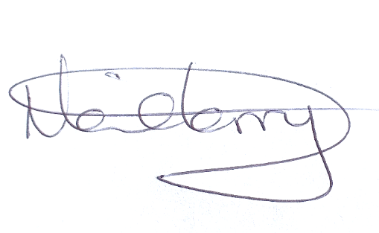
Neil Terry Date: 07/09/2026
Traffic Management and Network Manager

11. DECISION

As the officer holding the above delegation, I approve the progression of this Traffic Regulation Order.
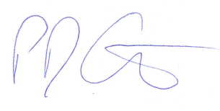
Paul Garrod Date: 08/09/2026
Head of Highways Delivery

Plan 1 – High Street, junction with Southlands, Weston, Bath – The No Parking At Any Time restrictions were requested by the Traffic Management Team to improve visibility splays around the junction.
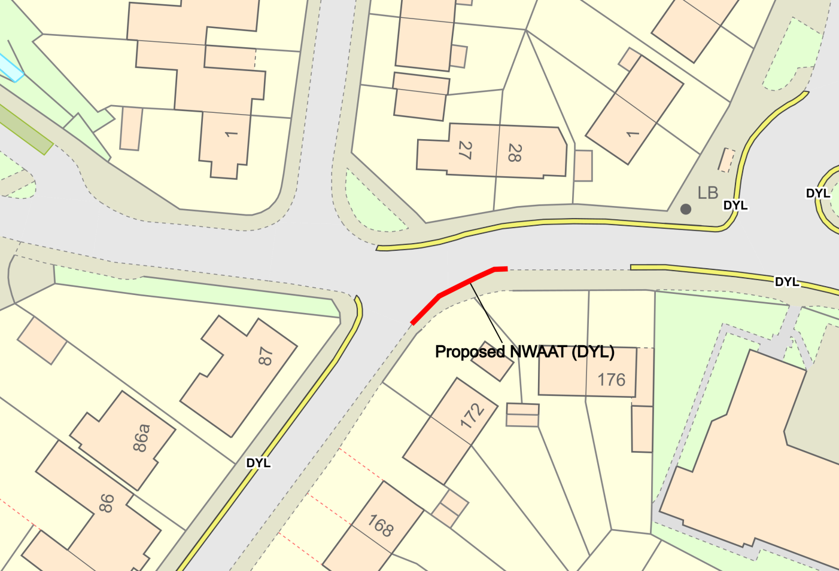

Plan 2 – Yomede Park, Newbridge, Bath – The No Parking At Any Time restrictions were requested by the local Ward Councillor to prevent obstruction around the junction due to parked vehicles.
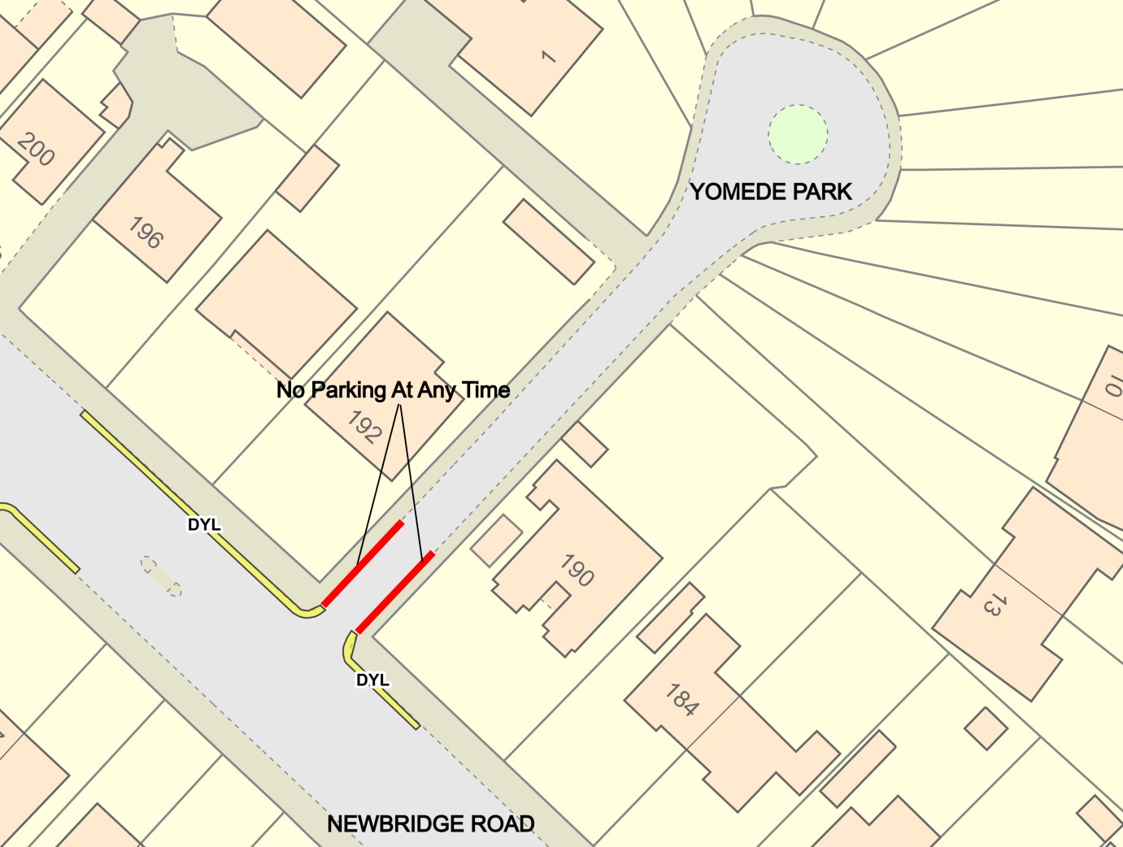

Plan 3 – High Street, Weston, Bath – The extension of the existing No Parking At Any Time restrictions and shortening of the parking bay was requested by the local Ward Councillors to improve access to Belton Court.
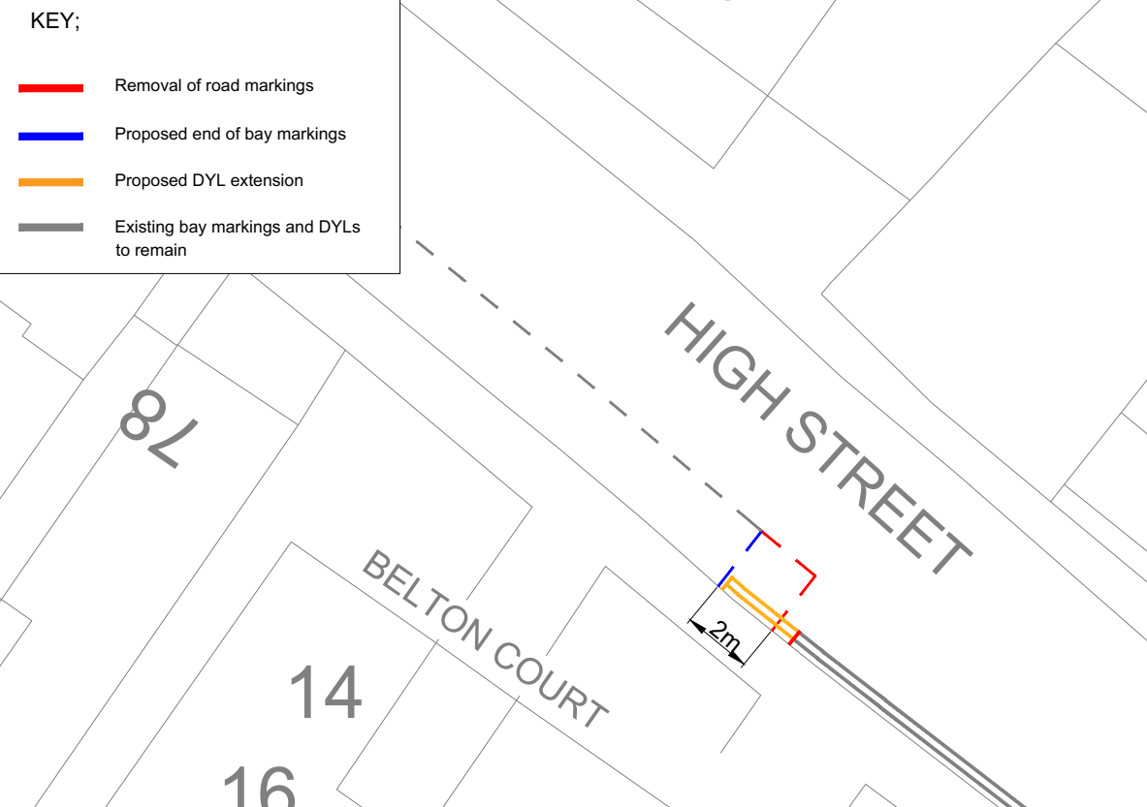

Plan 4 – Chandler Close, Weston, Bath – The conversion of the existing advisory Disabled Parking bays into enforceable Blue Badge Holders Only parking bays was requested by the Parking Services Team to allow enforcement of these bays to be carried out.
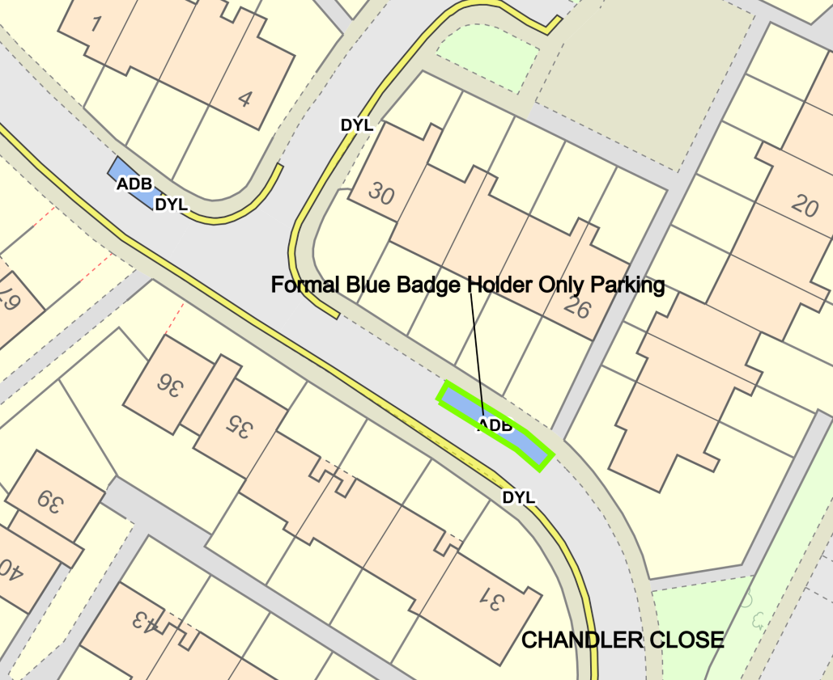
Plan 5 – Alpine Gardens, Walcot Bath – The extension of the existing No Parking At Any Time restrictions and removal of the parking bay was requested by the local Ward Councillor to prevent obstruction due to the narrow width of the highway.
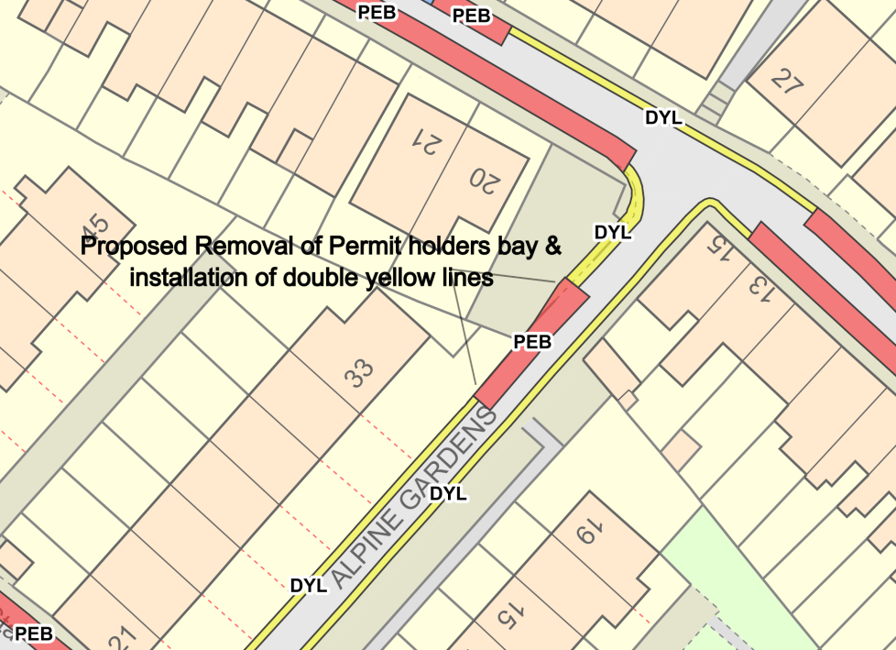

Plan 6 – Greenbank Gardens, Upper Weston, Bath – The No Parking At Any Time restrictions were requested by the local Ward Councillors to prevent obstruction of the highway due to parked vehicles on the existing advisory White Keep Clear markings.
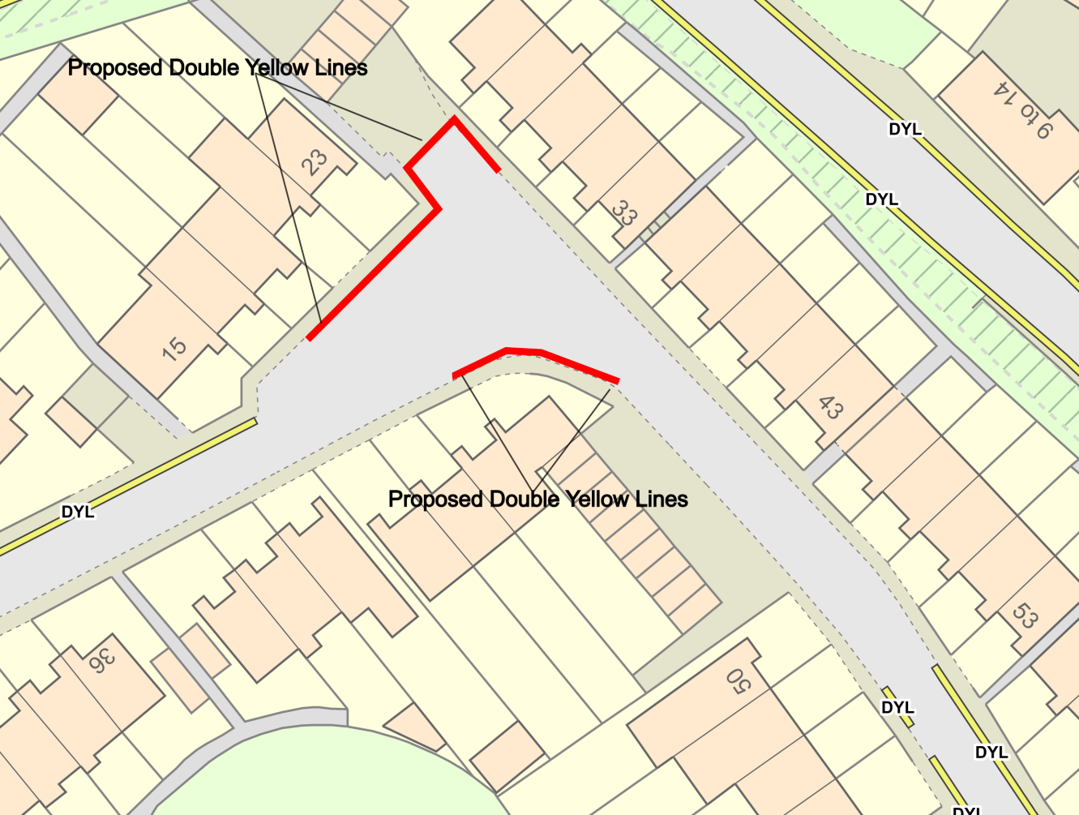
Plan 7 – Southlands, Upper Weston, Bath – The No Parking At Any Time restrictions were requested by the local Ward Councillors to prevent obstruction around the junction due to parked vehicles.
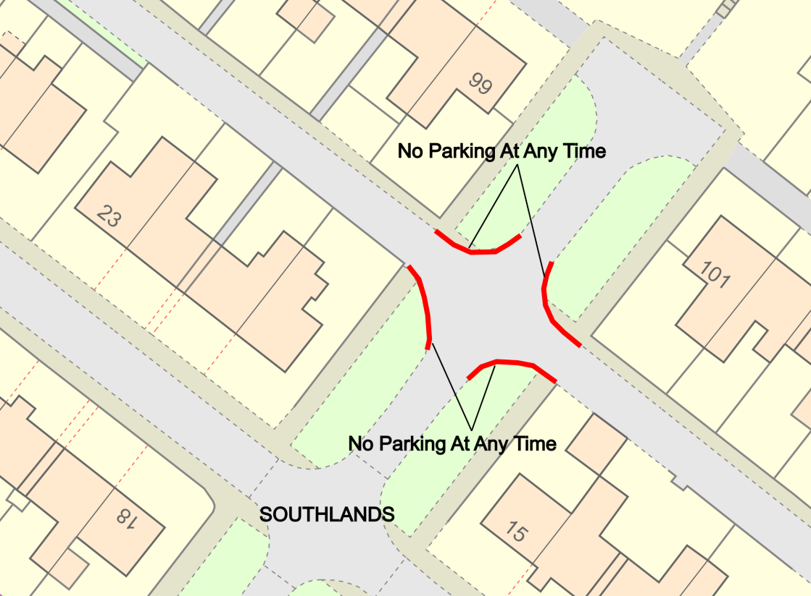

Plan 8 – Southlands, Upper Weston, Bath – The No Parking At Any Time restrictions were requested by the local Ward Councillors to prevent obstruction around the junction and bend due to parked vehicles.
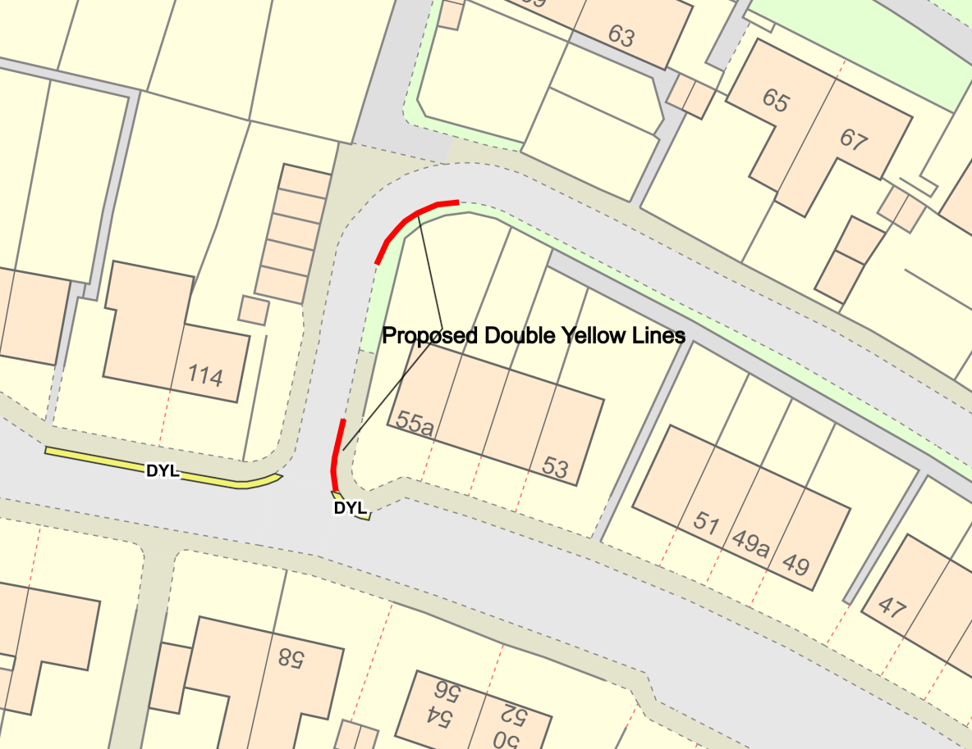

Plan 9 – Foxcombe Road, Newbridge, Bath – The removal of the existing Advisory Disabled Parking Bay and extension of the dual use Permit Holder / Limited Waiting Bay was requested by the local Ward Councillor to provide more on-street parking provision for local residents as the Disabled Bay is no longer required.
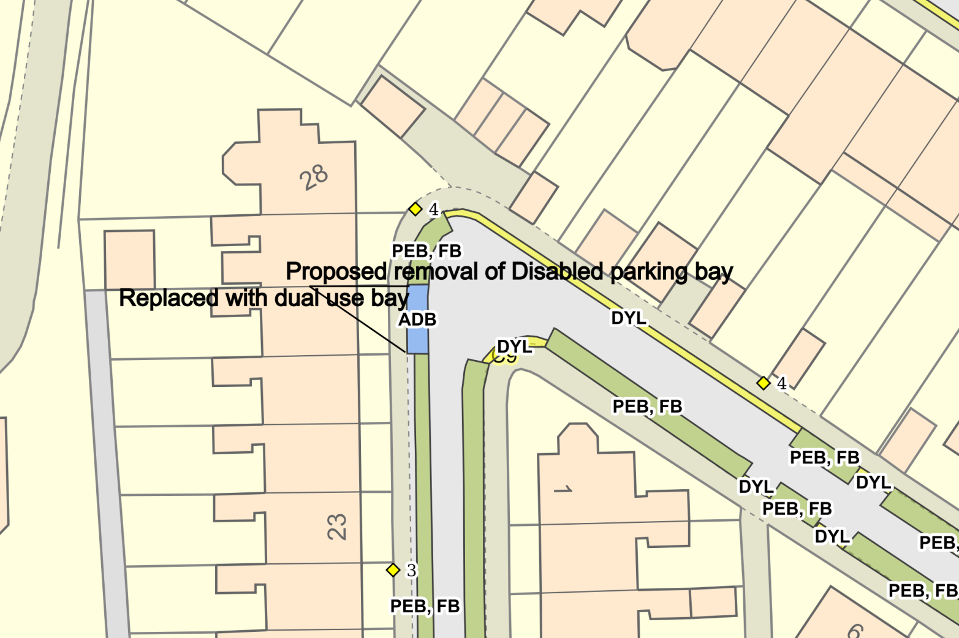

Plan 10 – Lansdown Road, Bath – The Red Route Clearway was requested by the Traffic Management Team to prevent obstruction of this key route due to parked vehicles.
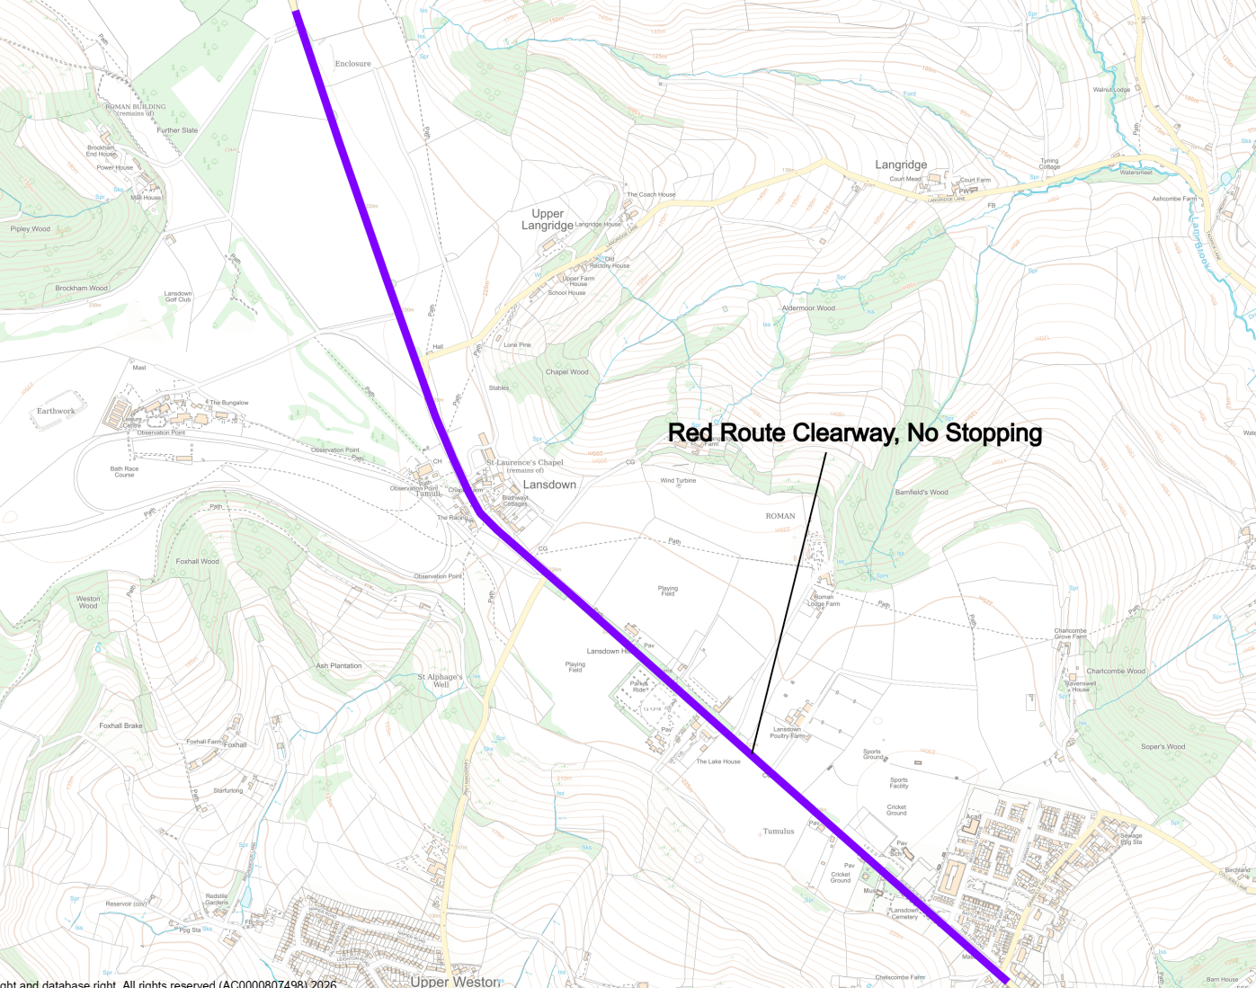
Plan 11 – Homelea Park East, Newbridge, Bath – The No Parking At Any Time restrictions were requested by the local Ward Councillor to prevent obstruction around the junction and bend due to parked vehicles.
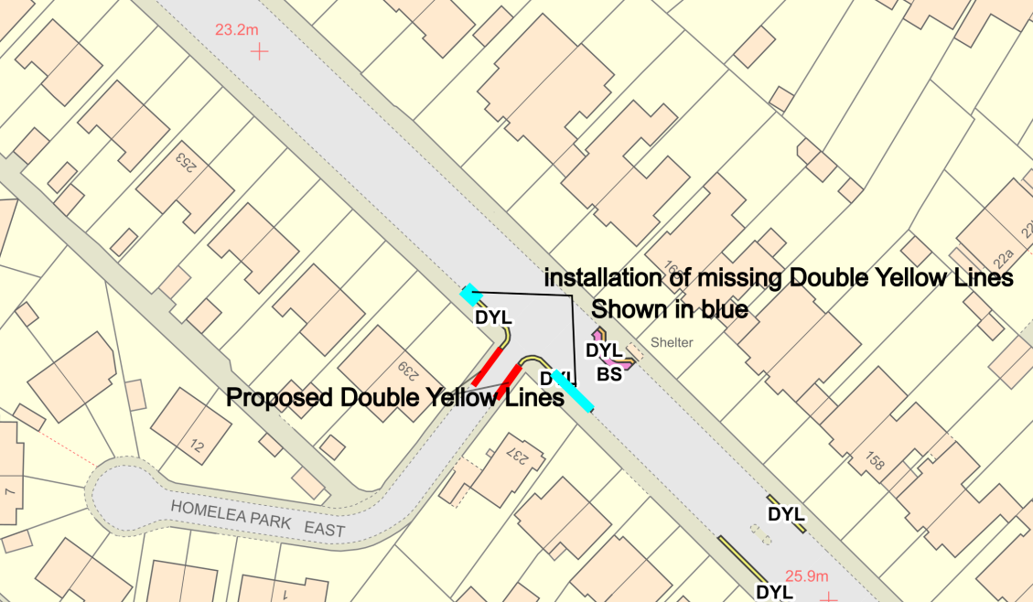

Plan 12 – Removed.

Plan 13 – Cranwells Park, Bath – The No Parking Between 10am – 4pm, Monday – Friday and 3 Hour Limited Waiting Bays, operating 10am – 4pm, Monday – Friday were requested by the local Ward Members and Cabinet Member to improve on-street parking provision for local residents and remove the commuter parking issue which leads to obstruction of the highway.
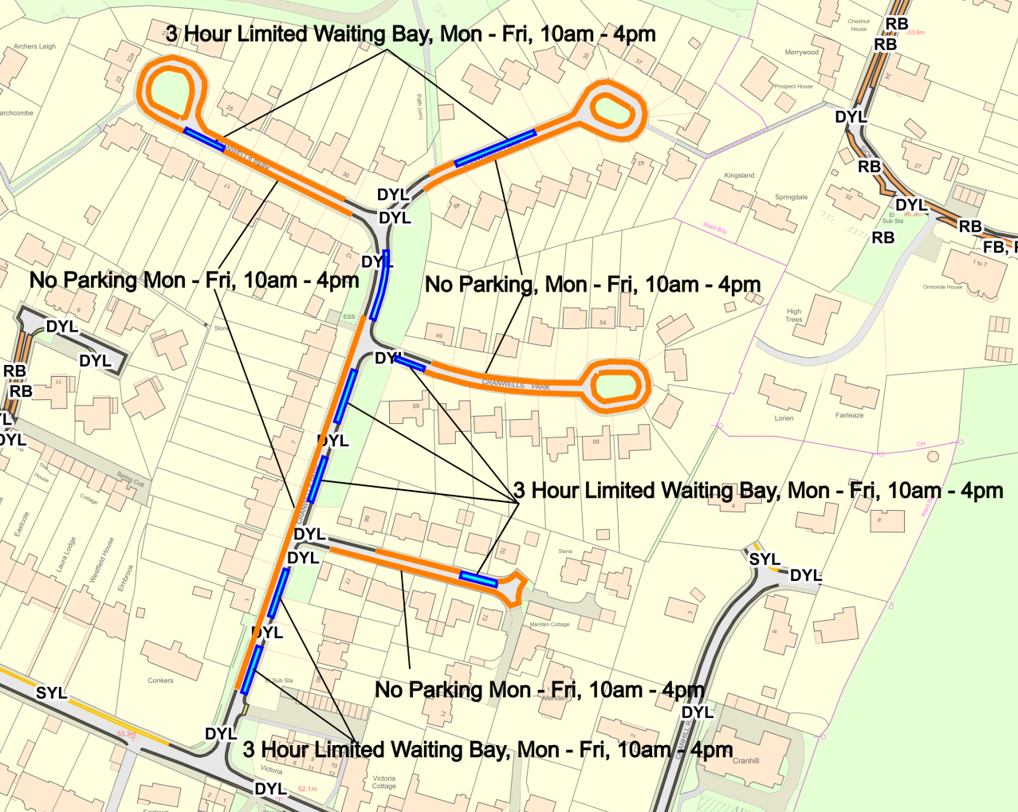
Plan 14 – Sion Road, Lansdown, Bath – The No Parking At Any Time restrictions were requested by the local Ward Councillor to create greater opportunities for motorists to safely pass opposing vehicles.
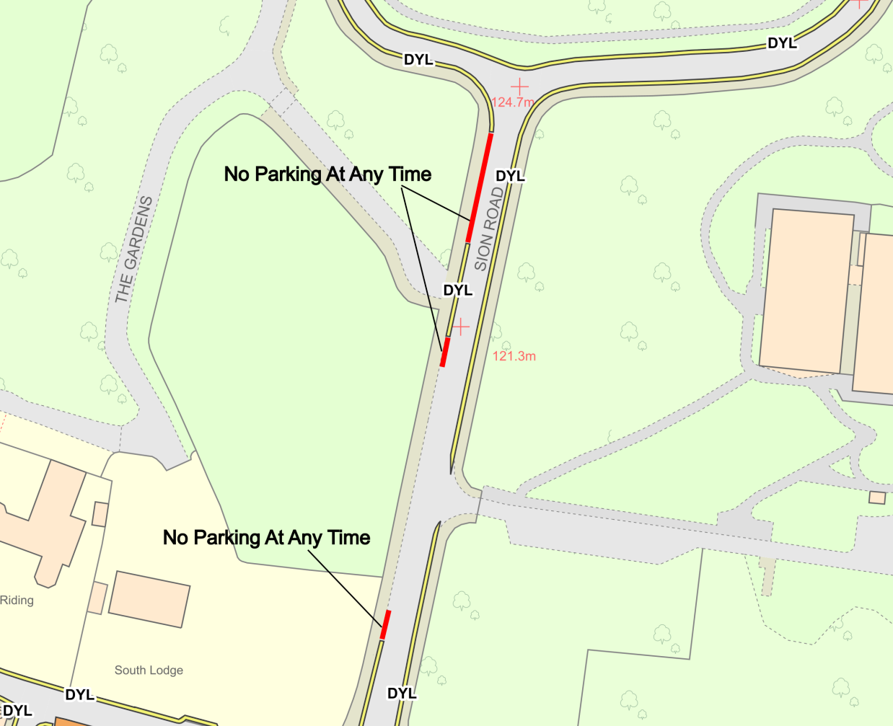

Plan 15 – Removed.

Plan 16 – Sion Hill, Lansdown, Bath – The extension of the existing No Parking At Any Time restrictions and reduction of the Permit Holder Bay was requested by the local Ward Councillor to prevent obstruction of the highway when vehicles are turning out from Sion Road.
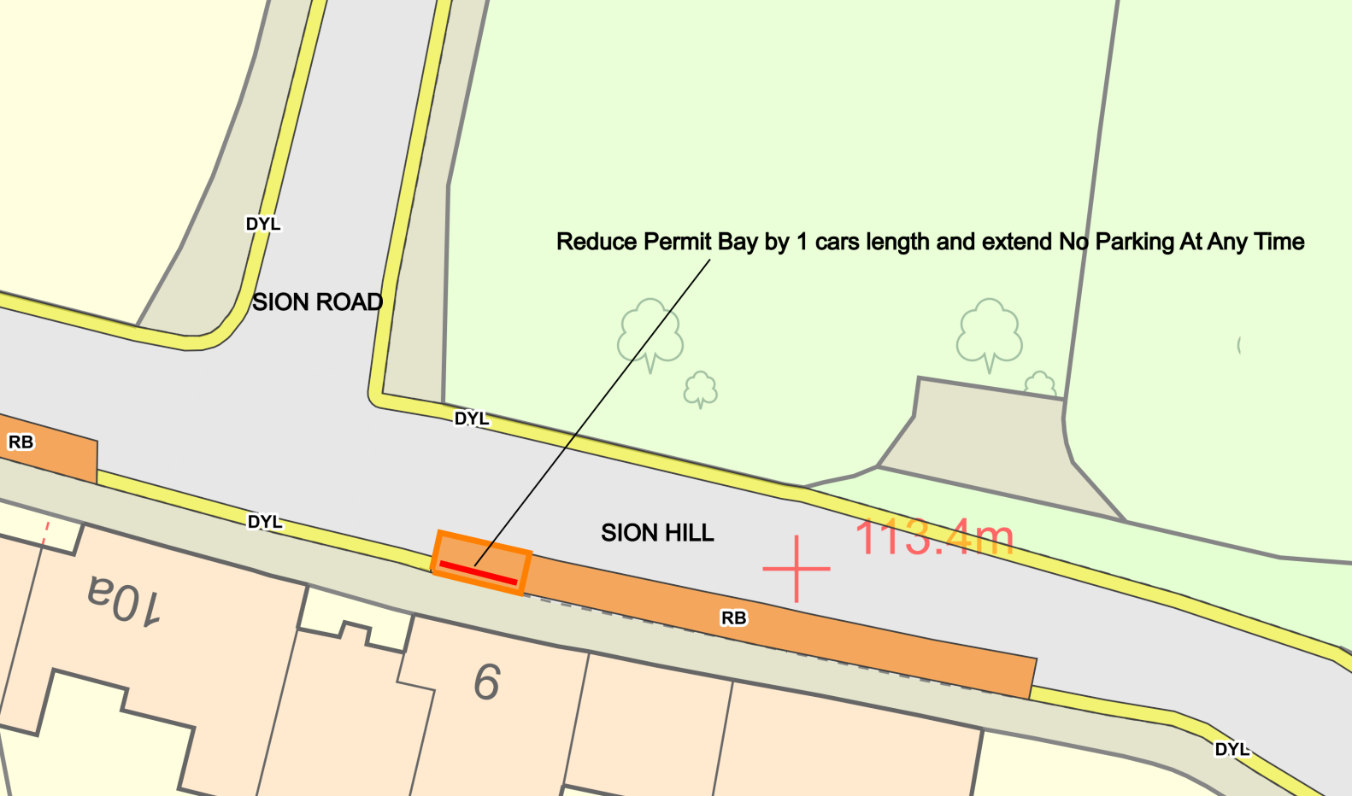
Plan 17 – Cavendish Road, Lansdown, Bath – The extension of the existing No Parking At Any Time restrictions and reduction of the Permit Holder Bays was requested by the local Ward Councillor to prevent obstruction of the highway and improve visibility splays.
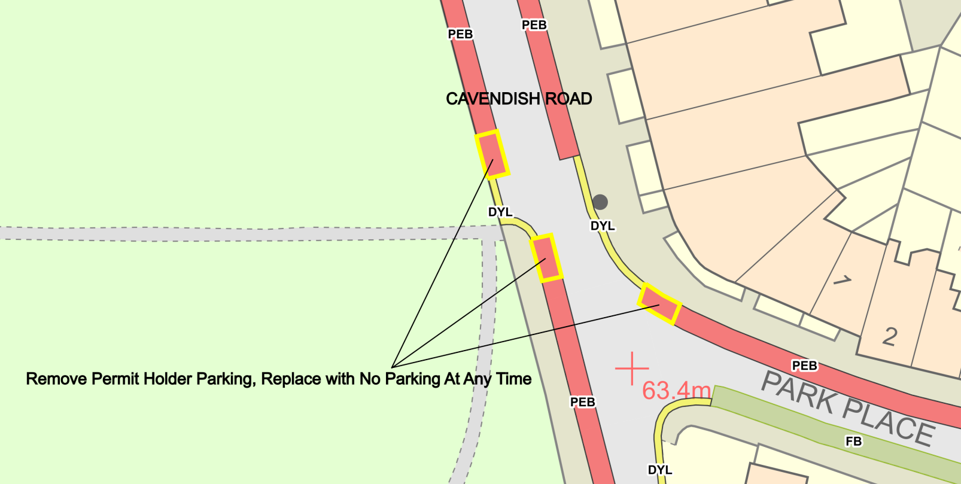

Plan 18 – Brookfield Park, Weston, Bath – The No Parking At Any Time restrictions were requested by the local Ward Councillor to prevent obstruction of and access to the highway due to parked vehicles.
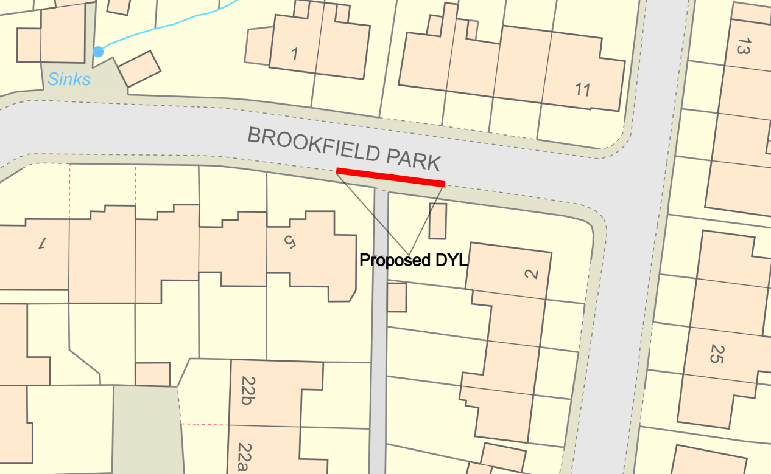

Plan 19 – Southlands, Weston, Bath – The enforceable Blue Badge Holders Only Disabled Parking bay was requested by the local Ward Councillor to prevent the misuse of the existing advisory Disabled Parking Bay in this location.
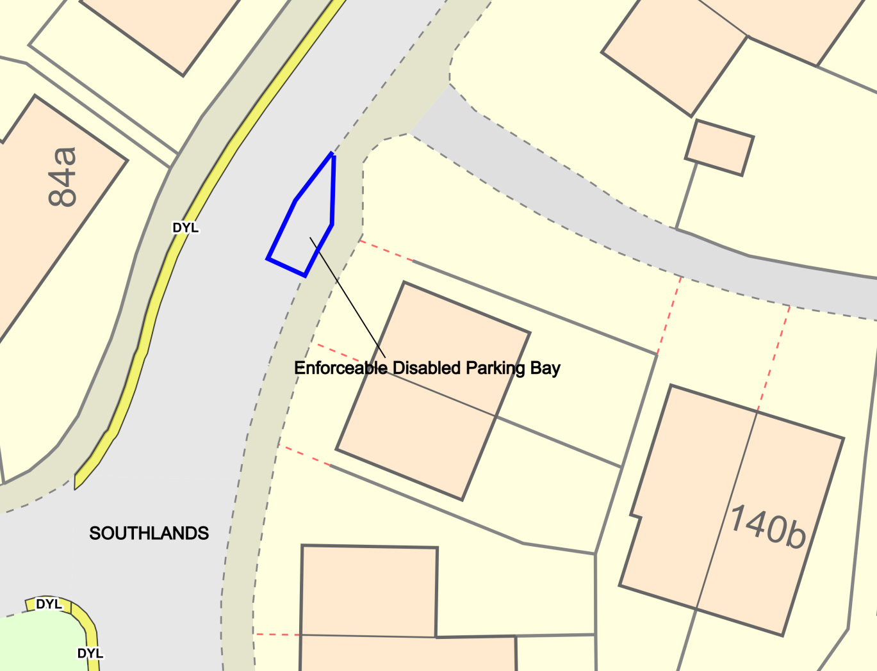

Plan 20 – Lansdown Road, Lansdown, Bath – The No Parking At Any Time restrictions were requested by the local Ward Councillor to prevent obstruction of and access to the highway due to parked vehicles.
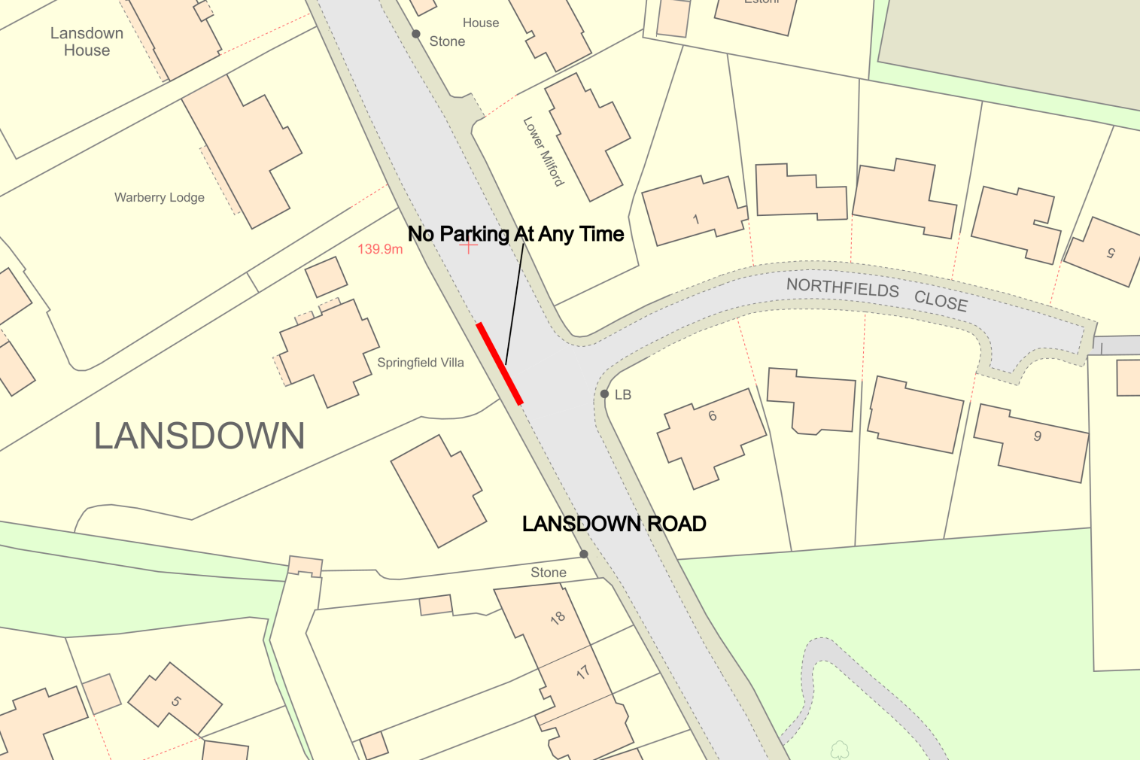

Plan 21 – Lower Bristol Road, Bath – The No Parking / Waiting / Loading At Any Time and Loading Only parking bay restrictions were requested by the Traffic Management Team to prevent obstruction of the highway and provide loading facilities within the area.

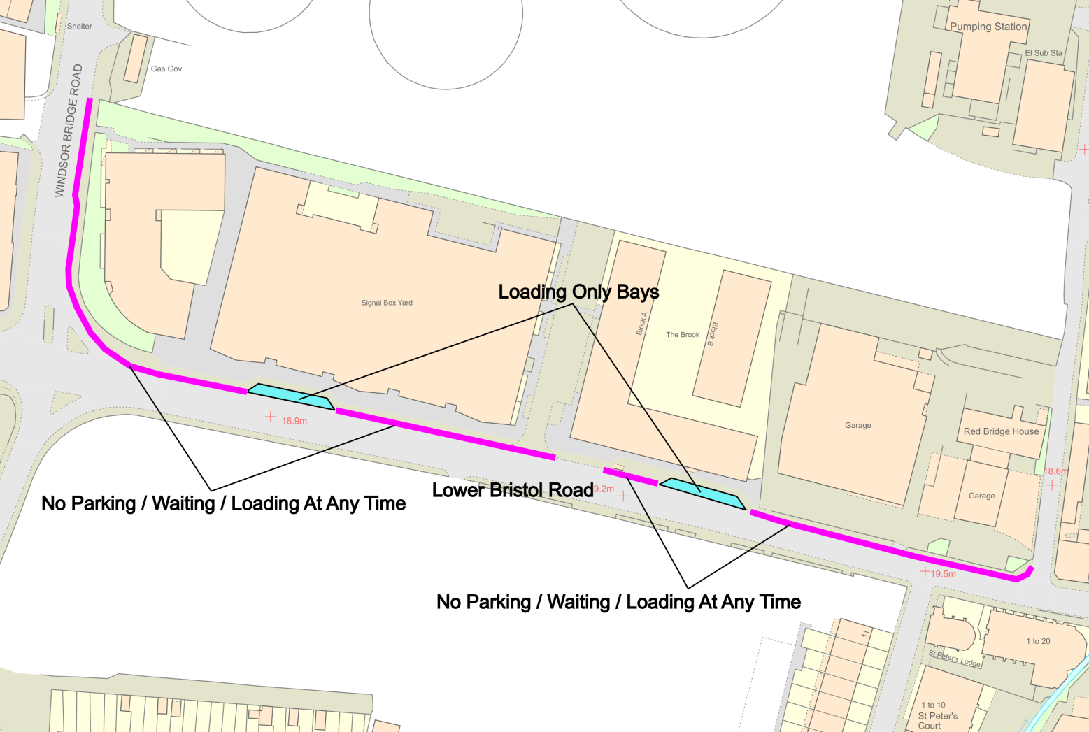

Plan 22 – Newbridge Road, Newbridge, Bath – The Blue Badge Holder Only Disabled Parking Bay was requested by the local Ward Councillor to prevent the current advisory bay being misused.
