
TRAFFIC PROPOSAL

Title of Proposal | BATH & NORTH EAST SOMERSET COUNCIL  (26-011) (WESTGATE BUILDINGS, BATH)  (PROHIBITION OF STOPPING, WAITING, LOADING AND PARKING PLACES) ORDER 2026
Reference TRO reference |  | 26-011
Closing date for Objections and Representations |  | 25th June 2026

NOTICE is given that the Bath and North East Somerset Council proposes to make an order under provisions contained in the Road Traffic Regulation Act 1984, the effect of which will be to introduce introduce the following variations to restrictions on Westgate Buildings, Bath.
- Bus Stop Clearway
- Introduce No Waiting No Loading At Any Time
- Relocation of Motorcycle parking bay
- Reduction of dual use parking bay to accommodate motorcycle bay
- Taxi Rank bays
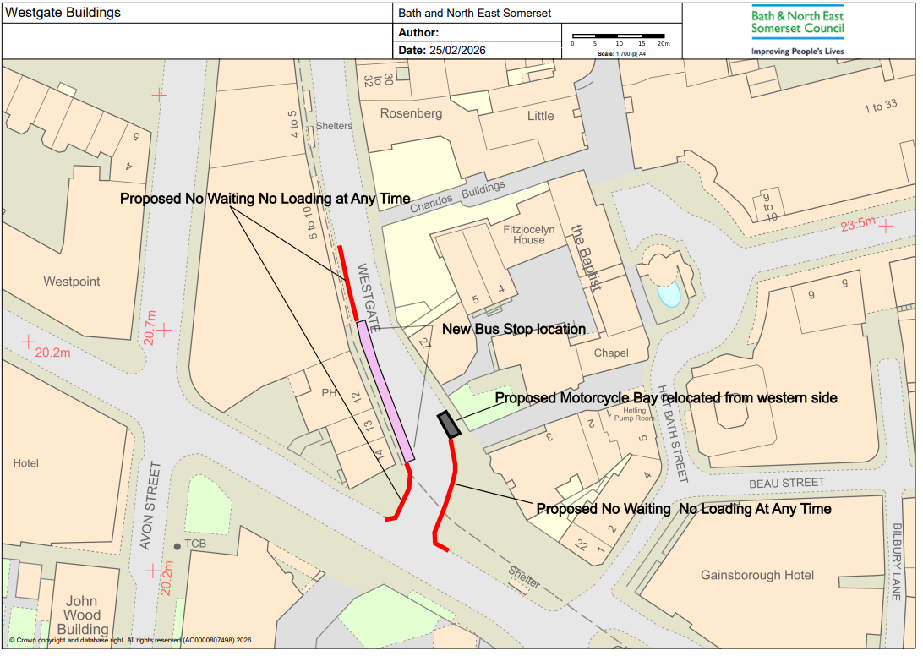
Full details of the proposals, together with a map and a Statement of the Council’s Reasons for proposing to make the order, may be inspected at the One Stop Shops at Manvers Street, Bath, The Hollies, High Street, Midsomer Norton and at the Civic Centre, Market Walk, Keynsham during normal office hours or may be requested, free of charge, by contacting by email council_connect@bathnes.gov.uk. The proposals may also be viewed on the Council’s website by searching for 26-011 on the webpage: www.bathnes.gov.uk/permanent-traffic-order-notices Or at: and selecting consultation 26-011 on the left-hand side of the screen.
Representations with respect to the proposal, together with the grounds on which they are made must be sent by 25th June 2026, by selecting consultation 26-011 at: https://consultation.appyway.com and completing the feedback form that can be seen in the bottom right-hand corner of the screen. Any enquiries can be submitted to email: TROs@bathnes.gov.uk Please quote the reference of the scheme: 26-011. Please note that all representations received may be considered in public by the Council and that the substance of any representation, together with the name and address of the person making it, could become available for public inspection.
Chris Major
Director of Place Management
Bath & North East Somerset Council
Dated: 4th June 2026
Traffic Management Team
Bath and North East Somerset Council
Lewis House, Manvers Street,
Bath, BA1 1JG

