TRAFFIC PROPOSAL

BATH AND NORTH EAST SOMERSET COUNCIL

PEDESTRIAN CROSSING (ZEBRA) AND SPEED TABLES
HIGH STREET, KEYNSHAM 201*

Reference: 21-005

Closing date for Objections and Representations | 16th December 2021

NOTICE is given that Bath and North East Somerset Council, in exercise of its powers conferred by section 23 of the Road Traffic Regulation Act 1984, and Sections 90A and 90C of the Highways Act 1980 and the Highways (Road Humps) Regulations 1999, proposes to introduce a zebra crossing and road humps in the High Street, Keynsham, as specified in the Schedules to this Notice.

The drawings and a Statement of the Council’s Reasons for proposing to make the Orders may also be inspected at the Councils’ One Stop Shops during normal office hours. The proposals may also be viewed on the Council’s website: www.bathnes.gov.uk, by searching for the reference number above.

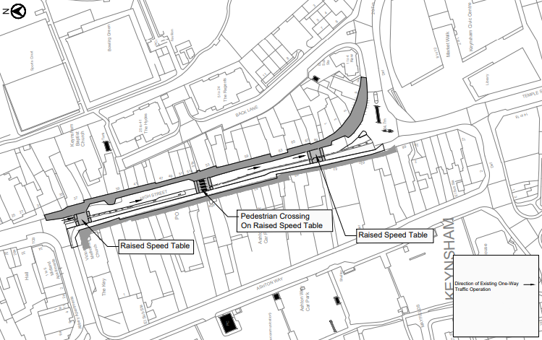

Objections and representations with respect to the proposals, together with the grounds on which they are made, must be sent in writing by the above date to the Council at the following addresses: Traffic Management Team, Bath and North East Somerset Council, Lewis House, Manvers Street, BATH, BA1 1JG or transportation@bathnes.gov.uk

Please quote the title and reference as shown above.

Please note that all representations received may be considered in public by the Council and that the substance of any comments, together with the name and address of the person making it, could become available for public inspection.

Traffic Management Team
Tel No: (01225) 394041
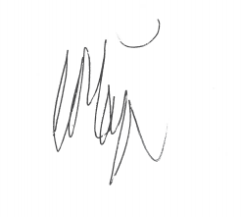
Chris Major
Director of Place Management
Bath & North East Somerset Council
Dated: 25th November 2021

SCHEDULES

PEDESTRIAN CROSSING

Road  High Street,  Keynsham | Type of Crossing  Zebra | Location  Centred on a point approximately 83 metres south of the centre of its junction with Charlton Road

ROAD HUMPS

Road | Type of Road Hump | Location
High Street,
Keynsham

Table 1 | 6 metre long raised table | Centred on a point approximately 13 metres south of the centre of its junction with Charlton Road
Table 2 | 6 metre long raised table | Centred on a point approximately 83 metres south of the centre of its junction with Charlton Road
Table 3 | 6 metre long raised table | Centred on a point approximately 148 metres south of the centre of its junction with Charlton Road

