Notice under Section 91 of the Localism Act 2011

10th July 2023

The Star Inn, High Street, High Littleton, Bristol, BS39 6HX, into Bath & North East Somerset Council’s list of Assets of Community Value

- Background

On 2nd May 2017 Bath & North East Somerset Council (‘the Council’) received a nomination under Section 89 of the Localism Act 2011 (‘the Act’) to list The Star Inn, High Street, High Littleton, Bristol, BS39 6HX as an Asset of Community Value. High Littleton Parish Council made the nomination. A map setting out the boundaries of the asset nominated to be listed (‘The Asset’) is provided as an Appendix to this notice.

Under Section 87 of the Act the Council must maintain a list of assets of community value.

Section 88 of the Act states that

(1) For the purposes of this Chapter but subject to regulations under subsection (3), a building or other land in a local authority’s area is land of community value if in the opinion of the authority—
(a) an actual current use of the building or other land that is not an ancillary use furthers the social wellbeing or social interests of the local community, and
(b) it is realistic to think that there can continue to be non-ancillary use of the building or other land which will further (whether or not in the same way) the social wellbeing or social interests of the local community.

(2) For the purposes of this Chapter but subject to regulations under subsection (3), a building or other land in a local authority’s area that is not land of community value as a result of subsection (1) is land of community value if in the opinion of the local authority—
(a) there is a time in the recent past when an actual use of the building or other land that was not an ancillary use furthered the social wellbeing or interests of the local community, and
(b) it is realistic to think that there is a time in the next five years when there could be non-ancillary use of the building or other land that would further (whether or not in the same way as before) the social wellbeing or social interests of the local community.

Under Section 89 of the Act, the Council can only enter assets into the list of Assets of Community Value in response to community nomination.

- Decision-Making Process
The Council’s Cabinet on October 10th, 2012, resolved to agree that:

2.1 Decision-making in response to nominations for entry into the List of Assets of Community Value under the Localism Act 2011 be delegated to the Director of People & Policy
(And, in the event of this Director having a conflict of interest, to a director nominated by the Corporate Director), drawing on the decision-making guidance as set out in Appendix One (of the report)
2.2 The Director of People & Policy be delegated decision-making with regard to updating this guidance, in consultation with the Council Leader, in response to experience of implementing the provisions, new regulations and emerging case law
2.3 The internal review process in relation to listing be undertaken by a director not involved in the initial decision
2.4 The Director for Property Services be delegated to make arrangements relating to the procedures following listing, including moratorium and compensation provisions, as set out in Appendix Two (of the report)

In accordance with this decision, the Director of People & Policy has now fully considered the nomination in light of the Act and the Assets of Community Value (England) Regulations 2012 (“the Regulations”). Following this consideration, the Director of People & Policy has decided to enter the property into its list of Assets of Community Value.

This decision has been taken because:

(1)
a) The Asset lies within the administrative boundaries of Bath & North East Somerset Council and the parish of High Littleton
b) High Littleton Parish Council is entitled under 89(2)b)(iii) of the Act to make a community nomination in respect of the Asset
c) The nomination from High Littleton Parish Council includes the matters required under Regulation 6 of the Regulations
(d) The Asset does not fall within a description of land which may not be listed as specified in Schedule 1 of the Regulations

and

(2) in the opinion of the Authority,

(a)The actual current use of the Asset that is not an ancillary use furthers the social wellbeing and interests of the local community.
(b) Given that the Asset remains fit for purpose to further the social interest and social wellbeing of the local community, and considering also that there are examples of similar and comparable assets serving these interests, it is realistic to think that the current non-ancillary use of the Asset will continue to further (whether or not in the same way as before) the social wellbeing or social interests of the local community.

The detailed assessment on which this decision is based, following the criteria adopted by the Council Cabinet on 10th October 2012, and fully considering information supplied by the nominee and other parties (including the owner), is set out in 4 below.

- What Happens Next
The Asset will now be placed on the list of Assets of Community Value which the Council is required to maintain under Section 87 of the Act.

In accordance with Section 91 of the Localism Act the Council will send this notice to:

The owner of the property
The occupier of the property
High Littleton Parish Council

The information will also be published on the Council’s website. The Asset will remain on the Council’s List of Assets of Community Value for a period of five years from the date of this notice unless removed with effect from some earlier time in accordance with the provisions of the regulations.

The Localism Act 2011 requires that the Council draw particular attention to the following:

(a) the consequences for the land and its owner of the land’s inclusion in the list, and

(b) the right to ask for review

The consequences for the land and its owner of the land’s inclusion in the list
Inclusion of assets on the List of Assets of Community Value is a local land charge under the Local Land Charges Act 1975. The Council is required under Schedule 4 of the Regulations to apply to the Land Registry for a restriction to be added to the registered title of the land that “no transfer or lease is to be registered without a certificate signed by a conveyancer that the transfer or lease did not contravene Section 95(1) of the Localism Act 2011”.

Under Section 95 of the Act an owner must notify the Council (at the following address: Director, Property Services, Lewis House, Manvers Street, Bath BA1 1JG) if they wish to enter into a relevant disposal (as defined in Section 96 of the Act) of that asset. Some types of disposal of listed assets are exempt and these are set out in full in Annex A of the document Community Right to Bid: Non-statutory advice note for local authorities. Annex A also identifies circumstances where, although there is no requirement in the legislation that the owner has to explain to the local authority that the disposal is exempt, it would be helpful for them to do so.

A moratorium period is triggered by notification under Section 95 to allow a Community Interest Group to submit a written request to be treated as a potential bidder for the asset. The owner is advised to refer to Part 5 Chapter 3 of the Act and the Regulations in full and to seek legal advice if they wish to dispose of the asset. A disposal of listed land which contravenes the Regulations and Act will be ineffective.

The owner of the asset does not have to sell the asset to the Community Interest Group. There is also a ‘protected period’ (18 months from the time that the owner notified the local authority of their intention to dispose of the asset) and during this time there can be no further moratoriums on sale and the owner is free to dispose of the property as they see fit.

The right to ask for review
Asset owners have the opportunity to request a review of the decision to enter an asset on the List of Assets of Community Value, within 8 weeks of listing. The internal review process in relation to listing will be undertaken by a director not involved in the initial decision.

Landowners wishing to request a review of the decision should do so in writing to the above address or to assets@bathnes.gov.uk by 7th September 2023, setting out the grounds for review and whether they are requesting an oral hearing.

Private owners may claim compensation for loss and expense incurred through the asset being listed including a claim arising from a period of delay in entering into a binding agreement to sell which is wholly caused by the interim or full moratorium period. Regulation 14 of the Regulations contains more detail on this.

Part 5, Chapter 3 of the Localism Act 2011 and the Assets of Community Value (England) Regulations provide further detailed information.

- Detailed Assessment of the Nomination of The Star Inn, High Street, High Littleton, Bristol, BS39 6HX, as an Asset of Community Value

Assets of Community Value Nomination – Assessment

DATE OF SUBMISSION: | 17/05/2023 | DATE DECISION TO BE MADE BY: | 10/07/2023
NOMINATED ASSET: | The Star Inn: High Street, High Littleton, Bristol, BS39 6HX The boundary of the asset is set out in the map which has been provided.
NOMINATION SUBMITTED BY: | High Littleton Parish Council

STEP A: This section considers the eligibility of the nominating body to make a nomination and of the asset to be an Asset of Community Value. It does this through a series of YES/NO ANSWERS

A1. Is the nominating organisation an eligible body to nominate?
Evidence supplied by nominee: | Mr Simon Gould  High Littleton Parish Council  18 Claremont Gardens  Hallatrow  Bristol  BS39 6EY
Feedback from other parties and other information gained in relation to this criterion: | None
Score (YES/NO) and any comments: | YES - The Council is satisfied that the nominating body is a parish council and is an eligible body to nominate.

A2. Does the nominating body have a local connection to the asset nominated?
Evidence supplied by nominee: | The asset is within the Parish of High Littleton.
Feedback from other parties and other information gained in relation to this criterion | Ward Councillor Ann Morgan stated, “ If it is a useful part of the community, I think this is a good idea.”  The Parish Council have included within their minutes that they would be making the nomination for The Star Inn.
Score (YES/NO) and any comments: | YES- The Council is satisfied that the nominating organisation has a local connection to the nominated asset.

A3. Does the nomination include the required information about the asset?
- Description of the nominated land including its proposed boundaries
- Names of current occupants of the land
- Names and current or last-known addresses of all those holding a freehold or leasehold estate in the land
Evidence supplied by nominee: | The asset is owned by Admiral Taverns:  Admiral Taverns, 4th Floor, HQ Building, 58 Nicholas Street, Chester, CH1 2NP  T: 01244 321 171  The current leaseholder can be contacted at the Star Inn:  High Street, High Littleton, Bristol, BS39 6HX  T: 01761 479766  The boundary of the asset is defined by the property boundary (i.e., pub buildings, car park and gardens).  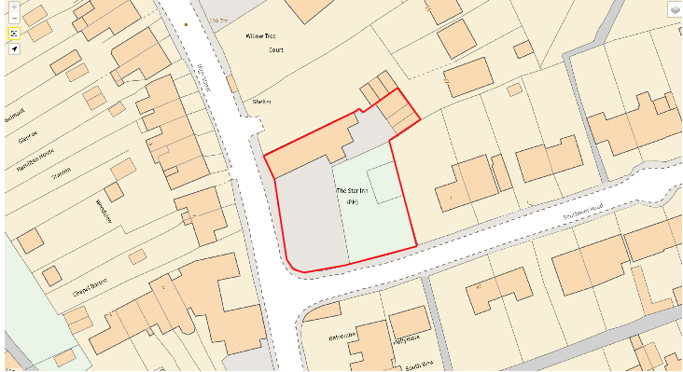  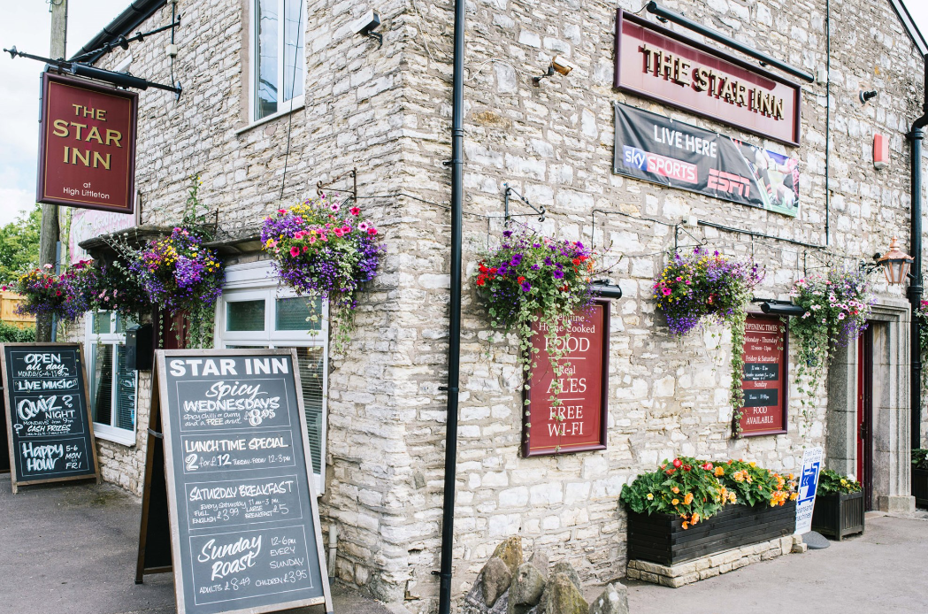
Feedback from other parties and other information gained in relation to this criterion: | None
Score (YES/NO) and any comments: | YES- the Council is satisfied that the nomination has included the required information about the asset.

A4. Is the nominated asset outside of one of the categories that cannot be assets of community value (as set out in Schedule 1 of the Assets of Community Value (England) Regulations 2012):
- A residence together with land connected with that residence
- Land in respect of which a site licence is required under Part 1 of the Caravan Sites and Control of Development Act 1960
- Operational land as defined in section 263 of the Town and Country Planning Act 1990.
Evidence supplied by nominee: | Nomination and supporting evidence sufficiently demonstrates that the asset is outside of the categories of assets within Schedule 1 of the Regulations
Feedback from other parties and other information gained in relation to this criterion: | None
Score (YES/NO) and any comments | YES- the Council is satisfied that the nomination is outside of one of the categories that cannot be assets of community value.

If YES to all of Part A, move on to Step B. If NO to one or more parts, please inform the nominator that the nomination is ineligible. Place nomination on list of unsuccessful nominations.

STEP B: This section considers the current or recent usage of the asset. It does this through a YES/NO answer and an identification as to whether the use is current or in the “recent past”

B1. Is the current or recent usage which is the subject of the nomination an actual and non-ancillary usage?
- NOTE 1: A working definition of “recent past” is “within the past three years”
- NOTE 2: A working definition of “non-ancillary” is that the usage is not providing necessary support (e.g., cleaning) to the primary activities carried out in the asset, but is itself a primary, additional, or complementary use.
Evidence supplied by nominee: | The asset is the only Public House in the village of High Littleton.
Feedback from other parties and other information gained in relation to this criterion: | None
Score (YES/NO) and any comments: | YES- the current usage which is the subject of the nomination is an actual and non-ancillary usage.  The next nearest public house is 1.3 miles away - The Old Station Inn, Wells Road Hallatrow.

If the current or recent usage that is the subject of the nomination is actual and non-ancillary, go to Step C. If not, place on the list of unsuccessful nominations.

STEP C: This section considers whether the use furthers (for current uses) or furthered (for uses in the recent past) the social interests or social wellbeing of the local community. It does this through a series of questions scored on the basis of evidence.

C1. Who benefits from the use?  - Does it meet the social interests of the community as a whole and not simply the users/customers of the specific service?  - Who will lose if the usage ceases? | Evidence provided by nominee | The pub is very much a locals’ pub, but always offers a warm welcome to visitors. Serving drinks and food to its customers, providing a relaxed place to meet with friends and families, a place to play traditional pub games or to relax in the garden while youngsters play,  The Star Inn is the social glue that binds the village. Without the pub, the social interests and sense of community would be fundamentally impacted for the worse.
 | Evidence gained from other relevant sources (owner, Ward member, Parish Council, B&NES Council) | The Star Inn has a website that shows they are open five days a week. The public house serve foods and is available for events.  The pub has a large beer garden with a safe children’s play area.
 | Enter score out of 25 and rationale | 12/25  High Littleton has only one public house. There is a recreation club and a fish and chip café and there are also a number of holiday lets in the area.  Overall, the public house meets the interests of the community as a whole by providing a welcoming and inclusive space for social interaction, organising community events, supporting local businesses, preserving cultural heritage, creating employment opportunities, fostering community engagement, and contributing to the overall well-being and vibrancy of the community.
C2. Is any aspect of the usage actively discouraged by the Council’s Policy and Budget Framework? | Evidence provided by nominee | No
 | Evidence gained from other relevant sources (owner, Ward member, Parish Council, B&NES Council) | None
 | Enter score out of 25 and rationale | 25 No aspect of the land or buildings usage is actively discouraged by B&NES Council’s Policy & Budget Framework.
C3. Why is the usage seen as having social value in the context of the community on whose behalf the nomination is being made? | Evidence provided by nominee | Located at the heart of the village, The Star Inn is very much a community pub, and the last remaining location in the village where families and friends can meet socially.  Day-to-day, the pub is an ever-present that defines the distinct culture of High Littleton – a community that is shaped by its rural roots, its coal-mining heritage and by the A39 road that links the community.  Entering the pub, any visitor would quickly gain a sense High Littleton’s culture by taking in the building and by listening to the chat of locals.  The pub is also the focal point for social gatherings around key events – e.g., Christmas celebrations and national sporting occasions – and for family celebrations.
 | Evidence gained from other relevant sources (owner, Ward member, Parish Council, B&NES Council) | None
 | Enter score out of 25 and rationale | 15/25  In summary, a pub's usage is seen as having social value in the context of the community because it facilitates social interaction, strengthens community cohesion, promotes cultural exchange, provides informal support networks, contributes to the local economy, and fosters community identity and pride.
C4. How strongly does the local community feel about the usage as furthering their social interests? | Evidence provided by nominee | The current landlord has decided to retire from the business and the property owner (Admiral Taverns) is currently seeking a new tenant.  While this nomination is submitted by the Parish Council, it is supported by the regular users of the pub who contacted the Parish Council to request it progresses this nomination.  It is clear that there is a strong sense of community within this group who have stated that they would consider purchasing and running the business as a going concern should the current owner’s attempts to find a new tenant fail.
 | Evidence gained from other relevant sources (owner, Ward member, Parish Council, B&NES Council)
 | Enter score out of 25 and rationale | 12/25  The community's feelings about the usage of their pub as furthering their social interests can vary based on several factors, including cultural norms, local traditions, demographics, and individual perspectives. However, in this community, the usage of a pub is regarded positive and seen as a valuable asset in furthering social interests.
Total score: | 64 /100

If STEP C meets a minimum scoring of 55%, go to Step D

STEP D: This section considers whether it is realistic to think that there can continue to be non-ancillary use of the building or other land which will further (whether or not in the same way) the social wellbeing or social interests of the local community.

For assets such as this where the actual non-ancillary usage is a current one (see Step B above), 88(1) (b) of the Localism Act requires the Council to consider whether in the opinion of the local authority it is realistic to think that there can continue to be non-ancillary use of the building or other land that will further (whether or not in the same way) the social wellbeing or social interests of the local community.

This will be considered through the following tests:

- If the asset is considered to remain fit for purpose (under D1 below), then this is considered to be sufficient grounds for thinking that it is realistic to think that continuing use of the asset will further the social wellbeing or social interests of the local community identified in Step C above.

- If the building is not considered to remain fit for purpose under D1, then an additional Test (under D2 below) will be applied to determine whether the asset could be made fit for purpose practically and within reasonable resource requirements and within timescales. The timescales to be applied for this to take place for assets with “recent usage” will be “within the next five years.”

D1. Has the building/land-take/space/legal requirement for this usage changed significantly since its initial use so that the asset is not fit for purpose?
Evidence supplied by nominee: | No.
Feedback from other parties and other information gained in relation to this criterion: | None
Score (YES/NO) and rationale | NO

If No to D1, place on register of Assets of Community Value, and do not go to D2. If Yes to D1, go to D2.

D2. Could the asset be made fit for purpose practically and within reasonable resource requirements and within timescales?
Evidence supplied by nominee: | Not Applicable
Feedback from other parties and other information gained in relation to this criteria: | Not Applicable
Score (YES/NO) and Rationale: | Not scored as NO answer to D1 above

If yes to D2, place on register of Assets of Community Value. If no to D2, place on list of unsuccessful nominations.

RECOMMENDATION: | THAT THIS ASSET BE PLACED ON THE ASSETS OF COMMUNITY VALUE
REASON FOR DECISION | (1)  a) The Asset lies within the administrative boundaries of Bath & North East Somerset and High Littleton Ward.  b) High Littleton Parish Council is entitled under 89(2)b)(iii) of the Act to make a community nomination in respect of the Asset  c) The nomination from High Littleton Parish Council includes the matters required under regulation 6 of the Regulations  (d) The Asset does not fall within a description of land which may not be listed as specified in Schedule 1 of the Regulations  and  (2) in the opinion of the authority,  (a) The current and recent use of the Asset that is not an ancillary use furthers the social wellbeing and interests of the local community  (b) Given that the Asset remains fit for purpose to further the social interest and social wellbeing of the local community, it is realistic to think that the current non-ancillary use of the Asset will continue to further (whether or not in the same way as before) the social wellbeing or social interests of the local community.
Decision Taken by | 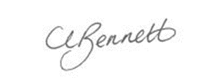  Cherry Bennett  Director of People & Policy  Bath & North East Somerset Council
Date | 10th July 2022

