Notice under Section 91 of the Localism Act 2011

1st June 2023

Entry of known as - The Ground Floor Area which includes the space occupied by Mardons Social Club and Teddy Bear (pre-school) - The Mardons Building, Mardons Close, Nightingale Estate, Westfield BA3 4NL into Bath & North East Somerset Council’s List of Assets of Community Value

- Background
On 6th April 2023, Bath & North East Somerset Council received a nomination under Section 89 of the Localism Act 2011 (“the Act”) to list Ground Floor Area which includes the space occupied by Mardons Social Club and Teddy Bear (pre-school) - The Mardons Building, Mardons Close, Nightingale Estate, Westfield BA3 4NL as an Asset of Community Value.

The nomination was made by Westfield Parish Council. A map setting out the boundaries of the asset nominated to be listed (“The Asset”) is provided as an Appendix to this notice.

Under Section 87 of the Act the Council must maintain a list of assets of community value.

Section 88 of the Act states that

(1) For the purposes of this Chapter but subject to regulations under subsection (3), a building or other land in a local authority’s area is land of community value if in the opinion of the authority—
(a) an actual current use of the building or other land that is not an ancillary use furthers the social wellbeing or social interests of the local community, and
(b) it is realistic to think that there can continue to be non-ancillary use of the building or other land which will further (whether or not in the same way) the social wellbeing or social interests of the local community.

(2) For the purposes of this Chapter but subject to regulations under subsection (3), a building or other land in a local authority’s area that is not land of community value as a result of subsection (1) is land of community value if in the opinion of the local authority—
(a) there is a time in the recent past when an actual use of the building or other land that was not an ancillary use furthered the social wellbeing or interests of the local community, and

(b) it is realistic to think that there is a time in the next five years when there could be non-ancillary use of the building or other land that would further (whether or not in the same way as before) the social wellbeing or social interests of the local community.

Under Section 89 of the Act, the Council can only enter assets into the list of Assets of Community Value in response to community nomination.

- Decision-Making Process
The Council’s Cabinet on October 10th, 2012, resolved to agree that:

2.1 Decision-making in response to nominations for entry into the List of Assets of Community Value under the Localism Act 2011 be delegated to the Director of People & Policy
(And, in the event of this Director having a conflict of interest, to a director nominated by the Corporate Director), drawing on the decision-making guidance as set out in Appendix One (of the report)
2.2 The Director of People & Policy be delegated decision-making with regard to updating this guidance, in consultation with the Council Leader, in response to experience of implementing the provisions, new regulations and emerging case law
2.3 The internal review process in relation to listing be undertaken by a director not involved in the initial decision
2.4 The Director for Property Services be delegated to decide relating to the procedures following listing, including moratorium and compensation provisions, as set out in Appendix Two (of the report)

In accordance with this decision, the Director of People & Policy has now fully considered the nomination in light of the Act and the Assets of Community Value (England) Regulations 2012 (“the Regulations”). Following this consideration, the Director of People & Policy has decided to enter the property into its list of Assets of Community Value.

This decision has been taken because:

(1)
a) The Asset lies within the administrative boundaries of Bath & North East Somerset Council and the parish of Westfield
b) Westfield Parish Council is entitled under 89(2)b)(iii) of the Act to make a community nomination in respect of the Asset
c) The nomination from Westfield Parish Council includes the matters required under Regulation 6 of the Regulations
(d) The Asset does not fall within a description of land which may not be listed as specified in Schedule 1 of the Regulations

and

(2) in the opinion of the Authority,

(a)The actual current use of the Asset that is not an ancillary use furthers the social wellbeing and interests of the local community.
(b) Given that the Asset remains fit for purpose to further the social interest and social wellbeing of the local community and considering also that there are examples of similar and comparable assets serving these interests, it is realistic to think that the current non-ancillary use of the Asset will continue to further (whether or not in the same way as before) the social wellbeing or social interests of the local community.

The detailed assessment on which this decision is based, following the criteria adopted by the Council Cabinet on 10th October 2012, and fully considering information supplied by the nominee and other parties (including the owner), is set out in 4 below.

- What Happens Next
The Asset will now be placed on the list of Assets of Community Value which the Council is required to maintain under Section 87 of the Act.

In accordance with Section 91 of the Localism Act the Council will send this notice to:

- The owner of the property
- The occupier of the property
- Westfield Parish Council

The information will also be published on the Council’s website. The Asset will remain on the Council’s List of Assets of Community Value for a period of five years from the date of this notice unless removed with effect from some earlier time in accordance with the provisions of the regulations.

The Localism Act 2011 requires that the Council draw particular attention to the following:

(a) the consequences for the land and its owner of the land’s inclusion in the list, and

(b) the right to ask for review

The consequences for the land and its owner of the land’s inclusion in the list
Inclusion of assets on the List of Assets of Community Value is a local land charge under the Local Land Charges Act 1975. The Council is required under Schedule 4 of the Regulations to apply to the Land Registry for a restriction to be added to the registered title of the land that “no transfer or lease is to be registered without a certificate signed by a conveyancer that the transfer or lease did not contravene Section 95(1) of the Localism Act 2011”.

Under Section 95 of the Act an owner must notify the Council (at the following address: Director, Property Services, Lewis House, Manvers Street, Bath BA1 1JG) if they wish to enter into a relevant disposal (as defined in Section 96 of the Act) of that asset. Some types of disposals of listed assets are exempt and these are set out in full in Annex A of the document Community Right to Bid: Non-statutory advice note for local authorities. Annex A also identifies circumstances where, although there is no requirement in the legislation that the owner has to explain to the local authority that the disposal is exempt, it would be helpful for them to do so.

A moratorium period is triggered by notification under Section 95 to allow a Community Interest Group to submit a written request to be treated as a potential bidder for the asset. The owner is advised to refer to Part 5 Chapter 3 of the Act and the Regulations in full and to seek legal advice if they wish to dispose of the asset. A disposal of listed land which contravenes the Regulations and Act will be ineffective.

The owner of the asset does not have to sell the asset to the Community Interest Group. There is also a ‘protected period’ (18 months from the time that the owner notified the local authority of their intention to dispose of the asset) and during this time there can be no further moratoriums on sale and the owner is free to dispose of the property as they see fit.

The right to ask for review
Asset owners have the opportunity to request a review of the decision to enter an asset on the List of Assets of Community Value, within 8 weeks of listing. The internal review process in relation to listing will be undertaken by a director not involved in the initial decision.

Landowners wishing to request a review of the decision should do so in writing to the above address or to assets@bathnes.gov.uk by 27th July 2023, setting out the grounds for review and whether they are requesting an oral hearing.

Private owners may claim compensation for loss and expense incurred through the asset being listed including a claim arising from a period of delay in entering into a binding agreement to sell which is wholly caused by the interim or full moratorium period. Regulation 14 of the Regulations contains more detail on this.

Part 5, Chapter 3 of the Localism Act 2011 and the Assets of Community Value (England) Regulations provide further detailed information.

- Detailed Assessment of the Nomination of The Mardons Building, Mardons Close, Nightingale Estate, Westfield BA3 4NL, as an Asset of Community Value

Assets of Community Value Nomination – Assessment

DATE OF SUBMISSION: | 06/04/2023 | DATE DECISION TO BE MADE BY: | 01/06/2023
NOMINATED ASSET: | The Ground Floor Area which includes the space occupied by Mardons Social Club and Teddy Bear (pre-school) - The Mardons Building, Mardons Close, Nightingale Estate, Westfield BA3 4NL  The boundary of the asset is set out in the map which has been provided. The address provided is Mardons Close, Nightingale Estate, Westfield BA3 4NL.
NOMINATION SUBMITTED BY: | Westfield Parish Council

STEP A: This section considers the eligibility of the nominating body to make a nomination and of the asset to be an Asset of Community Value. It does this through a series of YES/NO ANSWERS

A1. Is the nominating organisation an eligible body to nominate?
Evidence supplied by nominee: | Ms Lesley Close  Westfield Parish Council  The Oval Office  Cobblers Way  Westfield  BA3 4XS
Feedback from other parties and other information gained in relation to this criterion: | None
Score (YES/NO) and any comments: | YES - The Council is satisfied that the nominating body is an eligible body to nominate.

A2. Does the nominating body have a local connection to the asset nominated?
Evidence supplied by nominee: | The Mardons Building, Westfield, falls within the Westfield Parish Council boundary. The address is Mardons Close, Nightingale Estate, Westfield BA3 4NL.  Westfield Parish Council Minutes 6th March 2023  Westfield Parish Council Minutes 6th February 2023
Feedback from other parties and other information gained in relation to this criterion | None
Score (YES/NO) and any comments: | YES- The Council is satisfied that the nominating organisation has a local connection to the nominated asset.

A3. Does the nomination include the required information about the asset?
- Description of the nominated land including its proposed boundaries
- Names of current occupants of the land
- Names and current or last-known addresses of all those holding a freehold or leasehold estate in the land
Evidence supplied by nominee: | The nominated area is within the Mardons Building and consists of the ground floor, occupied by Mardons Social Club and Teddy Bear (pre-school) Nursery. See map 2 attached.  The Mardons Building is currently owned by Vistry (formerly Linden Homes) South West, Heron Rd, Sowton Industrial Estate, Exeter EX2 7LL.  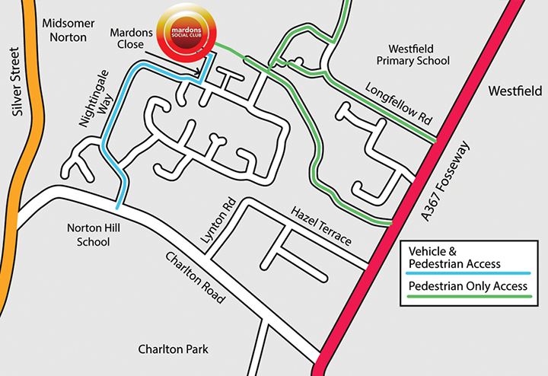  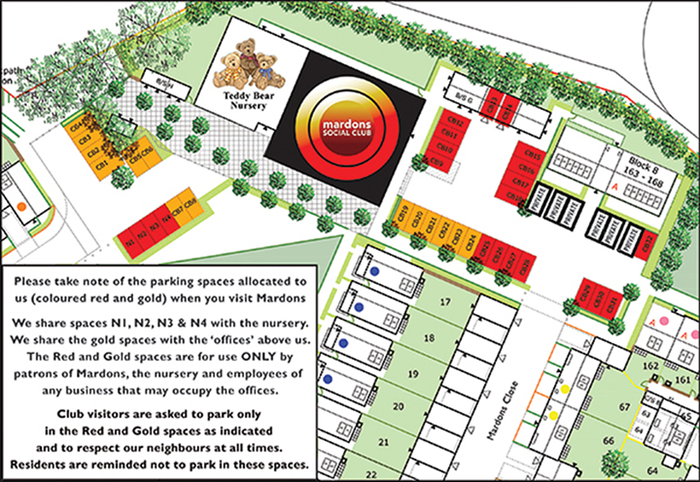
Feedback from other parties and other information gained in relation to this criterion: | None
Score (YES/NO) and any comments: | YES- The Council is satisfied that the nomination has included the required information.

A4. Is the nominated asset outside of one of the categories that cannot be assets of community value (as set out in Schedule 1 of the Assets of Community Value (England) Regulations 2012):
- A residence together with land connected with that residence
- Land in respect of which a site licence is required under Part 1 of the Caravan Sites and Control of Development Act 1960
- Operational land as defined in section 263 of the Town and Country Planning Act 1990.
Evidence supplied by nominee: | Nomination and supporting evidence sufficiently demonstrate that the asset is outside of the categories of assets within Schedule 1 of the Regulations
Feedback from other parties and other information gained in relation to this criterion: | None
Score (YES/NO) and any comments | YES – The Council it is satisfied that the nomination is outside of one of the categories that cannot be nominated as an asset of community value.

If YES to all of Part A, move on to Step B. If NO to one or more parts, please inform the nominator that the nomination is ineligible. Place nomination on list of unsuccessful nominations.

STEP B: This section considers the current or recent usage of the asset. It does this through a YES/NO answer and an identification as to whether the use is current or in the “recent past”

B1. Is the current or recent usage which is the subject of the nomination an actual and non-ancillary usage?
- NOTE 1: A working definition of “recent past” is “within the past three years”
- NOTE 2: A working definition of “non-ancillary” is that the usage is not providing necessary support (e.g., cleaning) to the primary activities carried out in the asset, but is itself a primary, additional, or complementary use.
Evidence supplied by nominee: | The ground floor of the Mardons Building has two current uses - Approximately 2/3rds of the space is used as a Social Club by the Community on midweek evenings and weekend daytime/ evening activities.  The remaining 1/3rd of the space is occupied by a pre-school children’s Nursery.  The activities of the Mardons Social Club are diverse and vibrant. They support the local community and are open to everyone.  The following activities are held at the Social Club, giving access in the daytime and evenings to hundreds of people per week - http://www.socialclub-info.co.uk/  - Skittles  - Free hall hire for wakes and other family life events  - Community events and consultations  - A meeting place for SWALLOW, an organisation for people with learning disabilities  - Pensioner Groups  - Live music every Saturday  - Big screen sports
Feedback from other parties and other information gained in relation to this criterion: | Details provided by Shoosmiths Solicitors on behalf of Linden Homes.  The Property is in mixed use, but that the use is comprised of certain discrete component parts, with the community use  being one such part. The community use is limited to the ground floor of the Property and is physically and functionally separate from the use of the first and second floors of the Property as offices.
Score (YES/NO) and any comments: | YES- It is the opinion of the Council that it is satisfied that the current usage which is the subject of this nomination is an actual and non-ancillary usage.

If the current or recent usage that is the subject of the nomination is actual and non-ancillary, go to Step C. If not, place on the list of unsuccessful nominations.

STEP C: This section considers whether the use furthers (for current uses) or furthered (for uses in the recent past) the social interests or social wellbeing of the local community. It does this through a series of questions scored on the basis of evidence.

C1. Who benefits from the use?  - Does it meet the social interests of the community as a whole and not simply the users/customers of the specific service?  - Who will lose if the usage ceases? | Evidence provided by nominee | In addition to its 700+ members and friends using the facilities during opening hours the club is offered to the Community at large for midweek daytime activities.  Since opening, there have been up to 1,500 people who have taken out membership through the years.  The midweek uses are offered generally free of charge, and very infrequently where a small fee is necessary to cover exceptional costs to the Club. The daytime Community use extends into double figures and includes Swallow, pensioner groups, Big Local and Parish Council for open community events. The management committee and trustees are local volunteers.  Evening / weekend activities include  Skittles 8 teams, alternating every other week on 4 nights per week.  Family get-togethers  Free hall hire for wakes and other family occasions such as weddings and engagements etc.  Big screen live sport.  Live music every Saturday.  Community Fund raising events for Carnival Clubs, Care Homes, etc. This includes quizzes, Seasonal Fayres etc.  The Nursery since opening has always had an Ofsted ‘good’ report or better. The average daily number of children attending is around 26. Clearly this is a huge asset to the local community particularly as there is a woeful lack of pre-school nurseries in the area.  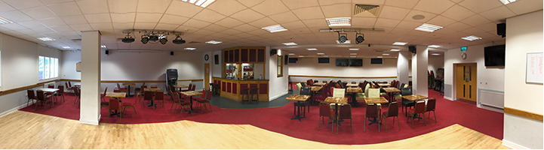
 | Evidence gained from other relevant sources (owner, Ward member, Parish Council, B&NES Council) | Online Evidence:  Teddy Bear Nursery  Westfield Warbler  Carer Café  Defibrillator Location  Mardons Social Club  Mardons on Facebook
 | Enter score out of 25 and rationale | The building meets the social interests of the local community in a variety of ways: social cohesion, alleviating loneliness, accessibility, marking vital life events such as weddings and wakes, fund raising, community consultations and providing care and education to the youngest members of this society. In a community where hardship is evident, this free or low-cost facility is the life blood of the neighbourhood.  The Mardons Building, Westfield therefore has a positive impact on the health and well-being of the community. It offers much needed local employment, giving jobs to over 16 people.  22 / 25
C2. Is any aspect of the usage actively discouraged by the Council’s Policy and Budget Framework? | Evidence provided by nominee | No.
 | Evidence gained from other relevant sources (owner, Ward member, Parish Council, B&NES Council) | Details provided by Shoosmiths Solicitors on behalf of Linden Homes - The necessary checks and balances are already in place to preserve the community use of the ground floor of the Property and the continuance of that use. Accordingly, with regard to the Property, the underlying purpose of the ACV regime is already being fulfilled via other regulatory means and the intervention of the Council to include the ground floor of the Property in its ACV list isn’t merited.
 | Enter score out of 25 and rationale | 25 / 25  No aspect of the land or buildings usage is actively discouraged by B&NES Council’s Policy & Budget Framework.  In the council’s opinion it is realistic that the ACV legislation can be used alongside the owner's protection measures.
C3. Why is the usage seen as having social value in the context of the community on whose behalf the nomination is being made? | Evidence provided by nominee | With no other premises in the area offering such a wide variety of modern facilities, the Social Club and Nursery are seen as an essential part of the local infrastructure.  This was clearly and recently demonstrated by the written comments submitted by the local community in response to the application for a change of use of the two floors above from offices to residential flats.  There were well in excess of 250 objections submitted in writing by the local community. This was understood to be a record number of objections, the majority of which showed the strength of feeling regarding the potential loss of both the Sports and Social Club and the Pre School. The building is the only one with internet connections sufficient for a ‘hybrid’ meeting in Westfield.
 | Evidence gained from other relevant sources (owner, Ward member, Parish Council, B&NES Council) | None
 | Enter score out of 25 and rationale | 10 / 25  It is the opinion of the Council that the areas of the building that are in use on the ground floor are realistically providing social value to the community.
C4. How strongly does the local community feel about the usage as furthering their social interests? | Evidence provided by nominee | Evidence pointing towards the importance of this building to the community can be found in the Westfield Neighbourhood Plan (Page 65).  https://www.westfieldparishcouncil.co.uk/council/neighbourhood-plan/  The Plan came to fruition in 2018 following three years of consultations with the public focussing on what they valued in the community and aspirations for the future. Policy 14 highlights the need for facilities to support the “social, recreational, and cultural.
 | Evidence gained from other relevant sources (owner, Ward member, Parish Council, B&NES Council) | This nomination is also supported by the B&NES Councillors for Westfield.  Cllr Eleanor Jackson states, “In an area where data from the Office of National Statistics indicates an unusually young population, but with older people with a high rate of respiratory illnesses, often isolated because of poor bus services, this building and the club running it is an oasis of fun and entertainment. I love the welcome I always get when I step through the door.
 | Enter score out of 25 and rationale | 18 / 25  The opinion of the Council is that it is satisfied that the ground floor area which includes the space occupied by Mardons Social Club and Teddy Bear (pre-school) provide the community with a good level of use and these are valued by those who are using the facilities.  There are unoccupied areas of the building that have not been considered as part of this nomination.
Total score: | 75 / 100

If STEP C meets a minimum scoring of 55%, go to Step D

STEP D: This section considers whether it is realistic to think that there can continue to be non-ancillary use of the building or other land which will further (whether or not in the same way) the social wellbeing or social interests of the local community.

For assets such as this where the actual non-ancillary usage is a current one (see Step B above), 88(1) (b) of the Localism Act requires the Council to consider whether in the opinion of the local authority it is realistic to think that there can continue to be non-ancillary use of the building or other land that will further (whether or not in the same way) the social wellbeing or social interests of the local community.

This will be considered through the following tests:

- If the asset is considered to remain fit for purpose (under D1 below), then this is considered to be sufficient grounds for thinking that it is realistic to think that continuing use of the asset will further the social wellbeing or social interests of the local community identified in Step C above.

- If the building is not considered to remain fit for purpose under D1, then an additional Test (under D2 below) will be applied to determine whether the asset could be made fit for purpose practically and within reasonable resource requirements and within timescales. The timescales to be applied for this to take place for assets with “recent usage” will be “within the next five years”.
D1. Has the building/land-take/space/legal requirement for this usage changed significantly since its initial use so that the asset is not fit for purpose?
Evidence supplied by nominee: | No, The Mardons Building was built as part of the new housing development in 2014 to accommodate the historic Mardons Sports and Social Club. However, the history of the Mardons’ Club goes back much further than this, being set up in this former mining and heavy engineering community to support and benefit those living and working in the area.  The underlying ethos of providing activities for supporting the local community is as strong as ever. The club, the nursery and the offices were meant to provide employment to compensate for the destruction of the old factories and the Norton Hill mine when the Nightingale Way housing estate was granted planning permission.  Only one factory remains close by, Sun Chemicals, and there is good connectivity should their employees wish to join the club or place their children in the nursery. Encouraging inward economic investment and employment is a Parish Council policy.
Feedback from other parties and other information gained in relation to this criterion: | Details provided by Shoosmiths Solicitors on behalf of Linden Homes  We have considered the details included in the Parish Council’s nomination. Crucially, it does not deal with our previous observations concerning the need for there to be evidence of community intent and some means of implementing and carrying out the Parish Council’s aspirations for the Property through community effort and enthusiasm, such that those aspirations can be considered realistic.  No details, skeleton or otherwise, have been provided of the formulation of a plan or proposal, or the sources of funding available, to acquire (and subsequently manage) the Property (whether the whole or part thereof) and to enable the community uses on the ground floor to continue.  The Parish Council’s nomination fails to demonstrate how the successful nomination of the ground floor of the Property (which would secure for the community a mechanism whereby it is afforded the opportunity to take initiative and to organise a bid for the Property) is an appropriate means of securing the continuation of the current community use and of ensuring that the Property (at ground floor level) will remain fit for purpose in this regard. Consequently, we fail to see how the second limb of the legal test set out in section 88(1) of 2011 Act can be considered satisfied
Score (YES/NO) and rationale | NO  In the council’s opinion it is realistic that the current and ongoing use of this asset will contribute to the social wellbeing and interests of the local community.  The asset is operating as a successful business with strong community support.  It is realistic that any changes will need to be made to the current management practices.  The community nomination requirements have been met. A forward plan from the Parish Council for organising a bid for the asset are not necessary.

If no to D1, place on register of Assets of Community Value, and do not go to D2. If yes to D1, go to D2.

D2. Could the asset be made fit for purpose practically and within reasonable resource requirements and within timescales?
Evidence supplied by nominee: | Not applicable
Feedback from other parties and other information gained in relation to these criteria: | Not applicable
Score (YES/NO) and Rationale: | Not scored as NO answer to D1 above

If yes to D2, place on register of Assets of Community Value. If no to D2, place on list of unsuccessful nominations.
RECOMMENDATION: | THAT THIS ASSET BE PLACED ON THE ASSETS OF COMMUNITY VALUE
REASON FOR DECISION | (1)  a) The Asset lies within the administrative boundaries of Bath & North East Somerset and Westfield Parish.  b) Westfield Parish Council is entitled under 89(2)b)(iii) of the Act to make a community nomination in respect of the Asset  c) The nomination from Westfield Parish Council includes the matters required under regulation 6 of the Regulations  (d) The Asset does not fall within a description of land which may not be listed as specified in Schedule 1 of the Regulations  and  (2) in the opinion of the authority,  (a) The current and recent use of the Asset that is not an ancillary use and furthers the social wellbeing and interests of the local community  (b) Given that the Asset remains fit for purpose to further the social interest and social wellbeing of the local community, it is realistic to think that the current non-ancillary use of the Asset will continue to further (whether or not in the same way as before) the social wellbeing or social interests of the local community.  (c) It is realistic to believe that the Asset will be supported in the future. Mardons Social Club has a management committee and a current membership of over 700 people as well as welcoming non-members.  (d) The Teddy Bear Nursey is run to offer child care provision five days a week. The nursery is well established and received an Ofsted rating of Good in 2017.
Decision Taken by | 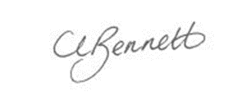  Cherry Bennett  Director of People & Policy  Bath & North East Somerset Council
Date | ^{nd} Aughust nd n1st June 20237th July 2022

