Notice under Section 91 of the Localism Act 2011

5th April 2022

Entry of known as Chew Stoke Village Shop, into Bath & North East Somerset Council’s List of Assets of Community Value

- Background

On 9th February 2022, Bath & North East Somerset Council received a nomination under Section 89 of the Localism Act 2011 (“the Act”) to list Chew Stoke Village Shop.

Chew Stoke Village Shop - Newbridge House, Bristol Road, Chew Stoke, Bristol, Bath And North East Somerset, BS40 8XE as an Asset of Community Value. The nomination was made by Chew Stoke Parish Council. A map setting out the boundaries of the asset nominated to be listed (“The Asset”) is provided within this notice.

Under Section 87 of the Act the Council must maintain a list of assets of community value.

Section 88 of the Act states that

(1) For the purposes of this Chapter but subject to regulations under subsection (3), a building or other land in a local authority’s area is land of community value if in the opinion of the authority—
(a) an actual current use of the building or other land that is not an ancillary use furthers the social wellbeing or social interests of the local community, and
(b) it is realistic to think that there can continue to be non-ancillary use of the building or other land which will further (whether in the same way) the social wellbeing or social interests of the local community.

(2) For the purposes of this Chapter but subject to regulations under subsection (3), a building or other land in a local authority’s area that is not land of community value as a result of subsection (1) is land of community value if in the opinion of the local authority—
(a) there is a time in the recent past when an actual use of the building or other land that was not an ancillary use furthered the social wellbeing or interests of the local community, and
(b) it is realistic to think that there is a time in the next five years when there could be non-ancillary use of the building or other land that would further (whether or not in the same way as before) the social wellbeing or social interests of the local community.

Under Section 89 of the Act, the Council can only enter assets into the list of Assets of Community Value in response to community nomination.

- Decision-Making Process
The Council’s Cabinet on October 10th 2012 resolved to agree that:

2.1 Decision-making in response to nominations for entry into the List of Assets of Community Value under the Localism Act 2011 be delegated to the Director of People & Policy
(and, in the event of this Director having a conflict of interest, to a Director nominated by the Corporate Director), drawing on the decision-making guidance as set out in Appendix One (of the report)
2.2 The Director of People & Policy be delegated decision-making with regard to updating this guidance, in consultation with the Council Leader, in response to experience of implementing the provisions, new regulations and emerging case law
2.3 The internal review process in relation to listing be undertaken by a Director not involved in the initial decision
2.4 The Director for Property Services be delegated to make arrangements relating to the procedures following listing, including moratorium and compensation provisions, as set out in Appendix Two (of the report)

In accordance with this decision, the Director of People & Policy has now fully considered the nomination in light of the Act and the Assets of Community Value (England) Regulations 2012 (“the Regulations”). Following this consideration, the Director of People & Policy has decided not to enter the property into its list of Assets of Community Value.

This decision has been taken because:

(1)
a) The Asset lies within the administrative boundaries of Bath & North East Somerset Council and the parish of Compton Martin
b) Chew Stoke Parish Council is entitled under 89(2)b)(iii) of the Act to make a community nomination in respect of the Asset
c) The nomination from Chew Stoke Parish Council includes the matters required under Regulation 6 of the Regulations
(d) The Asset does not fall within a description of land which may not be listed as specified in Schedule 1 of the Regulations

and

(2) in the opinion of the Authority,

(a)The actual current use of the Asset that is not an ancillary use which furthers the social wellbeing and interests of the local community.

(b)The village has been without a village shop for five years. The only effort that was made within the community to rectify this situation was a attempt by the Chew Stoke Inn in 2019/2020 to provide a limited service that operated at the height of the pandemic.

The detailed assessment on which this decision is based, following the criteria adopted by the Council Cabinet on 10th October 2012, and fully considering information supplied by the nominee and other parties (including the owner), is set out in 4 below.

- What Happens Next
The Asset will now be placed on the list of Unsuccessful Assets of Community Value Nominations which the Council is required to maintain under Section 87 of the Act.

In accordance with Section 91 of the Localism Act the Council will send this notice to:

- The owner of the property
- Chew Stoke Parish Council

The information will also be published on the Council’s website.

- Detailed Assessment of the Nomination of Chew Stoke Village Shop - Newbridge House, Bristol Road, Chew Stoke, Bristol, Bath And North East Somerset, BS40 8XE, as an Asset of Community Value

Assets of Community Value Nomination – Assessment

DATE OF SUBMISSION: | 09/02/2022 | DATE DECISION TO BE MADE BY: | 06/04/2022
NOMINATED ASSET: | Chew Stoke Village Shop  The boundary of the asset is set out in the boundary map in section A3.
NOMINATION SUBMITTED BY: | Chew Stoke Parish Council

STEP A: This section considers the eligibility of the nominating body to make a nomination and of the asset to be an Asset of Community Value. It does this through a series of YES/NO ANSWERS

A1. Is the nominating organisation an eligible body to nominate?
Evidence supplied by nominee: | Sarah-Jane Streatfeild-James, Clerk to the Parish Council  Chew Stoke Parish Council  c/o Sutton Cottage,  Church Lane,  Bishop Sutton  BS39 5XA
Feedback from other parties and other information gained in relation to this criterion: | None
Score (YES/NO) and any comments: | YES - The Council is satisfied that the nominating body is an eligible body to nominate.

A2. Does the nominating body have a local connection to the asset nominated?
Evidence supplied by nominee: | The site falls within the parish boundary of Chew Stoke Parish and within Bath and North East Somerset Council.  Chew Stoke previously had a village shop on the same site in the centre of the village.  Planning permission was permitted to redevelop the site and to include a new shop.  The previous shop was the only shop in a village of approx. 1000 residents, a new shop is required to sell fresh food, general groceries, stationary, newspapers for the residents and  visitors to the area.
Feedback from other parties and other information gained in relation to this criterion | None
Score (YES/NO) and any comments: | YES- The Council is satisfied that the nominating organisation has a local connection to the nominated asset.

A3. Does the nomination include the required information about the asset?
- Description of the nominated land including its proposed boundaries
- Names of current occupants of the land
- Names and current or last-known addresses of all those holding a freehold or leasehold estate in the land
Evidence supplied by nominee: | The building is situated on the Bristol Road, Chew Stoke and is part of the new development of houses in Malcolm Close. The shop has a flat above.  4 parking spaces are allocated to the shop to the side of the  building, in front of Newbridge House.  The current occupants of the land are Anita and Christopher Gamlen  Reference was given to planning application 16/00571/FUL which was for  Erection of 4no dwellings and 1no shop with flat above including associated amenity space and parking following demolition of existing garage, workshop and shop. (Resubmission) https://www.bathnes.gov.uk/webforms/planning/details.html?refval=16%2F00571%2FFUL  Decision Issued 28/10/2016  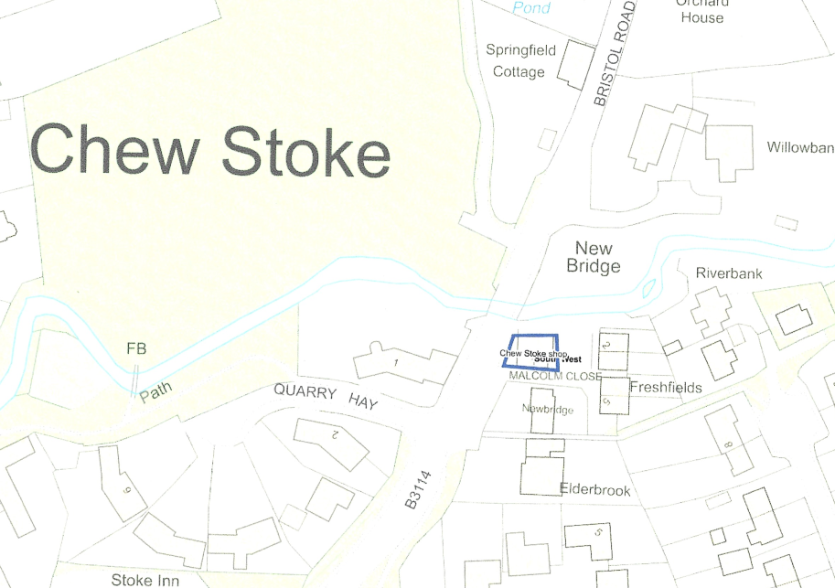
Feedback from other parties and other information gained in relation to this criterion: | Merrett & Co Solicitors on behalf of Chew Valley Properties Limited  The retail unit which has been put forward to you for listing is a new development constructed in 2021 and as yet unused. The new current building does not qualify as an ACV because it has had no use. The regime is not designed to allow community groups to select a building which has not previously been used or has not been used for a community purpose just because the group considers that it will be capable in the future of a community use.  The current new retail unit at Malcolm Close Chew Stoke the subject of this application has never been used in a way to further the social well-being or interests of the local community or at all. The legislation is drafted to protect assets of community value viewed retrospectively not prospectively.
Score (YES/NO) and any comments: | YES- the Council is satisfied that the nomination has included the required information about the asset.  The asset that has been nomoinated was part of a garage complex five years ago. The redevelopment of this site does now include a new shop which has to date has not had any previous use.

A4. Is the nominated asset outside of one of the categories that cannot be assets of community value (as set out in Schedule 1 of the Assets of Community Value (England) Regulations 2012):
- A residence together with land connected with that residence
- Land in respect of which a site licence is required under Part 1 of the Caravan Sites and Control of Development Act 1960
- Operational land as defined in section 263 of the Town and Country Planning Act 1990.
Evidence supplied by nominee: | Nomination and supporting evidence sufficiently demonstrate that the asset is outside of the categories of assets within Schedule 1 of the Regulations
Feedback from other parties and other information gained in relation to this criterion: | None
Score (YES/NO) and any comments | YES- the Council is satisfied that the nomination is outside of one of the categories that cannot be assets of community value

If YES to all of Part A, move on to Step B. If NO to one or more parts, please inform the nominator that the nomination is ineligible. Place nomination on list of unsuccessful nominations.

STEP B: This section considers the current or recent usage of the asset. It does this through a YES/NO answer and an identification as to whether the use is current or in the “recent past”

B1. Is the current or recent usage which is the subject of the nomination an actual and non-ancillary usage?
- NOTE 1: A working definition of “recent past” is “within the past three years”
- NOTE 2: A working definition of “non-ancillary” is that the usage is not providing necessary support (e.g. cleaning) to the primary activities carried out in the asset, but is itself a primary, additional or complementary use.
Evidence supplied by nominee: | The ground floor, shop area of the building is currently unoccupied.  It has not been openly advertised to rent.  A group of residents in Chew Stoke would like to setup a Community Shop and have contacted the owners about renting the premises. Despite further correspondence this offer to rent the shop has been so far declined and no indication of rental cost has been shared.  Previously the shop was used by residents of all ages.  The previously mentioned group of Chew Stoke residents carried out a survey in November 2021 to find out wha the village wanted.  - The survey was sent to every household in the village,  - 204 households completed the survey.  - The results showed an overwhelming support to have the shop retained in the village.  - 100% of respondents said they would use the shop daily or weekly; 63% at least weekly;  - 34% said they would need to use it daily for every day grocery items and newspapers.  - 80 households said they would be happy to volunteer regularly in such a shop.  The flat above the shop is residential and is occupied.
Feedback from other parties and other information gained in relation to this criterion: | None
Score (YES/NO) and any comments: | YES- the current usage which is the subject of the nomination is an actual and non-ancillary usage.  The redevelopment has taken place outside of the timing that is stated in the guidance of a three year period for the recent past. Although legislation does not state any given period, this benchmark period is what has been selected to be included within the Bath and North East Somerset Council Evaluation Criteria.  The nomination is for a shop that is part of a new development.  This site that has been redeveloped was part of a garage business that had workshop and shop that could be seen as ancillary usage.  The new shop unit would now be seen non-ancillary use.

If the current or recent usage that is the subject of the nomination is actual and non-ancillary, go to Step C. If not, place on the list of unsuccessful nominations.

STEP C: This section considers whether the use furthers (for current uses) or furthered (for uses in the recent past) the social interests or social wellbeing of the local community. It does this through a series of questions scored on the basis of evidence.

C1. Who benefits from the use?  - Does it meet the social interests of the community as a whole and not simply the users/customers of the specific service?  - Who will lose if the usage ceases? | Evidence provided by nominee | A shop would provide a focal point for the village, a hub to meet other residents,all ages would benefit, from the school children walking past daily to pop in for snacks and drinks, to the older generations collecting papers, or daily provisions.  This would help them remain active in walking to the shop.The shop is accessible to all due to its prime,central location in the village,fully accessible with pavements and parking outside.  Deliveries may be possible for those unable to leave their houses,but convenient for those who wish to collect day today supplies, prescriptions, newspapers etc. Residents would be able to shop for fresh supplies en route to work.  There is no other shop in the village.  The recent survey expressed a strong willingness to volunteer in the shop. This would further bring the community together in supporting each other,and looking out for the more vulnerable,elderly,and isolated in the community.  Many people come to the Chew Valley to cycle, run,and visit several sporting clubs,and would benefit from a shop.  Local events can be advertised,and tickets sold from such a shop.
 | Evidence gained from other relevant sources (owner, Ward member, Parish Council, B&NES Council) | Councillor Vic Pritchard, Ward Councillor for Chew Valley  “I would like to add my support for this application. It’s only until relatively recent years that Chew Stoke has been without the facility of a Village Shop and this opportunity for it to be reinstated should not be missed.  It would undoubtedly become an asset strengthening an already solid community going forward and I have every confidence in predicting its success.”  Councillor Karen Warrington, Ward Councillor for Chew Valley  “Residents are extremely keen to have a shop in the village so I wouldn’t oppose this.”  Merrett & Co Solicitors on behalf of Chew Valley Properties Limited  Although the unit is intended for retail use until it has been used as such it cannot be nominated and included in the list of Assets of Community Value as it fails to meet the requirements of the Localism Act 2011 section 88 (1) or (2).  There has never been a time when this building has been used to further the social well-being or interests of the local community as it has never been in use.  Without prejudice to the above and in the alternative even if the building housing the original garage shop to which the application refers still existed the test would not be met and the building could not be listed as an asset of community value.  The asset to which the application refers to is the shop that was ancillary to the primary use as a garage repair business Chew Valley Garage and was contained in the front office reception area of the garage. The garage office was behind the shop till area. The shop was ancillary to the garage in terms of turnover and floorspace and was subservient and parasitic to the garage business and could not have existed without the garage. The shop was where people would pay their garage bills it was an ancillary use. There was no non-ancillary use of the shop area which furthered the social wellbeing of then local community and so the condition in section 88(2)(a) was not satisfied.
 | Enter score out of 25 and rationale | 5/25  There is very little evidence of how the village shop provided any social interests to the community other than being a business that sold items to customers when it was open in the past.  No other details have been provided about how social interest was delivered through the previous shop to the community.
C2. Is any aspect of the usage actively discouraged by the Council’s Policy and Budget Framework? | Evidence provided by nominee | There is no evidence that a new shop is contrary to any of the council’s policies.  Conditions of the planning permission granted in 2017 to knock down the old shop and garage specified the new building at the roadside to be a shop. Residents are very keen to ensure that  this happens, and the building is not changed to a different usage.
 | Evidence gained from other relevant sources (owner, Ward member, Parish Council, B&NES Council) | None
 | Enter score out of 25 and rationale | 25/25  No aspect of the land or buildings usage is actively discouraged by B&NES Council’s Policy & Budget Framework.
C3. Why is the usage seen as having social value in the context of the community on whose behalf the nomination is being made? | Evidence provided by nominee | A group of residents are keen to set up a community shop in the village selling local produce, a range of everyday provisions, the shop would be managed and run by volunteers  from the village.  Supporting local businesses and reducing the carbon footprint of residents is a high priority.  Local produce would be available for sale, there by helping the local economy.  The survey found that 98% said yes, they thought having a community shop on the site of the previous shop on Bristol Road would further the social well-being and social interests on the  local community.
 | Evidence gained from other relevant sources (owner, Ward member, Parish Council, B&NES Council) | Merrett & Co Solicitors on behalf of Chew Valley Properties Limited  Chronology of the opening and closing of the shop in various locations of the village.  Chew Stoke has had four village shops which have all ceased trading.  - 1980’s/1990’s - The village shop was located on the main B3114 road on the corner next to the Chew Stoke Inn and was run by a local family from their residence. There was a separate Post Office. Both ceased trading.  - Late 1990’s for approximately 15 years Mr Malcolm Genge operated a vehicle repair garage known as Chew Valley Garage. After a few years Mr Malcolm Genge added a small ancillary shop in the front office reception area of the garage which he ran with his partner Carole Ogbourbe. He also applied for the Post Office but this was refused as not financially viable. (Post Offices in Compton Martin, West Harptree, Winford and Chew Magna). Two part-time shop attendants were employed.  - 2011 - Mr Kevin Gamlen and Mrs Anita Gamlen purchased Chew Valley Garage. In 2016 Mr Kevin Gamlen applied for the Post Office this was refused again. Five years ago in 2017 the small ancillary shop was shut due to its ongoing unsustainable losses and the opening of the refurbished and enlarged shop floors of both Chew Magna Co-op and the Winford Garage SPAR shops (operating 364 days per year 7 days per week from 6.30am to 10pm). The income opportunity of passing traffic from the B3130 Bristol/Pensford direction and from the A38 direction previously relied upon was substantially diminished. The passing traffic from the A368 was already being serviced by the West Harptree Village Stores and Manor Farm Bishop Sutton near the Chew Valley lake.  - 2019/2020 – The Chew Stoke Inn opened up the Chew Stoke Village Shop however Lee Lashenko reported there was limited community village support even with local fruit and vegetable deliveries during the pandemic lock downs when the local community was a captured market. This was the last village shop in the centre of the village (2 minutes stroll from nominated site Malcolm Close). The shop was shut again due to lack of community support and viability despite the pub car park being used daily by parents taking children to school as it is today.
 | Enter score out of 25 and rationale | 10/25  The community survey has provided an insight into would could be achieved if the right set of circumstances were to come together in the future. There is no clear evidence that show that this will happen.  The failure of the previous shop site in applying to become incorporate a post office indicates that the level of need is to small to attract sustainable additions to a village shop.  Other options are available to the majority of the community within a reasonable distance or home delivery services.
C4. How strongly does the local community feel about the usage as furthering their social interests? | Evidence provided by nominee | Chew Stoke residents have shown their desire for another shop in the village in signing a petition and attending PC meetings.  This is supported by the Parish Council and Ward Councillor.  The Chew Valley Neighbourhood Plan advises that “shops, cafes, restaurants and pubs are an important aspect of village life and a significant employment sector in the Plan Area.  Residents value these facilities and have indicated a desire to ensure they are retained  wherever possible.”And“ to maintain & enhance good quality, accessible facilities,including community, leisure and recreational facilities,such as local pubs and shops, thus ensuring that the diverse economic andsocialvitality is sustained and enhanced”.  Residents would be able to shop locally, reducing the need to drive to other villages for provisions. Many people drive, walk or cycle through Chew Stoke each day,and would benefit from an accessible place to stop and buy a range of provisions,sandwiches,or hot and cold drinks.  The nearest alternative shops are at WinfordFord garage (1.4 miles) ChewMagna(1.5 miles) or Bishop Sutton (3miles).  The recent survey found that if the village shop didn’t reopen, 94%felt it would be a significant loss to the local amenity and/or employment opportunities.
 | Evidence gained from other relevant sources (owner, Ward member, Parish Council, B&NES Council) | Merrett & Co Solicitors on behalf of Chew Valley Properties Limited  The shop was financially unviable and had run at a loss for several years being subsidised by the primary business of the garage. The accounts show that in 2016 when the enlarged Coop and Winford Ford Spar reopened the losses doubled in 2016 and 2017. This drove the decision to close the shop 5 years ago as annual losses of £30K were unsustainable.  The village shop has existed for a number of years and a chronology of Chew Stoke Village shop’s existence has been provided. The shop has struggled to be financially viable for a number of years and consequently a business plan should have been provided to show how the volunteers propose to make it viable. In the circumstances of this matter and in particular the substantial losses and strong competition without evidence to show that a new shop would be financially viable it is not realistic to think that within the next five years there will be a use which furthers the social wellbeing of the local community and so the condition in section 88(2)(b) is not satisfied.  The nominator has put forward some details of a survey without explaining the methodology used or the distribution of the survey or the form the survey took. There is no explanation as to why only 20% of the local community responded and there are no details as to who they are or why nearby residents were left out. This is wholly unsatisfactory and no weight should be attached to the information put forward by the nominator with regard to the survey.  The Chew Valley Garage closed in September 2018, 9 months later than the closure of shop in 2017. The building was demolished and the development permitted by BANEs planning permission ref 16/00571/FUL has been constructed. It is no longer possible to use the shop in the way it was used as it is no longer there, the demolition has brought the alleged protected building to an end. As regards the new build retail unit the nominator would have to satisfy the conditions of the Localism Act afresh as there has been no use of the building whatsoever and therefore this is impossible.  Consequently even if the building still existed the shop would not have met the criteria in section 88(2)(a) as it would not have been in the “recent past” i.e. the last three years according to BANES ACV Evaluation Criteria “ A working definition of “recent past” is “within the past three years”” and secondly that it was an ancillary use to the primary use which was as a garage.  The new retail unit is not even on the site of the old shop. I enclose an overlay plan of the old garage building with the overlap of the new unit over the old shop and only the hatched area is within the footprint of the old shop. You cannot list the new unit the majority of which is in a different location to the old shop. The remainder of the footprint of the old shop now comprises the access road to the new houses and the pavement areas to the front of the new unit and cannot be registered. Use as an accessway in accordance with the authorisation under the planning permission precludes use as a shop. The new building is constructed in a different location, the ACV regime does not allow the nominator to choose a new build that they would like to use.
 | Enter score out of 25 and rationale | 5/25  It is desirable to have a local shop in the village but there is little evidence within the nomination that explains how the elements of social interest has been lost over the five years that the shop has not been operating.
Total score: | 45/100  The scoring for this nomination fails to reach the minimum 55% required.

STEP C requires the nomination to achieve a minimum scoring of 55%

D1. Has the building/land-take/space/legal requirement for this usage changed significantly since its initial use so that the asset is not fit for purpose?
Evidence supplied by nominee: | The building has been erected according to the plans and has adequate space for a shop on the ground floor.  The building has not been advertised to let since it was rebuilt.  It has shop-front type windows. The shop is currently unoccupied. It would need fitting out internally as a shop and would require signage etc.
Feedback from other parties and other information gained in relation to this criterion: | Merrett & Co Solicitors on behalf of Chew Valley Properties Limited  Boundary map of the pre-development footprint vs the new shop footprint.  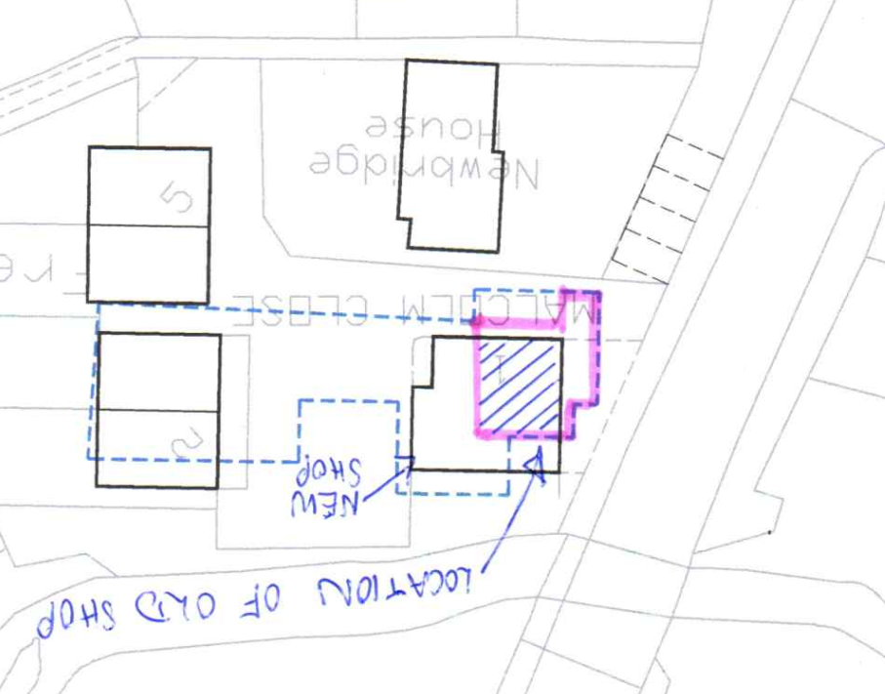  The current building has not been used as the village shop and the land before was used by the garage for vehicle repairs with an ancillary shop area shared in the front reception office.  The current building is ready for A1 retail shop fitting out specific to the incoming business.  The building has been offered to parties whom registered interest during construction before any interested expressed by the four local residents.  Further actions are pending 6th April 2022 decision.
Rationale | The replacement building could provide use as a new village shop.

D2. Could the asset be made fit for purpose practically and within reasonable resource requirements and within timescales?
Evidence supplied by nominee: | It is a perfect location for a small village shop, on the main route through the village, with parking available and is fully accessible.  The shop now has the correct frontage in situ.  A condition of the build was that the building to be used as a shop.  It is now fit for purpose to be used as a shop, although it needs fitting out internally and signage.The Community  Shop Venture would be prepared to look at how they could cover the costs of fitting out internally and are seeking grant support to assist with this.  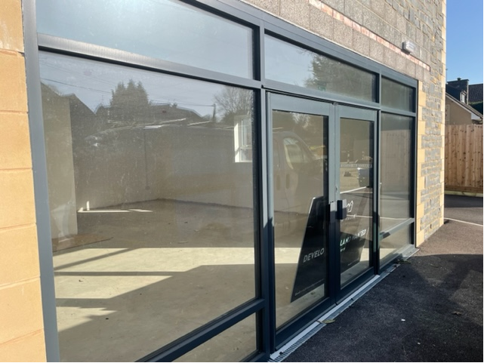
Feedback from other parties and other information gained in relation to this criteria: | Merrett & Co Solicitors on behalf of Chew Valley Properties Limited  As is the Chew Stoke Inn with much larger car parking facilities which is the last location of the village shop at the centre of the village.  A1 Retail shop unit is the condition of the planning use approved not just a community shop  It is not fitted out for a community shop and can accommodate any A1 retail shop unit under the use case approved in October 2016.  Less than 20% of the village responded to utilise a community shop. Placing the A1 Retail Shop unit on the Community Asset Register would further delay the property being leased or sold for another 6 months. This completely defeats the urgency claimed for a community need.
Rationale: | The new retail unit id currently available for rent. A organisation would need to take on the business and the unit would require fixures and fittings.

RECOMMENDATION: | THAT THIS ASSET WILL NOT BE PLACED ON THE ASSETS OF COMMUNITY VALUE
REASON FOR DECISION | (1)  a) The Asset lies within the administrative boundaries of Bath & North East Somerset and Chew Stoke Parish.  b) Chew Stoke Parish Council is entitled under 89(2)b)(iii) of the Act to make a community nomination in respect of the Asset.  c) The nomination from Chew Stoke Parish Council includes the matters required under regulation 6 of the Regulations.  (d) The Asset does not fall within a description of land which may not be listed as specified in Schedule 1 of the Regulations.  and  (2) in the opinion of the authority,  - The original shop ceased trading over five years ago.  - The premises were previously part of a garage complex which had workshops and the shop onsite. The shop at that time is seen to have been an ancillary use as part of the overall business that was trading at the location.  - The new premises have been built as a shop with a residential premises above. The shop would now be seen as non-ancillary use.  - The redevelopment has resulted with a A1 retail unit being available to the local community to lease from the owner who are keen to find a tennent.  - The case made in the nomination regarding future use shows that the community are keen to support the prospect of a community shop in the village. The opportunity exists for the community, if they wish, to negotiate with the owner to make this happen.  - The nomination puts forward the argument that the local community are supportive of coming together to set up and run a local shop. However there is very little information on any envdevour to make this happen at the original site since the closure of the village shop five years ago.  - The nomination mentions the prospect of setting up a delivery service to local residents if the shop were to reopen. Existing retailers already operate in the Chew Valley providing home delivery services.  - The nominiation explains that a community shop would bring back a focal point for the community. However it is not clear how this would be achieved and there was no evidence if and how the previous shop achieved this before its closure.  The authority recognises that the community would like to maintain a shop in the village, however the evidence that has been submitted in the nomination concludes that there is not a strong enough case for the asset to be listed.  Factors that are key to this decision are:  Five years have passed since a shop operated in the original location and there is little evidence provided that indicates that an effort has been made in this time to provide the community with an alternative.  The results of the community survey did provide positive points of community funding pledges and volunteering roles that may be achieved should a village shop be able to be reinstated.  There was no evidence that explain how the elements of social interest have been lost by the community over the five years that the shop has not been operating.  It is not clear that a viable business will be able to operate in the future. The evidence shows that the previous businesses have failed to stay sustainable.
Decision Taken by | 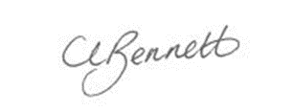  Cherry Bennett  Director of People & Policy  Bath & North East Somerset Council
Date | 5th April 20223rd December 20200

