TRAFFIC PROPOSAL

Title of Proposal | (NELSON WARD DRIVE, RADSTOCK) (PROHIBITION OF PARKING)  ORDER 202*
Reference: Nelson Ward Drive, Radstock |  | 20-018/LC
Closing date for Objections and Representations |  | 10th March 2022

NOTICE is given that the Bath and North East Somerset Council proposes to make an order under provisions contained in the Road Traffic Regulation Act 1984, the effect of which will be to install “No Parking at Any Time” waiting restrictions as part of the ongoing new housing development at Nelson Ward Drive, Radstock.

Full details of the proposal are contained in the draft order, which together with a map and a Statement of the Council’s Reasons for proposing to make the order may be inspected at the Councils’ One Stop Shops during normal office hours. The proposal may also be viewed on the Council’s website: www.bathnes.gov.uk, by searching for the reference number above.

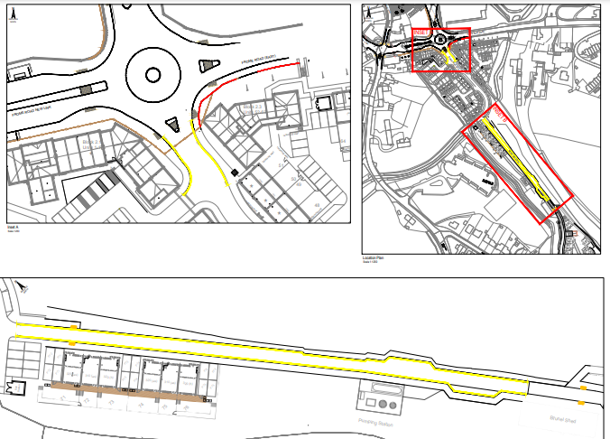

Objections and representations with respect to the proposal, together with the grounds on which they are made, must be sent in writing by the above date to the Council at the following addresses: Traffic Management Team, Bath and North East Somerset Council, Lewis House, Manvers Street, BATH, BA1 1JG or TRO_Processing@bathnes.gov.uk

Please quote the title and reference as shown above.

Please note that all representations received may be considered in public by the Council and that the substance of any comments, together with the name and address of the person making it, could become
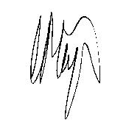
available for public inspection.

Traffic Management Team
Tel No: (01225) 394041

Chris Major
Assistant Director - Highways and Transport
Bath & North East Somerset Council
Dated: 17th February 2022

