…………………….(Young person’s Name).........................

Looked After Children
Information Pack

- Why do I need to be ‘looked after’ by Social Services?

There are many different reasons why children and young people become looked after. Your Social Worker will be able to explain why you need to be looked after and can answer questions that you have.

- Where will I live?

When you move into a new place when you become looked after, this place is called your placement. The type of placement you are in depends on lots of different things, but your social worker will make sure you are in a safe placement.
Types of placement include:
- Foster Placements which is where you live with another family in their house and they become your foster carers.
- Kinship Placement is when a family member like an aunt, uncle or grandparent looks after you.
- Residential placement which is a house where a number of looked after children all live together and are looked after by a team of staff. Here you will have a keyworker who will get to know you and give you any support you need.
- How long will I be looked after?

- Your views are important and where possible your Social Worker will involve you when making decisions about where you live. However, this will depend on what is right and safe for you.
Depending on the type of placement you are in, there are different plans. These could be:
- Being looked after for a short time with the plan to move back home with a family member
- Being looked after by foster carers or by family members on a long-term basis

- Will I see my friends and family?

Your social worker will help you keep in touch with your family and friends and anyone else that is important to you. Your social worker will help to arrange visits with your family if you would like to see them.
If you are not able to see someone you would like to, your social worker will make sure you know why.

- What is it like living with a foster family?

Your social worker will work hard to find a foster family that they think is right for you. This is very important, especially if you are going to stay there for a long time.
Every foster family is made up of different people. Some have their own children and some have foster children. All foster carers treat you as part of the family and want to help keep you safe by looking after you and listening to you.
We will try and find a foster family who have a similar ethnic and cultural background to you, if this is important to you. This could be the same religious beliefs and celebrations as you.
At first, it might feel strange to be in a new home, but your social worker will come with you to help you meet the family.

- What about my education?

We will try and keep you at the same school if that is what you want and we are able to help with this. If we cannot do this, your social worker will talk about any changes to make sure you are happy with them. We will then work with your school to make sure we give you all the help you need. We will make a plan call a Personal Education Plan (PEP) and tell you which teacher in school is there to look after your needs.

- What about my health?

When looked after you will receive good health care. You will continue to have regular checks with the dentist, optician and any other health workers that you would usually see or need to see. When you first become looked after, you will also be offered a health assessment which will be done by a doctor or a nurse. They will be able to answer any questions that you may have. If you stay looked after for a long time you will have a health assessment once a year.

- What are all the different meetings and forms?

The meetings and forms are for you and about you in order to help plan your future.
Care plan
- Every child looked after has a care plan which includes:
- Why you need to be looked after
- How long you will be looked after
- Who you will be going to live with and where
- What contact you will have with your family and friends
- What support you need in education
- Anything else that is important to you and your care
You should keep a copy of your Care Plan in this pack.
Placement information record
This is where all the information that is important for your daily needs is written. This includes:
- Rules of your new home
- How we will help you to stay healthy
- How you will get to see your friends and family
- How you will get to school
- Any activities that you would like to do
- How we can help you with any religious, racial or cultural needs
- How often you will see your social worker
Review meetings
Review meetings happen to make sure that the plans that we make are carried out and met. We will also think about any changes we need to make within these plans. Once settled in your placement these will happen every six months.
Before the meetings, your social worker will ask you if there is anything you want to be talked about, whether you would like to come and whether you want an advocate to speak for you. An advocate is someone who will listen to you and give you information to help you make choices. They can also speak for you at meetings to make sure you have a say in decisions that are made. An advocate is there for you and separate from your social worker. For more information see the leaflet in this pack.
Other people who will be at the meeting include an Independent Reviewing Officer, your social worker, your carer and you parents may be invited too.

- Independent Reviewing Officer

What they do for you:
- They are in charge of your Looked After Reviews and you should have the same IRO at all your LAC reviews. This is so you can both get to know each other.
- They will meet you before the meeting to see what you want to say at your meeting.
- They ensure care plans are right for you and approve any changes.
- They write down and send out the recommendations from your LAC reviews.
- They ensure that everything in your care plan is happening.
- They ensure that everyone is focused on meeting your needs.
- They ensure timely and appropriate actions are taken to meet your needs.

- What happens if I am an older teenager?

When you are 16 or over your social worker will help you complete a pathway plan. Your pathway plan will include:
- Who will support you after you leave care
- Where you will live
- Your plans for education or work
- Support for practical independent skills such as cooking
- What money you will be able to get
- Any other help you may need
If you leave care after you are 16, Social services will help you until you are 21 or 24 if you are in full time education.

- What are my rights?
Rights are like a set rules that make sure you are treated properly and fairly.
- To be involved in decisions made about you and your life
- To be treated fairly and with respect
- To be listened to
- To be healthy and safe
- To have an education
- To have an advocate
- To complain if there are things you are not happy about
- To see an independent visitor if you do not see your family very often
Your social worker will:
- Put your safety and wellbeing first
- Listen to your wishes and feelings
- Make a clear plan for your future with you and let you see the plan
- Review the plan to make sure everything is working
- Keep your parents informed about how you are doing
- Help you to keep in touch with your friends and family

- What should I do if I want something stopped, started or changed?
Your social worker is there to help you if there are and problems or concerns that you have. If you want something to top start or change then speak to your social worker, your carers or an advocate as they will be able to help you find a solution.
An advocate is some who:
- Is independent. Advocates are not part of social services or health services but work for a charity children’s charity called Off the Record.
- Will put you first, listen to you and ask you what you would like to happen. You are the boss!
- Help you know your rights and what you are entitled to
- Help you say how you feel or speak on your behalf
- Help you understand what’s going on
- Help you make a complaint if you are not happy
- Support you at meetings
- Make sure people listen to you and know what you want
- Will keep what you say private unless you or anyone else could be or is hurt.
To find out more about an advocate please watch the DVD that comes with this pack.
“
Knowing my rights helps me feel in control of what was happening to me

They help say the things I want to say
”
“
“
My advocate helps me understand what my options are…It was nice to have someone to listen to me and not tell me
Young person aged 14

”
”
”
Young person aged 16
Young person aged 12
How do I get an advocate?
Please call/text on 01225 312481 or 07753 891 745
Email: advocacy@offtherecord-banes.co.uk
Facebook page /offtherecordyouth

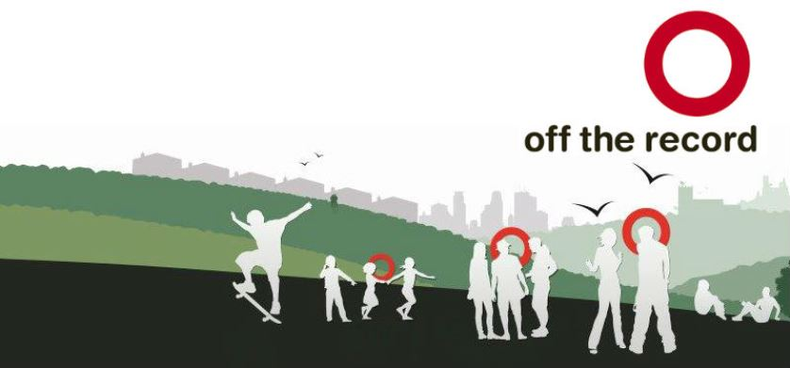

- How can I make a complaint?

You have the right to complain if you are concerned about how you are being treated or about the decisions that have been made about you.
You can do this by filling in a complaint form that you can get from your social worker or reviewing officer. You can also contact the complaints manager, Sarah Watts on 01225 477931 or sarah_watts@bathnes.gov.uk
You can also contact Sarah if you have any suggestions about how we could do things better. Even small suggestions can help to change how we help you and other young people.

You can also access information about all your rights whilst in care at:
http://www.bathnes.gov.uk/services/children-young-people-and-families/children-care/information-children-and-young-people-care..

