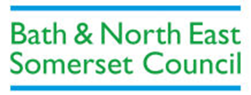

Cross-Party working group to consider options to strengthen community representation and civic governance within Bath
Interim Report for Comment - July 2014

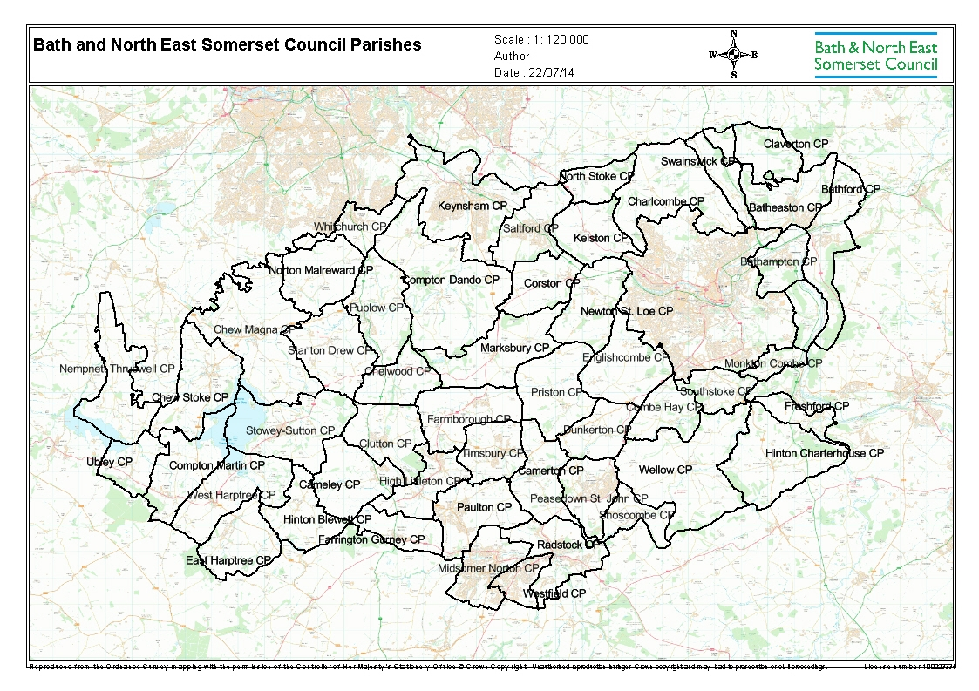
Bath is Unparished

- Summary and Key Issues for Comment

A cross-party member working group has been meeting since May 2014 to consider options to strengthen community representation and civic governance within Bath. This means the unparished area referred to on the map on the front cover of this report.

As part of the process of preparing a report to Council for its meeting on 11 September 2014, the group has agreed to request comments on this interim report, which reflects its work so far. Comments received will be considered in preparing the final report and will also be reported to the Council meeting.

This interim report considers three options. These are:

- No Change
- A “Voice for Bath” committee (to include co-opted stakeholders as well as B&NES elected members)
- The parishing of Bath - either as a single parish for the City or multiple parishes for different parts of the City. This would require a Community Governance Review

The key questions you are asked to consider when making your comments are:

- Of the three options set out above, which is your preferred option?

- For the “Voice for Bath” committee option:

  - What should be its role and functions?
  - Which stakeholders should be co-opted onto it?
  - Should these stakeholders have voting rights (for information about under which circumstances stakeholder co-optees are able to vote, please see Appendix 1)
  - How many of the 32 Bath elected members of Bath & North East Somerset should serve on it?

- For the parish options:

  - Should Bath be parished as a whole (with one Parish Council for the City of Bath) or should there be multiple parishes for Bath?
  - If there were to be multiple parishes, how should Bath be parished?

When responding, the member working group asks that you consider:

- …which option best provides easier ways for local people in Bath to have their voices heard on the issues that affect them

- …which option best provides a clear “Voice for Bath” to address the perceived “democratic deficit” in the City?

- …which option best delivers local services in a more effective and convenient way, for example by focusing better on local priorities or by attracting new resources

- … the costs to the Bath and North East Somerset Council Tax Payer of any new arrangements and whether the benefits to local communities are commensurate with these

- …timescales for delivery. Please note that one or more Parish Councils can only be established following a Community Governance Review

- …changes such as the Community Infrastructure Levy

- …the extent to which you are satisfied with current arrangements

Comments on the interim report are invited from all residents and businesses in Bath and North East Somerset and should be sent to:

governanceoptions@bathnes.gov.uk

by 5pm on 26th August.

- Background Information

As a result of discussions initiated at the second Bath City Conference, Bath & North East Somerset Council at its meeting of May 8th 2014 agreed to establish a cross-party member working group to identify a preferred option to Council to strengthen community representation and civic governance within Bath. The members of this group can be found at Appendix 2.

The working group has met seven times to examine in detail a range of options. It has asked for reports, information and clarification. Initial input and views were requested and the minutes of the group’s meetings have been placed on the Bath City Conference website and also circulated to parish councils.

This document sets out the outcomes so far of these discussions in the form of this interim report for comment. This is designed to inform the final report to Council on September 11th.

The deadline for comments on this document is 5pm on 26th August and these will be considered by the members of the working group at its meeting of 28th August.

To comment on this report please contact
governanceoptions@bathnes.gov.uk

- The Current Position

The working group, as well as considering options for change, has also examined in detail the present system of governance and community representation in Bath & North East Somerset, which comprises the following:

- Bath & North East Somerset Council is the “principal authority” and as such secures a wide range of services for local communities. Bath & North East Somerset Council levies the same Council Tax precept across all communities in Bath & North East Somerset to help pay for these services.
- The Council is made up of 65 elected councillors who make decisions on how to provide these services on behalf of local people within the 37 wards that make up Bath & North East Somerset. These councillors are elected every 4 years with the next election due to take place in May 2015.
- In addition to the Bath & North East Somerset level of governance, there are currently 45 directly-elected parish and town councils (as well as 3 parish meetings) in the area outside of the City of Bath. Parish Councils may raise their own additional precept which may be spent on a range of local services. See Appendix 3 for a full list of the powers of parish and town councils.
- In the City of Bath, the 32 Charter Trustees are responsible for maintaining the Charter of the City. The Charter Trustees comprise the 32 Bath & North East Somerset councillors for the wards of the City of Bath and it is from these that the Mayor of Bath is selected. There is no parish council within the City of Bath. See Appendix 4 for more information about the Charter Trustees of Bath

The working group has identified a number of concerns about these current structures, particularly the perception of a “democratic deficit” in Bath and the lack of a “voice” for Bath. “No Change” has however been identified by the working group as a potential option as implementing new structures and approaches presents potential challenges, including costs to Council Taxpayers. More detail- including potential benefits, implementation and costs - of the three options are set out in the next section.

4. Potential options for strengthening community representation and civic governance within Bath.

Including the “no change” option, the working group considered a total of 9 separate options. These are set out in Appendix 5.

Following detailed discussions, the working group has now identified 3 of these as the options which it wishes to consider further and on which comment is being requested prior to the report to Council. These are:

- No Change
- A “Voice for Bath” Committee (including stakeholders as well as B&NES elected members)
- The parishing of Bath - either as a single parish for the City or multiple parishes for different parts of the City.

The working group agrees that options B and C in particular can help deliver the aims of strengthening community representation and civic governance within Bath, but in different ways and with different costs and benefits. Under all options, however, Bath & North East Somerset Council would remain responsible for major services such as social care, highways, school admissions, children’s services, environmental protection, planning decisions and so on. Bath & North East Somerset Councillors will continue to represent their wards as at present.

These three options are explained more fully below, under the following headings:

- What difference would we see?
- Potential benefits
- Implementation
- Costs

Option A - No change

What difference would we see?
There would be no difference to the current situation. The Charter Trustees of Bath would continue their current limited role of preserving the historic identity of the City by carrying out ceremonial functions and selecting the Mayor. The Trustees are Bath & North East Somerset councillors from Bath wards: they can raise funding for ceremonial and related purposes. The Charter Trustees cannot do this to enhance local services, nor do they have a role to act as a “voice” for the City of Bath as a whole.

Any additional powers for the Charter Trustees over and above their current functions would require central government regulations, and granting of this this is considered highly unlikely.

Potential benefits
Under these arrangements Bath & North East Somerset councillors and officers would continue to engage locally on a range of projects relevant to the City and its communities. For example, the “local proportion” of the Community Infrastructure Levy, which has to be spent in the locality of the development, would be agreed through Bath & North East Somerset Council processes, albeit requiring further engagement at local level on this.

Implementation
Under “no change”, the Council would still be required to consider how it implements the “local proportion” element of the Community Infrastructure Levy which presents particular challenges in the unparished area of Bath. More information on this is set out in Appendix 6.

Costs
Council Tax payers in Bath wards currently pay £6.58 (Council Tax band D) to the Charter Trustees of the City of Bath.

Option B- A “Voice for Bath” committee (including stakeholders as well as B&NES elected members

What difference would we see?
This option would see a new Council committee formed of all or some of the Bath & North East Somerset elected members who represent Bath wards, alongside co-opted stakeholders such as local residents’ groups. This “Voice for Bath” committee would exercise some of the functions which are currently carried out either by Bath & North East Somerset Council, or by its Cabinet, a committee or through other delegations.

Potential benefits
At its simplest, the new body could begin by acting in an advisory capacity to the Cabinet, responding to consultations and acting as a “voice” for the City. It could advise on how best to manage issues such as the local proportion of the Community Infrastructure Levy and Neighbourhood Planning, ensuring there is the right form of community engagement. More information on the local proportion of the Community Infrastructure Levy is set out in Appendix 6. An example of a body working in this type of way is the Winchester Town Forum. More information on the Winchester Town Forum is available at Appendix 7.

Implementation
It would be possible to establish a “Voice for Bath” committee relatively quickly, drawing on models from other areas such as Winchester. However, agreement would need to be secured on exact Terms of Reference and co-options.

Cost
A “Voice for Bath” committee would not be able to raise any precept over and above the current Bath & North East Somerset precept. There would be an additional cost of running it, depending on how often it would meet. Running a “Voice for Bath” committee would cost an estimated £1500 for each meeting held. For example, if the “Voice for Bath” committee were to meet 6 times a year it would cost £9000. This would be paid for from the Bath & North East Somerset Council Tax precept.

Option C– The parishing of Bath- either as a single parish for the City or multiple parishes for different parts of the City (this would require a Community Governance Review)

What difference would we see?
This would mean either a new Bath City (Parish) Council being established to cover the whole of the unparished area of Bath or a number of parishes within Bath City. Any new parish council or councils would be directly elected, separately from Bath & North East Somerset councillors and could levy a precept to enhance local services, as with current parishes outside of Bath.

A single parish council for the whole City would take on the duties of the Bath Charter Trustees and the Chairman of that Council would become the Mayor of Bath, the Charter Trustees be dissolved and the functions be transferred.
Alternatively, a number of parish councils, of smaller geographical area, could be formed within the City of Bath. Each of these smaller parishes would have the same legal powers as a larger parish. It would be possible for some parts of the City of Bath to be parished, with others not. The implications of this, particularly for the Mayoralty of Bath, are set out in Appendix 8.

Potential benefits
Parish Councils are the most local form of government and can represent a wide range of populations as there are no legal limits on population sizes. The general rule is that they are based on an area which has real community identity and shared interests. (You may see the words “Parish Councils” and “Town Councils” used, but they mean the same thing - the only difference being that the Chairman of a Town Council can have the title of Mayor). If the whole City of Bath were to become one parish its parish council would have the status of a City Council as the current Charter would transfer to it.

Parish councils can choose to deliver services that improve their local area and for this they are able to raise a precept through the Council Tax. As they are directly elected they can be seen to provide an additional democratic voice offering accountability to the electorate. Parished areas are able to prepare a Neighbourhood Plan and when this happens this gives them direct access to a higher “local proportion” of the Community Infrastructure Levy. Parishes also receive this “local proportion” directly to spend in their areas.

Whatever parish council(s) were to be formed in the City of Bath, Bath & North East Somerset Council would still exist and would remain responsible for major services such as social care, highways, education admissions, children’s services, environmental protection, planning decisions etc. Bath & North East Somerset Councillors would continue to represent individuals and groups in their wards.

Implementation
Bath & North East Somerset has the power to establish parish councils. However, it may only do this following a Community Governance Review, and any implementation could only therefore take place subject to this. The process for implementing a Community Governance review is set down by central government and more information on this can be found in Appendix 9. A Community Governance Review would require a period of 6-12 months to undertake.

Costs
If a single parish council were to be created covering the whole of the area of the Charter Trustees for Bath, the Charter Trustees would be replaced by the new parish council, which would be a City Council. This would then carry out its functions and recover the costs by setting a council tax precept. There would be a cost to Bath & North East Somerset Council in undertaking a Community Governance Review. Costs are currently unknown and would depend on the approach taken, but a budget of £100,000 is envisaged.

All parish costs and precepts vary depending on the size of the councils and the services they deliver. The parish precepts for residents in Bath & North East Somerset range from £5.99 to £133.85.

5. I need more information before responding

The working group has discussed the three options in detail and has prepared a detailed “pros” and “cons” list for each of them. This is set out in Appendix 10. There is also a detailed analysis of the differences between the parishing and “Voice for Bath” committee options contained in Appendix 11.

There are also a series of Frequently Asked Questions set out below:

- Under what circumstances can co-optees to the “Voice for Bath” committee vote?

- Which members of Bath & North East Somerset Council formed the working group?

- What are the powers of town and parish councils?

- What is the role of the Charter Trustees of Bath?

- What options have been considered by the working group?

- What is the Community Infrastructure Levy and what is the relevance to this discussion?

- What is the Winchester Town Forum?

- What are the implications for the Mayoralty of Bath?

- What is a Community Governance Review?

- What are the detailed pros and cons of the options being put forward by the working group?

- What is the difference between a parish council and an area committee?

