Bath & North East Somerset Council

Advice & Information Strategy 2014 – 2017

**Contents**

**Section 1 – Introduction – why we need a strategy**

**Section 2 – Scope**

**Section 3 – Aims and outcomes**

**Section 4 – What we need to do**

**Section 5 – How we will assess and monitor progress**

**Appendix 1 – Action Plan**

Section 1 - Introduction – why we need a strategy

Introduction

Bath & North East Somerset Council is committed to putting people first and its communities at the heart of everything we do.

Alongside the delivery of essential services, the provision of advice and information is a primary function of any council. Wherever and however customers and communities touch the organisation, whether it is face to face, one of the 2 million telephone calls we receive each year, on line or via social media they want access to advice or information. The Council provides this directly and also commissions other partner organisations to provide it. If we want to ensure we deliver on our commitments of a high quality advice and information service it is essential that we have a clear strategy.

Definitions

For the purposes of this strategy the definitions we are using are:

* **Information** – materials which can be passively available or actively distributed and mediated. Includes self-help (websites, other digital communications and more conventional leaflets etc) and provision through direct contact with trained personnel (call centres, Face to Face, community provision etc).
* **Advice** - Guidance and direction on a particular course of action which needs to be undertaken in order to realise a need, access a service or realise individual entitlements.(Source: Margiotta et al).
* **Support** – the support people receive to access advice and information so that they can make full use of it to make their own decisions.

The Drivers

There are a number of drivers for development of an advice and information strategy, they include:

* **Central Government** - The Care Act 2014 and the Think Local, Act Personal agenda –articulate the Government’s increasing emphasis on enabling people to make informed choices for themselves. The Care Act also requires that the Authority must establish and maintain a service to provide comprehensive advice and information on care and support.
* **Housing Needs** – housing costs in Bath & North East Somerset and Bath in particular are high in comparison to other areas in the South West and the rest of England. The area also suffers from relatively low incomes. As a result, good quality housing is often difficult to find and sustain. We want to ensure that people receive good advice and information on housing to enable them to avoid the risk of homelessness.
* **Responding to Welfare Reform** – the Government has embarked on a rolling programme of welfare reform including the introduction of universal credit; we must ensure we are able to respond effectively to the advice and information needs of individuals and families affected by these national policies.
* **Council corporate objectives** - Promoting independence and positive lives for everyone; Creating neighbourhoods where people are proud to live; Building a stronger economy
* **The local Joint Health and Wellbeing Strategy** – Helping people stay healthy, Improving the quality of people's lives, Creating fairer life chances
* **Customer expectations** - our population expects to be able to access advice and information in a variety of different ways to enable them to make decisions about their managing their lives. It also expects that it will be accurate, relevant and available where and when it is they need it.

Section 2 - Scope

The Council’s strategy has been developed to ensure that advice and information provision is sufficiently wide ranging and flexible in order to meet the needs of its population at any point in their lives.

Who

Bath and North East Somerset Council is committed to the provision of advice and information that is universal and available to our entire population. At the same time it recognises that particular groups or individuals with more complex needs may require specific and targeted support to enable them to use and access advice and information provided.

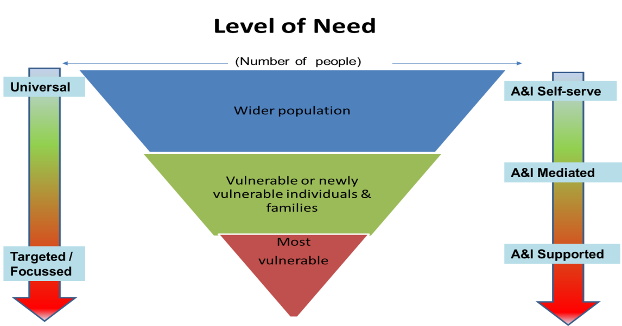

The majority people, most of the time will be able to access advice and information for themselves or with support from family, friends and neighbours. However there will always be a need for specialist or independent advice for some groups of people or types of problems.

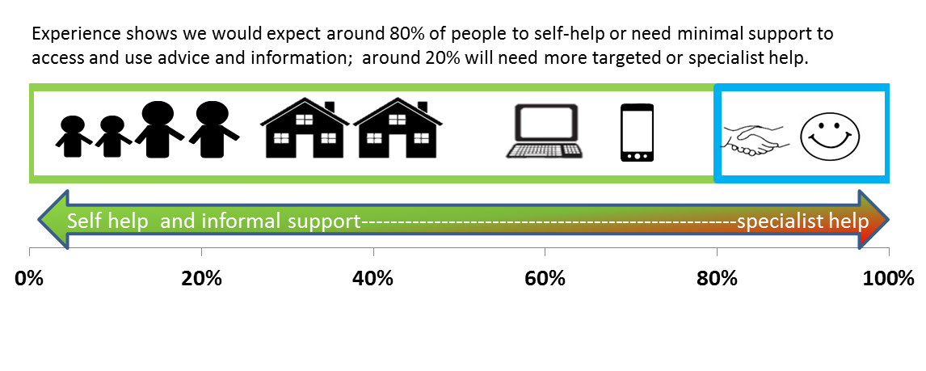

This strategy is intended to ensure that information and advice is universal but also provided in a way which will meet the needs of those who need extra help and support as well.

What

The Council recognises that the advice and information needs of customers fit into some key themes, within each of these are several sub-themes. There will also be considerable overlap as peoples’ lives do not fit into neat boxes:

* Legal rights
* Housing
* Finance
* Health and social care
* Childcare, education or training
* Employment

We know that at certain times in peoples’ lives something will happen (a “life event”) which could trigger a need for a range of different or linked advice and information. These can occur throughout our lives and include (among others):

* Birth of a child
* Marriage / Partnering
* Illness / disability
* Entering, moving on or leaving education
* Gaining or losing employment
* Moving home
* Relationship breakdown
* Bereavement

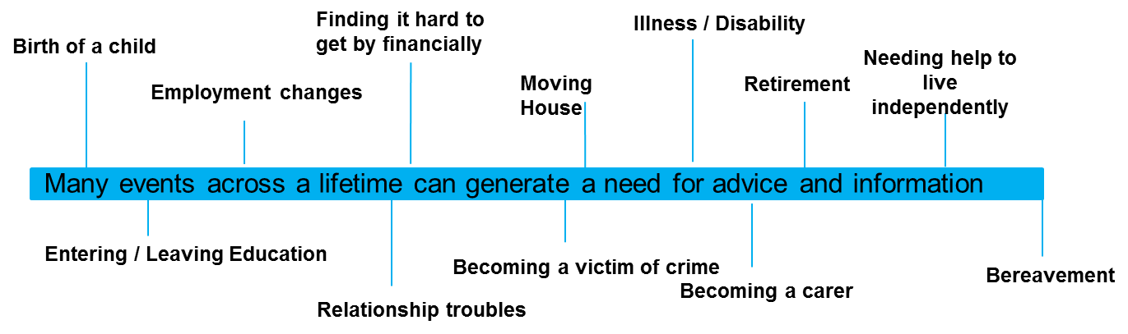

This strategy will ensure that advice and information is provided in a way which makes the right links for people and makes it easy for them to access everything relevant to their particular circumstances.

How

Delivery of advice and information services will be through a variety of mechanisms and may include:

* Local Authority staff and / or infrastructure
* Partner organisations
* Commissioned providers
* Community groups working with the Authority.

The new delivery framework will need to work differently, co-ordinating services and reducing gaps and duplication in provision.

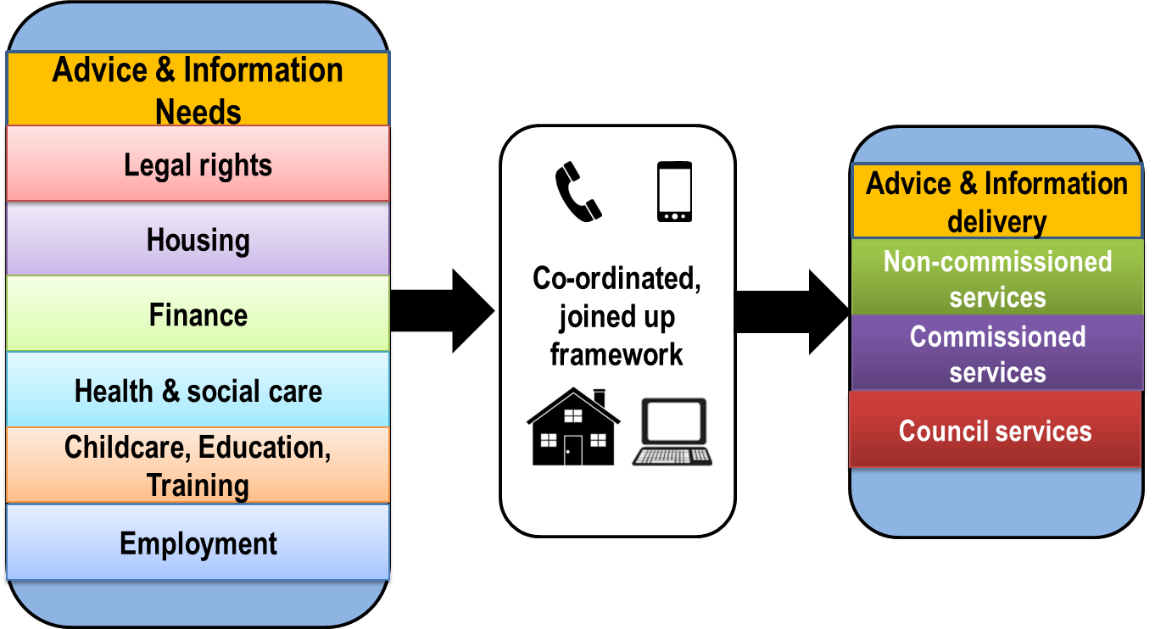

This strategy will ensure that regardless of which organisation is delivering information and advice, the service will be of high quality. There will be frameworks and protocols in place which will enable consistency in approach so that we can be confident the customer will receive what is needed and is never ‘in the wrong place’.

Section 3 – Aims and Outcomes

**The Strategy will ensure:**

* High quality advice and information is available to all those who need it
* Advice and information is available how, when and where needed and in accessible formats.
* Effective partnership working is in place.
* The delivery model is sufficiently flexible to allow for the changing local context.

Outcomes

We will be satisfied that our strategy is successful in Bath & North East Somerset if:

* Advice and information provided, **accurately reflects** the needs of our local population and the services available.
* **People** **know how and where** to get the advice and information they need, when they need it.
* People get the **right advice and information the first time** they seek it
* **People** **have choices** in how they access advice and information appropriate to their needs
* People receive the same **high quality, consistent and accessible** advice and information wherever they access it
* People are able to use the advice and information provided to **maximise independence** and delay the need for more intensive support
* People who don’t usually seek advice and information are **more likely / able to do so**
* Delivery mechanisms recognise a person’s presenting needs and **tailor advice and information appropriately**.
* Provision of advice and information **aligns and links with other corporate strategies**
* The Council is able to discharge its **statutory duties** relating to the provision of advice and information.

Section 4 – What we need to do

To deliver this strategy the Council will need to ensure that:

* The issues and needs of our population are well understood so that the advice and information provided accurately reflects these.
* The appropriate infrastructure (resources, technology) and delivery model are in place to support universal access to advice and information.
* The appropriate resources and delivery model is in place to support those who need help to make best use of advice and information.
* Current and future commissioning plans for advice and information services, are explicit about the way in which plans secure best value and, also, meet and/or contribute to the outcomes set out in this Strategy.

In order to achieve the aims and outcomes of the strategy, we have identified four key areas of activity that will help us to deliver better advice and information for our customers.

**Activity 1: Increase general awareness of advice and information and also improve access for ‘unengaged’ and socially excluded groups**

Everyone who needs advice and information will know it is available and how to access it. We will make advice and information available in ways which mean those who may be otherwise reluctant to access and use it are able and willing to do so. We will ensure it is a positive, non-stigmatising experience. This will include ensuring that commissioned services targeted at meeting the needs of unengaged and socially excluded groups reflect the outcomes of this Strategy, including any specific access needs.

**Activity 2: Improve how we communicate our message**

Advice and information will be in clear, everyday language, easy to understand and accessible to all. It will be delivered in a way that stresses the importance of people staying connected and part of local community and emphasises a person’s ability to have choice, control and independence.

**Activity 3: Improve our co-ordination, infrastructure and delivery models**

We will make sure that the co-ordination, signposting and referral between advice and information providers and across professional / organisational boundaries are improved. Advice and information services will be flexible enough to adapt to changing local / national circumstances. We will ensure that “no door is the wrong door” for the customer. Future commissioning specifications will be explicit about how the service being commissioned will co-ordinate with and signpost and refer to other advice and information providers and across professional/organisational boundaries.

**Activity 4: Improve the quality and consistency of advice and information, making it relevant to the individual circumstance whenever possible.**

People will get the right advice and information first time. It will be consistent, up to date and relevant to the person’s need regardless of where, when or how they contact us.

A detailed action plan will be developed in partnership with the Sector. It will identify the key timelines, objectives that need to be delivered within the available resources and any statutory or specialised advice and information commissioning intentions. It will include a programme of service reviews to ensure best value and that the most appropriate delivery mechanism is in place to deliver the Strategy.

Section 5 - How we will assess and monitor progress

Monitoring

We will use a range of methods to measure progress towards making our strategy a reality for people in Bath & North East Somerset. These can be broadly summarised under three main headings as follows:

1. **Monitoring and Managing Quality** – We will develop and regularly review and revise key performance measures to ensure they are focussed and targeted towards delivering the outcomes we have set. This will inform both advice and information services delivered by the Council and by commissioned services.
2. **Facilitating a Sector Voice** – We will develop a forum for advice and information provider organisations to facilitate a ‘do and review’ approach to delivering our strategy. Through the forum, commissioned service providers will be tasked with helping us develop and deliver a coherent offer to local people who need advice and information services
3. **Service User Voice** – We will actively and regularly seek feedback from customers and service users through case studies, on-going sector review, mystery shopping and direct reporting.

Managing the strategy

It is critical that the impact of this strategy is considered within a wider context. In order to ensure this, the following steps will be taken:

* Cabinet and relevant PDS Panels will receive an update on implementation of the strategy 12 months from the time of adoption
* The Bath and North East Somerset Health and Wellbeing Board will receive 6-monthlyreports on performance, including delivery against outcomes and the findings of specific contract reviews.
* All Council services delivering advice and information and partner organisations or commissioned services delivering advice and information on behalf of or contracted by, the Council will adhere to this strategy.