**Licence No:**

**Bath & North East Somerset Council**

Street Works

Lewis House, Manvers Street,

Bath BA1 1JG

**Telephone: 01225 394041**

**Email: network_licences@bathnes.gov.uk**



**Building Materials/Container Licence**

**Highways Act 1980, Sections 137 and 171**

Please provide the following information and return the form before you wish to place the building materials/ container on the highway. For applications with over 5 working days notice, an administration fee of £67 must be paid via our portal link. For applications with under 5 working days notice an administration fee of £100 must be paid via our portal link.

Further administration fees of : Renewals (£49), retrospective (£132) payment/document chase fees (£12 per chase) and safety inspections (£55 per inspection) Please allow 5 working days’ notice before the previous licence expires.

Please note, the maximum single period of permission is 28 days. Any extension into a further 28 day period (renewal) will require a separate application and process fee. Renewals should be applied for prior to expiry of the existing licence.

Plus a charge to cover loss of income when on-street parking bays are suspended, to be arranged with Parking Services by the applicant on 01225 477133 or [parking @bathnes.gov.uk](mailto:parking_services@bathnes.gov.uk)

**Application for: Building Materials: Container:** *(Please tick)*

**Applicant details**:

|  |  |
| --- | --- |
| **Name:** | **Tel No Office Hours:**  **Tel No Out of Hours:** |
| **Address** | **Email:** |

**Contractor Details:**

|  |  |
| --- | --- |
| **Name:** | **Tel No Office Hours:**  **Tel No Out of Hours:** |
| **Address:** | **Email:** |

**Proposed Location of building materials/ container**

|  |
| --- |
| **Full Location Address:** |
| **Container Dimensions:** |
| **Width of Existing Carriageway:** |
| **Description of Materials and Approx Quantity:** |

|  |  |  |
| --- | --- | --- |
| **Dates Required** | From: | To: |

The licensee will fully indemnify Bath & North East Somerset Council against all actions, claims, demands, losses, and expenses whatsoever in respect of loss of life or personal injury or damage to property, howsoever caused, arising out of or in any way attributable to the presence of the building materials/ container. To support this indemnity **the contractor must provide proof of their public liability to the value of £5 million** in respect of any one claim, with no limit on the number of claims.

I/we hereby apply to Bath & North East Somerset Council to deposit building materials/a container on or over the footpath/carriageway in connection with the building demolition, alteration, repair, maintenance or cleaning of the building/property/site.

I/we hereby agree to comply with the terms and conditions set out overleaf and with all other statutory rules and regulations which may apply to these circumstances.

|  |  |
| --- | --- |
| **Signed:** | **Name (block capitals):** |
| **Position in Company:** | **Date:** |

**PUBLIC LIABILTY INSURANCE RIDER FORM**

**Rider to Conditions for Placing Building Materials/ Container on the highway.**

I/we confirm that PUBLIC LIABILITY INSURANCE is held in the name of the applicant, as detailed below. I/we also confirm that the limit of insurance cover is to a minimum of £5 million, and that the insurance covers the period as detailed on the application. I understand that this requirement is in addition to other conditions and requirements detailed on the application. **Please supply copies of Public Liability insurance with this application and return to Bath & North East Somerset Council.**

|  |  |
| --- | --- |
| **Signed:** | **Name (block capitals):** |
| **Position in Company:** | **Date:** |
| **Company Name:** | |

**Bath & North East Somerset Council - OFFICE USE ONLY**

Bath & North East Somerset Council, as the Highway Authority, in exercise of the above powers **grant permission** in accordance with the details and conditions given on this form to the above contractor to place building materials/ container on the highway.

Further conditions:

The deposit/container may only remain between 09:30 hours and 15:30 hours

The deposit/container may only remain overnight and until:

The deposit/container must be guarded by temporary traffic signals, because the

width of the carriageway is less than 5.5 metres.

**Access to all underground apparatus, and street furniture to be accessible at all times and not be restricted.**

|  |  |
| --- | --- |
| Additional Comments: | |
| Signed (authorising officer) | Date: |

**PLEASE NOTE: FAILURE TO COMPLY WITH THE CONDITIONS OF THIS LICENCE MAY RENDER THE LICENCE VOID**

**CONDITIONS OF DEPOSITING BUILDING MATERIALS/ CONTAINER ON THE HIGHWAY (Highways Act 1980. Section 171)**

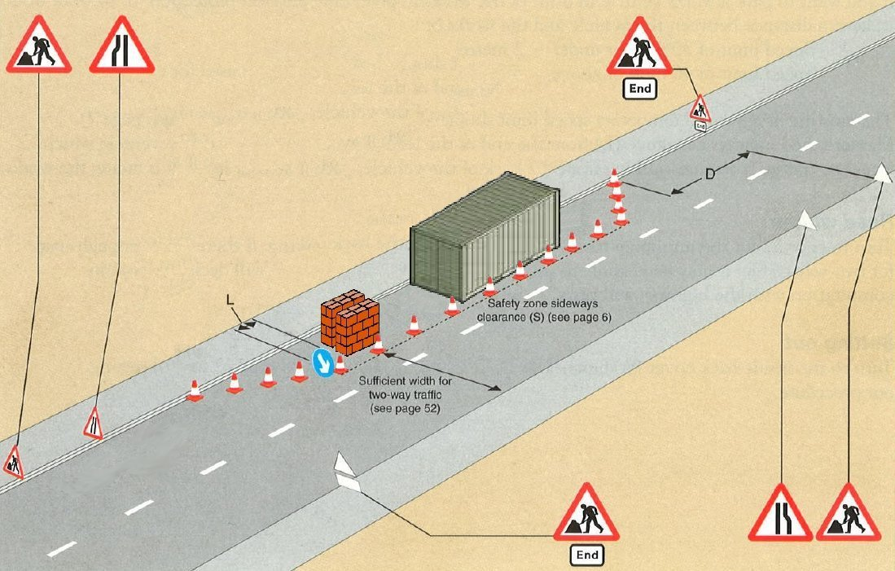

**DUTIES OF THE LICENSEE**

The Licensee must:

1. Place and keep traffic cones on the highway (see diagram) in daylight for each deposit.
2. Keep and deposit under 5 metres long and 2 metres wide: minimum 15 metres between deposits.
3. Not block the channel or gutter nor allow material to enter drains.
4. Not obstruct a gully or manhole.
5. Not deposit flammable, explosive, or noxious material.
6. Not mix materials on the highway surface (Penalty £200 – See Section 170 Highways Act)

(But mixing on a board may be used).

1. Clear the deposits by the time stated.
2. Sweep and remove all spillage and debris from the highway.

And, if the deposit is authorised to remain overnight:

1. Place and maintain during lighting-up hours, a minimum of 5 lamps (minimum 1 candle-power each) for each deposit (see diagram).
2. Place and maintain warning signs as directed by the Highways Authority **(Chapter 8).**
3. Immediately remove the deposit at the request of any Statutory Undertaker who requires the site.
4. Give a copy of the licence to the person receiving the materials.

**Penalty for non-observance**

If the Council has to take action to remedy a breach of these conditions or to repair damage, the full costs shall be recovered from the licensee.

**Legal Indemnity**

The Licensee shall indemnify and save harmless the B&NES Council and/or its servants and agents against and from all claim demands, actions, costs and damages however arising out of by or in consequence of the depositing materials/ a container on the carriageway, footway or verge. The period of indemnity to run from the commencement of the deposit to the final removal of the same.

**Conditions to be observed by both supplier and owner of the deposit**

**Materials shall not be deposited:**

1. Within 15 metres of any road junction.
2. In any bus lane during its period of operation
3. During the hours of darkness – unless specially authorised).
4. Where parking restrictions or traffic measures are in force (unless specially authorised).
5. In major shopping areas and their access roads at, e.g. Christmas, Sales etc.
6. Near public meeting places, e.g. churches, schools, football grounds etc.