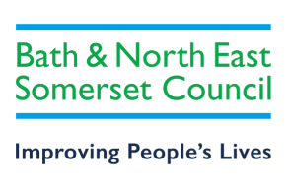
OAP – Section D - Forms
Costed Provision Map
Pupil Name: Date of Birth: Year:
Setting:
Area of Need | Aim of Provision/Link to SMART target/EHCP outcome | Recommended by | Support/Intervention | Frequency/  Duration | Staffing Ratio | Start Date | End Date | Cost per Week | Cost per Year
Communication and Interaction

Cognition and Learning

Social, Emotional and Mental Health

Sensory and Physical

Additional

 |  |  |  |  |  |  |  | Total Cost
Please note that you may not have provision for all areas of need. It is also normal for a single area to have multiple outcomes, or for one intervention/support strategy to apply across several areas of need.

