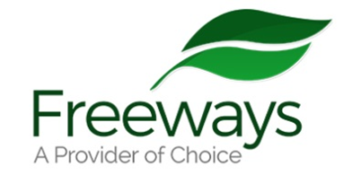
You come One Stop Shop no need appointment
Freeways Floating Support
Service Drop in sessions

You have learning Disability, Autism, ADHD and over 18 years?
BSL your first language?

We help FREE support with:

- Grants, Foodbank, bills and shopping vouchers.
- Support with finding house/flat
- Contacting Homesearch to help with your account – help find new house/flat
- Help Call Landlord or report repairs
- Money advice
- Support you pay rent or bills
- Help understand letters
- Support with your debts
- Support your benefits
- Help with Universal Credit
- Help Blue Badge and bus pass

Please come we look forward to meeting you. No need appointment.



One Stop Shop. Lewis House. 3-4 Manvers St, Bath
BA1 1JQ

Email AngeRogers@freeways.org.uk Call 01225 830416
Text 07879423791

Registered Charity 298603

