** TEMPLATE **
Your logo
Add Community Name

Community Emergency Plan

Version: xx

Date of Plan: xx
This Plan is next due for review on: xx

If an emergency occurs, your first action should ALWAYS be to contact the emergency services by dialling 999

Map of area covered by plan is on Page XX


Supported by

Contents
1. First things to do in the event of an emergency 2
2. Activating the community emergency plan 3
3. Communications in an emergency 4
4. Emergency Team initial actions 6
5. Checklist for Team Meeting: 7
6. Community resources and skills 8
6.1 Evacuation Assembly Points 8
6.2 Local Skills and Resources 9
6.3 Local Risk Assessment 10
7. Map of the Community 11
8. Emergency Contact numbers 12
9. Top Tips – Personal Resilience 13
10. Useful information 14

Introduction

Communities are strongest when they are prepared. This Community Emergency Plan has been developed to help our local area respond effectively to major disruptions such as severe weather, power outages, flooding, fires, or other incidents that may impact daily life. While emergency services will always do their best to assist, there may be times when they cannot reach us immediately. In these situations, a well-organised community response can make a meaningful difference.
The purpose of this plan is to bring together local knowledge, resources, and volunteers so that we can support one another during emergencies. It outlines the actions our community can take, identifies key local risks, and highlights the people, skills, and assets we can call upon when needed. The plan also provides clear information on communication routes, essential contacts, and safe locations.
This is a living document and should be reviewed regularly to ensure it remains accurate and reflects the needs and strengths of our community. By understanding the plan and knowing how we can contribute, each of us plays a part in keeping our community safe, resilient, and ready to respond.

First things to do in the event of an emergency

- Ring 999 to inform the Emergency Services and provide

- Clear
- Concise
- Actual information as soon as possible

- Contact the plan volunteers

- Meet at the Coordinators Assembly Point

Primary Coordinator Assembly Point

Name of Venue: INSERT NAME

Address of Venue: INSERT LOCATION

In the event that the above location is inaccessible the following will be used:

Backup Coordinator Assembly Point

Name of Venue: INSERT NAME

Address of Venue: INSERT LOCATION

The coordinator and Plan Group may then decide to:

- Agree locations and open Evacuation Assembly Point/s [If required]

- Contact plan volunteers with specific skills, equipment or resources who may be able to help with the emergency situation
- Contact other plan volunteers using the other Communications Tree

Activating the community emergency plan

The Plan may be activated when:
- An emergency has occurred
- Warnings are received prior to an anticipated emergency
- Emergency services request support or are not able to attend immediately.
- No emergency / warning has occurred but it is felt a community response would be of benefit, particularly for more vulnerable residents e.g. prolonged cold snap and icy conditions.

Until help arrives and without endangering yourself or other local people contact the appropriate members of the community listed in the plan and ask them to report to the agreed assembly point.

When the emergency services or other responders have arrived try to make contact with them, explain who you are and what your role is.

Role | Name | Tel | Mobile | Address
Coordinator
Deputy
Team Member 1
Team Member 2

Add more team members to suit your plan needs or available volunteers
- The Plan can be activated by the Emergency coordinator based on that person’s assessment of the situation. It is easier to stop the plan should events come under control sooner than expected than to not respond at all.
- Sometimes full plan activation will not be required and the plan should also be seen as a resource to solve smaller issues within the community
- If details of an incident are received from a source other than the emergency services or local authority then those receiving the notification must contact the emergency services to ensure they are aware of the incident. This may require making a 999 call.

Communications in an emergency

If appropriate, and safe the Emergency Team should aim to meet face to face to assess and give direction
The primary communications channels are:
- Insert primary communication channels for your community eg: WhatsApp for Coordination Team
- Village news email or other for broadcasting messages to the community

Emergency Team initial actions
On receipt of the initial contact
- If it comes from the emergency services or BANES, note their immediate requirements, if any.
- If it comes from another source:
  - Ensure that the emergency services are aware of the incident
  - If necessary call 999
  - Contact the Co-ordinator (or next in line) and decide if the plan should be activated (in full or in part)
Assembly points for the emergency team
The location needs to be in a safe and accessible area (depending on the emergency)
- Primary assembly location: xxxxxx
- Backup assembly location: xxxxxx
Emergency team members should:
- Assemble at designated assembly point
- Make initial contact with BANES and/or the emergency services
- Review the situation and identify/take actions (if safe to do so)
- Keep a log of proceedings and update each other on actions
- When the emergency services or other responders arrive, make contact with them, agree roles and actions and follow their lead.

Checklist for Team Meeting:

- Assess the current situation
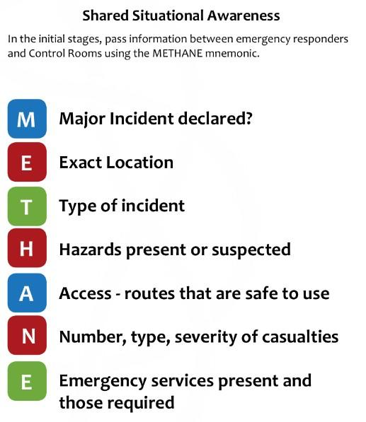
- Allocate roles, such as:
  - Coordination, communications, contacting those with the relevant local skills and resources, contacting vulnerable residents, opening up assembly/evacuation centres, gathering further information on the incident.

- Communications
  - Are WhatsApp and/or phone systems available (or is door knocking required)?
  - Contact the community group coordinators to start cascade
  - Contact people with relevant skills and resources

- Establishing contact with the emergency services
  - Pass on any useful information (use METHANE)
  - Agree roles, communications and resources required
  - Follow lead taken by responders

- What actions can be safely taken (eg. If emergency services delayed)
  - Supporting the vulnerable
  - Opening up assembly points ( and stationing a team member there)
  - Contacting people on the resources/skills list

Community resources and skills

6.1 Evacuation Assembly Points

Record here details of accommodation that would be suitable for persons, including casualties, requiring temporary shelter until help arrives e.g. halls, hostels, churches etc. Local authority premises, schools, leisure/community /day centers will be opened by the local authority as appropriate.

Key Holders Name | Facility Address | What3Words | Telephone No. | Mobile No. | Email Address

Ensure that the managers of these buildings are aware of their inclusion in this Plan, and that they are briefed as to what might be expected of them in an emergency i.e. to open the building, provide shelter (including heating if appropriate) and refreshments to evacuees.

6.2 Local Skills and Resources

Resources available within the community include:
- Eg: 4 wheel drives
- Trailers
Skills available within the community include:
- Eg: First Aid
Name | Phone | Insert resources – 1 per column | Insert Skills – 1 per column | Eg: Trailor | Eg: First Aid
Mr Smith | 075xxxxxxx |  |  | x
Mrs Johnson | 075xxxxxxx |  | x |  | x

Defibrillator

Location:
What3Words:
Access code:

6.3 Local Risk Assessment
Known potential hazards
Insert information eg:
Gas pipeline (& map)
Or
Local catchment area – flooding (& map if available)

Map of the Community
Eg: GIS Map (if you need support for maps email emergencyplanning@bathnes.gov.uk)

Emergency Contact numbers

Name / Contact | Role | Daytime contact number | 24hr contact number
Emergency Services |  | 999 | 999
Local GP Surgeries
B&NES Council | Emergency Planning Duty Officer | 01225 47 7477 | 01225 47 7477
Environment Agency | Floodline | 0345 9881188
Environment Agency | Incident Hotline | 0800 807060 | 0800 807060
NHS Direct
Utility companies

Top Tips – Personal Resilience
There is an important part to be played by individuals and households to help themselves at a personal level. There is a lot that individuals can do to cope better during, and recover quicker from, an emergency.
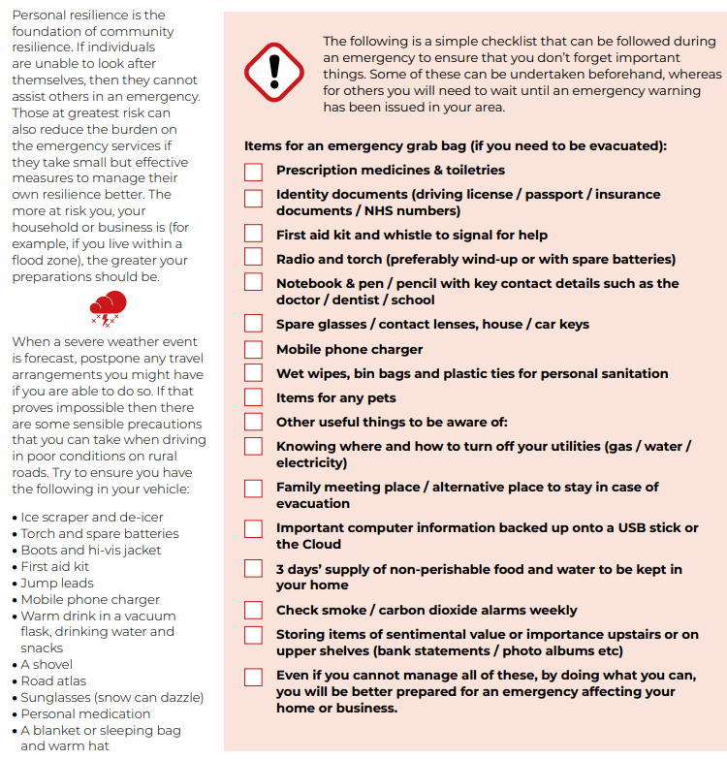

Useful information

Avon and Somerset Local Resilience Forum (LRF) community risk register (a guide to the top 10 risks in this region and what you can do to be prepared in your home)
https://media.aspolice.net/uploads/production/20200107090454/Community-Risk-Register.pdf
Reporting a power cut (and advice)
National Grid - How to report a power cut
Registering as a vulnerable customer
National Grid - Priority services
Bristol water report a problem
https://www.bristolwater.co.uk/home/account-and-services/your-water/problems-with-my-water
Bristol water register as vulnerable
https://www.bristolwater.co.uk/home/account-and-services/your-account/priority-services
Wessex Water report a problem
https://www.wessexwater.co.uk/report-a-problem
Wessex Water register as vulnerable
https://www.wessexwater.co.uk/help-and-advice/priority-services
Weather warnings and advice (Met Office)
UK weather warnings - Met Office
Flood alerts and guidance
How to plan ahead for flooding - Check for flooding - GOV.UK (check-for-flooding.service.gov.uk)
Flood maps are available online
Flood map for planning - GOV.UK (flood-map-for-planning.service.gov.uk)
A guide to rural community resilience is available on the communities prepared website
Building resilience in rural communities – Communities Prepared

