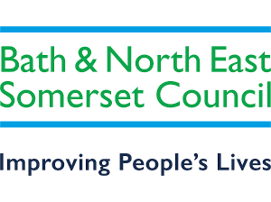
Bath & North East Somerset Council
Streetworks & Events, Lewis House,
Manvers Street, Bath BA1 1JG
Tel: Council Connect 01225 394041
Email: network_licences@bathnes.gov.uk

APPLICATION FOR CONSENT FOR OVERSAILING OF HIGHWAY BY TOWER CRANE
Section 178 Highways Act 1980

APPLICANT
Name (contractor) …………………………………… Tel…………………
Address…………………………………………………
…………………………………………………
………………………………………………… Post Code…………………

I/We appply for permission to oversail the Highway with a tower crane to be erected.
At……………………………………………………………………………………………..
From (date)………………….. to ………………………… (provisional)

Proposed length of jib is…………………. Metres abve the highway
The following documents are aslo attached:-
- A site plan showing crane centre and circle swept by end of jib, aslo the adjacent roads.
- A drawing showing the crane foundation.
- A design certificate for the crane foundation.
- Copy of Public Liability Insurance to the minimum of £5.000,000 per incident.

I confirm that the foregoing details are correct and acknowledge that the works referred to above must be conducted in accordance with the requirements of the New Roads and Street Works Act 1991, associated legislation, and Codes of Practice, together with any conditions imposed by the Street Authority in the relevant Licence.
I also confirm the sum of £275.00 is payable to Bath and North East Somerset Council via the Council Webpay portal for the administrative and monitoring costs in the provision of this consent (Link to follow completed application). For applications made with under 5 working days’ notice the sum of £310.00 is payable. Retrospective (£550.00), Emergency applications (additional to licence fee £66.15).

Signed …………………………… For ……………………………………………….
Dated ………………….

Bath and North East Somerset Council, as the Highway Authority, in exercise of powers under the Highways Act 1980 grant permission, in accordance with the details given on this form and the attached conditions, to the above contractor to oversail the highway with the tower crane.

Signed ………………………… Date ……………………
Street works & Events, Lewis House, Manvers Street, Bath, BA1 1JG

Conditions: -

