**OFFICER DECISION REPORT - TRAFFIC REGULATION ORDER (TRO)**

3

**APPROVAL TO PROGRESS TRO**

PREPARED BY: Traffic Management Team, Highways and Traffic Group

|  |  |
| --- | --- |
| **TITLE OF REPORT:**  **PROPOSAL:**  **SCHEME REF No:**  **REPORT AUTHOR:** | **Lansdown Speed Review**  **40 MPH Speed Limit**  **23-019**  **Gina West** |

**1. DELEGATION**

The delegation to be exercised in this report is contained within **Part 3**, **Section 4** of the Constitution under the **Delegation of Functions to Officers,** as follows:

|  |  |
| --- | --- |
| **Section A** | The Chief Executive, Strategic Directors, Divisional Directors and Heads of Service have delegated power to take any decision falling within their area of responsibility….” |
| **Section B** | Without prejudice to the generality of this, Officers are authorised to:  serve any notices and make, amend or revoke any orders falling within his/her area of responsibility. |
| **Section D9** | An Officer to whom a power, duty or function is delegated may nominate or authorise another Officer to exercise that power, duty or function, provided that Officer reports to or is responsible to the delegator. |

*For the purposes of this report, the Director of Place Management holds the delegated power to make, amend or revoke any Orders.*

**2. LEGAL AUTHORITY**

This proposal is made in accordance with the Road Traffic Regulation Act 1984, which under Section 1 provides, generally, for Orders to be made for the following reasons, and in the case of this report specifically for the reason(s) shown below:

|  |  |  |
| --- | --- | --- |
| (a) | for avoiding danger to persons or other traffic using the road or any other road or for preventing the likelihood of any such danger arising, or | X |
| (b) | for preventing damage to the road or to any building on or near the road, or |  |
| (c) | for facilitating the passage on the road or any other road of any class of traffic (including pedestrians), or |  |
| (d) | for preventing the use of the road by vehicular traffic of a kind which, or its use by vehicular traffic in a manner which, is unsuitable having regard to the existing character of the road or adjoining property, |  |
| (e) | (without prejudice to the generality of paragraph (d) above) for preserving the character of the road in a case where it is specially suitable for use by persons on horseback or on foot, or |  |
| (f) | for preserving or improving the amenities of the area through which the road runs, or | X |
| (g) | for any of the purposes specified in paragraphs (a) to (c) of subsection (1) of section 87 of the Environment Act 1995 (air quality) |  |

**3. PROPOSAL**

To reduce the speed limit on Lansdown Road from 50mph to 40mph between the existing de-restricted speed limit (prior to the first vehicular entrance to Bath Racecourse and approximately 200m north of the junction with Langridge Lane) to the existing 40mph speed limit adjacent to Old Sulians RFC ground.

To reduce the speed limit on Lansdown Lane from 60mph to 40mph between its junction with Lansdown Road and the existing 20mph on the approach to its junction with Napier Road.

These proposals are shown on the drawing below.

**4. BACKGROUND**

Lansdown Road:

The speed limit along the section of Lansdown Road in question was reduced from 60mph to 50mph in August 2017. However, it is apparent that collisions are still occurring at the junction with Lansdown Lane, and anecdotal evidence would suggest that non-motorised activity along this section of the road is generally increasing.

Although there is only one road junction, there are also several Public Rights of Way, busy vehicular entrances, and various establishments accessed from Lansdown Road, including Bath Racecourse, Lansdown Golf Club, The Charlcombe Inn, Lansdown Park and Ride, Walcott RFC, and Larkhall Athletic football club, and various residential and business properties.

Having due regard for the turning movements and activity associated with these Public Rights of Way, vehicular entrances, and establishments, it is considered appropriate to reduce the speed limit to 40mph, as proposed.

Lansdown Lane:

The speed limit along the section of Lansdown Lane in question has remained 60mph, but it is considered that the change in speed limit from 60mph to 20mph (on the approach to the junction with Napier Road) is too great, and that there should be a more gradual transition between the speed limits.

In consideration of this transition in the speed limits, however, it has been noted that there are several residential and business vehicular entrances within the existing 60mph speed limit, along with access to a regular car boot sale and Public Rights of Way. There are also several relatively sharp bends in the road, which also has a gradient of 20%.

It is considered appropriate, therefore, to reduce the speed limit to 40mph between Lansdown Road and the existing 20mph speed limit, as proposed.

# 5. SOURCE OF FINANCE

The scheme is included in the 2023/24 Transport Improvement Programme.

**6. CONSULTATION REQUIREMENT**

Theproposal requires informal consultation with the Chief Constable, Ward Members, and the Cabinet Member for Highways.

PROPOSAL APPROVED FOR INFORMAL CONSULTATION WITH THE CHIEF CONSTABLE AND WARD MEMBERS.

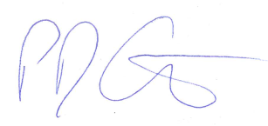

Paul Garrod Date: 3rd August 2023

Traffic Management and Network Manager

**7.** **COMMENTS RECEIVED TO DATE**

**Chief Constable -** It is understood from the attached that the proposal is to “*reduce the speed limit on Lansdown Road from 50mph to 40mph between the existing de-restricted speed limit (prior to the first vehicular entrance to Bath Racecourse and approximately 200m north of the junction with Langridge Lane) to the existing 40mph speed limit adjacent to Old Sulians RFC ground.*

*“To reduce the speed limit on Lansdown Lane from 60mph to 40mph between its junction with Lansdown Road and the existing 20mph on the approach to its junction with Napier Road*. “

With regard to the proposed speed limit alterations, as previously discussed, we have a Force stance regarding the introduction of speed limits, which has been written to reflect the current speed environment. I copy this below for your information.

“*Speed limits are only one element of speed management and local speed limits should not be set in isolation. They should be part of a package with other measures to manage speeds, which include engineering, visible interventions and landscaping standards that respect the needs of all road users and raise the driver’s awareness of their environment, together with education, driver information, training and publicity.*

*The police service has to ensure all resources are used effectively in responding to community priorities. Avon and Somerset Constabulary will support all appropriate speed limits, including 20mph roads, where;*

*The limit looks and feels like the limit, giving visiting motorists who wish to conform that chance; the desired outcome has to be speeds at the limit chosen so as to achieve safe roads for other and vulnerable users, not high speeds and high enforcement;*

*The limit is self-enforcing (with reducing features) not requiring large scale enforcement;*

*The limit is only introduced where mean speeds are already close to the limit to be imposed, (24mph in a 20mph limit) or with interventions that make the limit clear to visiting motorists;*

*Speeding problems identified in an area must have the engineering, site clarity and need re-assessed, not simply a call for more enforcement.*

*Enforcement will be considered in all clearly posted limits, given other priorities, and this will be by:*

*Targeted enforcement where there is deliberate offending and the limits are clear; Where limits are not clear ( that is they don’t feel like or look like the limit or are on inappropriate roads), they will not be routinely enforced, only targeted where there is intelligence of obvious deliberate disregard which may result in increased threat, harm or risk to other road users.*

*Deliberate high harm offenders will always be targeted and prosecuted whereas enforcement against drivers who simply misread the road may not be appropriate. None of the above should in anyway leave the impression that we will not enforce the law. As with all speed limits, and other enforcement work, we will use evidence to ensure that our resources are allocated in the most appropriate way using appropriate tactics.*

*Enforcement of limits that do not comply with the above representations could lead to mistaken offending and could risk the loss of public support. Enforcement cannot and must not take the place of proper engineering and or clear signing.*”

The attached also references “*The speed limit along the section of Lansdown Road in question was reduced from 60mph to 50mph in August 2017.  However, it is apparent that collisions are still occurring at the junction with Lansdown Lane, and anecdotal evidence would suggest that non-motorised activity along this section of the road is generally increasing* “.

With regard to Lansdown Road, there is concern that the revised speed limit on Lansdown Road as shown on the attached Report will not currently meet the criteria that “the limit looks and feels like the limit” as outlined in the Force stance.

Although there is no mention made in the TRO Report of any remedial measures to address the collision history referenced, anecdotally we are aware of concerns with lighting at the junction of Lansdown Road/ Lansdown Lane and also with signage as vehicles fail to recognise the junction <https://goo.gl/maps/QgCuuRZsudpEbhGj8>.

Data held shows that there were 10 collisions in this area, involving 22 casualties and 39 vehicles

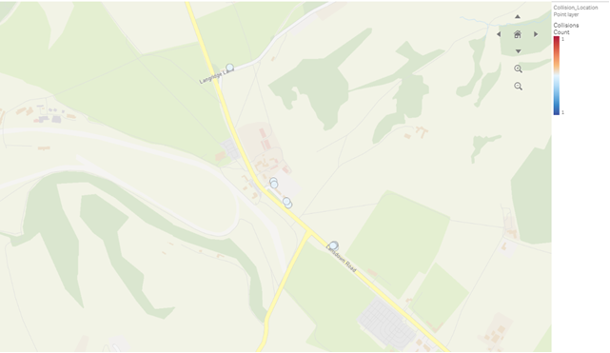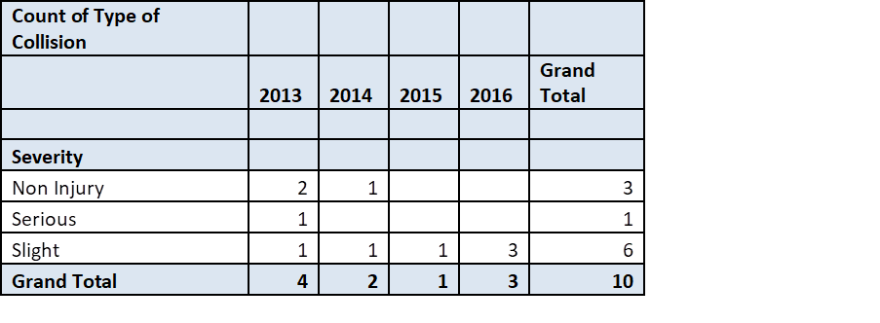

Of these collisions -

2013/1268         15/02/2013 07:50           Slight – fail to give way at Lansdown Road/ Lansdown Lane junction

2014/4239         12/06/2014 10:10           Non Injury but located at Lansdown Road/ Lansdown Lane junction and ARB completed

2016/2776         09/04/2016 16:55           Slight – driver error at Lansdown Road/ Lansdown Lane junction

We hold a further 2 slight injury collisions for 2022 – 2023 in a different database, but neither are related to the junction.

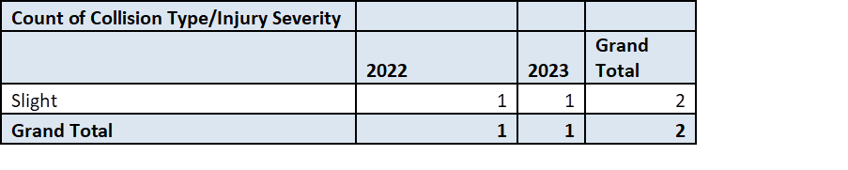

It is the general view that if injury collisions are reported, non-injury collisions are likely to have occurred at the same location, and anecdotally we are aware of this being the case at this location.

Within the length of the proposed revised speed limit, prior to the Lansdown Road/Lansdown Lane junction, Lansdown Road is the approach to the Racecourse, Golf Course, the Charlcombe Inn and an area of residential properties. After the junction, Lansdown Road is the approach to the Lansdown Park and Ride, and several sporting clubs and facilities, farms etc.

All of these are set back from the carriageway and the majority have large carparks and frequent access/egress onto Lansdown Road, leading to an impression that there is little requirement for a reduced speed by motorists as the road is straight, the environment appears open and there are no physical measures to promote compliance with the proposed revised limit.

<https://goo.gl/maps/8EgXx7DkgwKPMVqh6> approach to racecourse.

<https://goo.gl/maps/HRPSmoKyYnKLJ5oy6> approach to golf course.

<https://goo.gl/maps/TF8MtX81CNsov959A> approach to the Charlcombe Inn and the area of residential properties.

<https://goo.gl/maps/WisEanzkkmAwrEXV8> approach to the Lansdown Road/Lansdown Lane junction.

<https://goo.gl/maps/2Cd7xxKiuc32S6F46> approach to the Lansdown Park and Ride, and several sporting clubs and facilities, farms etc.

with the same true of the reverse approach.

I am aware that signage of the Give Way from Lansdown Lane onto Lansdown Road has been recently enhanced, with directional signage in the verge opposite Lansdown Lane to assist in driver awareness of the junction and Give Way required. However, on the approach from the Charlcombe Inn and the area of residential properties towards the junction, recent signage for the Clear Air zone obscures both the ADS and weight restriction signage which reduces motorist awareness of the junction <https://goo.gl/maps/CTdxbQ8UPJBFpV9s5> and of the weight/width restriction on Lansdown Lane, from that direction.

There is no illumination of the Lansdown Road/Lansdown Lane junction itself. “Lighting” is in the form of a small “pin” lamp at the traffic island adjacent to the junction <https://goo.gl/maps/a8zPBdGJG2itQbkP6> This is sited past the junction and infers that conspicuity of the junction during times of darkness is minimal.

Is felt that improvements to the Lansdown Road / Lansdown Lane junction in terms of lighting to enhance visibility of the junction during the hours of darkness, and realignment of the ADS/Clear Air Zone signage on the approach from the Racecourse could improve conspicuity and awareness of the junction. This, together with road markings adjacent to repeater signage along the road length, could encourage compliance with the lower speed limit proposed and improve road safety.

Although there is signage for the junction on the approach from the Park and Ride direction, it is some distance from the junction itself and relates to the weight/width restrictions on Lansdown Lane more than being an ADS. Could this sign be repeated to improve awareness of the junction, supporting the reduced speed limit?

During a recent site visit, it was noted that existing road markings (Slow, etc.,) have eroded over time in some locations.

Anecdotally, it is also known that the length of road for which the reduced speed limit is proposed may be subject to fog and inclement weather, which may also reduce conspicuity.

With regard to the reduction in speed limit on Lansdown Lane, we are aware of the history and geometry of the road at this location, alongside existing restrictions for weight and width. Please could road markings be introduced to promote compliance with the proposed limit, particularly downhill, towards the existing 20mph speed limit? (I am unsure if there is existing signage for the 20% gradient on Lansdown Lane, although I am aware of bend signage)

We do not, as part of our response on behalf of the Chief Constable to formal consultation, check the accuracy or validity of what is being proposed but we do consider implications for road safety and enforcement.

We always expect that:

a) the powers being exercised are available to you as traffic authority, are valid and are appropriate for the proposals;

b) the descriptions of the lengths of road, the road names, the road numbers and any directional descriptions are correct and accurate;

c) where any proposals replace existing restrictions or prohibitions, that the previous orders are adequately revoked or varied;

d) the mandatory traffic signs giving legal effect to the order will be fully TSRGD compliant, will give drivers adequate guidance and will place to accord to the descriptions in the order.

We have worked on the assumption that, by submitting this TRO for consultation, you are also confirming the above points and that subject to consultation process, an order will be made. Any enforcement action taken by the Police will be based on this and, should this transpire not to be the case, Avon & Somerset Constabulary will not accept any liability – financial or otherwise – arising as a result.

*Officer response – All signs and road markings at the junction of Lansdown Lane and Lansdown Road, and on each approach, will be reviewed as part of the speed reduction scheme, and any necessary modifications will be incorporated into the proposals. There are currently no plans to introduce street lighting at the junction, but this will be investigated further with colleagues in our Street Lighting Team.*

**Parking** – No comment

**Ward Members**

**Cllr Kevin Guy** – No comment

**Cllr Sarah Warren** – No comment

**Cllr Lucy Hodge** – I fully support and welcome this proposal to reduce the speed limit on sections of Lansdown Road and Lansdown Lane to 40 mph.

**Cllr Mark Elliot** –No comment

**Cllr Ruth Malloy** – I support this reduction in the maximum speed limit.

**Cllr Malcom Treby** - Please can I register my objection to this proposal. Regarding Lansdown Lane, the only accidents on this road (as reported online) have been at the junction with Lansdown Road, and so I don’t see the need to change the speed limit on this road to 40mph. On Lansdown Road too, I have the same thoughts, the current 50 mph limit is a perfectly acceptable speed limit along this road – there may be points where traffic would be sensible to be going slower, but the limit is just that, a limit and not a suggested speed.

I would be supportive of a 50mph limit rather than 40mph on this Lansdown Lane, as I struggle to think of any point on this road where it would be appropriate to go over 50 mph.

*Officer response – these comments are noted. Although it is agreed there are some sections of the road where it is safe to drive at 50mph, the aim of the proposal is to bring about consistency in speed limits, to reduce vehicle speeds overall and avoid drivers speeding up after they have passed the junction. Lower vehicle speeds can help reduce the likelihood of collisions occurring and if they do occur there is less likelihood of serious injuries occurring.*

**Cabinet Member**

**Manda Rigby –** No comment

**8. RECOMMENDATION**

As no significant objections and/or comments have been received following the informal consultation described above, the public advertisement of the Traffic Regulation Order should progress.

PROPOSALS APPROVED FOR INFORMAL CONSULTATION WITH THE CABINET MEMBER FOR HIGHWAYS.



Paul Garrod Date: 27th September 2023

Traffic Management and Network Manager

**9.** **DECISION**

As the officer holding the above delegation, I approve the progression of this Traffic Regulation Order.

In taking this decision, I confirm that due regard has been given to the Council’s public sector equality duty, which requires it to consider and think about how its policies or decisions may affect people who are protected under the Equality Act.

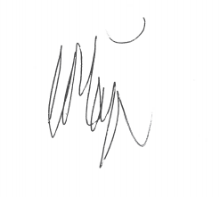

Chris Major Date: 02/10/2023

Director for Place Management

**10.** **PUBLIC CONSULTATION**

**Support – 2**

1. I have looked at the proposal for the additional 40 mph section on Lansdown Road. In principle I agree provided there is a review period to ensure that this addition has the desired effect of reducing road traffic accidents. If no improvement is seen, then I think the council should take further interventions.
2. We support this proposal, as we have previously flagged up safety concerns surrounding the junction where Lansdown Lane meets Lansdown Road which is central to this proposed 40mph zone. However, Councillors remain very concerned that this proposal does not go far enough to address the safety issues. We feel it would be of further benefit to also include a more focussed 30mph zone encompassing all three approaches to the junction mentioned above and potentially also the adjacent residential area. This is a very busy locality with high volumes of traffic attempting to negotiate a dangerous junction, vehicles turning in and out of The Charlcombe Inn, Lansdown Golf Club, Bath Racecourse, and various residences not to mention pedestrians on footpaths etc. Councillors feel the use of flashing warning signs to highlight the junction ahead would be beneficial and serve as an additional reminder for drivers to take care. We would also suggest safety at the junction continue to be closely monitored as we believe it may well be necessary to introduce more extensive safety measures at the junction if significant improvements are not seen.

**Objections – 2**

1. I use this stretch of road *daily* and have done so for over twenty years I see no reason for this reduction and therefore must **object** to it.  The current limit of 50 mph is a reasonable one and therefore largely complied with. It was only reduced from 60mph a few years ago, this new 40 MPH limit will not be seen as reasonable and will just mean a lot more drivers will not comply and needlessly be criminalised.
2. I am writing to you to strongly object to the above proposal. We have over the years had more and more restrictions imposed upon us - lowering the speed limit from 60 mph to 50mph and more recently a stretch into 40 and then 30mph.  Double white lines and traffic bollards have emerged and the road now - which is a main route into Bath for many, including the Park and Ride bus - is totally safe for all users.  
     
   Good drivers anticipate road conditions and drive accordingly.  Trying to legislate for every eventuality by falsely trying to slow down all traffic actually has the opposite effect.  People see a 40 mph sign and slam on their brakes with little regard to other road users.  Then often they will keep well under the speed limit in an attempt to be ‘safe’.  
     
   This has the knock-on effect of causing frustration from all other drivers who are forced to bunch up behind these ‘safe’ slow drivers.  The result of imposing yet more unnecessary speed restrictions on stretches of clear, straight road will result in more accidents and inevitably will lead to traffic issues which to date have been avoided.  
     
   It is short-sighted and totally wrong for BANES to keep imposing these anti-motorist orders.  It may, if policed, bring in more revenue from the poor unsuspecting motorist who incurs fines and points for no reason.  
     
   I have driven safely for over 45 years.  I have never crashed my car.  But I have become so fed up with councils imposing restrictions just for the sake of pretending it is in the interest of road users.  It is NOT in the interests of anyone who uses this stretch of road.  
     
   Why try and mend something which is not broken?

B&NES Response –

