OFFICER DECISION REPORT – TRAFFIC REGULATION ORDER (TRO)
3

APPROVAL TO PROGRESS TRO

PREPARED BY: Traffic Management Team, Highways and Transport Group

TITLE OF REPORT:  PROPOSAL:  SCHEME REF No:  REPORT AUTHOR: | Walley Lane Speed Restriction  30mph Speed Limit  21- 031/LC  Design and Projects Team / Neil Terry

1. DELEGATION

The delegation to be exercised in this report is contained within Part 3, Section 4 of the Constitution under the Delegation of Functions to Officers, as follows:

Section A | The Chief Executive, Strategic Directors, Divisional Directors and Heads of Service have delegated power to take any decision falling within their area of responsibility….”
Section B | Without prejudice to the generality of this, Officers are authorised to:  serve any notices and make, amend or revoke any orders falling within his/her area of responsibility.
Section D9 | An Officer to whom a power, duty or function is delegated may nominate or authorise another Officer to exercise that power, duty or function, provided that Officer reports to or is responsible to the delegator.

For the purpose of this report, the Director of Place Management holds the delegated power to make, amend or revoke any Orders.

2. LEGAL AUTHORITY

This proposal is made in accordance with the Road Traffic Regulation Act 1984, which under Section 1 provides, generally, for Orders to be made for the following reasons, and in the case of this report specifically for the reason(s) shown below:

(a) | for avoiding danger to persons or other traffic using the road or any other road or for preventing the likelihood of any such danger arising, or | X
(b) | for preventing damage to the road or to any building on or near the road, or
(c) | for facilitating the passage on the road or any other road of any class of traffic (including pedestrians), or
(d) | for preventing the use of the road by vehicular traffic of a kind which, or its use by vehicular traffic in a manner which, is unsuitable having regard to the existing character of the road or adjoining property,
(e) | (without prejudice to the generality of paragraph (d) above) for preserving the character of the road in a case where it is specially suitable for use by persons on horseback or on foot, or
(f) | for preserving or improving the amenities of the area through which the road runs, or | X
(g) | for any of the purposes specified in paragraphs (a) to (c) of subsection (1) of section 87 of the Environment Act 1995 (air quality)

3. PROPOSAL

Replace the existing 40mph speed limit eastbound approach to the Dam to a proposed 30mph speed limit. Continue the proposed 30mph speed limit to replace the existing 50mph speed limit over the Dam to a point east of the vehicular entrance to picnic area no1. Continuing east from this point replace the existing 50mph speed limit with a 40mph speed limit. Continue the proposed 40mph speed limit to the existing 40mph speed limit near the junction with Hollowbrook Lane.

The proposals are shown on the attached drawings.

4. BACKGROUND

Works have taken place to implement improvements to pedestrian and cycle facilities across the Chew Valley Dam as part of the Chew Valley Lake Recreational Trail. Reducing the east and west approach and over the dam to a 30mph speed limit, together with traffic calming build outs along the length of the dam will contribute to speed reduction across the dam and highlight the increased use of the widened shared use footway/ cycleway. Heading east from the Dam along Walley Lane, the existing 50mph will be reduced to 40mph to further emphasis the nature of this road and its use by all forms of transport accessing the facilities of Chew Valley Lake and its surroundings.

5. SOURCE OF FINANCE

This proposal is being funded by the capital Design budget, project code TCY011

6. CONSULTATION REQUIREMENT

The proposal requires informal consultation with the Chief Constable, Ward Members, Parish Council, and the Cabinet Member for Transport.

7. COMMENTS RECEIVED TO DATE

Chief Constable

Thank you for your email and attachments regarding proposed speed restrictions associated with the Chew Valley Recreational Trail.

I have had correspondence with Alison regarding these proposals.

As previously discussed, we have a Force stance regarding the introduction of speed restrictions, which has been written to reflect the current speed environment. I copy this below for your information.

“Speed limits are only one element of speed management and local speed limits should not be set in isolation. They should be part of a package with other measures to manage speeds, which include engineering, visible interventions and landscaping standards that respect the needs of all road users and raise the driver’s awareness of their environment, together with education, driver information, training and publicity.

The police service has to ensure all resources are used effectively in responding to community priorities.
Avon and Somerset Constabulary will support all appropriate speed limits, including 20mph roads, where;

The limit looks and feels like the limit, giving visiting motorists who wish to conform that chance;
the desired outcome has to be speeds at the limit chosen so as to achieve safe roads for other and vulnerable users, not high speeds and high enforcement;
the limit is self-enforcing (with reducing features) not requiring large scale enforcement;
the limit is only introduced where mean speeds are already close to the limit to be imposed, (24mph in a 20mph limit) or with interventions that make the limit clear to visiting motorists;
speeding problems identified in an area must have the engineering, site clarity and need re-assessed, not simply a call for more enforcement.

Enforcement will be considered in all clearly posted limits, given other priorities, and this will be by:

Targeted enforcement where there is deliberate offending, and the limits are clear;

Where limits are not clear (that is they don’t feel like or look like the limit or are on inappropriate roads), they will not be routinely enforced, only targeted where there is intelligence of obvious deliberate disregard which may result in increased threat, harm or risk to other road users.

Deliberate high harm offenders will always be targeted and prosecuted whereas enforcement against drivers who simply misread the road may not be appropriate.

None of the above should in anyway leave the impression that we will not enforce the law. As with all speed limits, and other enforcement work, we will use evidence to ensure that our resources are allocated in the most appropriate way using appropriate tactics. Enforcement of limits that do not comply with the above representations could lead to mistaken offending and could risk the loss of public support.

Enforcement cannot and must not take the place of proper engineering and or clear signing.”

We do not, as part of this consultation, check the accuracy or validity of what is being proposed but we do consider implications for road safety and enforcement. We always expect that:
a) the powers being exercised are available to you as traffic authority, are valid and are appropriate for the proposals;
b) the descriptions of the lengths of road, the road names, the road numbers and any directional descriptions are correct and accurate;
c) where any proposals replace existing restrictions or prohibitions, that the previous orders are adequately revoked or varied;
d) the mandatory traffic signs giving legal effect to the order will be fully TSRGD compliant, will give drivers adequate guidance and will placed to accord to the descriptions in the order.

We have worked on the assumption that, by submitting this TRO for consultation, you are also confirming the above points and that subject to consultation process, the order will be made. Any enforcement action taken by the Police will be based on this and, should this transpire not to be the case, Avon & Somerset Constabulary will not accept any liability – financial or otherwise – arising as a result.

Ward Members

Councillor Karen Warrington - I agree with the speed restrictions especially in the dam area up to Denny Lane where there have been a few historical accidents but fortunately no serious injuries.

Councillor Vic Pritchard – no comments received.

Parish Councils

Chew Magna PC is in agreement with the proposal for a 30mph limit from Chew Stoke to the Salt & Malt.

Chew Stoke PC – no comments received
Cabinet Member for Transport

Councillor Manda Rigby - I’m happy for this TRO to proceed

8. RECOMMENDATION

As no significant objections and/or comments have been received following the informal consultation described above, the public advertisement of the Traffic Regulation Order should progress.

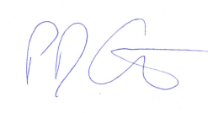
Paul Garrod Date: 15/07/2022
Traffic Management and Network Manager

9. DECISION

As the officer holding the above delegation, I approve the progression of this Traffic Regulation Order.

In taking this decision, I confirm that due regard has been given to the Council’s public sector equality duty, which requires it to consider and think about how its policies or decisions may affect people who are protected under the Equality Act.

Chris Major 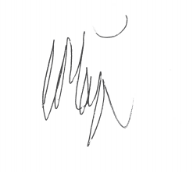 Date: 15/07/2022
Director for Place Management

Plan 1 – Existing 40mph speed limit changed to proposed 30mph speed limit.

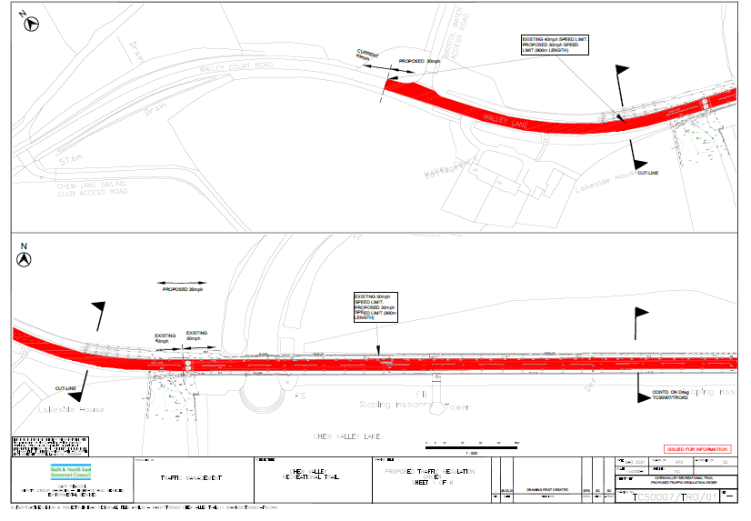

Plan 2 – Existing 40mph speed limit changed to proposed 30mph speed limit. Existing 50mph speed limit changed to proposed 40mph speed limit.

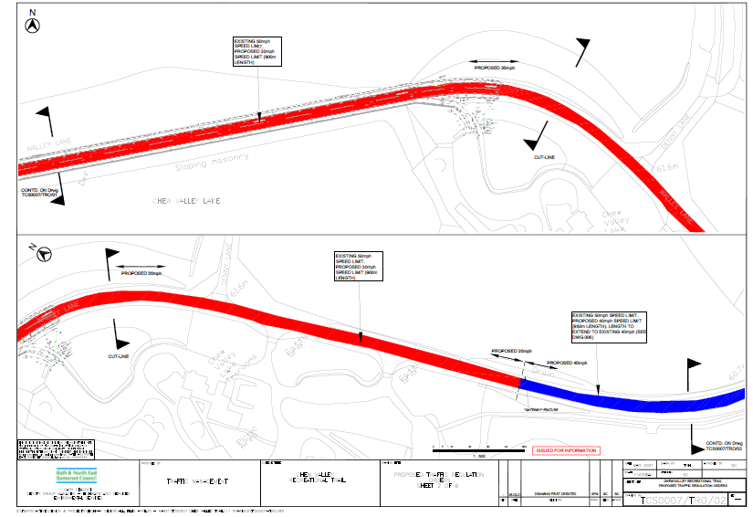

Plan 3 – Existing 50mph speed limit changed to proposed 40mph speed limit.

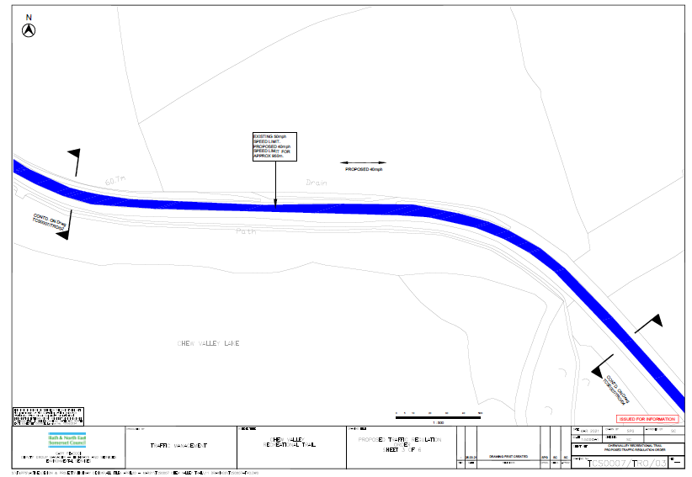

Plan 4 – Existing 50mph speed limit changed to proposed 40mph speed limit.

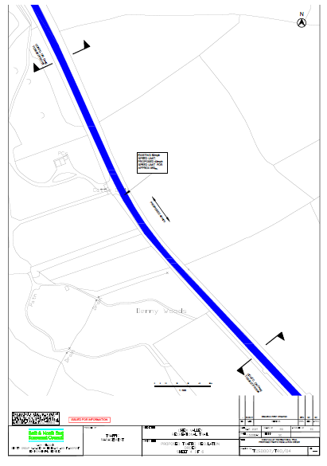

Plan 5 – Existing 50mph speed limit changed to proposed 40mph speed limit. Proposed 40mph extends to existing 40mph.

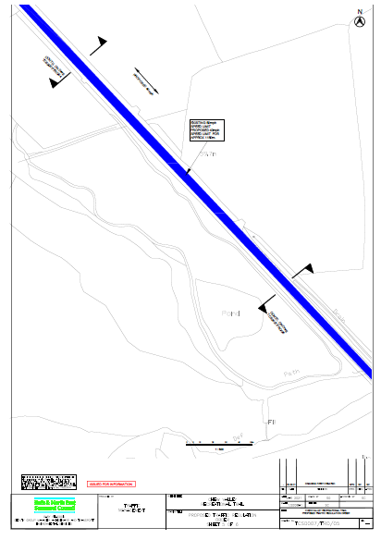

Plan 6 – Existing 50mph speed limit changed to proposed 40mph speed limit. Proposed 40mph extends to existing 40mph.

