


Final Report

Prepared for Bath and North East Somerset Council

June 2022

Economic Strategy Evidence Base

Table of Contents
1 Introduction 1
2 Business Demography 2
3 Employment Floorspace Losses 13
4 Economic Forecasts and Scenarios 16
Appendix 1: Business Counts by Sub Area 23

Job Number: | 21 10 03
Version Number: | 3.0
Approved by: | Joshua Harding-Jones
Date: | 21 June 2022

Introduction
    - Bath and North East Somerset (B&NES) Council’s current Economic Strategy was published in 2014. In the subsequent seven years both the B&NES and national economy have changed significantly. Many underlying issues within the B&NES economy are seen to have been exacerbated by the Covid-19 pandemic. As a result, the Council is reviewing its Economic Strategy, led by the Business and Skills team.
    - The Economic Strategy is a central element in the Council’s core mission of ‘Improving People’s Lives’. An updated Economic Strategy is being developed in conjunction with the Council's new Local Plan and its net zero aspirations to fully set the Council on course to develop an inclusive and sustainable future for its residents.
    - On behalf of the Council, Hardisty Jones Associates has prepared this evidence base to support the preparation of an updated Economic Strategy for B&NES.
    - This report covers three topics, each covered in turn in a standalone chapter:
- Chapter 2 – Business demography: analysis of publicly available ONS data covering business counts, sector profile, business size, and considers the key sector focus of the B&NES economy; and analysis of secure ONS data covering business counts and sector profiles at the B&NES ‘sub area’ level.
- Chapter 3 – Employment land losses: assesses the negative employment and GVA impacts on the B&NES economy of employment floorspace losses across the local authority area. Following a review of the Council’s existing approach to quantifying the headline economic impact of employment land losses across B&NES and its constituent sub areas, this chapter sets out suggested methodological improvements, along with new findings based on an updated approach.
- Chapter 4 – Economic forecasts and scenarios: provides a summary of baseline economic forecast scenario for the B&NES area, as well as consideration of the alternative growth scenarios as provided by Oxford Economics. The forecasts were originally produced to inform the preparation of the West of England Employment Land Spatial Needs Assessment (ELSNA) and Spatial Development Strategy (SDS), which is currently being prepared.

Business Demography
    - This chapter sets out an analysis of ONS data covering business counts, sector profile, business size, and considers the key sector focus of the B&NES economy.

Business Counts
    - There are currently 8,495 enterprises recorded in B&NES (2020).
    - The number of enterprises in B&NES has increased by 22% over the period 2010–21. This growth continued through the Covid-19 pandemic.
    - However, this level of growth is much below that recorded across the West of England (WoE) Local Enterprise Partnership (LEP) (32%) and UK (32%).

Sector Profile
    - Figure 2.1 shows the number of enterprises across industries of the economy (sectors with negligible numbers of enterprises have been excluded for ease of interpretation).
Figure 2.1: Number of enterprises by section, B&NES (2021)

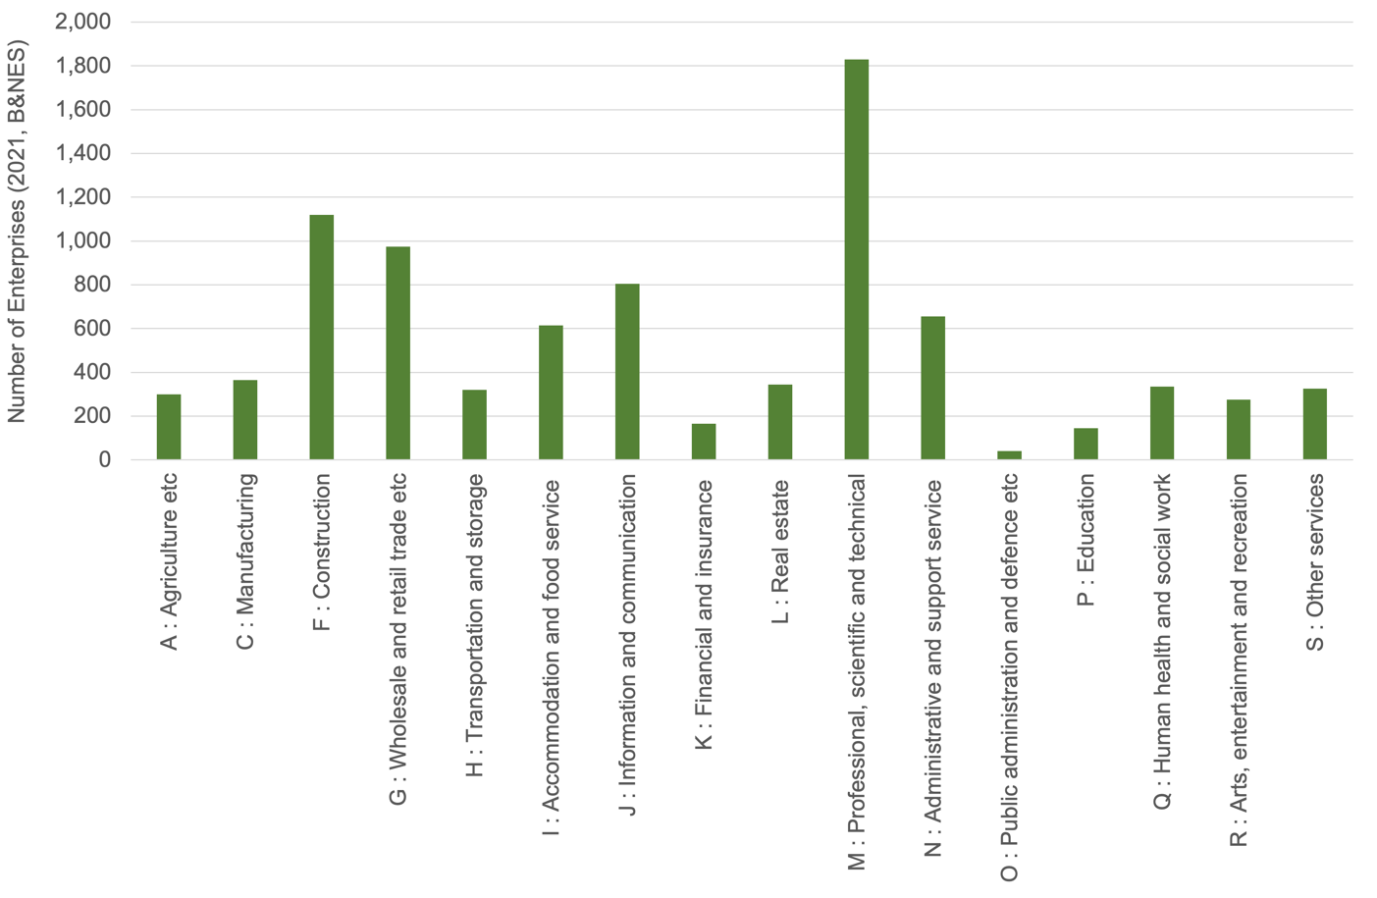
Source: ONS Business Counts

Key Sector – Professional, Scientific and Technical Activities
    - The sector with the greatest number of enterprises is Professional, scientific and technical activities. There are 1,830 businesses within this sector in B&NES. This accounts for 21% of all enterprises.
    - This sector has increased its share from 19% of enterprises in 2010. There are now 500 additional businesses in this sector than in 2010.
    - This sector also shows a relatively high concentration in B&NES compared to both the WoE LEP and UK i.e. the sector accounts for a higher share of businesses in B&NES than benchmark areas. The level of concentration has increased over the period 2010–21.
    - Overall this suggests the Professional, scientific and technical activities sector is of particular importance to B&NES. It is large, growing and exhibits a strong concentration compared to benchmark areas.

Other Important Sectors
    - Other large sectors, as measured by the number of enterprises include:
- Construction – 1,120 enterprises
- Wholesale and retail trade – 975 enterprises
    - Both account for more than 10% of enterprises in B&NES.
    - The Construction sector has seen a small amount of growth over the period 2010–21 and it represents a similar share of the economy compared to the UK average, and is marginally smaller than the WoE LEP average.
    - The Wholesale and retail sector has reduced in size over the period 2010–21 with 70 fewer enterprises. The sector is relatively under-represented compared to both the WoE and UK averages.
    - Other sectors with strong concentrations include:
- Accommodation and food services (relative to both WoE and UK)
- Information and communication (relative to UK, but not WoE)
- Public administration
- Arts, entertainment and recreation
    - The Accommodation and food services sector, along with the Arts, entertainment and recreation sector combine to form the tourism and leisure sector across B&NES. Both sectors have experienced growth in the number of enterprises over the period 2010–21 and both show strong concentrations relative to the WoE LEP and UK averages. In combination they account for around 900 businesses, 10% of the total. In combination these make tourism and leisure a second key sector for B&NES.
    - The Information and communication sector accounts for around 800 enterprises and has grown by one third (33%, 200 enterprises) over the period 2010–21. The sector accounts for a similar share of the economy as the WoE LEP average, but around 20% more than the UK average. This indicates it is a specialism of both B&NES and the WoE LEP area. This evidence suggests Information and communication is a key sector for B&NES.
    - The Public administration sector accounts for only 40 enterprises and therefore small in that regard, accounting for just 0.5% of enterprises in B&NES. As a result, statistical variations can be very pronounced and comparisons and percentage change over time figures should be treated with caution. However, the data shows the sector has increased by 25 enterprises since 2010 – more than doubling in size – and it has a very high concentration relative to the WoE and UK averages.

Business Size
    - 89% of enterprises in B&NES are micro enterprises (employing 0–9 persons). This share has remained relatively flat over the last 10 years, and is very similar to WoE LEP (89%) and UK average (90%) shares.
    - B&NES has a higher proportion of small businesses (employing 10–49 persons), with 10% compared to 9% across the WoE LEP and 8% at UK level. This segment has also experienced the strongest growth over the period 2010–21 (32%). This level of growth is much greater than experienced at sub-regional or national level.
    - 1% of B&NES enterprises are medium sized (employing 50–249 persons). This is lower than the WoE LEP and UK levels (both 2%). Growth in this segment has also been much lower in B&NES (9%) than both WoE LEP (28%) and UK (24%).
    - Less than 0.5% of enterprises across B&NES are large (employing more than 250 persons). The share is marginally lower than subregional and national averages. Large enterprises make up a very low share across all areas. However, they can account for a substantial share of total employment. Rounding of the data provided can also make interpretation of such small data points problematic.
    - The sectors with a high proportion of enterprises that are larger than micro enterprises includes:
- Education
- Human health and social work
- Water utilities
- Accommodation and food services

Key Sector Focus
    - Three key sectors have been identified here. These are considered in more detail below to understand issues around sub-sector strengths and size profiles.
    - A proxy measure for sector concentration, or agglomeration, is a ‘location quotient’ (LQ). This is a measure of the concentration of a particular sector in an area. This is constructed by dividing the share of enterprises in the subject area by the share of the same sector in a benchmark area – in this case the UK. A figure of 1 indicates an equal share in both places. A figure above 1 shows a relative concentration in the subject area. A figure below 1 shows a lower-than-average concentration in the subject area.

Professional, Scientific and Technical
    - There are sub-sector specialisms across six of the seven SIC07 divisions that form the broader Professional, scientific and technical activities SIC07 section. The most significant relative concentration is in veterinary activities, but this is small in absolute terms with 45 enterprises.
    - There are specialisms in activities of head offices and management consultancy activities; architectural and engineering services; scientific R&D, advertising and market research; and other professional and scientific activities. The only activity with a LQ lower than 1 is legal and accounting activities.
    - The largest sub sector in terms of the number of enterprises is activities of head offices and management consultancies, with 780 enterprises. There are more than 300 enterprises in architectural and engineering, and other professional and scientific activities.
    - As with the wider economy, a very high proportion of the Professional, scientific and technical enterprises are micro (employing 0–9 persons).

Tourism and Leisure
    - Within the Accommodation and food sector, the genuine specialism is within the accommodation sector. This has a LQ of 1.7 compared to the UK. The food and beverage sub-sector has a LQ of 1.1, showing a degree of specialism, but to a marginal extent.
    - However, in terms of the number of enterprises, the food and beverage sub-sector dominates with 510, compared to 100 in the accommodation sub-sector.
    - Both sub-sectors have grown over the last 10 years.
    - Within the Arts, entertainment and recreation sector the two sub-sector specialisms are creative, arts and entertainment, and libraries, archives, museums and other cultural activities. These have very high LQ values. The creative, arts and entertainment sub-sector includes 160 enterprises. The libraries, archives, museums and other cultural activities account for only 15 enterprises – making it small in absolute terms.

Information and Communication
    - Reviewing the data to find other sub-sectors with relative specialisms and more than 25 enterprises identifies the following:
- Publishing activities – with 95 enterprises and a very high LQ. This sector has been growing.
- Information service activities – with a strong LQ and 35 enterprises.
- Computer programming has more than 535 enterprises and a positive LQ relative to the UK. It is lower compared to the WoE, indicating a strong LQ across the sub-region.

B&NES Sub Area Business Distribution
    - Analysis of business (local units) trends across the four B&NES sub areas is based on the ONS Business Structure Database (BSD). This data shows a significant concentration (53%) of B&NES businesses within the Bath City sub area. The remaining sub areas collectively account for the other half of all businesses in B&NES – Rural Area (22%), Somer Valley (16%), and Keynsham (8%).
    - Performance in business change has varied from the above weighting of business distribution. Bath City and Somer Valley sub areas have accounted for slightly less business growth than their weighting, with Keynsham and Rural Area accounting for slightly more business growth than their weighting. It is possible a rise in homeworking has driven recent growth in the Rural Area’s business numbers.
Figure 2.2: Distribution of businesses (local units) by sub area, as share of B&NES total
(2020) and change (2011–2020)

 | Bath | Keynsham | Rural Area | Somer Valley
Share of B&NES businesses (2020) | 53% | 8% | 22% | 16%
Share of B&NES business change (2011–2020) | 46% | 11% | 30% | 12%

Source: HJA analysis of BSD (ONS)

    - Given Bath City’s predominance in its share of B&NES businesses, it is unsurprising that, for the most part, it has the highest share of businesses based on individual SIC07 sections too. Figure 2.3 sets out the distribution of each sub area as a share of B&NES’ business base by SIC07 section, Table 2.1 sets out each sub area’s LQ by SIC07 section, and Appendix 1 sets out business counts by SIC07 section for each sub area during 2011 and 2020.
    - Taking the ‘all sectors’ distribution as a baseline:
- Bath City has particularly high business shares in services sectors, namely: Information and communication (62%); Finance and insurance (58%); Real estate (61%); and Professional, scientific and technical activities (62%).
- Bath City has particularly high business shares in sectors strongly associated with the leisure and tourism/visitor economy, namely Accommodation and food (67%) and Arts, entertainment and recreation (61%).
- There is a relatively even distribution of business activity in production sectors, namely: Manufacturing, Construction, and Transport and storage – Keynsham (11%/14%/19%), Rural Area (24%/29%/18%), and Somer Valley (30%/26%/31%) have particularly high shares in these industries.
- Business activity in Public administration and defence is distributed very evenly between Bath City (28%), Rural Area (29%), and Somer Valley (31%).
- Rural Area (77%) dominates business activity in the Agriculture, forestry and fishing sector.

Figure 2.3: Distribution of businesses (local units) by sub area and SIC07 section, as share
of B&NES total (2020)

SIC07 section | Bath City | Keynsham | Rural Area | Somer Valley
A: Agriculture, forestry and fishing | 9% | 4% | 77% | 11%
C: Manufacturing | 34% | 11% | 24% | 30%
F: Construction | 32% | 14% | 29% | 26%
G: Wholesale and retail | 60% | 8% | 14% | 17%
H: Transport and storage | 32% | 19% | 18% | 31%
I: Accommodation and food | 67% | 6% | 15% | 11%
J: Information and communication | 62% | 8% | 20% | 10%
K: Financial and insurance | 58% | 9% | 19% | 13%
L: Real estate | 61% | 6% | 24% | 9%
M: Professional, sceintific and technical | 62% | 6% | 21% | 11%
N: Administrative and support services | 51% | 8% | 26% | 16%
O: Public administration and defence | 28% | * | 29% | 31%
P: Education | 53% | 7% | 21% | 18%
Q: Human health and social work | 56% | 10% | 15% | 19%
R: Arts, entertainment and recreation | 61% | 7% | 20% | 12%
S: Other services | 56% | 10% | 15% | 19%
All Sectors | 53% | 8% | 22% | 16%
Source: HJA analysis of BSD (ONS)
Note: some figures may not sum due to rounding

Table 2.1: Sub area location quotient by SIC07 section (2020)
SIC07 section | Bath City | Keynsham | Rural Area | Somer Valley
A: Agriculture, forestry and fishing |  | 0.21 | 2.10 | 0.42
B: Mining and quarrying | * |  | *
C: Manufacturing | 0.43 | 1.08 | 0.86 | 1.51
D: Electricity, gas, steam etc | * |  | * | *
E: Water supply; sewerage, waste management etc | * | * | * | *
F: Construction | 0.62 | 1.60 | 1.33 | 1.60
G: Wholesale and retail | 1.06 | 0.87 | 0.62 | 1.00
H: Transport and storage | 0.23 | 1.15 | 0.46 | 0.92
I: Accommodation and food | 1.52 | 0.91 | 0.76 | 0.76
J: Information and communication | 1.37 | 1.10 | 1.10 | 0.82
K: Financial and insurance | 1.24 | 1.24 | 0.83 | 0.83
L: Real estate | 1.11 | 0.83 | 1.11 | 0.56
M: Professional, sceintific and technical | 1.44 | 0.85 | 1.25 | 0.85
N: Administrative and support services | 0.82 | 0.94 | 1.05 | 0.94
O: Public administration and defence | 0.00 | * | 1.31 | 1.31
P: Education | 0.85 | 0.85 | 0.85 | 1.28
Q: Human health and social work | 0.99 | 1.19 | 0.79 | 1.19
R: Arts, entertainment and recreation | 1.46 | 0.73 | 1.09 | 0.73
S: Other services | 1.08 | 1.08 | 0.54 | 1.08
Source: HJA analysis of BSD (ONS)

Sub Area Business Distribution – Observations
    - Table 2.2 below sets out a discussion of the main drivers of the B&NES business base according to sub area business activity.
Table 2.2: Observations on businesses activity by sub area and SIC07 sections
SIC07 section | Comments
A: Agriculture, forestry and fishing | - Rural Area is by far the most represented sub area in its share of B&NES businesses active in this industry (77%).  - Rural Area has a very high LQ (2.1), indicating it is a strongly concentrated industry.
B: Mining and quarrying | [Data suppressed]
C: Manufacturing | - Somer Valley is particularly well represented in its share of B&NES Manufacturing businesses, compared to other sectors.  - Somer Valley has a high LQ (1.51), indicating it is a strongly concentrated industry.  - B&NES has not experienced significant change in this sector between 2011–2020. There were minor losses in Somer Valley and minor gains in Rural Area during this period.  - Although Bath City has a relatively low share of B&NES Manufacturing businesses (34%) compared to other sectors, it is still an important location for this activity, accounting for over a third of B&NES Manufacturing businesses.
D: Electricity, gas, steam etc | [Data suppressed]
E: Water supply; sewerage, waste management etc | [Data suppressed]
F: Construction | - Rural Area (29%), Somer Valley (26%), and Keynsham (14%) are well represented in their share of B&NES Construction businesses, compared to other sectors.  - These sub areas have high LQs – 1.33, 1.60, and 1.60 respectively –indicating that Construction activity is strongly concentrated.  - Business growth (+29%) in this sector has been steady in B&NES between 2011–2020 compared to UK growth rates (+33%). Rural Area (35%), Somer Valley (30%), and Keynsham (24%) sub areas have made significant contributions to growth in B&NES over this period.  - Although Bath City has a relatively low share of B&NES Construction businesses (32%) compared to other sectors, and made a lower contribution to growth compared to other sub areas (9%), it is still an important location for this activity, accounting for just under a third of B&NES Construction businesses.
G: Wholesale and retail | - Bath City is well represented in its share of B&NES Wholesale and retail businesses (60%).  - No sub area has a particularly high concentration of Wholesale and retail activity.  - B&NES as a whole saw losses (–3%) in this sector over the period 2011–2020, indicating weak performance compared to national growth rates (+6%).
H: Transport and storage | - B&NES as a whole has a very low concentration of businesses in this sector (0.46).  - Somer Valley (31%) and Keynsham (19%) are well represented in their share of B&NES Transport and storage businesses compared to other sectors.  - Keynsham (1.15) is the only sub area with a LQ over 1.0 – other sub areas have a relatively low concentration of businesses in this sector.  - Business growth (+2%) in this sector has been weak in B&NES between 2011–2020 compared to UK growth rates (+70%).  - Bath City has a relatively low share of B&NES Transport and storage businesses (31%) compared to other sectors, although it is still an important location for this activity, accounting for just under a third of B&NES Transport and storage businesses.
I: Accommodation and food | - Bath City (67%) is very well represented in its share of B&NES Accommodation and food businesses, accounting for around two-thirds of B&NES businesses in this sector.  - Bath City has a high concentration of businesses in this sector (LQ = 1.52).  - Other sub areas show relatively weak activity levels in this sector.  - Business growth (+22%) in this sector has been slower in B&NES between 2011–2020 compared to UK growth rates (+30%).
J: Information and communication | - Bath City (62%) is very well represented in its share of B&NES Information and communication businesses, accounting for close to two-thirds of B&NES businesses in this sector.  - Bath City has a high concentration of businesses in this sector (LQ = 1.37). Keynsham and Rural Area also have above average business concentration in this sector (both LQ = 1.10). B&NES in general has quite a high concentration of businesses in this sector (LQ = 1.23).  - Bath City (59%) has made the most significant contribution to business growth in this sector in B&NES between 2011–2020. B&NES as a whole has seen steady business growth (+32%) in this sector between 2011–2020, although behind the UK growth rate (+50%).
K: Financial and insurance | - Bath City (62%) is very well represented in its share of B&NES Financial and insurance businesses, accounting for 58% of B&NES businesses in this sector.  - Bath City and Keynsham sub areas have a high concentration of businesses in this sector (both LQ = 1.24).  - Bath City (38%), Rural Area (38%), and Somer Valley (25%) made similar contributions to business growth in this sector in B&NES between 2011–2020. Growth in Keynsham was relatively flat. Business growth in this sector at the B&NES level (+19%) was in line with UK growth (+18%).
L: Real estate | - Bath City is very well represented in its share of B&NES Real estate businesses, accounting for 61% of B&NES businesses in this sector.  - Bath City and Rural Area (both LQ = 1.11) have reasonably high concentrations of businesses in the sector.  - Bath City (55%) and Rural Area (40%) have made the most significant contributions to business growth in this sector in B&NES between 2011–2020. Business growth in this sector at the B&NES level (+25%) has been steady between 2011–2020, although behind UK growth (+31%).
M: Professional, sceintific and technical | - Bath City is very well represented in its share of B&NES Professional, scientific and technical businesses, accounting for 62% of B&NES businesses in this sector.  - Bath City (LQ = 1.44) and Rural Area (LQ = 1.25) sub areas have high concentrations of businesses in this sector – Bath City in particular.  - Bath City (59%) has made the most significant contribution to growth in this sector in B&NES between 2011–2020, with the Rural Area (21%) also making a notable contribution. Business growth in this sector at the B&NES level (+36%) has been good between 2011–2020, although slightly behind UK growth (+40%).
N: Administrative and support services | - Businesses in this sector are spread relatively in line with whole economy distributions across B&NES. This means Bath City is a significant location (51% of B&NES) for businesses in Administrative and support services.  - Most sub areas have an average concentration of businesses in this sector (LQ = 0.94–1.05), with Bath City having a slightly lower concentration (LQ = 0.82).  - Bath City (49%) and Rural Area (35%) have made the most significant contributions to business growth in this sector between 2011–2020. Business growth in this sector at the B&NES level (+36%) has been steady, but quite some way behind the UK growth rate (+55%).
O: Public administration and defence | - Business numbers in this sector are spread very evenly throughout sub areas – Somer Valley (31% of B&NES total), Rural Area (29%), and Bath City (28%). Keynsham (data suppressed) has a lower share of B&NES businesses in this sector.  - Rural Area and Somer Valley (both LQ = 1.31) have a high concentration of businesses in this sector.
P: Education | - Businesses in this sector are spread relatively in line with whole economy distributions across B&NES. This means Bath City is a significant location (53% of B&NES) for businesses in Education.  - Somer Valley (LQ = 1.28) has a relatively high concentration of businesses in the sector. Other sub areas have a lower concentration, with a LQ of 0.85 across other locations.  - Rural Area is the only sub area that has seen modest growth in businesses in this sector between 2011–2020. Business levels in other sub areas have either been flat or slightly declining. Business levels in this sector at the B&NES level (–2%) have gone down between 2011–2020, compared to a UK growth rate of +11%.
Q: Human health and social work | - Businesses in this sector are spread relatively in line with whole economy distributions across B&NES. This means Bath City is a significant location (56% of B&NES) for businesses in Human health and social work.  - Keynsham and Somer Valley (both LQ = 1.19) have a relatively high concentration of businesses in this sector, with Bath City (LQ = 0.99) relatively average, and Rural Area relatively low (LQ = 0.79).  - Rural Area (44%) has made the most significant contribution to business growth in this sector between 2011–2020. B&NES business growth in this sector (+9%) has been relatively steady, in line with UK growth (+11%).
R: Arts, entertainment and recreation | - Bath City is very well represented in its share of B&NES Arts, entertainment and recreation businesses, accounting for 61% of B&NES businesses in this sector.  - Bath City (LQ = 1.46) has a relatively high concentration of businesses in this sector.  - B&NES as a whole saw relatively flat business levels in this sector over the period 2011–2020, indicating weak performance compared to national growth rates (+15%).
S: Other services | - Businesses in this sector are spread relatively in line with whole economy distributions across B&NES. This means Bath City is a significant location (56% of B&NES) for businesses in Other services.  - Most sub areas have a relatively average concentration (LQ = 1.08) of businesses in this sector, with the Rural Area the only sub area with a very low LQ (0.54).  - B&NES saw growth of +8% in businesses in this sector between 2011–2020 – a slightly slower growth rate that the UK average (+15%).

Sub Area Business Distribution – Summary
    - In summary, each sub area is a key driver of the B&NES business base in the following sectors:
- Bath City:
- All sectors except for Agriculture, forestry and fishing.
- Keynsham:
- Construction (share, concentration, and growth contributor);
- Transport and storage (share and concentration); and
- Information and communication (concentration).
- Rural Area:
- Agriculture, forestry and fishing (high share and concentration);
- Manufacturing (share);
- Construction (share, concentration, and growth contributor);
- Transport and storage (share);
- Real estate (concentration and growth contributor); and
- Public administration and defence (high share and concentration).
- Somer Valley:
- Manufacturing (high share and concentration);
- Construction (share, concentration, and growth contributor);
- Transport and storage (high share);
- Financial and insurance (growth contributor); and
- Public administration and defence (high share and concentration).

Employment Floorspace Losses
    - This chapter assesses the negative employment and GVA impacts on the B&NES economy of employment floorspace losses across the local authority area.
    - Following a review of the existing approach to quantifying the headline economic impact of employment land losses across B&NES and its constituent sub areas, this chapter sets out findings based on an updated approach.

Purpose
    - B&NES Council is concerned at the economic impacts arising from the loss of employment sites and premises to other uses. In order to communicate negative impacts more effectively, a high-level model of jobs and GVA impacts has been developed, to evidence the economic impacts more effectively.

Findings
    - Table 3.1 below sets out the floorspace, employment, and GVA losses across B&NES and sub-areas over the period 2011–2020, based on an update approach as set out above.
Table 3.1: Floorspace (sq m), employment (FTE), and GVA losses – B&NES and sub areas
(2011–2020)
Geography | Floorspace  (sq m) | Employment (FTE) | GVA  (£m per annum)
OFFICE
B&NES | –21,400 | –1,400 | –£91.0 m
Bath | –17,600 | –1,200 | –£74.6 m
Keynsham | 1,300 | 100 | £5.4 m
Somer Valley | –3,100 | –200 | –£13.3 m
Rural | –2,000 | –100 | –£8.4 m
INDUSTRIAL
B&NES | –91,400 | –2,200 | –£92.7 m
Bath | –45,100 | –1,100 | –£45.7 m
Keynsham | –35,500 | –900 | –£36.0 m
Somer Valley | –6,400 | –200 | –£6.4 m
Rural | –4,000 | –100 | –£4.1 m
Note: some figures may not sum due to rounding
    - GVA for B&NES in 2018 is recorded as approximately £4 billion (ONS). Therefore, the indicative losses listed in Table 3.1 equate to around 4.6% of annual GVA losses in B&NES as a result of floorspace and equivalent employment losses.
    - In terms of distribution across B&NES, the issue is particularly significant in Bath City sub area in terms of office uses, with Bath City accounting for a high share of losses in floorspace that support business activities in service sectors the sub area is a key driver of.

Overall Approach

Employment impacts
    - The HCA Employment Density Guide (3rd edition, 2015) remains robust and respected – there is no other guidance used widely or from such a respected source. There is potential that following the Covid-19 pandemic the way in which office space is utilised will change, which may impact on employment density assumptions. However – in the absence of alternative reliable evidence – the existing guidance remains the primary source for employment density assumptions.
    - For office floorspace, the predominance of E(g)(i) uses in the office sector makes it reasonable to adopt a single employment density assumption for office uses.
    - However, when dealing with industrial uses the adopted approach considers the weighting of the various uses within the average employment density assumption. For example, within industrial uses there are three typologies – B2, B8, and E(g)(iii). A weighting has been applied based on the general balance of floorspace (or employment) within B&NES. This draws on data from the Valuation Office Agency (VOA).
    - The density assumptions within the HCA guidance vary in terms of being stated as NIA, GIA or GEA. An adjustment has been applied consistently with the measures of lost floorspace within the AMR, to which the assumptions are applied. HCA guidance recommends an adjustment of 15% is applied to convert from NIA to GIA, and an adjustment of 5% to convert from GIA to GEA.
    - The job density assumptions established above have then been applied to the reported losses of office and industrial floorspace across the B&NES UA area and the four constituent sub areas.

GVA impacts
    - The approach to calculating GVA per job utilises ONS data for GVA by SIC07 section for local authorities and employment by SIC07 class for local authorities to establish an indicative GVA per job figure.
    - Applying ONS Business Register and Employment Survey (BRES) data to HJA’s proprietary model for converting employment figures by SIC07 class to employment by use class establishes a distribution of office and industrial floorspace by SIC07 section.
    - Applying this distribution to ONS data for GVA by SIC07 section for local authorities establishes a weighted GVA per job figure for both office and industrial uses, reflecting the current sector mix of the B&NES economy.
    - These GVA per job assumptions have then been applied to the reported losses of office and industrial floorspace across the B&NES UA area and the four constituent sub areas to derive a proxy measure for GVA impacts.

Potential enhancements
    - The AMR figures quoted are for all office and industrial land, and not on a site-by-site basis. The use of an overall average density is therefore necessary. However, if more detailed monitoring records exist, this would allow for a finer grained analysis.
    - There may be potential enhancements to consider wider effects, such as indirect and induced effects that are felt through the B&NES economy in terms of the supply chain and the expenditure of workers. However, in considering these effects there are other additionality factors that should be considered, in order to estimate the full local (B&NES) impact. These include substitution, displacement, deadweight and leakage.
    - Including this added level of complexity may not be deemed beneficial at this stage.

Economic Forecasts and Scenarios
    - This chapter provides a summary of the baseline economic forecast scenario for the B&NES area, as well as consideration of the alternative growth scenarios as provided by Oxford Economics. The forecasts were produced to inform the preparation of the West of England Employment Land Spatial Needs Assessment (ELSNA) and Spatial Development Strategy (SDS), which is currently being prepared.

Baseline or Business as Usual Forecasts
    - Baseline or ‘business as usual’ forecasts have been purchased from Oxford Economics to inform the West of England Spatial Development Strategy. Oxford Economics is one of the leading economic forecasters for UK local and regional economies. These were produced in May 2020, as a result they do take explicit account of the impact of Covid-19 on the economy, albeit at a very early juncture in the crisis.
    - There is often discussion about whether forecasts should be termed ‘policy on’, ‘policy off’, ‘baseline’ or ‘business as usual’. Each of these terms has helpful and unhelpful connotations. Nevertheless, there is a need to use some form of terminology within this review. We therefore clarify the following:
- The forecasts as initially provided by the forecaster are referred to in this report as baseline forecasts. This enables a contrast between the original forecast scenarios and any alternative scenarios that might be considered.
- However, the forecaster’s ‘baseline’ scenario draws on historic economic performance of the area as one of the determining factors. It also draws on detailed analysis of national and sectoral economic potential. The forecasts are not therefore developed assuming a policy vacuum or absence. Whilst they are not developed with explicit reference to future local policy, the historic period on which they draw also included efforts from national, regional and local economic development stakeholders to deliver a prosperous economy. A level of economic development action is therefore inherent within the forecasts. For this reason, the term ‘business as usual’ can appear more helpful. However, this implies no consideration is taken of wider economic factors, which will determine the economic prospects of the UK economy. This would be a misinterpretation.
    - The summary analysis set out below considers the historic period 2000–2019 and the forecast period 2019–2035. 2019 has been chosen as the baseline year for analysis in order to mitigate against the statistical risks associated with selecting a starting point (i.e. 2020 or later) affected by the Covid pandemic. 2035 has been chosen as the end year since the Upside and Downside scenarios (discussed in more detail below) are not provided beyond this point.

Scenarios
    - The forecast scenarios provided by Oxford Economics are:
- Baseline: main characteristic is a reasonably strong economic rebound in 2021.
- Upside: main characteristic is a stronger economic recovery in 2021 – only modestly improved on the baseline.
- Downside: main characteristic is a more severe GVA impact and a more sluggish economic recovery, with employment decreasing in both 2020 and 2021.
    - Scenarios have been provided for B&NES and all other local authorities in the South West, as well as the UK. B&NES performance is presented against UK Baseline scenario performance to provide additional context.

Headline Economic Performance
    - Set out below is analysis of three key indicators of headline economic performance:
- Total Employment – a measure of total jobs including employment and self-employment
- Gross Value Added (GVA) – a measure of economic output
- Productivity – a measure of output per job
    - As a result of small discrepancies in the way data is modelled by forecasters, the charts set out below use an index rather than absolute values. This ensures that at 2022 the two datasets align, and makes it easier to interpret any divergence between the different approaches. It also allows comparison of local and national figures.

Total Employment
    - Figure 4.1 shows historic and forecast trends for total employment in B&NES. The Baseline, Upside, and Downside forecasts are set out, as well as a historic (2000–2019) comparison with ONS data (Jobs Density) and a UK Baseline scenario comparison across the entire period 2000–2035.
Figure 4.1: Total employment scenarios, index (2019 = 100)

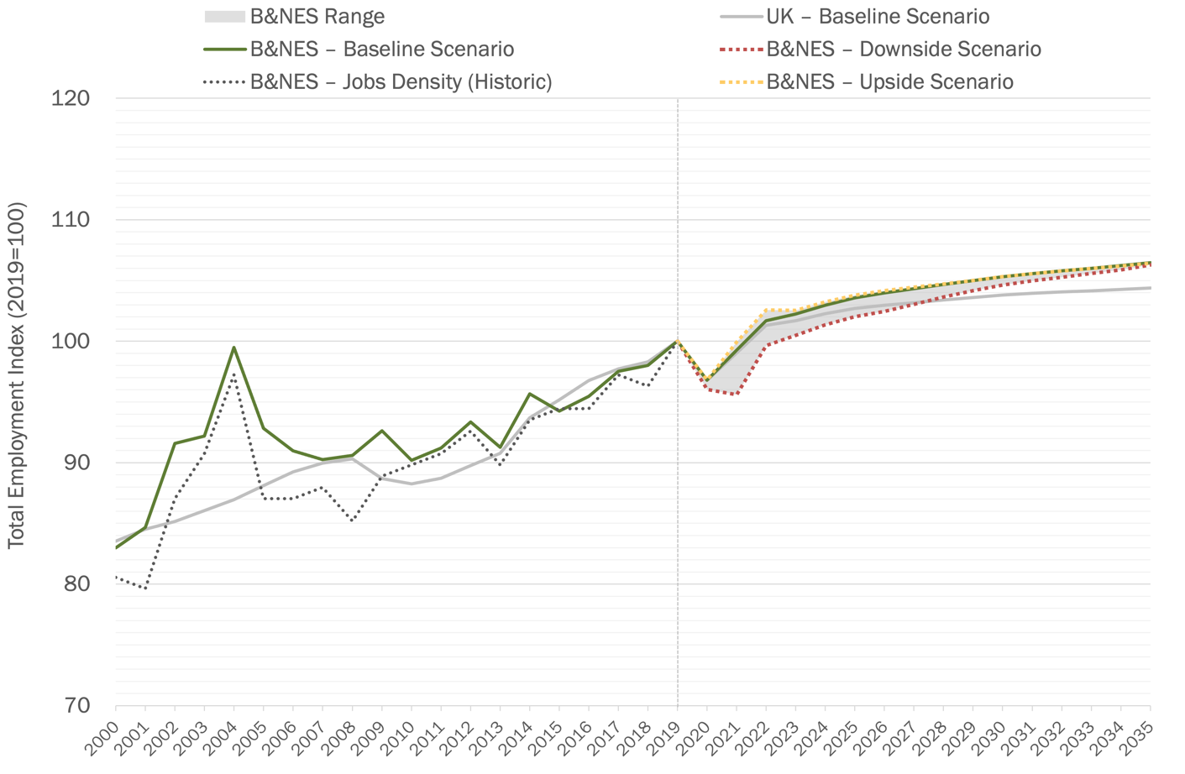
    - Over the period 2019–2035, all scenarios forecast a continued growth in employment in B&NES (0.5% per annum), albeit at a lower rate than historic growth (1.0% per annum). The main difference between scenarios at the B&NES level is during the period 2019–2022 – the period covering the immediate impact of the pandemic. The Upside scenario forecasts a rapid bounce back effect from the end of 2020, re-establishing pre-pandemic employment levels by 2021, with growth beyond pre-pandemic levels during 2022 and beyond. The Baseline scenario is very similar to the Upside scenario. The Downside scenario predicts a slower recovery – a further decrease in employment levels during 2021, with a return to pre-pandemic levels during 2022, followed by slightly higher growth beyond this point resulting in a convergence with the Upside and Baseline scenarios around 2035.
    - From around 2022 onwards, the Baseline and Upside scenarios predict that employment growth in B&NES will outstrip the national (UK) rate. The Downside scenario shows similarly strong employment growth from around 2022, however it takes until around 2028 for the Downside scenario to begin to overtake Baseline UK performance compared to pre-pandemic levels.
    - In absolute terms the forecasts indicate an increase of somewhere between 6,600–6,800 jobs over the period 2019–2035. This equates to around 330–340 jobs per annum – much lower than the approximately 900–1,050 jobs per annum over the historic period 2000–2019.

Gross Value Added (GVA)
    - Figure 4.2 shows historic and forecast trends for total GVA in B&NES. The Baseline, Upside, and Downside forecasts are set out, as well as a historic comparison (2000–2019) with ONS data, and a UK Baseline scenario comparison across the entire period 2000–2035.
Figure 4.2: Total GVA scenarios, index (2019 = 100)

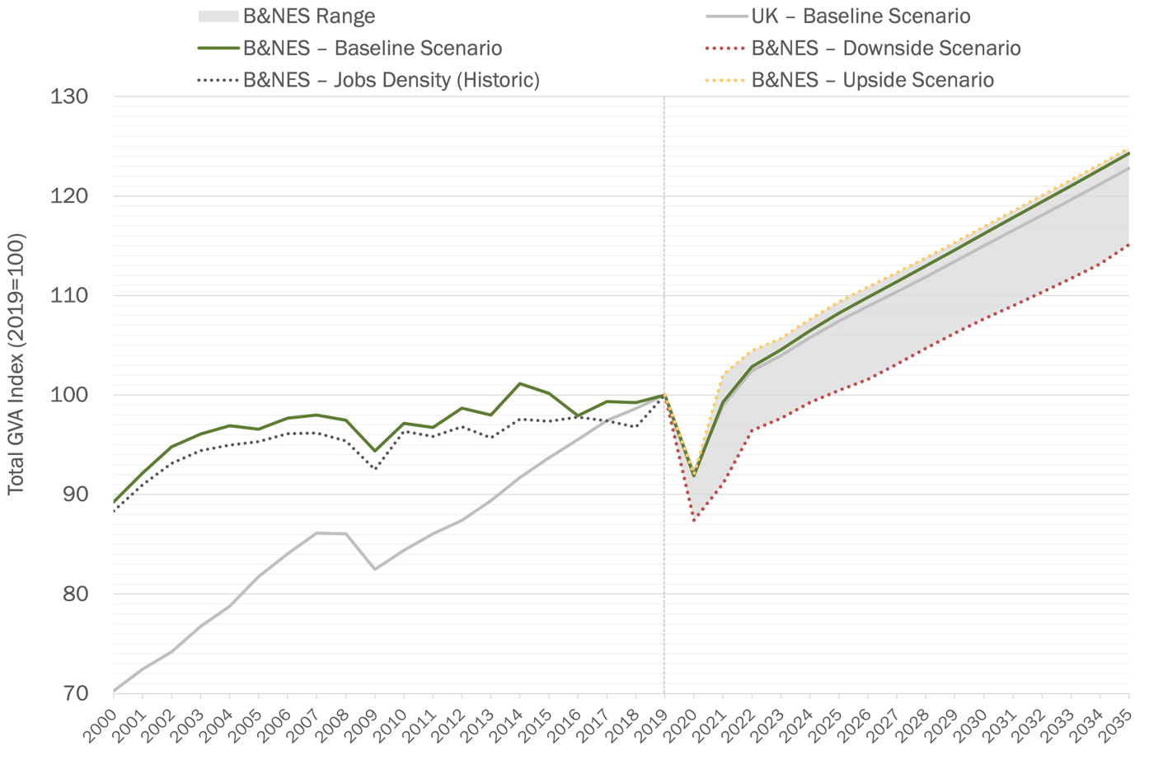
    - Over the period 2019–2035, all scenarios forecast a continued growth in GVA in B&NES (1.4%–1.5% per annum), at a higher rate than historic growth (0.6% per annum). However, this small difference in annual change equates to a significant difference between the Baseline/Upside scenarios and the Downside scenario over the whole forecast period 2019–2035.
    - All scenarios point to a significant decline in GVA during 2020. The GVA decline set out in the Baseline and Upside scenarios is smaller than the Downside scenario, and the recovery rate is stronger. Under the Downside scenario, GVA levels in B&NES do not recover to converge with the Baseline and Upside scenarios during the forecast period (2019–2035). This is primarily a result of the initial shock caused by the pandemic, in combination with a long-term growth rate that is slightly weaker in the Downside scenario compared to the other two scenarios.
    - From around 2022 onwards, the Baseline and Upside scenarios predict that GVA growth in B&NES will begin to marginally outstrip the national (UK) rate. The Downside scenario shows similarly strong GVA growth from around 2022, however due to the initial shock of the pandemic under this scenario, and parallel GVA growth rates compared to the national (UK) rate, the Downside scenario lags well behind national (UK) performance compared to pre-pandemic levels.
    - In absolute terms the Baseline and Upside scenarios forecast an increase of around £1 billion GVA over the period 2019–2035, and the Downside scenario forecasts an increase of around £600 million GVA over the same period.

Productivity
    - Figure 4.3 shows historic and forecast trends for total productivity in B&NES. The Baseline, Upside, and Downside forecasts are set out, as well as a historic comparison with ONS data, and a UK Baseline scenario comparison across the entire period 2000–2035.
Figure 4.3: Total productivity scenarios, index (2019 = 100)

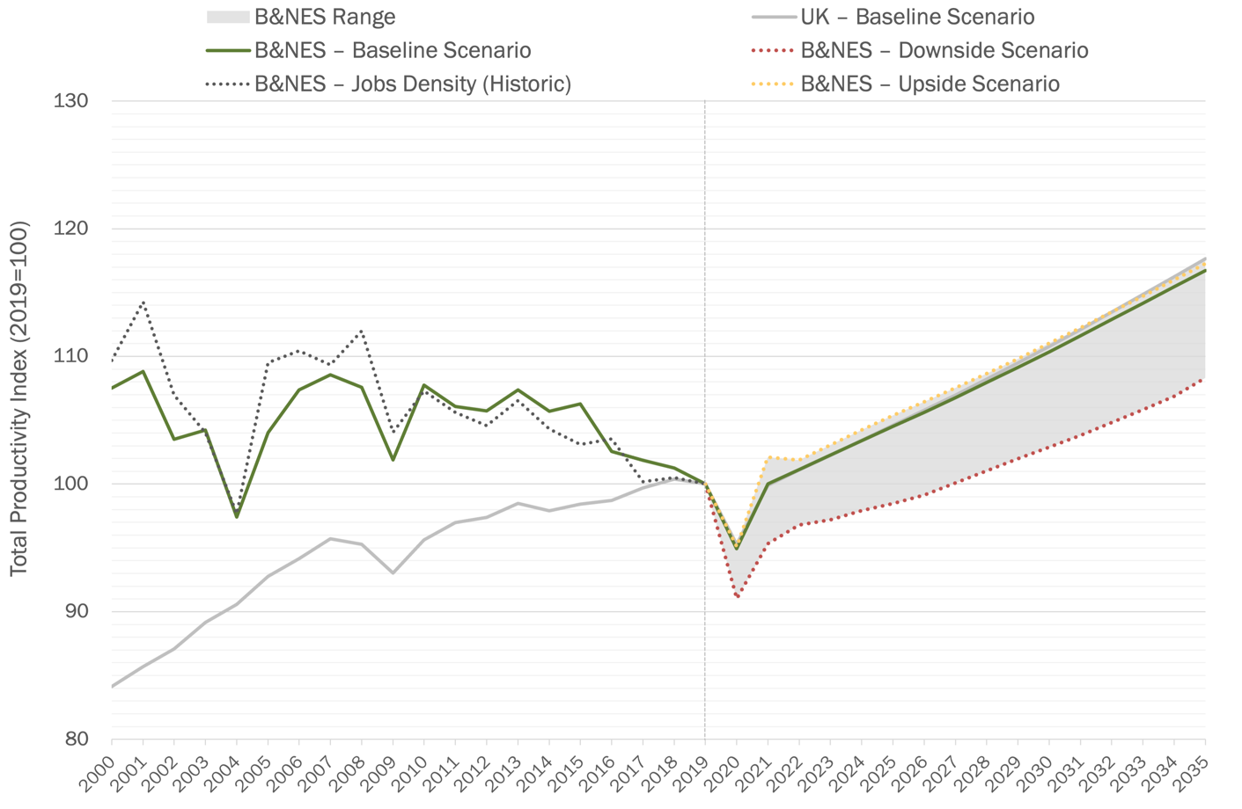
    - Over the period 2019–2035, all scenarios forecast growth in productivity in B&NES (0.9%–1.1% per annum) – a reversal of historic productivity declines (–0.4% per annum). However, this small difference in annual change equates to a significant difference between the Baseline/Upside scenarios and the Downside scenario over the whole forecast period 2019–2035, driven by the shortfall in GVA under the Downside scenario set out above.
    - All scenarios point to a significant decline in productivity during 2020. The GVA decline set out in the Baseline and Upside scenarios is smaller than the Downside scenario, and the recovery rate is stronger. Under the Downside scenario, productivity levels in B&NES do not recover to converge with the Baseline and Upside scenarios. This is primarily a result of the initial shock caused by the pandemic in terms of GVA, in combination with a long term growth rate that is slightly weaker in the Downside scenario compared to the other two scenarios.
    - The Baseline and Upside scenarios predict that productivity growth in B&NES will track with the national (UK) growth rate until around 2025, at which point the national (UK) productivity growth rate will begin to outperform B&NES compared to pre-pandemic levels. The Downside scenario shows similar productivity growth from around 2022, but from a much weaker starting position. The Downside scenario therefore lags well behind national (UK) performance compared to pre-pandemic levels.

Sectoral Performance
    - Figure 4.4 sets out the variation in sectoral employment forecasts in B&NES under the three scenarios – Baseline, Upside, and Downside. Overall, there is not too much difference between scenarios when taking a sector-by-sector view of the forecasts.
    - The direction of change in each sector (positive vs. negative) is the same in B&NES as the national (UK) trend.
Figure 4.4: Employment change by sector (2019–2035)
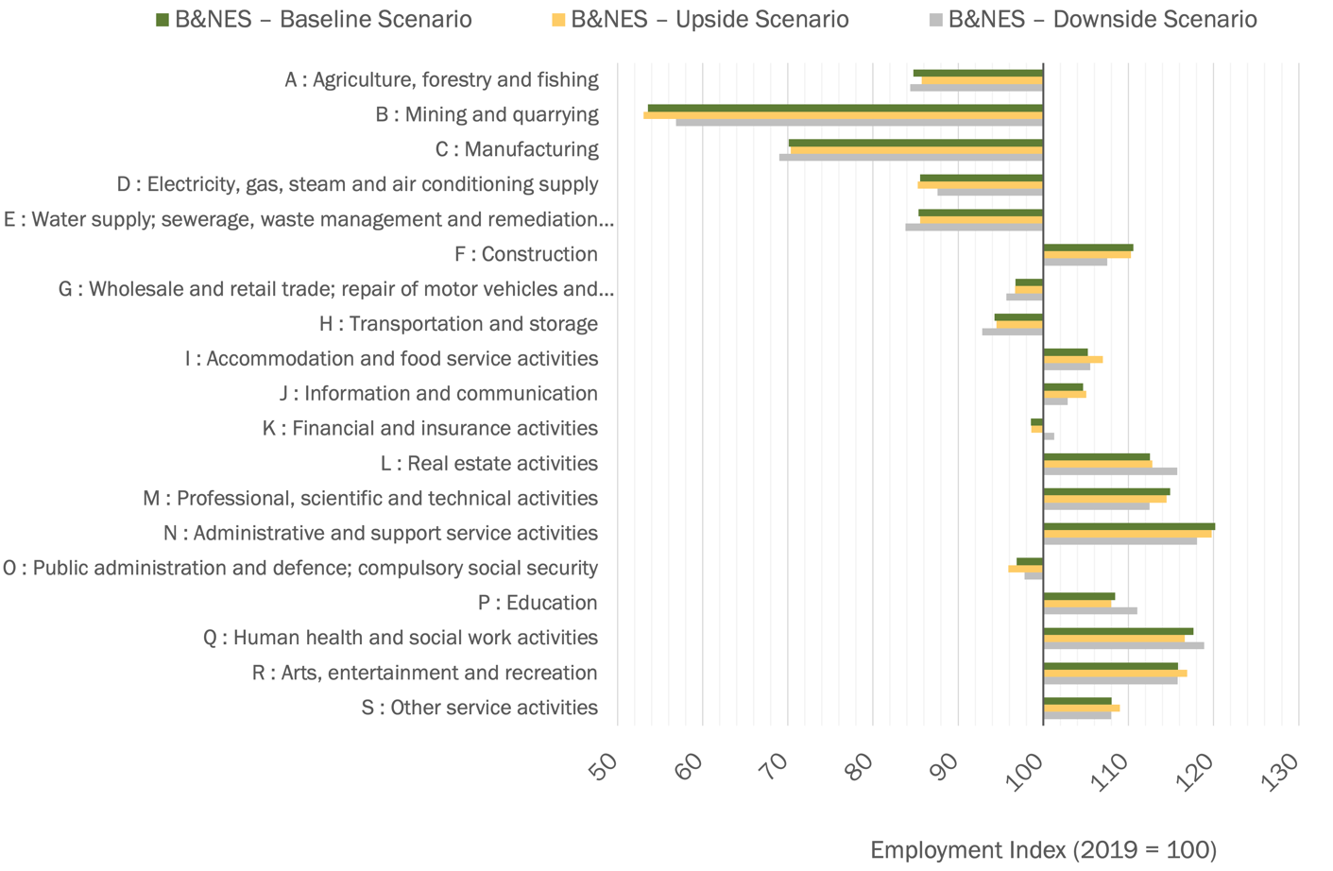
    - Figure 4.5 considers the change in GVA by sector. This shows that GVA is anticipated to grow for most sectors in B&NES, except for: Agriculture, forestry and fishing; Mining and quarrying; and Public Services. GVA in Manufacturing is expected to increase slightly in B&NES over the forecast period, whereas it is expected to decrease slightly at a national (UK) level.
    - There are some major differences between sectors in GVA change between scenarios. In every sector, the Downside scenario is forecasting significantly lower GVA growth (or greater GVA losses), than the Baseline and Upside scenarios.
Figure 4.5: GVA change by sector (2019–2035)
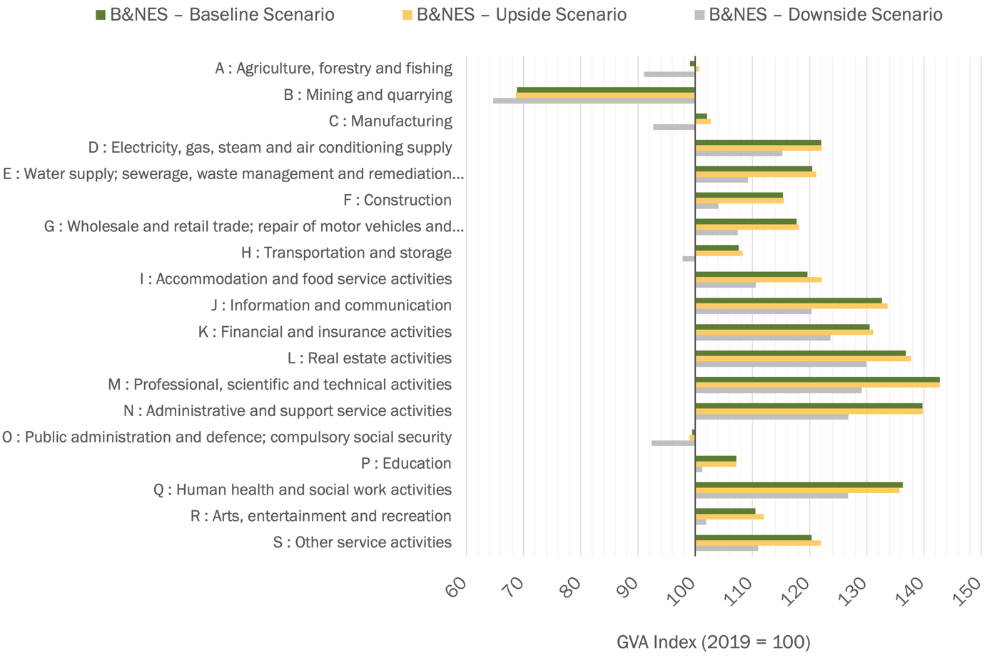

    - Figure 4.6 considers the change in productivity by sector. This shows that productivity is anticipated to grow for most sectors in B&NES, with the exception of: Education; and Arts, entertainment, and recreation.

Figure 4.6: Productivity change by sector (2019–2035)
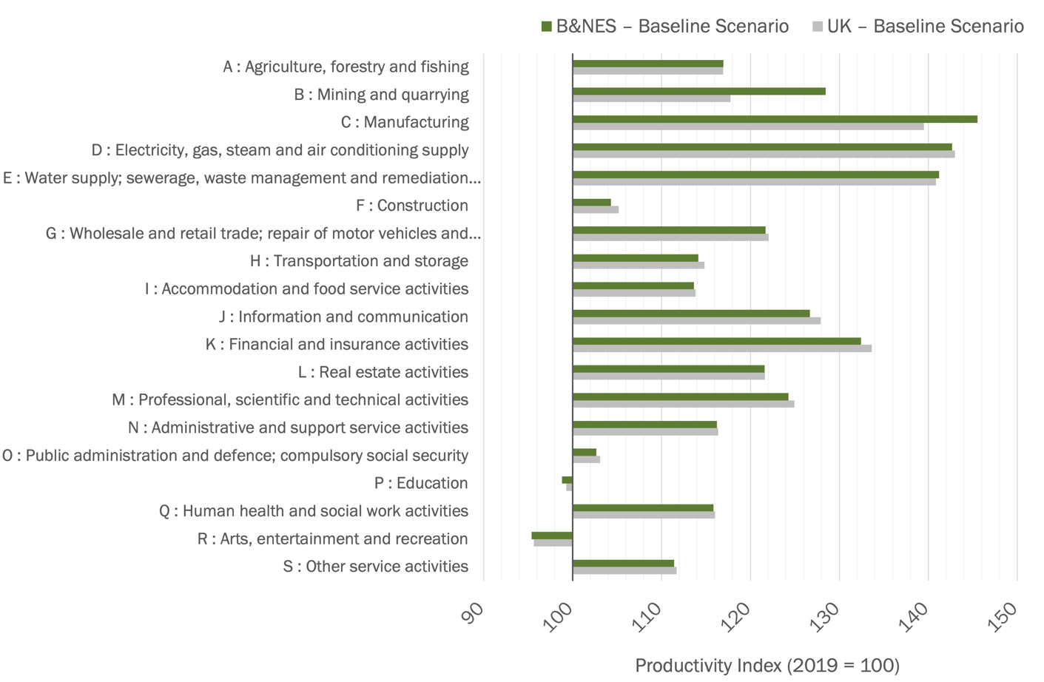

Appendix 1: Business Counts by Sub Area

Table A1.1: Business counts (local units) by SIC07 section for B&NES sub areas (2011)
SIC Section | Bath City | Keynsham | Rural Area | Keynsham
A: Agriculture, forestry and fishing | 15 | * | 190 | 25
B: Mining and quarrying | * |  | *
C: Manufacturing | 130 | 40 | 70 | 135
D: Electricity, gas, steam etc | * |  | * | *
E: Water supply; sewerage, waste management etc | * | * | * | *
F: Construction | 335 | 90 | 235 | 215
G: Wholesale and retail | 890 | 140 | 210 | 280
H: Transport and storage | 55 | 25 | 50 | 75
I: Accommodation and food | 420 | 35 | 80 | 70
J: Information and communication | 415 | 30 | 135 | 65
K: Financial and insurance | 120 | 20 | 30 | 20
L: Real estate | 185 | 20 | 50 | 40
M: Professional, sceintific and technical | 870 | 65 | 295 | 135
N: Administrative and support services | 310 | 55 | 135 | 105
O: Public administration and defence | 25 | * | 10 | 15
P: Education | 120 | 20 | 45 | 45
Q: Human health and social work | 285 | 45 | 60 | 85
R: Arts, entertainment and recreation | 195 | 15 | 50 | 40
S: Other service activities | 190 | 40 | 55 | 65
Grand Total | 4,575 | 660 | 1,710 | 1,415
Source: HJA based on ONS

Table A1.2: Business counts by SIC07 section for B&NES sub areas (2020)
SIC Section | Bath City |  | Keynsham |  | Rural Area |  | Keynsham
A: Agriculture, forestry and fishing | 25 |  | 10 |  | 215 |  | 30
B: Mining and quarrying | * |  |  |  | *
C: Manufacturing | 130 |  | 40 |  | 95 |  | 115
D: Electricity, gas, steam etc | * |  |  |  | * |  | *
E: Water supply; sewerage, waste management etc | * |  | * |  | * |  | *
F: Construction | 360 |  | 155 |  | 330 |  | 295
G: Wholesale and retail | 895 |  | 125 |  | 215 |  | 260
H: Transport and storage | 70 |  | 40 |  | 40 |  | 70
I: Accommodation and food | 510 |  | 50 |  | 120 |  | 85
J: Information and communication | 550 |  | 70 |  | 175 |  | 90
K: Financial and insurance | 135 |  | 20 |  | 45 |  | 30
L: Real estate | 240 |  | 25 |  | 90 |  | 35
M: Professional, sceintific and technical | 1,195 |  | 110 |  | 410 |  | 205
N: Administrative and support services | 400 |  | 65 |  | 200 |  | 125
O: Public administration and defence | 20 |  | * |  | 25 |  | 25
P: Education | 120 |  | 15 |  | 50 |  | 40
Q: Human health and social work | 290 |  | 50 |  | 80 |  | 95
R: Arts, entertainment and recreation | 195 |  | 20 |  | 65 |  | 40
S: Other service activities | 195 |  | 35 |  | 50 |  | 65
Grand Total | 5,345 |  | 850 |  | 2,210 |  | 1,620
Source: HJA based on ONS

Defined by the ONS as: the smallest combination of legal units which has a certain degree of autonomy within an Enterprise Group.
UK SIC (2007) is divided into 21 sections, each denoted by a single letter from A to U. The letters of the sections can be uniquely defined by the next breakdown, the divisions (denoted by two digits). The divisions are then broken down into groups (three digits), then into classes (four digits) and, in several cases, again into subclasses (five digits).
The LQ value is lower than 1 relative to the West of England, indicating a very high WoE LQ relative to the UK.
Defined by the ONS as: individual sites that belong to an Enterprise.
Bath City, Keynsham, Rural Area, and Somer Valley – defined as per Bath & North East Somerset Employment Growth and Employment Land Review (March 2020).
Data for B: Mining and quarrying; D: Electricity, gas, steam etc; and E: Water supply, sewerage, waste management etc is suppressed, therefore sectors are not displayed in the analysis. BSD data requires access via the ONS Secure Research Service. Due to data disclosure controls some data requires suppressions in order to avoid identification of individual data points.
Latest available.
Formerly B1c.
Regional gross value added (balanced) by industry: local authorities by ITL1 region: TLK South West current prices.
Business Register and Employment Survey.
However, there is a conceptual question of whether the site should be considered on the basis of previous use or potential use. For the purposes of providing a high level estimate the current approach may well have the best return on the time investment required. If utilising past use, it may be possible to draw on IDBR data to build a picture based on actual employment accommodated on sites. However, this would have to be aggregated to ensure confidential business data is not disclosed.
Regional gross value added (balanced) by industry: local authorities by ITL1 region: TLK South West current prices

