**OFFICER DECISION REPORT – TRAFFIC REGULATION ORDER (TRO)**

1

**INFORMAL CONSULTATION (Chief Constable, Ward Members and**

**Parish Councils)**

PREPARED BY: Traffic Management Team, Highways and Transport Group

|  |  |
| --- | --- |
| **TITLE OF REPORT:**  **PROPOSAL:**  **SCHEME REF No:**  **REPORT AUTHOR:** | **Walley Lane Speed Restriction**  **30mph Speed Limit**  **21-031/LC**  **Design and Projects Team / Lewis Cox** |

**1. DELEGATION**

The delegation to be exercised in this report is contained within **Part 3**, **Section 4** of the Constitution under the **Delegation of Functions to Officers,** as follows:

|  |  |
| --- | --- |
| **Section A** | The Chief Executive, Strategic Directors, Divisional Directors and Heads of Service have delegated power to take any decision falling within their area of responsibility….” |
| **Section B** | Without prejudice to the generality of this, Officers are authorised to:  serve any notices and make, amend or revoke any orders falling within his/her area of responsibility. |
| **Section D9** | An Officer to whom a power, duty or function is delegated may nominate or authorise another Officer to exercise that power, duty or function, provided that Officer reports to or is responsible to the delegator. |

*For the purpose of this report, the Director of Place Management holds the delegated power to make, amend or revoke any Orders.*

**2. LEGAL AUTHORITY**

This proposal is made in accordance with the Road Traffic Regulation Act 1984, which under Section 1 provides, generally, for Orders to be made for the following reasons, and in the case of this report specifically for the reason(s) shown below:

|  |  |  |
| --- | --- | --- |
| (a) | for avoiding danger to persons or other traffic using the road or any other road or for preventing the likelihood of any such danger arising, or | X |
| (b) | for preventing damage to the road or to any building on or near the road, or |  |
| (c) | for facilitating the passage on the road or any other road of any class of traffic (including pedestrians), or |  |
| (d) | for preventing the use of the road by vehicular traffic of a kind which, or its use by vehicular traffic in a manner which, is unsuitable having regard to the existing character of the road or adjoining property, |  |
| (e) | (without prejudice to the generality of paragraph (d) above) for preserving the character of the road in a case where it is specially suitable for use by persons on horseback or on foot, or |  |
| (f) | for preserving or improving the amenities of the area through which the road runs, or | X |
| (g) | for any of the purposes specified in paragraphs (a) to (c) of subsection (1) of section 87 of the Environment Act 1995 (air quality) |  |

**3. PROPOSAL**

Replace the existing 40mph speed limit eastbound approach to the Dam to a proposed 30mph speed limit. Continue the proposed 30mph speed limit to replace the existing 50mph speed limit over the Dam to a point east of the vehicular entrance to picnic area no1. Continuing east from this point replace the existing 50mph speed limit with a 40mph speed limit. Continue the proposed 40mph speed limit to the existing 40mph speed limit near the junction with Hollowbrook Lane.

The proposals are shown on the attached drawings.

**4. BACKGROUND**

Works are due to take place to implement improvements to pedestrian and cycle facilities across the Chew Valley Dam as part of the Chew Valley Lake Recreational Trail. Reducing the east and west approach and over the dam to a 30mph speed limit, together with traffic calming build outs along the length of the dam will contribute to speed reduction across the dam and highlight the increased use of the widened shared use footway/ cycleway. Heading east from the Dam along Walley Lane, the existing 50mph will be reduced to 40mph to further emphasis the nature of this road and its use by all forms of transport accessing the facilities of Chew Valley Lake and its surroundings.

# 5. SOURCE OF FINANCE

This proposal is being funded by the capital Design budget, project code TCY011

**6. CONSULTATION REQUIREMENT**

Theproposal requires informal consultation with the Chief Constable, Ward Members, Parish Council, and the Cabinet Member for Transport.

PROPOSALS APPROVED FOR INFORMAL CONSULTATION WITH THE CHIEF CONSTABLE, WARD MEMBERS and PARISH COUNCIL.

Date: 25th November 2021



Paul Garrod

Traffic Management and Network Manager

Plan 1 – Existing 40mph speed limit changed to proposed 30mph speed limit.

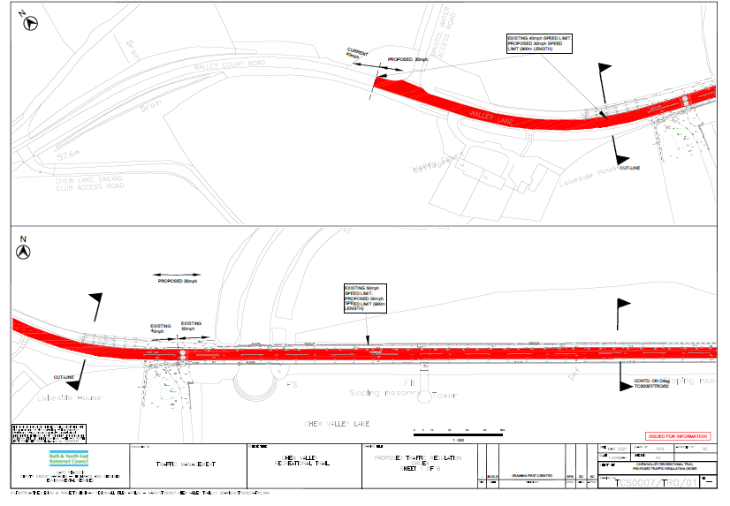

Plan 2 – Existing 40mph speed limit changed to proposed 30mph speed limit. Existing 50mph speed limit changed to proposed 40mph speed limit.

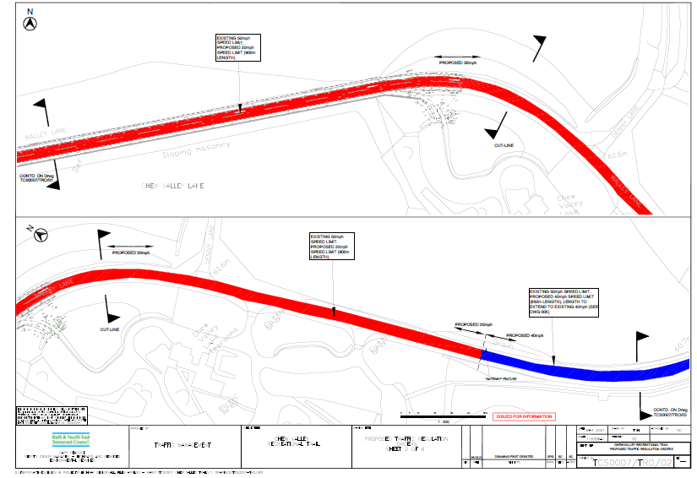

Plan 3 – Existing 50mph speed limit changed to proposed 40mph speed limit.

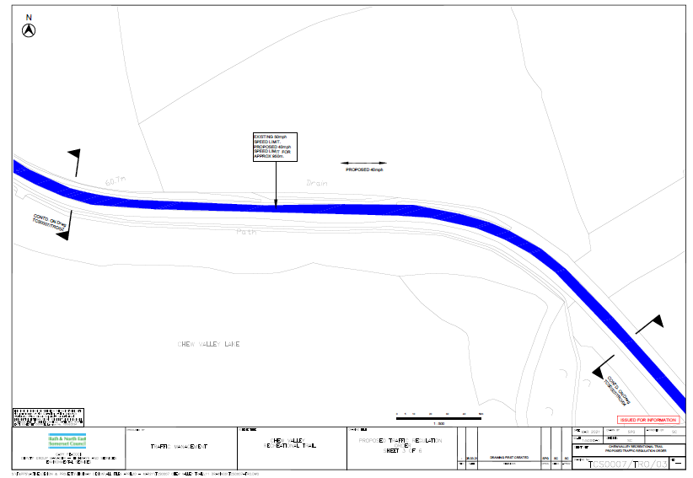

Plan 4 **–** Existing 50mph speed limit changed to proposed 40mph speed limit.

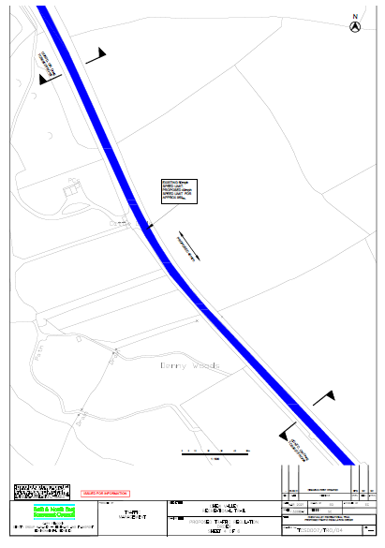

Plan 5 **–** Existing 50mph speed limit changed to proposed 40mph speed limit. Proposed 40mph extends to existing 40mph.

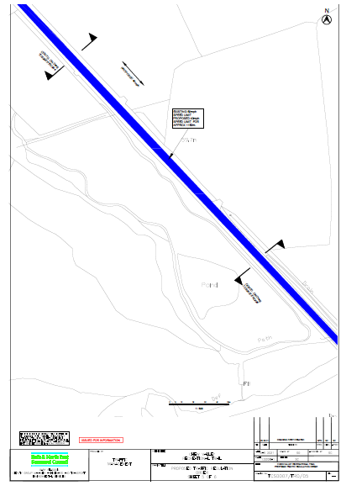

Plan 6 **–** Existing 50mph speed limit changed to proposed 40mph speed limit. Proposed 40mph extends to existing 40mph.

