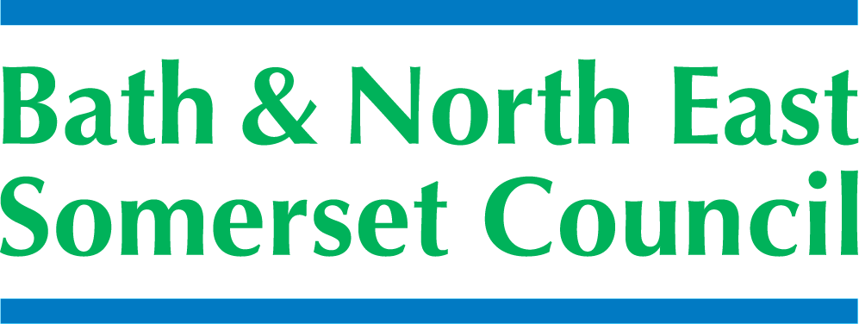

**Bath and North East Somerset Council**

**Special Educational Needs and Disability**

**Personal Budget Policy November 2015**

1. **1. introduction**

1.1 The following policy relates to the duties of Bath and North East Somerset Council in relation to the Children and Families Act, 2014, the Statutory Guidance and Code of Practice for special educational needs and disability 0-25 years, 2014 and the ‘The Special Educational Needs (Personal Budgets) Regulations 2014.

1.2 It has been developed in consultation with: parents, health providers, commissioners, social care and education.

1. 1.3 The SEND Code of Practice defines a personal budget as an amount of money identified by the local authority to deliver parts of the provision set out in an Education Health and Care plan (EHC). Families will be able to request a personal budget as part of the planning process, i.e. when a local authority is drawing up an EHC plan or at the annual review.
2. 1.4 Following an assessment of need it may be decided that additional resources, from one or from multiple sources, are needed in order to meet the outcomes that have been identified in the joint assessment. The local authority or health service traditionally uses this money to purchase services on behalf of the child/young person and their family. However, a personal budget will offer the family more choice and control about the services they receive. The budget will be made clear to parent carers and young people so they can be involved in all decision making in order to choose the right provision to best meet the outcomes identified in their child’s EHC plan.
3. 1.6 The SEND Code of Practice is clear that funding for personal budgets will relate to more specialist and individualised provision. In education, this means provision funded wholly or partly from the local authority’s high needs funding and does not include funding for school place or services the school or college is expected to provide as part of the local offer.

**2. Relevant legislation**

2.1

* Section 49 of the Children and Families Act 2014,
* The Special Educational Needs (Personal Budgets) Regulations 2014,
* National Health Service (Direct Payments) Regulations 2013
* Care Act 2014
* Section 117(2C) of the Mental Health Act 1983
* Care and Support (Direct Payments) Regulations 2014

1. **Definitions**

**EHCP:** Education, Health and Care Plan

**EHC Panel:** Multi-agency panel sitting fortnightly to see all cases and allocate personal budgets.

**B&NES:** Bath and North East Somerset Council

**CCG:** Bath and North East Somerset Clinical Commissioning Group

1. **What is a Personal Budget?**

4.1 Personal budgets are an allocation of funding made for children and young people with SEND and their families, after an assessment of their needs and will be outlined in an EHCP. Parents or young people can request a Personal Budget as part of an EHCP Needs assessment. It will cover aspects of the Plan that can be offered as a personal budget. It will not cover the cost of a named educational placement

4.2 Families will be able to request a personal budget as part of the planning process, i.e. when a local authority is drawing up an EHCP or at the annual review.

4.3 Families can decide how they want it to be managed:

* As a direct payment. (set out in ‘Personal Budget Direct Payment Agreement) The funding is paid direct to the family who will manage it to deliver support as set out in the EHCP.
* As a ‘commissioned budget’ where the local authority manages the notional budget for the family.
* By a provider (for example a school or voluntary service).
* Or as a combination of the three options above.

4.4 A personal budget can include funding from education, health and social care. In education, a personal budget will be available where support provided by the school/college (including any special educational provision as set out in the local offer) cannot meet the student’s support needs. The funding for this element of the personal budget will come from the local authorities ‘high needs block’.

4.5 Some children and young people may also have a personal budget that includes funding from social care and/or for health services; in these cases it will be possible to bring the funding together to use as a single budget focused on holistic and child/family centred support to meet needs and outcomes.

4.6 Schools or colleges can choose to contribute some of their own budget including pupil premium if required, to a child or young person’s personal budget. Personal budgets are designed to pay for the elements of provision that the local and health authorities have agreed can be offered as a direct payment. A direct payment will be the mechanism of receiving the personal budget.

4.7 The statutory regulations state:

*“Direct payments may only be made ….. If the person*

*(a) Appears to the local authority to be capable of managing direct payments without assistance or with such assistance as may be available to them;*

*(b) Where the recipient is an individual, is over compulsory school age;*

*(c) Does not lack capacity within the meaning of the 2005 Act to consent to the making of direct payments to them.*

4.8 Parents have control of a personal budget up to the end of year 11 (post compulsory school age). It is then the young person who has this responsibility, as long as they have the mental capacity as defined by the Mental Capacity Act, unless they elect for their parent/carer to manage their funding

3.8 The aim of Direct Payments is to increase an individual’s independence and choice by giving them control over the way services they receive are delivered. Direct payments are cash payments made instead of, either fully or partly, of specified services from local authority or health services. The payment must be sufficient to enable users to purchase services to meet their agreed provision and must be spent on services that meet the outcomes and services as laid out in the EHCP.

3.9 Direct Payments allow people to take more control of their lives and decide which services they should purchase themselves, rather than having them provided. Therefore there is increased choice about the services to meet individual need. They are only applicable for certain aspects of the EHCP and will entail increased responsibility, for instance the employment aspects of any people directly employed as part of this process.

1. **Personal budget process:**

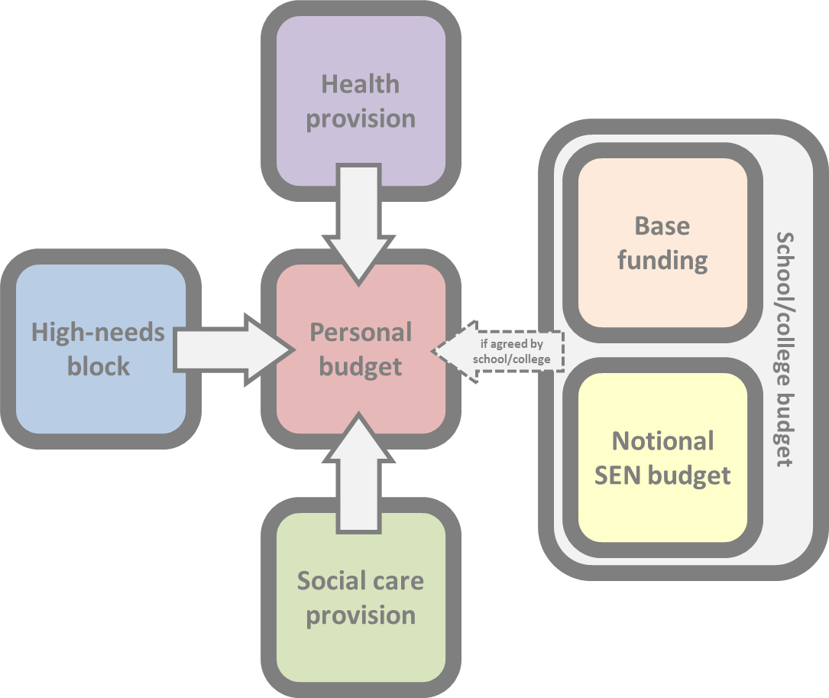

* Funding from different agencies will be allocated to a personal budget through the SEND panel.
* The ‘High Needs Block’ (HNB) is seen as the primary source for potential personal SEN budgets;
* However the HNB is also the source of funding for targeted support such as specialist teacher
* Services, sensory impairment support and of funding for out-of-area placements, i.e. it is a commissioning budget and hence the same approach should be adopted to exploring how it is currently used and how this will develop.

1. **6. Decision making processes**
2. 6.1 The process that will be implemented to agree a personal budget will:-

* be based on clear, agreed outcomes
* be transparent and challengeable
* allow families and young people to manage agreed elements of the additional and individual support they need
* be an integral part of the planning process in order to empower creative solutions
* reflect the holistic nature of an EHCP, covering education, health and care as appropriate, where additional and individual support is needed
* come with the support needed for parents and young people to take up and manage it
* support and inform market development
* Allow for local flexibility.

**7. What’s in/not in scope for a personal budget?**



* Funding from universal services will not be included in a personal budget.
* Funding from specialist commissioned targeted services and support will not be included in a personal budget
* Funds within block contracts where disaggregating the funds would have a negative impact on the wider population will not be included in a personal budget

1. **How the amount of a personal budget will be decided and by whom?**

6.1 B&NES will ensure that the amount of money agreed in a personal budget will be sufficient to secure the agreed provision in order to meet the outcomes set out in the EHCP. This will be agreed at the SEND panel.

6.2 B&NES may increase or decrease the amount provided that it is satisfied the amount is sufficient to secure the agreed provision.

1. **Reduction in Funding**

7.1 Where there is a reduction in needs of the EHCP following assessment, Banes will to reduce the funding and will provide 28 working days’ notice to the recipient and set out in the notice the reasons for its decision.

7.2 B&NES will reconsider its decision when requested to do so by the recipient.

7.3 B&NES will not consider more than one reconsideration.

1. **Repayment and recovery**

8.1 B&NES may require a recipient to repay part or all of the monies where:

1. The circumstances of the child or young person have changed in a manner that has an impact on the appropriateness of the agreed payments.
2. All or parts of the payments have not been used to secure the agreed provision.
3. Theft, fraud or another offence has occurred in relation to the payments.
4. The child or young person has died.

8.2 Where B&NES decide to seek a repayment of any portion of the payments, B&NES will give notice in writing setting out:

1. The reasons for the decision
2. The amount to be repaid.
3. A reasonable timescale within which the money must be repaid.
4. **Monitoring and review**

9.1 B&NES will monitor the use of personal budgets to the recipient at least once in the first three months and when conducting a review or reassessment of an EHCP under section 44 of the Children and Families 2014 Act.



1. **Information about changes and crisis**

11.1 Any changes in a child’s situation will need to be reviewed at EHC panel.

13.5 The use of personal budgets should be informed by a person centred approach to planning hence ensuring that any personal budget is used in the most appropriate and efficient way.

**Review Date: November 2018**