Guide to Setting
up an E-Team

Updated February 2017

Contents

Introduction Page 4
What is an E Team? Page 4
Applying for the £100 Start-up grant Page 5
Reporting back on progress – template Page 6
Setting up an E Team – Step by Step Page 7
Doing a survey Page 8
E Teams – Common problems and solutions Page 9
Local Support Agencies Page 10
National Support Agencies Page 11
Case studies for inspiration Page 12

Acknowledgements
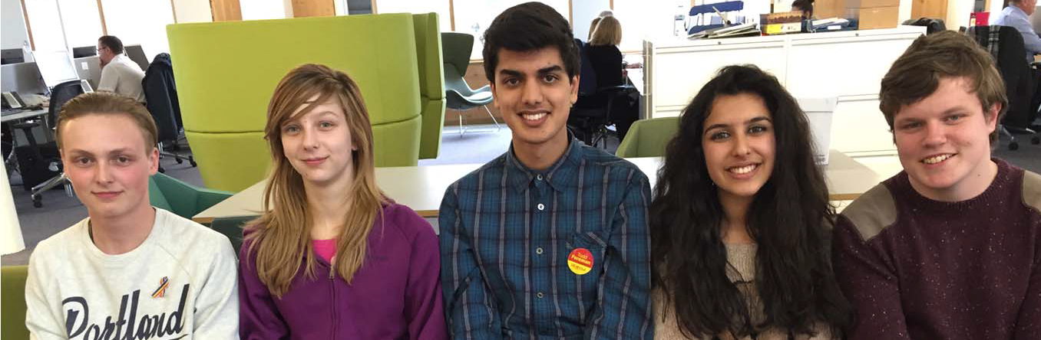
Special thanks to Tommie, Holly, Shyam, Savarna and Sam who helped write the first edition of this guide in 2015 – using their own experiences of setting up an E Team.

Introduction
This guide is intended to help you to set up an E-team and create a group to take action within your school, club or other environment. Every school and every setting has different problems, it’s just about thinking about the best way to approach them.

Throughout the guide there will be ideas and resources that you may find useful. At the end of the guide contact details for local and national organisations that your E-Team may be interested in.
What is an E-Team?
An E-Team is a group of young people supported by adults that works to make their setting a welcoming and equal environment for everyone.

In a primary school an E Team might focus on finding ways to promote friendships and celebrate difference. In secondary schools or youth settings, E teams can work towards addressing equalities issues, such as racism, sexism, HBT (Homophobic, Biphobic and Transphobic) discrimination

The role of an E-Team
E-teams can be organised in different ways to meet the needs of your school or your setting. Depending on where you are based the structure of your E-team will differ.

An E-team can provide:

1. A forum for equalities topics
This provides the group with a meeting space to talk about things that are happening in the school, to voice concerns and come up with ideas.

2. A campaigning role
With enough support, it is possible to start a campaign in any setting. A campaign can include all or some of the following:
- Undertaking surveys
- Raising awareness of specific issues – e.g. disabled access
- Inspiring people outside the school (e.g. parents) to get involved
- Taking action – e.g. to stop bullying or name calling.

Don’t forget to celebrate achievements and progress!!

3. A benefit to your school or setting

- E-Teams can help a school to check if it is making progress on tackling bullying or issues of inequality.

- E- teams can also provide a great support structure enabling adults, children and young people to really work together to create changes and for everyone to develop important new skills

The £100 E Team Grant ££££

A grant of £100 is given to help to set up all new E Teams. The E Team can decide how to spend the money; for example it can be used for resources or materials that will help with your campaign idea.

E Teams who have already had a £100 start-up grant can apply for an additional grant if they want to focus on a new area of equalities – such as celebrating different families, tackling homophobic, biphobic and transphobic bullying, promoting race equality, or disability equality.

Contact Kate_Murphy@bathnes.gov.uk for more information or visit the E Teams web page:

http://www.bathnes.gov.uk/services/your-council-and-democracy/equality-and-diversity/e-teams;

Keep a record of what you do and write up the impact of your campaigns. This can not only give everyone a great sense of achievement but the wider community locally and even nationally can learn a lot from your experience.

School or setting
What we have been doing

Comments from pupils / staff / parents

What we spent our grant on

What difference it has made in our school / setting

What we are going to do next

Insert a picture
E Team Progress

Setting up an E- team - Step by Step

Start off by getting a few people together who are passionate about making your school (or setting) more equal. This is a really important part because you need to make sure you are committed and able to handle any potential set-backs.

Getting a supportive teacher, PSHE lead or project worker on board from the start really helps. They can give the support with your ideas or campaigns.

If you are in a school setting it is also helpful to have the backing of senior members of staff. You could go and speak to them directly or put together a presentation for the leadership team. You can also find out if anyone else is interested like governors, (or trustees), SMAs, teachers, teaching assistants. This can really benefit your E-team as the more people you have, the easier it is to start up your campaigns because you will already have the links throughout your school or organisation.

It is important to let the whole school or setting know about your E-team. In a school you can do this by holding assemblies where you can explain the reasons for setting up an E- team and outline some of the potential issues.
In other settings you could arrange a session for your group to explain the ideas or campaigns they want to focus on.

You all then need to decide where and when will you meet. Some E-teams meet weekly, some fortnightly and some monthly. It is up to your team to decide what suits you all best.
Write a constitution (e.g. what is the purpose of your group and how will it be run)
Apply for the £100 grant!!!

Doing a survey

What is a survey?
A survey is a set of questions to find out about what people think, and find out what their experiences have been. For example, you might want to find out if pupils think your school is a welcoming place for everyone.

You could use a survey to find out some of the issues children and young people are often concerned about - for example feeling bullied or isolated, or worried about name calling, or concerned about inappropriate language or behaviours. A survey can give people a chance to tell people about bullying or and share their ideas on how to tackle it.

Why have a survey?
Surveys are an invaluable tool for analysing the views of a group of people. They can highlight major issues within your school or setting regarding inequality and this information can help you to decide on which campaigns/projects would be best for your school. They can also be useful in checking if anything changes as a result of setting up an E-team or launching a campaign.

What sort of questions are asked in a survey?

Ideally the types of questions you should ask fall into these categories:

- Questions which require a ‘Yes/No’ answer
- Scaling questions (i.e. where you rate something on a scale of say,
- 1 – 5 (1 being a low score, 5 being the highest)
- Statements that require a response from ‘I strongly disagree to I strongly agree.
- Multiple choice questions

These questions are quick to analyse and provide useful raw data. However, you also need qualitative evidence which can be very useful when promoting the E-Team. For this purpose, it is also useful to have a ‘comments box.’

An FREE online survey such as ‘survey monkey’ provides an easy way for you to design a short series of questions. It is also useful as it breaks down the response data for you.

See Our E Teams web page for an example of a survey that an E Team ran in their secondary school: http://www.bathnes.gov.uk/services/your-council-and-democracy/equality-and-diversity/e-teams;

E Teams - Problems and Solutions

P I want to start an E-team but no one is interested.

S Start off small, i.e. with two or three young people and a member of staff. Do not try to tackle issues that are too huge.
P My school/group does not think that we have a problem with equalities or bullying.

S A whole school/group survey can show that there are often hidden issues. You can also refer to the SHEU (School, Health, and Education Unit) survey. Kate_murphy@bathnes.gov.uk can let you know if your school has done this survey.
P My school is worried that if we set up an E-team, OFSTED will think we have a problem.

S Actually OFSTED will be impressed that you are working together to solve a problem rather than hiding it. Give examples of other schools who are successfully tackling equalities issues. See the E Teams web page for Case Studies and the E-Team Newsletter.
P How do we keep the interest going?

S Have regular meetings, emphasise progress, hold assemblies and give out positive messages.
P What happens when key people leave? Won’t the group fall apart?
S It is important that your constitution emphasises that everyone owns the E-team and must take an equal responsibility. The E-team should cross the age range and always be recruiting new members. There will be leaders in the group but everyone should be encouraged to take a lead.
Local Support Agencies
Off The Record
Provides, free, confidential and independent services for children and young people that support the development of their emotional health and wellbeing. This organization provides advocacy and disability support (Young Inclusion Advocates) Junior and Senior in Care Council and an active Youth Forum
http://www.offtherecord-banes.co.uk/

SPACE LGBT Youth Group
If you are aged between 13-21 years and identify as Lesbian, Gay, Bisexual, Trans, Asexual or other sexual/gender minority, or you are questioning your sexuality and/or gender identity, then Off the Record offers a weekly LGBT+ youth group called SPACE for young people living in the Bath and North East Somerset area. http://www.offtherecord-banes.co.uk/our-services/lgbt/;

Black Families Education Support/Voice Minority Project
Supplementary school and mentoring service providing help with educational achievement, school choice and appeals, school exclusion, racial discrimination and harassment, SEND and making a complaint. The Voice Minority project has made a film about being from a black or minority ethnic background and growing up in B&NES.
http://www.blackfamilies.org.uk/

Project 28
Supporting young people who are socially excluded for reasons such as homelessness, alcohol or drug problems, learning disabilities or emotional difficulties.
http://www.dhi-online.org.uk/do/bath/project-28/

Mentoring Plus
Mentoring for young people needing extra support with family education, emotional needs and employability.
http://www.mentoringplus.net/

Stand Against Racism and Inequality (S.A.R.I.)
This provides help for a
nyone experiencing discrimination of any kind. SARU can also run workshops for schools.
http://www.sariweb.org.uk/

Young Carers Service, Carers Centre
This service provides support and help for young people who are looking after a family member.
www.banescarerscentre.org.uk/youngcarers

Child and Adolescent Mental Health Service (CAMHS)
This provides specialist NHS children and young people’s mental health service.
http://www.oxfordhealth.nhs.uk/children-and-young-people/young-people/south-west/

National Support Agencies

British Youth Council
Empowers young people aged 25 and under to influence and inform the decisions that affect their lives. They support young people to get involved in their communities and democracy locally, nationally and internationally, making a difference as volunteers, campaigners, decision-makers and leaders.
http://www.byc.org.uk/aboutus
ChildLine will help anyone under 19 in the UK with any issue they’re going through. Whether it’s something big or small, trained counsellors are there to support you.
ChildLine is free, confidential and available any time, day or night. You can talk to a ChildLine counsellor on the phone or by email
https://childline.org.uk/ Tel: 0800 1111

NSPCC - National Society for the Prevention of Cruelty to Children -

The NSPCC stands up for children, demanding that laws change and action is taken to better protect them
https://www.nspcc.org.uk/

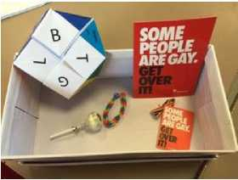
Case Study - Chew Valley E-team - promoting LGBT equality

What are the main issues?
- Homophobic, bi-phobic and transphobic (HBT) bullying and attitudes around the school.
- Some staff lacked understanding and awareness of LGBT issues.
- New Year 7s were not aware of the school values and ethos.
What did you do to address these? The E-Team has trained school staff (including lunch time assistants, teaching assistants and the school leadership team [SLT]).
Campaigns during Lesbian, Gay, Bisexual and Transgender history month in February include

  - A poster competition to raise awareness of the need to tackle HBT and sexual bullying. There were over 300 entries, and the winners are displayed around school.
  - Stonewall films "Fit” and "Free” have been shown at lunchtimes throughout LGBT History Month.
  - A "Break down the Wall of HBT Bullying” campaign: boxes containing messages, rainbow pins, wristbands, and other goodies were built then knocked down to symbolise the eradication of HBT behaviour. The wall had to be re-built on numerous occasions as 500 pupils and staff wanted to be involved!
  - Pupils and staff were interviewed by Radio Bristol about their campaigns.
  - Chew Valley pupils supported the Local Authority at LGBT History Month events at the Holburne Museum and spoke at a special meeting for LGBT schools staff.
Who was involved?
The E-Team is made up of pupils and a member of staff (PSHE lead, Lou Pope). The whole school community has been involved in the campaigns including SLT, teachers, support staff and pupils from every year group.
What has changed as a result?
- There is a raised level of awareness of the need to take a stand, and a real buzz about the school, especially around Sir Ian McKellen’s visit and during LGBT history month. People want to get actively involved!
- A growing sense of pride at being at Chew Valley School, which now has a national reputation for its work.
- Staff are more confident and willing to discuss LGBT issues rather than signposting to other services or the E-Team.
- 100 ‘Equalistar’ awards have been made by pupils to staff who actively challenge discrimination and promote and celebrating difference.
Case Study - Norton hill E-team - promoting LGBT equality
What are the main issues?
- Support for LGBTQ (Lesbian, Gay, Bisexual, Transgender or Questioning) Young People in both Norton Hill and Somervale (their federated) school.
- Support for straight young people who are targeted either because they’re perceived to be LGBT or because of who they are friends with.
- The need to raise awareness of LGBT issues and promote LGBT equality across the school communities.
What did you do to address these?
- Established the "Heroes” group (a sub-group of the E-Team) - which focuses specifically on LGBTQ issues.
- Established a group of 6th Form LGBTQ to support and buddy younger pupils who are LGBTQ. This is done both individually and in groups.
- Worked directly with the SPACE Co-ordinator at Off the Record who has delivered training to the E-teams.
- Resource packs have been developed for the purpose of raising awareness of HBT bullying.
- Ran focused campaigns in assemblies and during LGBT history month.
Who was involved?
- E-Team members (60 + young people plus LGBT staff, other staff and a governor).
- A Team of 6 6th Formers who are themselves LGBTQ.
- The whole school community has been invited to get involved in campaigns across the two schools.
What has changed as a result?
- A decrease in HBT language & attitudes.
- A better understanding of the history of HBT discrimination.
- Since Sir Ian McKellen’s visit lots of positive energy and especially the development of the HEROS group.
- Straight young people beginning to realise that it is a collective responsibility.
What are the next steps?
- To raise more money for E-Team campaigns and activities.
- To focus on issues surrounding transphobia.
- To develop more work with local schools via the E Summit and through local partnerships including schools.

Norton Hill E Team’s work:
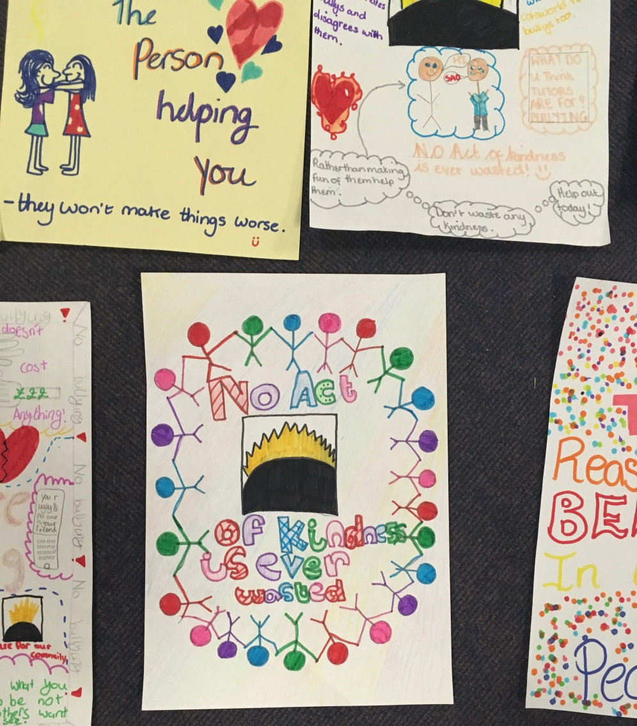

Writhlington E Team’s Work:

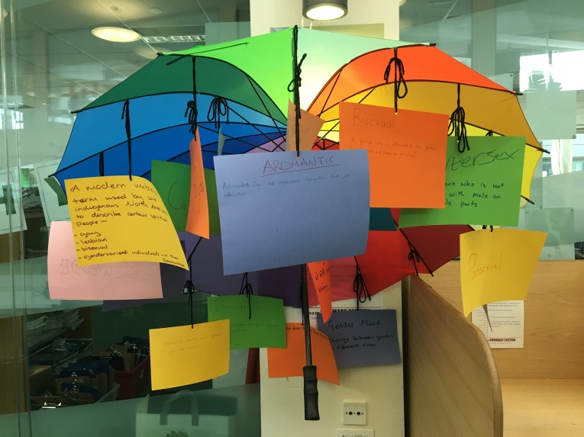

Visit http://www.bathnes.gov.uk/services/your-council-and-democracy/equality-and-diversity/e-teams/e-teams-resources-sharing; for lots more ideas!!

