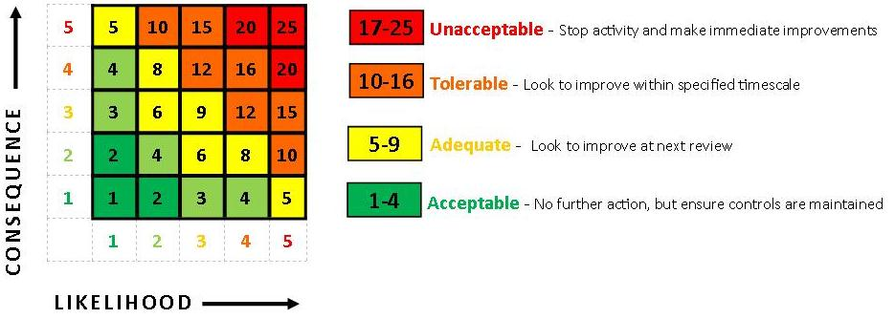
Event Risk Assessment
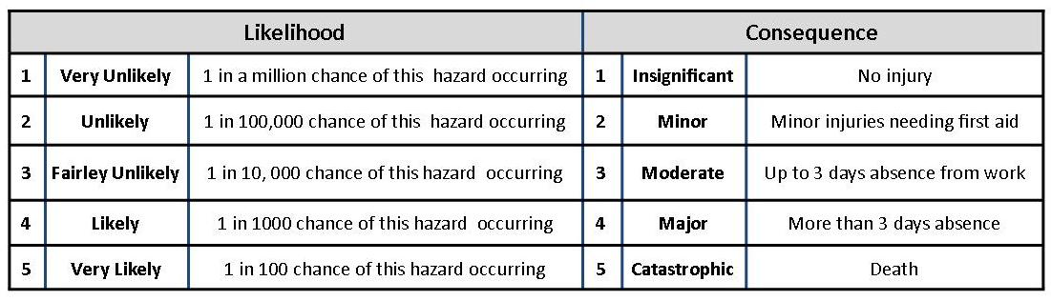

EVENT: |  | LOCATION: |  | DATE: |  | REVIEW DATE
ASSESSOR: |  | DATE OF EVENT: |  | SIGNED:

HAZARDS  IDENTIFIED | GROUPS OF PERSONS AT RISK | EXISTING CONTROLS | RISK  INDEX  L X S = R |  |  | FURTHER RISK MANAGEMENT | RISIDUAL RISK  INDEX |  |  | DATE  COMPLETE  &  SIGNED
 |  |  | L | S | R |  | L | S | R
SLIPS/TRIPS/  FALLS | Staff  Volunteers  Public  Visitors | Regular inspections of all relevant areas carried out | 3 | 3 | 9 | - Keep all pathways clear and ensure all wires, equipment etc is set up correctly not causing any trip hazards.  - Safety officer to check sites before opening.  - Regular inspections of all areas | 2 | 3 | 6
CRUSHING (Crowd) | Staff  Volunteers  Public  Visitors | - Main risk area will be around Tour Series circuit – controls by means of  barriers and a carefully evaluated stewarding plan  - Lower risks at Henrietta Park & RVP for family and Sportive events but B&NES staff & stewards will be present | 3 | 5 | 15 | - Ensure all staff and volunteers are fully briefed of emergency procedures  - Site evacuation plan in place  - Access points around site to enable speedy evacuation  - Regular monitoring of crowd | 2 | 5 | 10
TEMPORARY STRUCTURES | Staff  Volunteers  Public  Visitors  Contractors | - Competent contractor used for installation of marquee at RVP  - Sign off of marquee by contractor  - Gazebos to be weighted in all four corners and staked where necessary  - Structural integrity checked by Building Control as part of SAGE process. | 3 | 4 | 12 | - Safety inspection of all structures including gazebos  - Regular monitoring of weather conditions  - Dismantle gazebos if weather conditions become adverse – i.e. winds approaching 24mph or as per manufacturer’s technical instructions | 2 | 4 | 8
EXPOSURE TO VIOLENT SITUATIONS | Staff  Volunteers | - Employment of security personnel. | 3 | 4 | 12 | - Stopping work if situation deteriorates.  - Removal of high visibility jackets and moving away from the area. | 2 | 4 | 8
ADVERSE WEATHER  CONDITIONS | Staff  Stewards  Volunteers  Visitors | - Work to stop if conditions bad or too hot  - First aid cover with paramedics  - Monitor local weather reports prior to event day and plan accordingly  - Sunscreen available from welfare kit for employees  - Shaded areas available for rest.  - Weather monitored in the preceding weeks, site managed to prevent damage to ground. | 3 | 2 | 6 | - Event staff to monitor site conditions, and to have authority to stop activities on site in the event of severe weather constituting a risk to health and safety of those on site until conditions improve  - Ensure supply of water/bottled water available at Information Point/Event control  - In case of hot weather - Make regular announcements on PA about applying sun block/screen especially for children.  - Ensuring employees are checked whilst working in extreme or prolonged situations & have adequate breaks.  - Removal of persons affected by extremes of weather. | 3 | 1 | 3
VEHICLE MOVEMENT | Staff  Volunteers  Public  Visitors  Contractors | - Public access to be maintained for public use  - Event Staff to monitor ground conditions and specify additional protection/exclusion as required.  - Contractor to be informed of site restrictions/site rules.  - Clear pathway for emergency vehicles. | 3 | 5 | 15 | - No vehicles to be allowed to move during events – n.b. Henrietta Park where children will be present  - Monitor all works during build, event, and break down.  - All vehicles to check in with steward when accessing the parks – RVP or Henrietta Park.  - All large vehicles to only reverse with assistance of a banksman. | 2 | 5 | 10
SPORTS PARTICPATION | Visitors | - Qualified medics presence on site  - All activities are supervised by suitably qualified staff and risk assessments in place. | 3 | 3 | 9 | - Ensure regular H&S inspections of all areas  - Medical facilities available en route of sportive | 2 | 3 | 6
CHILD PROTECTION | Visitors  Public | - Activity deliverers are DBS check or are supervised by DBS checked event staff  - Designated Lost Children Area and Lost Children member of staff assigned | 3 | 3 | 9 | - Event Staff, Contributors and First Aid staff briefed on Child Protection procedures  - 2 x DBS staff provided by Safe & Sound | 2 | 3 | 6
FOOD POISONING | Staff  Volunteers  Public  Visitors | - All traders have to provide in advance copies of food hygiene certification, details of training and risk assessments  - Toilets have hand washing facilities  - First aid post on site  - Drinking water available | 3 | 4 | 12 | - Ensure toilets are kept clean  - Ensure water supply is constant  - Monitor food traders hygiene practises | 2 | 4 | 8
MANUAL HANDLING | Staff  Volunteers  Contractors | - Event staff informed not to lift anything on own and if in doubt not to move  - Contractors will be working under their own H&S policies  - Core Event Team have completed Manual Handing training | 3 | 3 | 9 | - Monitor work being carried out on site.  - Mechanical aides used where possible | 2 | 3 | 6
WASTE DISPOSAL | Staff  Volunteers  Public  Visitors | - Rubbish bags and bins provided  - Contractors and contributors to be responsible for clearance of their areas  - Site signed off as clean by BANES  - Bins and sacks provided around site | 4 | 2 | 8 | - Ensure litter bins are regularly emptied  - Ensure toilets are cleansed  - Ensure water supply is constant  - Ensure litter bins are emptied  - Contributors and traders supplied with bags and encouraged to tidy area before leaving  - Litter pickers employed to tidy area throughout the event. | 3 | 2 | 6
FIRE  IN REGISTRATION AREAS or in CONCESSIONS | Staff  Volunteers  Public  Visitors  Contractors | - Incident & Evacuation plan drawn up and circulated  - Minimum 4m pathways to allow access for emergency services.  - Use of trained security and stewards, advised of location of fire point location.  - Gas canisters of traders contained within the unit therefore away from potential tampering.  - Caterers agree to comply with current legislation and have provided their gas safety certificates and are trained in fire safety. | 3 | 5 | 15 | - Fire point location clearly outlined on site map  - Any rubbish build up removed immediately by dedicated waste removal services throughout the event  - Concessions to provide own fire risk assessments & waste disposal arrangements  - All road closures will be removed to allow access to emergency vehicles. | 2 | 5 | 10
STAFF SHORTAGES | Staff  Volunteers | - Clear deputies identified for key roles in EMP  - At least two people know the detail plans for every element of the event  - Event Management Plans and key documents in folder held at Event Control | 2 | 1 | 3 | - EMP’s/TMP for Tour (Sweetspot), Tour (B&NES), Sportive and Family Rides provided. | 2 | 1 | 3
NOISE | Staff  Volunteers  Public  Visitors  Contractors | - Speakers face away from houses where possible  - Residents and local businesses consulted | 4 | 1 | 4 | - Noise levels monitored | 3 | 1 | 3
DISABILITY DISCRIMINATION | Public  Visitors | - Site is accessible for wheelchair users  - Inclusive activities available  - Disabled toilets available at RVP & Henrietta Park | 2 | 1 | 2 | - Additional facilities provided at Henrietta Park | 2 | 1 | 2
MEDICAL EMERGENCY | Staff  Volunteers  Public  Visitors  Contractors | - All stewards are assigned number and are marked on the site plan – stewards to report back to emergency number via their assigned number.  - First Aid cover provided by experienced qualified medics  - Clearly identifiable first aid points  - Emergency procedures in place  - Regular H&S inspections of all areas | 3 | 5 | 15 | - Route is accessible to emergency vehicles at all times.  - Medical facilities available for all events including en route for Sportive
CANCELLING THE EVENT | Staff  Volunteers  Public  Visitors  Contractors | - Cancellation procedure in place | 1 | 1 | 1 | - Cancellation would be in the interest of public safety.  - Incident media plan in place | 1 | 1 | 1

