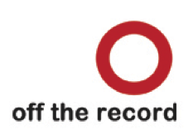
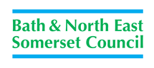

How can I make a difference for Looked After Young People?
If you are aged 11-18 then you can join SICC (Senior In Care Council).
You can:
- Have your say and make changes for young people in care
- Improve the services you use
- Inspire other young people to get their voices heard
- Take part in trips and fun activities
- Build your skills and confidence
- Meet other young people

The types of things we do – what young people have to say:
“Interviewing workers for their jobs.”
Young person aged 13
“Making sure our views are heard by meeting people ourselves - like student social workers.”
Young person aged 14.

SICC

“Making films and art projects like graffiti.”
Young person aged 14
“Updating the pledge - a list of promises to children and young people in care and care leavers. We campaign to make sure it is being stuck to by workers.”
Young person aged 18

“Going on trips to celebrate – we’ve been on a boat trip and to Jimmy Spices.”
Young person aged 13

How can I get involved?
Please call us on 01225 312481 or Email: office@offtherecord-banes.co.uk

