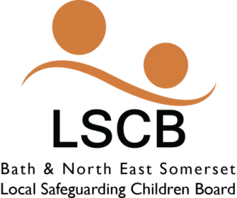

Appendix A

B&NES Safeguarding Children Board
Escalation Policy for Resolving Professional Disagreement

Recording Pro-forma

Please send for the attention of the LSCB and LSAB Business Support Manager and Divisional Director for Specialist and Targeted Services if required to: Safeguarding.AdministrationTeam@bathnes.gcsx.gov.uk

Case Details Date of Original Escalation:

Child’s Name: D.O.B:
Address:

Agencies/ Workers involved
Names | Designation | Agency | Contact Details

Nature of Professional Disagreement
Attempts to resolve issue
Dates:

Outcome:

Unresolved Dispute and Referral to LSCB Chair
Date of Referral:
Chairs Decision to Convene a Resolution Panel: Yes or No

Outcome of LSCB Resolution Panel

