Basic per-pupil entitlement (AWPU)
8.1

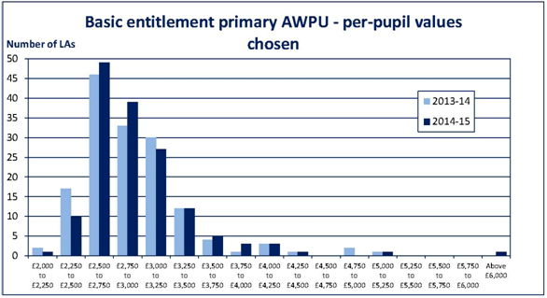

2014-15 B&NES Primary AWPU - £2,462.44

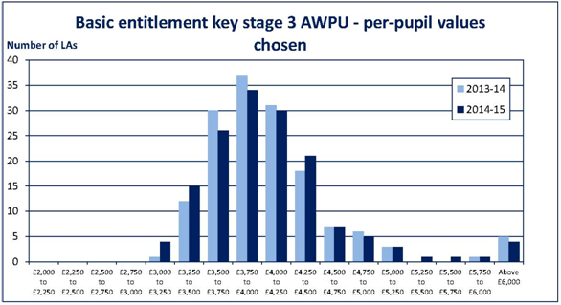

2014-15 B&NES KS3 AWPU - £3,446.35

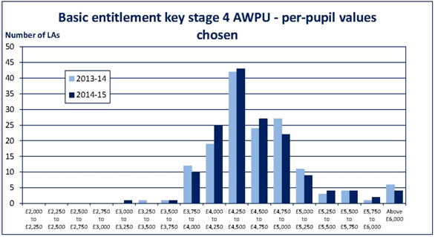

2014-15 B&NES KS4 AWPU - £4,379.93

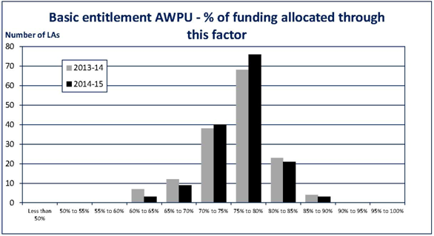

2014-15 B&NES AWPU % funding - 76.78%

Deprivation

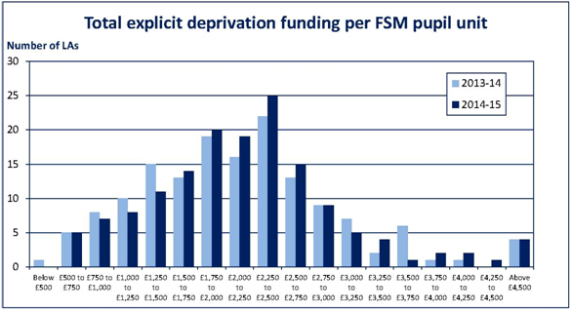

2014-15 B&NES total deprivation funding per FSM - £2,993.22

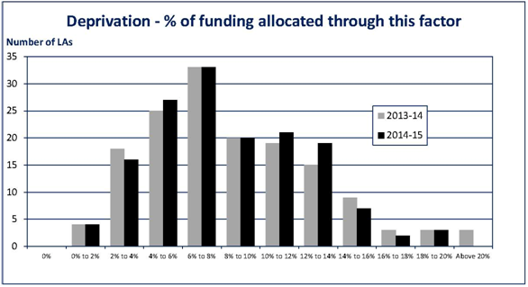

2014-15 B&NES % of funding allocated through deprivation – 7.45%

Looked After Children

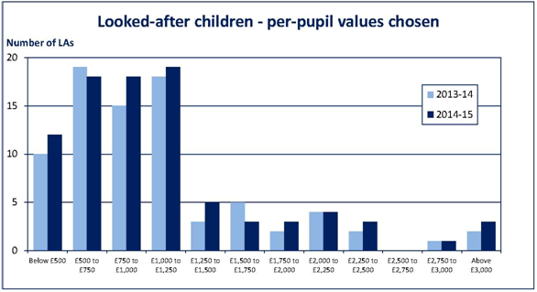

2014-15 B&NES Looked-after children per pupil value – £1,000

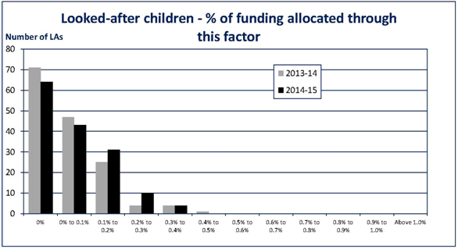

2014-15 B&NES Looked-after children % funding allocated - 0.09%

Prior Attainment

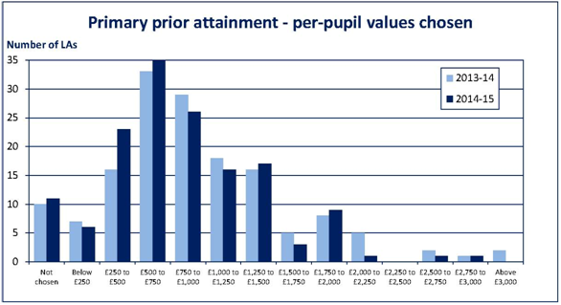

2014-15 B&NES Primary Prior attainment per pupil value - £550.71

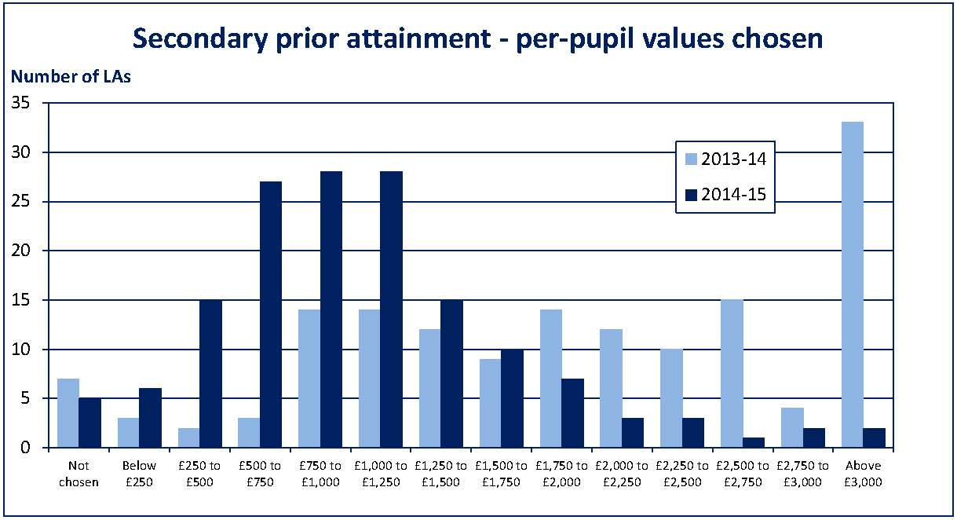

2014-15 B&NES Secondary Prior attainment per pupil value - £1,396.77

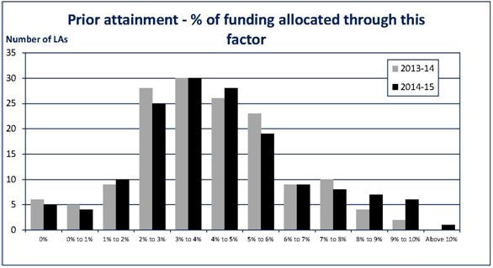

2014-15 B&NES Prior Attainment % funding allocated - 4.46%

English as an additional language

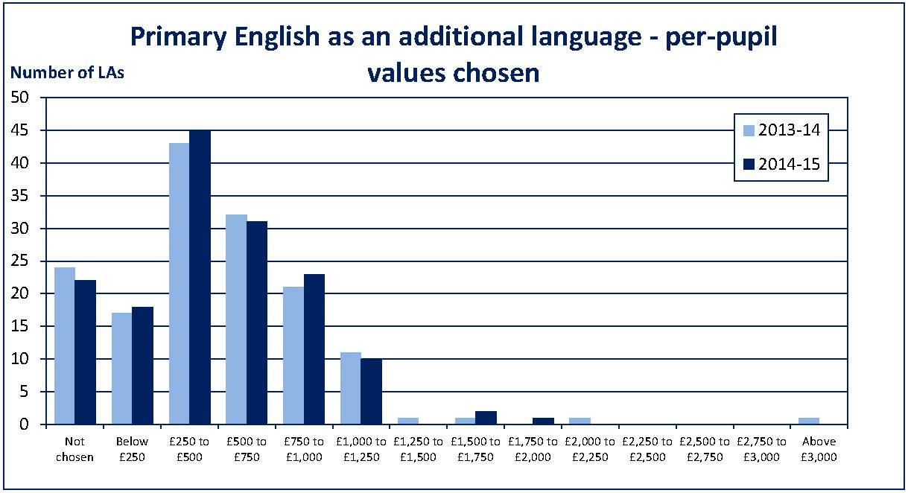

2014-15 B&NES Primary English as an additional language per pupil value - £1,000

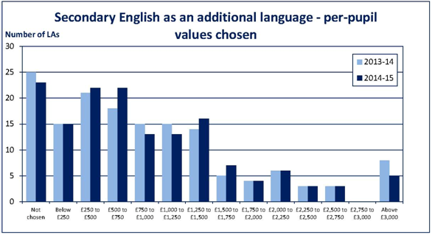

2014-15 B&NES Secondary English as an additional language per pupil value - £2,000

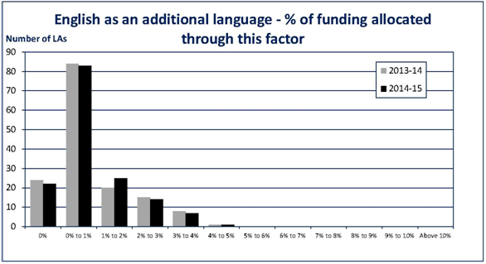

2014-15 B&NES English as an additional language % funding allocated – 0.22%

Mobility

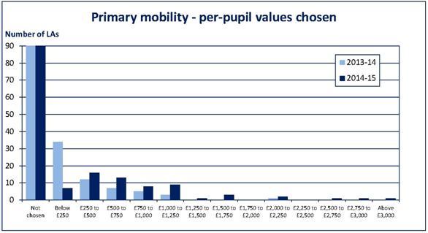

2014-15 B&NES Primary mobility per pupil value - £500

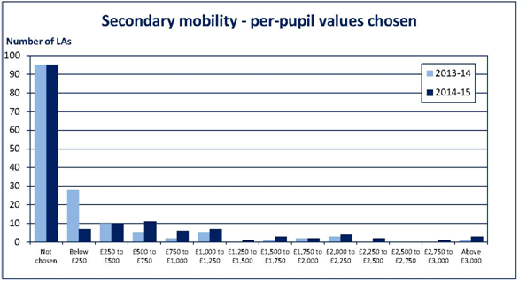

2014-15 B&NES Secondary mobility per pupil value - £500

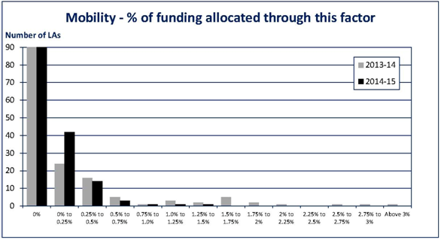

2014-15 B&NES Mobility % funding allocated – 0.01%

Total funding through pupil led factors

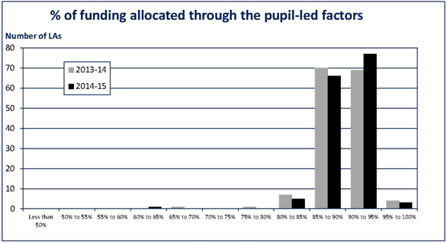

2014-15 B&NES % funding allocated through pupil led factors – 89%

Lump Sums

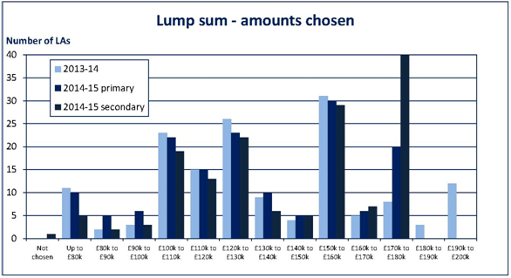

2014-15 B&NES Lump sum amount chosen – £115,642

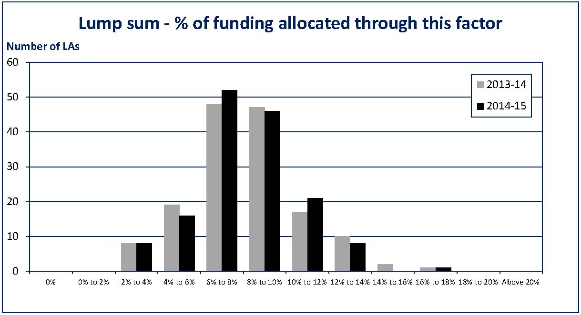

2014-15 B&NES % funding allocated through lump sum factor – 9.78%

Sparsity

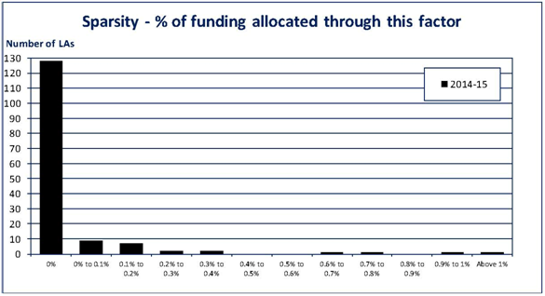

2014-15 B&NES % funding allocated through Sparsity factor – zero

Primary: Secondary funding ratios

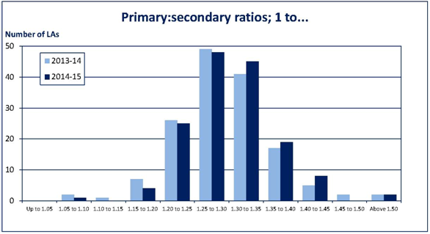

2014-15 B&NES Primary: Secondary ratio – 1:31

Notional SEN Allocations

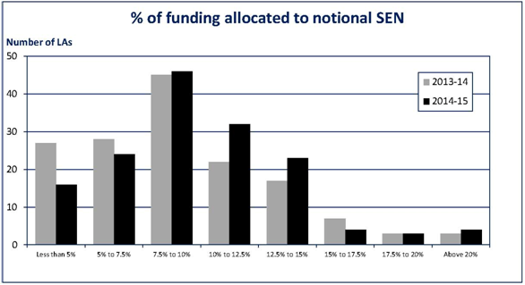

2014-15 B&NES % funding allocated to notional SEN – 9.13%

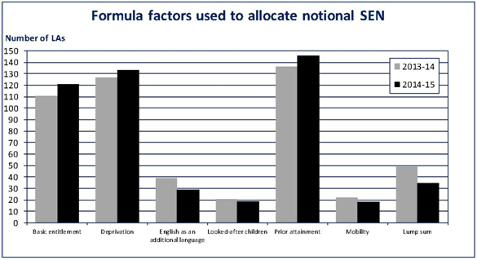

2014-15 B&NES factors used to allocate notional SEN – Basic entitlement, Deprivation, Prior attainment and lump sum

