**August 2014 update**

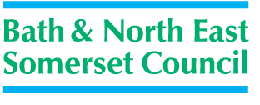

**Public toilet improvement plan continues**

The Council’s contract with Healthmatic Ltd will provide comprehensive cleaning and management services for fifteen years. It means that 15 public toilets in parks, play areas, green spaces and key transport hubs will remain open. The contract has now guaranteed the provision of high quality toilets for our residents and visitors for many years – something which we have never previously been able to do.  That is in the context of very serious pressures on local government finance and this protected level of provision in Bath and North East Somerset is not something that many Councils could offer at the moment.

The new cubicles being installed by Healthmatic combine a number of improvement features:

* A high standard of cleanliness and safety and able to handle large numbers of people using them
* Large enough for a parent with a couple of small children and a pushchair to use together so parents and carers can keep a better eye on their children
* Built into the existing toilet buildings, disability compliant with safe sharps boxes
* Many more baby-changing facilities than there are now, accessible to male and female parents and carers.
* High-tech controls means access can be 24 hours / 7 days a week all year or the timers can be adjusted remotely to suit local needs
* Access by coin entry to a private cubicle with its own hand-washing and drying facilities (as for the existing auto-loos in Bath and North East Somerset which have been operating successfully for 10 years)
* Resistant to vandalism and misuse with an easy clean tiled interior and hard-wearing fittings
* Removal of the male/female separate areas into unisex cubicles, access by coin entry, both deterrents to anti-social behaviours
* Problems are detected remotely enabling rapid response by Healthmatic’s engineering and maintenance teams

Continued/…..

All of the refurbished facilities will be charged at 20p for use, in order to make the contract sustainable.

There are over 110 councils all over the UK with Healthmatic toilets, from busy night-time city centres like Glasgow to tourist destinations like the Cotswolds, Oxfordshire and North Somerset.

This is a typical interior of a new direct access cubicle, disability compliant, with baby changing facility.

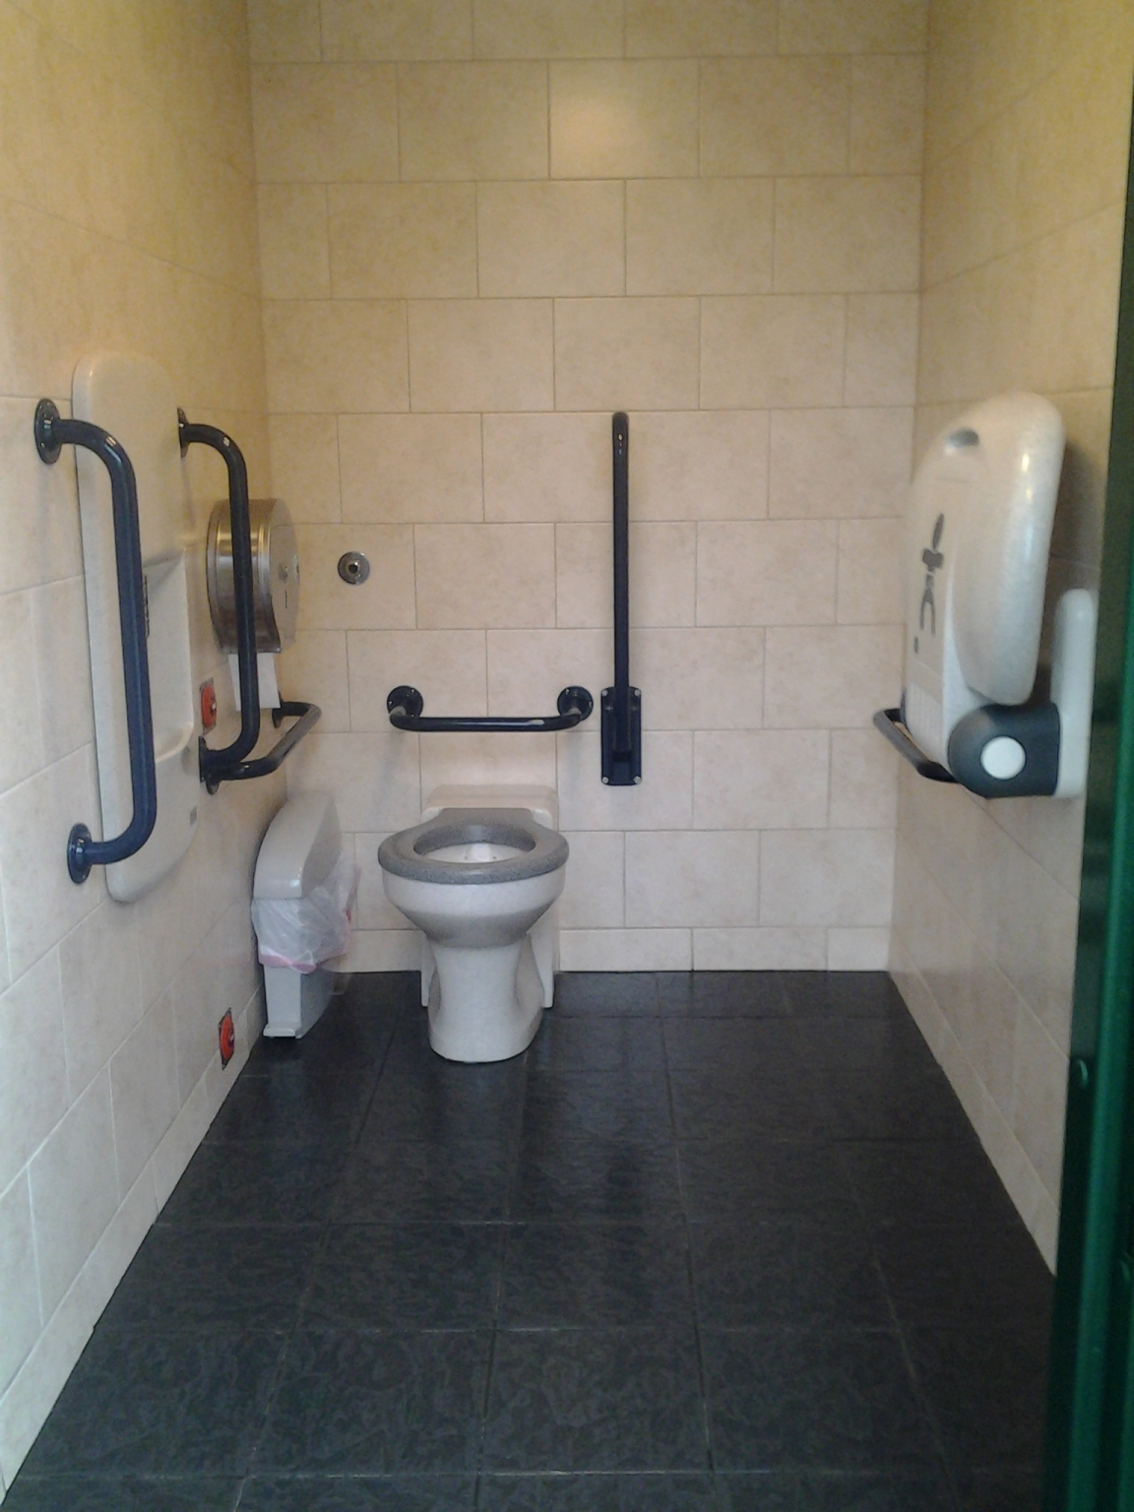

Continued/…..

**More details of the improvement plans:**

* **9 toilets in parks, play areas and green spaces:** No of new cubicles

Royal Victoria Park play area 8

Parade Gardens 2

Memorial Park – Keynsham 2

Sydney Gardens 2

Alice Park 2 - completed

Henrietta Park 2

Monksdale Road 2 – completed

Alexandra Park 2

The Shallows in Saltford 1

When big events are held in parks, organisers are required to hire in portable toilets. This will continue to be the case.

* The **4 other locations are**: No of new cubicles

Monmouth Street 4 - completed

Riverside Coach Park tbc

Charlotte Street Car Park 4

Odd Down Park & Ride 2 - completed

* The current auto-loos at Charlotte Street and Shaftesbury Road will continue in operation until at least 2020;
* A new facility will open at Newbridge Park & Ride later in 2014;
* Temporary cleaning, locking and repairs only arrangement: Ashton Way, Keynsham (until the town centre is redeveloped in Autumn 2014 and the new Council development opens), Gullock Tyning, Midsomer Norton (until mid-2015 when the leisure contract is awarded with public convenience provision included);
* Following a period of working with the community and ward councillors to assess a business case, these locations were closed on 14 July; Dominion Road – Twerton, High Street – Weston, Bradford Road - Combe Down and Peasedown St John. The future of these buildings will come through identifying any alternative productive use by another Council service area before opening up to the market for lease or sale.
* We are continuing to work with a local business in Larkhall Square on an innovative arrangement to provide a public toilet service together.
* Paulton Parish Council have worked with the Council to take over fully running the public conveniences on a 15 year agreement.
* The Council is continuing to work with Batheaston Parish Council over the public toilets building in London Road car park in support of their Vision Plan.